ORACLE JAVA FOUNDATIONS ASSOCIATE CERTIFICATION
AN INDUSTRIAL INTERNSHIP TRAINING REPORT

Based on the Oracle Java Foundations Associate certification course

Submitted by

A JENITA ROSELIN
24BLC1033

BECM399J - SUMMER INDUSTRIAL INTERNSHIP

in partial fulfilment for the award of the degree of
BACHELOR OF TECHNOLOGY
in
ELECTRONICS AND COMPUTER ENGINEERING



October 2026
School of Electronics Engineering
VIT Chennai
DECLARATION BY THE CANDIDATE

I hereby declare that the report titled “ORACLE JAVA FOUNDATIONS ASSOCIATE CERTIFICATION - AN INDUSTRIAL INTERNSHIP TRAINING REPORT”, submitted to VIT Chennai in partial fulfilment of the requirements for the award of the degree of Bachelor of Technology in Electronics and Computer Engineering, presents my learning and understanding of the topics covered in the Java certification course and describes my independent Personal Finance Management System project done to deepen my understanding of the course contents in a separate chapter.
I further declare that the report has been prepared for academic review and that the project chapter is distinguished from the course content. Any implementation, testing, or deployment described in the final submitted version will be limited to work completed by me. This report has not been submitted, in whole or in part, for the award of any other degree or diploma.

Location: Chennai | A Jenita Roselin
Date: | Signature of the Candidate
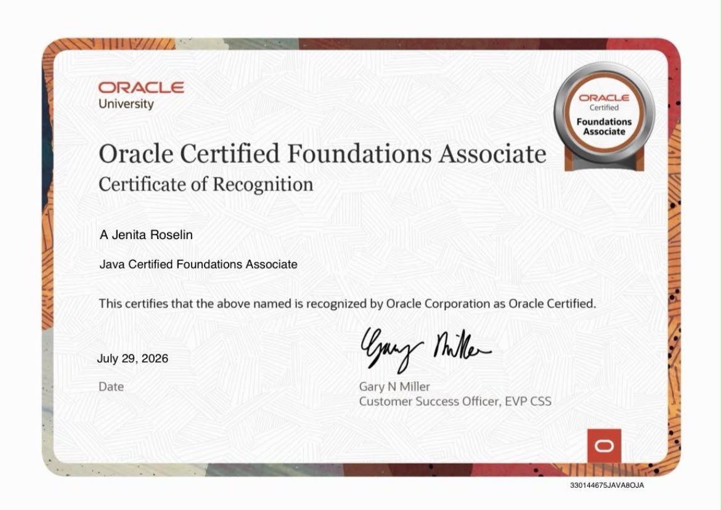
School of Electronics Engineering

BONAFIDE CERTIFICATE

This is to certify that the report titled “Oracle Java Foundations Associate Certification - An Industrial Internship Training Report”, submitted by A Jenita Roselin (24BLC1033) to VIT Chennai in partial fulfilment of the requirements for the award of the degree of Bachelor of Technology in Electronics and Computer Engineering, is a record of the certification-course learning documented by the candidate and an independent project presented for academic review.
The report is submitted for review and approval by the appropriate academic authorities.

Signature of the Examiner | Signature of the Examiner
Date: __________________ | Date: __________________
Head of the Department (B.Tech ECM)
ACKNOWLEDGEMENT
I would like to express my sincere gratitude to Oracle for providing learning resources that helped me develop a structured understanding of Java programming and the Java SE platform. Studying the course topics broadened my knowledge of object-oriented programming, collections, exception handling, database connectivity, security, and application deployment.
I am thankful to VIT Chennai and the School of Electronics Engineering for providing the academic opportunity to undertake the summer industrial internship course requirement and present my learning through this report.
I also acknowledge the value of the programming concepts and development tools that supported my independent Personal Finance Management System project. Working on this project provides a practical context for connecting Java and database concepts with application development.
Finally, I thank my faculty members, peers, family, and everyone who encouraged me during the learning and report-preparation process.

A Jenita Roselin
(24BLC1033)
TABLE OF CONTENTS
Preliminary Pages | 2
Declaration by the Candidate | 2
Bonafide Certificate | 3
Acknowledgement | 4
Table of Contents | 5
List of Abbreviations | 9
Abstract | 10
1. INTRODUCTION  1.1 About the Course  1.2 About Oracle  1.3 Motivation for Taking the Course  1.4 Objectives  1.5 Learning Outcomes  1.6 Organization of the Report | 11
2. INTRODUCTION TO JAVA AND OBJECT-ORIENTED PROGRAMMING  2.1 Overview of Java  2.2 Key Features  2.3 Object-Oriented Programming  2.4 JDK, JRE, and JVM  2.5 Compilation and Execution  2.6 JShell | 13
3. PRIMITIVE TYPES, OPERATORS AND FLOW CONTROL  3.1 Primitive Data Types  3.2 Variables, Constants, and Type Conversion  3.3 Operators  3.4 Conditional Statements  3.5 Loops and Branching  3.6 Relevance | 15
4. STRINGS, DATE, TIME AND NUMERIC OBJECTS  4.1 String Handling  4.2 Wrapper Classes and Autoboxing  4.3 Date and Time API  4.4 Numeric Precision  4.5 Formatting and Localization | 17
5. CLASSES, OBJECTS AND IMPROVED CLASS DESIGN  5.1 Classes and Objects  5.2 Instance and Static Members  5.3 Constructors and the ‘this’ Keyword  5.4 Overloading and Encapsulation  5.5 Immutability and Enums  5.6 Factory Methods, Memory, and Parameter Passing  5.7 Design Relevance | 19
6. INHERITANCE, POLYMORPHISM, INTERFACES AND RECORDS  6.1 Inheritance  6.2 Overriding and Polymorphism  6.3 Abstract, Final, and Sealed Classes  6.4 Interfaces and Composition  6.5 Generics and Common Interfaces  6.6 Records  6.7 Object-Oriented Design | 21
7. ARRAYS, COLLECTIONS AND FUNCTIONAL PROGRAMMING  7.1 Arrays  7.2 Java Collections Framework  7.3 Iteration and Concurrent Access  7.4 Nested Classes and Lambdas  7.5 Stream API  7.6 Aggregation and Parallel Streams  7.7 Relevance | 23
8. EXCEPTION HANDLING, INPUT/OUTPUT AND CONCURRENCY  8.1 Exception Handling  8.2 Exception Keywords  8.3 Logging, Debugging, and Assertions  8.4 Input and Output  8.5 Serialization  8.6 Concurrency and Threads  8.7 ExecutorService and Thread Safety  8.8 Singleton Pattern  8.9 Relevance | 25
9. ADVANCED JAVA CONCEPTS AND ENTERPRISE INTEGRATION  9.1 Java Platform Module System  9.2 Annotations  9.3 Advanced Generics and Type Erasure  9.4 JDBC  9.5 Transactions  9.6 Security and Secure Coding  9.7 Design Patterns and WatchService  9.8 Relevance | 27
10. JAVA APPLICATIONS AND CLOUD DEPLOYMENT  10.1 Introduction  10.2 Application Design Principles  10.3 Compilation and Packaging  10.4 Cloud Deployment  10.5 Oracle Cloud Considerations  10.6 Benefits and Challenges  10.7 Relevance | 29
11. PERSONAL FINANCE MANAGEMENT SYSTEM  11.1 Introduction  11.2 Problem Statement  11.3 Objectives  11.4 Scope  11.5 Technology Stack  11.6 System Architecture  11.7 Database Design  11.8 Implementation  11.8.1 Backend  11.8.2 Database Integration  11.8.3 Security  11.8.4 User Interface  11.9 Testing and Results  11.10 Java Concepts Applied  11.11 Challenges  11.12 Future Enhancements  11.13 Conclusion | 31
12. LEARNING EXPERIENCE AND CONCLUSION  12.1 Learning Experience  12.2 Key Topics Learned  12.3 Challenges and Areas for Improvement  12.4 Future Learning Plans 12.5 Conclusion | 35
References | 37

LIST OF ABBREVIATIONS
Abbreviation | Meaning
API | Application Programming Interface
CLI | Command-Line Interface
GC | Garbage Collection
IDE | Integrated Development Environment
I/O | Input/Output
JAR | Java Archive
JDBC | Java Database Connectivity
JDK | Java Development Kit
JRE | Java Runtime Environment
JPMS | Java Platform Module System
JVM | Java Virtual Machine
OOP | Object-Oriented Programming
ORM | Object-Relational Mapping
SQL | Structured Query Language
UI | User Interface

ABSTRACT
This report documents the learning undertaken through the Oracle Java Foundations Associate Certification course as part of the Summer Industrial Internship academic requirement. It presents the major concepts covered across Java fundamentals, object-oriented programming, strings and date/time APIs, class design, inheritance, interfaces, records, arrays, collections, functional programming, exception handling, input/output, concurrency, modules, annotations, generics, JDBC, secure coding, and cloud deployment.
The report is organized to explain the purpose and essential principles of each topic, with selected examples illustrating key Java language and platform features. It is intended to communicate conceptual learning clearly without claiming that every course exercise or demonstration was completed.
A separate chapter presents the independent Personal Finance Management System project, developed using Java 17, Spring Boot, PostgreSQL, Spring Security, and Flyway as the recorded technology stack. That chapter distinguishes the architecture and functionality from features.
The report concludes by reflecting on the learning outcomes and the relevance of Java concepts to structured application development.
CHAPTER 1
INTRODUCTION

1.1 About the Course
The Oracle Java Foundations Associate Certification course provides a structured introduction to the Java language and platform, extending from foundational syntax to more advanced application-development concepts. The course covers the principles required to write, organize, and understand Java programs, along with APIs and tools used in practical software development.
The subject matter progresses from primitive data types, operators, control flow, and object-oriented programming to collections, streams, exceptions, input/output, concurrency, modularity, database connectivity, security, and deployment. This progression helps connect language fundamentals with the wider responsibilities involved in building software.

1.2 About Oracle
Oracle is a technology company known for database systems, enterprise software, and the development and stewardship of Java technologies. Java is a general-purpose programming language and platform used in desktop, server-side, enterprise, and other application environments. The Java platform provides libraries and runtime facilities that support application development across compatible environments.

1.3 Motivation for Taking the Course
A structured Java course is relevant to developing a strong foundation in programming and backend application development. Java's type system, object-oriented model, standard libraries, and ecosystem provide useful tools for designing maintainable applications. Studying Java SE 17 also offers an opportunity to understand both basic language constructs and more advanced topics such as collections, streams, JDBC, and concurrency.

1.4 Objectives
- Understand Java syntax, data types, operators, and control-flow statements.
- Apply object-oriented principles such as encapsulation, inheritance, abstraction, and polymorphism.
- Understand common Java APIs for strings, date/time values, collections, and file operations.
- Study exception handling, logging, debugging, and resource management.
- Understand the basics of functional programming, streams, and concurrency.
- Explore modularity, annotations, generics, JDBC, secure coding, and application deployment.
- Relate course concepts to an independent software project without confusing project work with course assignments.

1.5 Learning Outcomes
The intended learning outcomes include the ability to read and explain Java programs, select suitable language constructs, understand common APIs, reason about errors and resource management, and recognize design considerations involved in database-driven applications. The course also supports further study of Java frameworks and backend development.

1.6 Organization of the Report
Chapters 2 to 10 present the technical subjects in the course outline. Chapter 11 documents the independent Personal Finance Management System project. Chapter 12 summarizes the learning experience, challenges, and future learning plans. References are provided at the end.
CHAPTER 2
INTRODUCTION TO JAVA AND OBJECT-ORIENTED PROGRAMMING

2.1 Overview of Java
Java is a statically typed, class-based, general-purpose programming language. Java source code is compiled into bytecode, which can be executed by a compatible Java Virtual Machine (JVM). This model supports portability across systems that provide compatible runtimes.

2.2 Key Features
- Platform independence through bytecode and the JVM.
- Object-oriented language features for organizing data and behaviour.
- Static type checking and exception handling.
- Automatic memory management through garbage collection.
- A standard library that supports collections, networking, I/O, date/time operations, and other common tasks.
- Concurrency facilities for coordinating multiple tasks.

2.3 Object-Oriented Programming
Object-oriented programming organizes software around objects that combine state and behaviour. A class defines a type and describes the fields and methods associated with its instances.
- Encapsulation groups data and operations and controls access to internal state.
- Abstraction exposes essential operations while hiding implementation details.
- Inheritance allows a class to derive behaviour and state from another class.
- Polymorphism allows a common interface or superclass reference to work with different concrete implementations.

2.4 JDK, JRE, and JVM
The JVM executes Java bytecode. The Java Development Kit (JDK) includes development tools such as the compiler as well as runtime components. The term Java Runtime Environment (JRE) is commonly used to describe the runtime components needed to execute Java applications, although modern Java distributions may package these components differently.

2.5 Compilation and Execution
javac HelloWorld.java
java HelloWorld

The ‘javac’ command compiles source code into class files. The ‘java’ command launches the program using the JVM. A typical introductory program defines a class and a ‘main’ method as its entry point.

2.6 JShell
JShell is an interactive tool introduced in Java 9 that allows developers to evaluate Java expressions and statements without creating a complete source file. It is useful for exploring syntax and testing small pieces of code.
CHAPTER 3
PRIMITIVE TYPES, OPERATORS AND FLOW CONTROL

3.1 Primitive Data Types
Java has eight primitive data types: ‘byte’, ‘short’, ‘int’, ‘long’, ‘float’, ‘double’, ‘char’, and ‘boolean’. Integer types represent whole-number values, floating-point types represent approximate real-number values, ‘char’ represents a UTF-16 code unit, and ‘boolean’ represents a logical true-or-false value.

3.2 Variables, Constants, and Type Conversion
A variable in java is a named storage location with a declared type. The ‘final’ keyword can be used to indicate that a variable may be assigned only once. Widening conversions (implicit typecasting) generally convert a value to a type capable of representing a broader range, while narrowing conversions (explicit typecasting) may lose information and often require a manual cast.
int count = 10;
double measuredValue = count;
int roundedDown = (int) 3.9;
final double TAX_RATE = 0.08;

3.3 Operators
Java provides arithmetic, assignment, relational, equality, logical, unary, bitwise, shift, and conditional operators. Operator precedence determines the order of evaluation, while parentheses can make intended grouping explicit.
Operator category | Examples | Purpose
Arithmetic | +, -, *, /, % | Performs numeric calculations
Relational | <, <=, >, >= | Compares ordered values
Equality | ==, != | Tests equality or inequality
Logical | &&, ||, ! | Combines or negates boolean expressions
Assignment | =, +=, -=, *= | Assigns or updates a variable
Conditional/Ternary | condition ? a : b | Selects one of two expressions
Bitwise / shift | &, |, ^, <<, >> | Performs bit-level operations

3.4 Conditional Statements
The ‘if’, ‘if-else’, and ‘switch’ constructs allow a program to select a path based on conditions or the value of an expression. Clear conditions and well-structured branches improve readability and reduce logical errors.

3.5 Loops and Branching
Java supports ‘for’, enhanced ‘for’, ‘while’, and ‘do-while’ loops. The ‘break’ statement exits a loop or switch statement, while ‘continue’ advances to the next iteration of a loop. The appropriate loop depends on whether the number of iterations is known and when the loop condition should be checked.

3.6 Relevance
These fundamentals underpin input validation, financial calculations, transaction filtering, and conditional business rules. Numeric types and rounding require particular care in financial software; binary floating-point types should not be assumed to represent all decimal currency values exactly.
CHAPTER 4
STRINGS, DATE, TIME AND NUMERIC OBJECTS

4.1 String Handling
The ‘String’ class represents text and is immutable: operations that appear to modify a string produce a new string rather than changing the original object. Common methods include ‘length()’, ‘charAt()’, ‘substring()’, ‘contains()’, ‘equals()’, and ‘toLowerCase()’.
String content should normally be compared using ‘equals()’ rather than ‘==‘, because ‘==‘ compares object references. ‘StringBuilder’ provides a mutable sequence of characters and can be more suitable when text is repeatedly appended or modified.

4.2 Wrapper Classes and Autoboxing
Wrapper classes such as ‘Integer’, ‘Double’, and ‘Boolean’ provide object representations of primitive values. Autoboxing converts a primitive value to its corresponding wrapper type where supported, and unboxing converts a wrapper to its primitive value. Developers should be mindful that unboxing a null wrapper can cause a ‘NullPointerException’.

4.3 Date and Time API
The ‘java.time’ package provides immutable types for representing dates, times, and durations. ‘LocalDate’ represents a date, ‘LocalTime’ represents a time of day, and ‘LocalDateTime’ represents a date and time without a time zone. ‘Period’ describes date-based amounts, while ‘Duration’ describes time-based amounts.

4.4 Numeric Precision
The ‘BigDecimal’ class supports decimal arithmetic with explicit precision and rounding control. It is often suitable for monetary calculations where exact decimal representation is required. Construction from a string is generally preferable when the intended decimal value must be preserved exactly.
import java.math.BigDecimal;

BigDecimal price = new BigDecimal("19.95");
BigDecimal quantity = new BigDecimal("3");
BigDecimal total = price.multiply(quantity);

4.5 Formatting and Localization
Formatting APIs present numeric and date/time values in a readable form. Locale-sensitive formatting can adapt output to language and regional conventions. A robust application should distinguish stored values from their display format and avoid treating formatted text as the underlying data.
CHAPTER 5
CLASSES, OBJECTS AND IMPROVED CLASS DESIGN

5.1 Classes and Objects
A class defines fields and methods, while an object is an instance of a class. Fields store object state and methods implement behaviour. Constructors initialize new instances and may be overloaded to support different initialization requirements.

5.2 Instance and Static Members
Instance fields belong to individual objects. Static fields and methods belong to the class itself rather than to a particular instance. Static methods cannot directly access instance members without an object reference.

5.3 Constructors and the this Keyword
A constructor has the same name as its class and no return type. The ‘this’ reference identifies the current object and can distinguish instance fields from parameters with the same name. Constructor chaining can reduce duplicated initialization logic.

5.4 Overloading and Encapsulation
Method overloading allows methods to share a name while differing in parameter lists. Encapsulation uses access modifiers such as ‘private’, package-private access, ‘protected’, and ‘public’ to control visibility. A class can expose controlled methods rather than permitting arbitrary direct modification of its internal state.

5.5 Immutability and Enums
An immutable object cannot have its observable state changed after construction. Immutability can simplify reasoning about an object's behaviour. An ‘enum’ defines a fixed set of named constants and is appropriate when a value must belong to a known set of choices.

5.6 Factory Methods, Memory, and Parameter Passing
Static factory methods provide named alternatives to constructors and can communicate the purpose of object creation. Java manages object memory automatically through garbage collection, which reclaims memory associated with objects that are no longer reachable. Java is pass-by-value: for object arguments, the value copied is the reference, so a method can mutate a referenced object but cannot replace the caller's reference variable itself.

5.7 Design Relevance
These concepts support clear domain models, predictable object lifecycles, and controlled access to application data. A well-designed class should have a coherent responsibility and expose only the operations needed by its callers.
CHAPTER 6
INHERITANCE, POLYMORPHISM, INTERFACES AND RECORDS

6.1 Inheritance
Inheritance allows a subclass to reuse and specialize accessible members of a superclass. The ‘extends’ keyword declares class inheritance. The ‘super’ keyword can refer to superclass members and can be used to invoke a superclass constructor.

6.2 Overriding and Polymorphism
A subclass can override an inherited instance method to provide specialized behaviour. At runtime, dynamic method dispatch selects the implementation associated with the actual object. This allows code to work with a common superclass or interface while supporting different implementations.

6.3 Abstract, Final, and Sealed Classes
An abstract class cannot be instantiated directly and may declare abstract methods. A ‘final’ class cannot be subclassed. A sealed class restricts which classes may directly extend it, using ‘permits’ or permitted subclasses declared according to Java's rules.

6.4 Interfaces and Composition
An interface defines a contract that implementing classes agree to provide. Interfaces support polymorphism and can help reduce dependencies on concrete classes. Composition builds a class by giving it references to other objects; it is often a flexible alternative to deep inheritance hierarchies.

6.5 Generics and Common Interfaces
Generic types allow classes and methods to operate on different reference types with compile-time checking. Common interfaces such as ‘Comparable’ and ‘Comparator’ support ordering, while interfaces from the collections framework provide shared operations across data structures.

6.6 Records
Records are a concise form for declaring classes intended primarily to represent data. The compiler supplies components, accessors, and implementations of methods such as ‘equals()’, ‘hashCode()’, and ‘toString()’, subject to the record's declared components and any explicit overrides. Records are implicitly final and are useful for simple data carriers.

6.7 Object-Oriented Design
Inheritance, interfaces, and composition help organize related responsibilities. Good design uses abstraction where it improves clarity and avoids introducing hierarchies or abstractions that do not solve a real problem.
CHAPTER 7
ARRAYS, COLLECTIONS AND FUNCTIONAL PROGRAMMING

7.1 Arrays
An array stores a fixed number of elements of one declared type. Array indexes begin at zero, and the array's length is available through its ‘length’ field. Multidimensional arrays in Java are arrays whose elements may themselves be arrays.

7.2 Java Collections Framework
The Java Collections Framework provides interfaces and implementations for storing and manipulating groups of objects. ‘List’ maintains an ordered sequence and permits duplicates; ‘Set’ models unique elements; ‘Queue’ supports elements awaiting processing; ‘Deque’ supports operations at both ends; and ‘Map’ associates keys with values.
Interface | Common implementations | Typical use
List | ArrayList, LinkedList | Ordered sequence of elements
Set | HashSet, LinkedHashSet, TreeSet | Unique elements
Queue / Deque | ArrayDeque, LinkedList | Queue or double-ended processing
Map | HashMap, LinkedHashMap, TreeMap | Key-value associations

7.3 Iteration and Concurrent Access
Collections can be traversed using loops, iterators, and other supported APIs. Structural modification during iteration must follow the relevant collection's rules. Concurrent access requires attention to thread safety; ordinary collections are not automatically safe for unsynchronized concurrent modification.

7.4 Nested Classes and Lambdas
Nested classes are declared within another class and can help keep related implementation details together. Lambda expressions provide concise implementations of functional interfaces, especially interfaces with a single abstract method.
List<String> names = List.of("Ada", "Grace", "Linus");
names.forEach(name -> System.out.println(name));

7.5 Stream API
Streams support declarative processing of data through pipelines. Intermediate operations such as ‘filter()’ and ‘map()’ describe transformations, while terminal operations such as ‘collect()’, ‘forEach()’, and reduction operations trigger processing. Streams do not themselves store data.
List<Integer> values = List.of(2, 5, 8, 11);
List<Integer> evenValues = values.stream()
.filter(value -> value % 2 == 0)
.toList();

7.6 Aggregation and Parallel Streams
Aggregation operations summarize data, for example by counting, summing, grouping, or reducing values. Parallel streams may process elements concurrently, but they are not automatically faster. Performance, thread safety, ordering, and side effects should be considered before choosing parallel execution.

7.7 Relevance
Arrays and collections support in-memory data handling, while streams can simplify filtering and summarizing records. In a finance application, these tools may support category grouping, date filtering, or report preparation when such features are implemented.
CHAPTER 8
EXCEPTION HANDLING, INPUT/OUTPUT AND CONCURRENCY

8.1 Exception Handling
An exception interrupts the normal flow of execution. Java distinguishes checked exceptions, unchecked exceptions, and errors. Checked exceptions generally must be caught or declared, while unchecked exceptions are subclasses of ‘RuntimeException’. Errors usually represent serious conditions that applications are not expected to handle routinely.

8.2 Exception Keywords
The ‘try’ block encloses statements that may fail, ‘catch’ handles specified exceptions, and ‘finally’ provides a place for cleanup. ‘throw’ explicitly throws an exception, while ‘throws’ declares possible exceptions in a method signature.
try {
int result = 10 / 0;
System.out.println(result);
} catch (ArithmeticException e) {
System.out.println("Division by zero is not allowed.");
} finally {
System.out.println("Execution completed.");
}

8.3 Logging, Debugging, and Assertions
Logging records events and diagnostic information. Java's ‘java.util.logging’ API supports severity levels such as SEVERE, WARNING, and INFO. Debugging tools provide breakpoints, step execution, variable inspection, and call-stack information. Assertions check assumptions during development and testing, but they should not replace validation of user input.

8.4 Input and Output
Java supports standard input and output through ‘System.in’, ‘System.out’, and ‘System.err’. ‘Scanner’ can parse console input. Character streams process text, while byte streams handle raw binary data. The ‘java.nio.file’ APIs, including ‘Path’ and ‘Files’, provide operations for reading, writing, and managing file-system paths.

8.5 Serialization
Serialization converts object state into a form suitable for storage or transmission. Java object serialization uses classes such as ‘ObjectOutputStream’ and ‘ObjectInputStream’ for serializable objects. Deserializing untrusted data can be dangerous, so applications should avoid accepting arbitrary serialized objects from untrusted sources.

8.6 Concurrency and Threads
Concurrency allows multiple tasks to make progress during overlapping periods. Java supports threads through ‘Thread’ and ‘Runnable’. Calling ‘start()’ initiates a separate thread of execution; calling ‘run()’ directly is an ordinary method call on the current thread.

8.7 ExecutorService and Thread Safety
‘ExecutorService’ offers a higher-level way to submit tasks and manage execution resources. When threads access shared mutable data, race conditions may occur. Synchronization, locks, concurrent data structures, and reduced shared state help manage such risks.

8.8 Singleton Pattern
The Singleton pattern aims to provide one shared instance of a class. A Singleton accessed by multiple threads must be implemented carefully to ensure safe initialization and safe handling of any mutable state.

8.9 Relevance
Exception handling, logging, I/O, and concurrency are relevant to robust applications. A finance application must manage invalid input and database failures, handle resources carefully, and coordinate concurrent updates so that shared data remains consistent.
CHAPTER 9
ADVANCED JAVA CONCEPTS AND ENTERPRISE INTEGRATION

9.1 Java Platform Module System
The Java Platform Module System, introduced in Java 9, organizes packages into named modules with explicit dependencies and access boundaries. A ‘module-info.java’ file declares module requirements and exported packages.
module com.example.finance {
requires java.sql;
exports com.example.finance;
}

The ‘requires’ directive declares a dependency and ‘exports’ makes a package accessible to other modules. Modular deployment can also support custom runtime images containing the modules needed by an application.

9.2 Annotations
Annotations provide metadata about classes, methods, fields, and other program elements. Common annotations include ‘@Override’, ‘@Deprecated’, ‘@SuppressWarnings’, and ‘@FunctionalInterface’. Their effects depend on how the compiler, runtime, framework, or other tools process them.

9.3 Advanced Generics and Type Erasure
Generic classes and methods improve reuse while maintaining compile-time type checking. Bounded type parameters restrict acceptable types, and wildcards such as ‘? extends Number’ and ‘? super Integer’ express flexible type relationships. Java primarily implements generics through type erasure, so most generic type parameters are not represented as distinct runtime types.

9.4 JDBC
Java Database Connectivity (JDBC) is an API for communicating with relational databases. Its components include ‘Connection’, ‘Statement’, ‘PreparedStatement’, ‘ResultSet’, and ‘SQLException’. A typical workflow establishes a connection, prepares and executes SQL, processes returned data, manages transactions when required, and releases resources.
String sql = "SELECT account_name FROM accounts WHERE account_id = ?";
try (PreparedStatement statement = connection.prepareStatement(sql)) {
statement.setInt(1, accountId);
try (ResultSet resultSet = statement.executeQuery()) {
while (resultSet.next()) {
System.out.println(resultSet.getString("account_name"));
}
}
}

The example assumes that ‘connection’ and ‘accountId’ have already been defined. Parameterized SQL separates the statement structure from supplied values and helps reduce SQL injection risk.

9.5 Transactions
A database transaction groups operations into a logical unit of work. JDBC provides transaction controls such as ‘setAutoCommit()’, ‘commit()’, and ‘rollback()’. For related changes, such as debiting one account and crediting another, transactions help ensure that the operations succeed or fail together.

9.6 Security and Secure Coding
- Validate external input against expected formats, types, and ranges.
- Use parameterized SQL rather than concatenating untrusted values into queries.
- Apply least-privilege access to database accounts and application resources.
- Keep passwords, tokens, and other secrets out of source code and user-facing error messages.
- Manage resources reliably and avoid exposing sensitive diagnostic details.

9.7 Design Patterns and WatchService
Design patterns provide reusable approaches to recurring design problems and should be selected only when appropriate. The ‘WatchService’ API in ‘java.nio.file’ can monitor registered directories for events such as file creation, modification, or deletion. A monitoring application must process events and manage watch keys and resources correctly.

9.8 Relevance
Modules, annotations, generics, JDBC, and secure coding provide concepts useful for structuring database-backed applications. Their practical use should be documented against the actual implementation rather than assumed from the presence of a dependency.
CHAPTER 10
JAVA APPLICATIONS AND CLOUD DEPLOYMENT

10.1 Introduction
Application development includes more than writing source code. Software must be organized, compiled, packaged, configured, and executed in an appropriate environment. The course introduced Java application deployment concepts, including the deployment of Java SE applications to Oracle Cloud.

10.2 Application Design Principles
- Modularity divides a system into components with clear responsibilities.
- Encapsulation controls access to internal state.
- Reusability reduces unnecessary duplication.
- Maintainability makes changes and debugging easier.
- Separation of concerns keeps distinct responsibilities from becoming tightly coupled.

10.3 Compilation and Packaging
Java source files are compiled into bytecode stored in ‘.class’ files. Related classes and resources can be packaged into JAR files. An executable JAR may identify its entry point through manifest metadata. The target environment must provide a compatible Java runtime and required dependencies.
javac HelloWorld.java
java HelloWorld

10.4 Cloud Deployment
Cloud deployment makes an application available in a cloud execution environment rather than only on an individual development machine. A general workflow includes preparing and compiling the application, packaging its classes and resources, configuring the runtime environment, deploying the package, verifying execution, and maintaining the application.

10.5 Oracle Cloud Considerations
The course includes Java SE application deployment to Oracle Cloud. The exact procedure depends on the chosen Oracle Cloud service and the application's requirements. Important considerations include runtime compatibility, resource allocation, application configuration, dependency management, security, monitoring, and cost.

10.6 Benefits and Challenges
Cloud environments can support accessibility, centralized operation, flexible resource selection, and integration with other services. They also introduce configuration, security, cost-control, and operational-monitoring responsibilities. A successful deployment requires both a correctly prepared application and a suitable target environment.

10.7 Relevance
Deployment concepts are relevant when moving a Java application from local development to a shared environment.
CHAPTER 11
PERSONAL FINANCE MANAGEMENT SYSTEM

11.1 Introduction
The Personal Finance Management System is an independent software development project developed to apply Java programming, backend application development, relational database management, and web application concepts to a practical financial-management application.
The system is implemented using Java 17 and Spring Boot, with PostgreSQL used for persistent relational data storage. The backend follows a layered architecture consisting of controllers, services, repositories, and entities. Spring Security is used to provide application security, while Flyway is used to manage database schema migrations.
The project provides a structured environment for recording and retrieving personal financial information. The implementation focuses on maintaining financial records in a relational database while applying validation, security, and separation of application responsibilities.

11.2 Problem Statement
Managing personal financial information manually can make it difficult to maintain an accurate record of income, expenses, payment methods, and financial summaries. Records may be distributed across notebooks, spreadsheets, banking applications, or other sources, making it difficult to obtain a consolidated view of personal finances.
The Personal Finance Management System addresses this problem by providing a centralized application for storing financial records and retrieving meaningful summaries from the stored data. The system uses a relational database to maintain structured financial information and a Spring Boot backend to process requests and enforce application-level rules.

11.3 Objectives
The primary objectives of the project are:
- To develop a Java-based backend application for managing personal financial records.
- To use Spring Boot to implement a structured web application backend.
- To use PostgreSQL for persistent relational data storage.
- To implement database schema versioning using Flyway.
- To organize application functionality using controllers, services, repositories, and entities.
- To implement financial record management using database-backed operations.
- To provide financial summaries based on stored financial records.
- To implement payment-method management as part of financial record organization.
- To apply input validation and security mechanisms.
- To test the implemented functionality and verify its interaction with the database.

11.4 Scope
The scope of the implemented system includes backend functionality for managing personal financial information and its associated database records.
The implemented design covers financial transactions, payment methods, categories, user-related data, and financial summaries. The backend is structured so that business logic is handled by service classes rather than being placed directly inside REST controllers.
The project also includes database migration management using Flyway and database schema validation through Hibernate configuration.

11.5 Technology Stack
Technology | Recorded role
Java 17 | Primary programming language
React
  Frontend/client-side application
Vite
  Frontend development and build tooling
Spring Boot | Backend application framework
Spring Web | Web-related application functionality
Spring Data JPA
  Persistence and interaction with relational database entities
Spring Security | Security and authentication-related configuration
PostgreSQL | Relational database management system
Flyway | Versioned database schema migration
Maven
  Project dependency and build management
IntelliJ IDEA | Editing, building, and debugging

The backend is implemented using Java 17 and Spring Boot. PostgreSQL provides persistent storage, while Flyway manages the evolution of the database schema. Spring Data JPA is used for database interaction through repository and entity abstractions.

11.6 System Architecture
The application follows a layered architecture in which requests originating from the client are processed by the Spring Boot backend before reaching the PostgreSQL database.
The main backend layers have the following responsibilities:
- Controller Layer: Receives HTTP requests and exposes REST endpoints.
- DTO Layer: Represents request and response data transferred between the client and backend.
- Service Layer: Contains application-specific business logic and coordinates operations.
- Repository Layer: Provides database access through Spring Data JPA.
- Entity Layer: Represents persistent database entities.
- Security Layer: Handles authentication and protection of application resources.
- Database Layer: PostgreSQL stores persistent application data.
- Migration Layer: Flyway manages database schema changes in a controlled sequence.
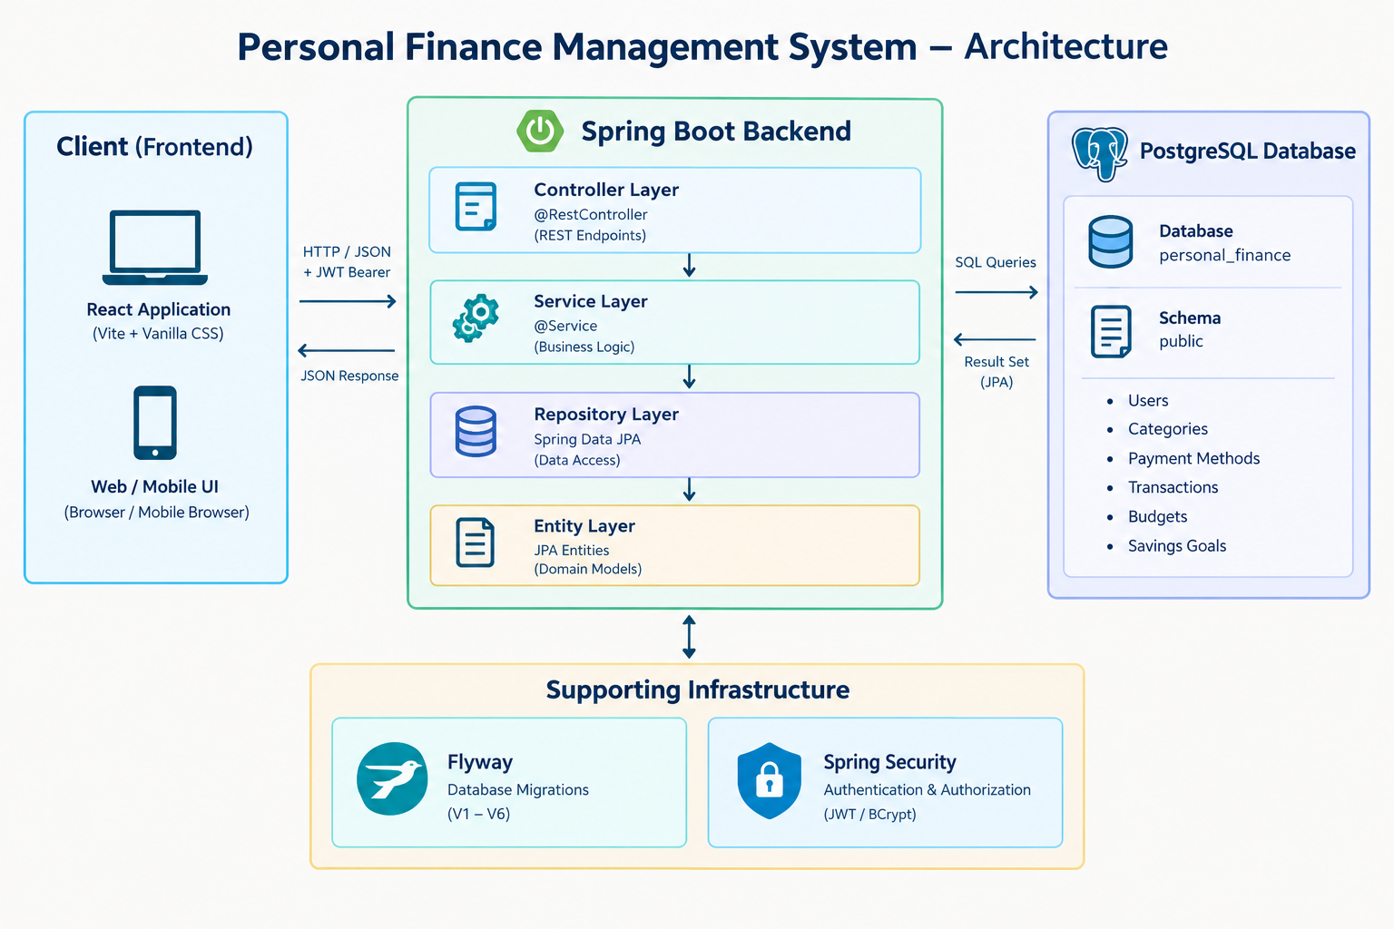

11.7 Database Design
The project uses PostgreSQL as its relational database management system. The configured database is personal_finance, using the public schema.
The project uses Flyway for version-controlled database migrations. Hibernate is configured with ddl-auto=validate, meaning Hibernate validates the database structure against the mapped entities rather than automatically generating or modifying the database schema.
Parameter | Recorded configuration
Database | PostgreSQL
Database name | personal_finance
Schema | public
Java version | 17
Schema validation | ddl-auto=validate
SQL logging | show-sql=true
Database Migration | Flyway
The database is designed around user-owned financial information. The major entities represented in the implementation include:
- Users
- Categories
- Payment Methods
- Financial Transactions
- Budgets
- Savings Goals
The financial transaction records form the central part of the system because they provide the underlying data from which financial summaries and spending information can be calculated.
Payment methods are maintained separately from transactions and can subsequently be associated with individual financial records. Similarly, categories provide a structured way of classifying financial transactions.
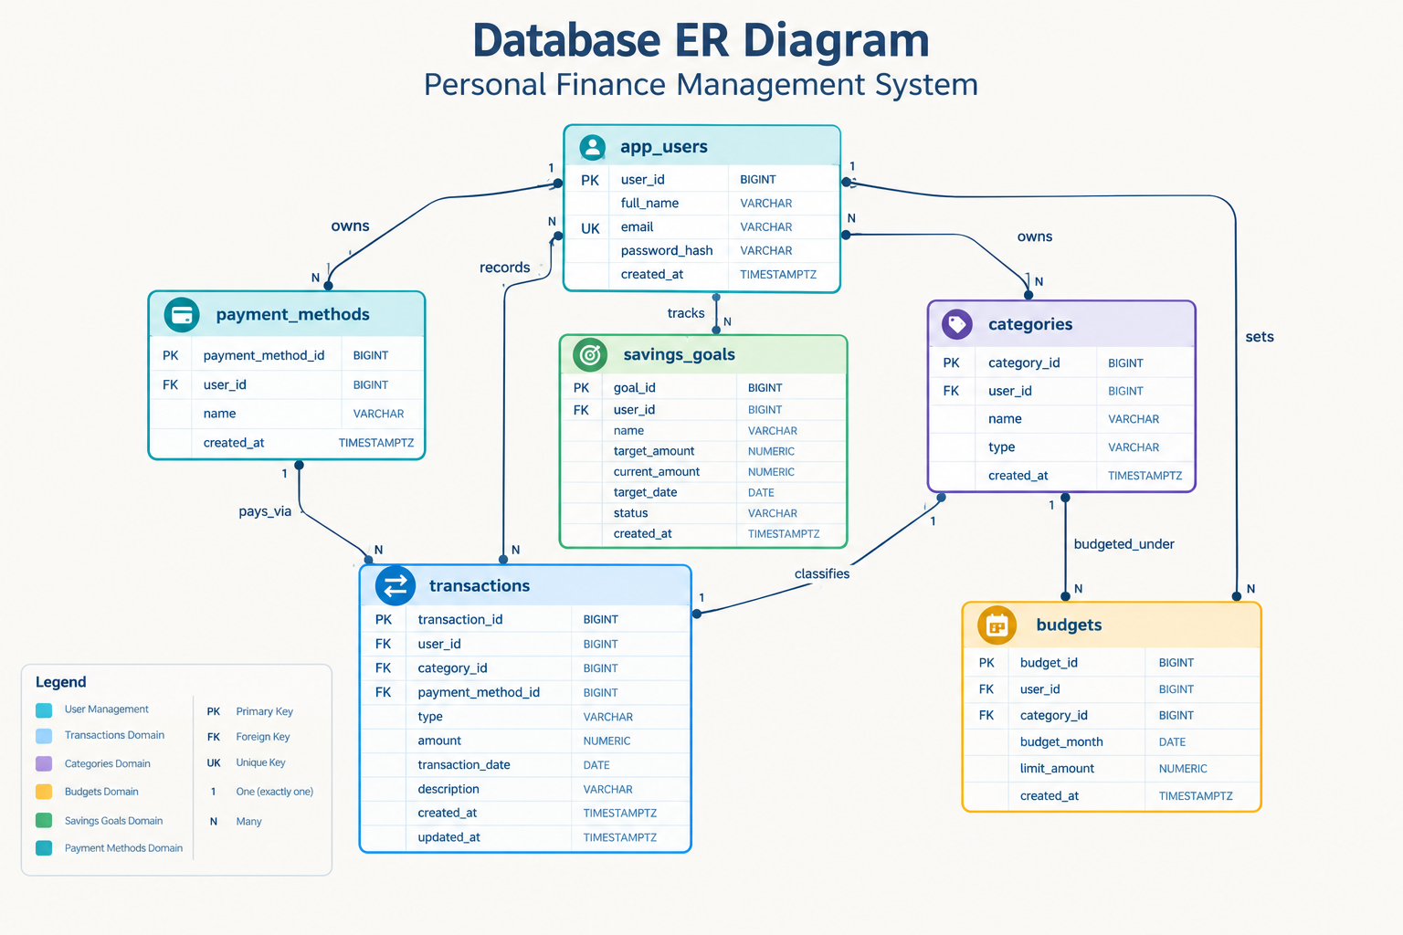
Flyway is used to apply database changes in a controlled sequence. Each migration represents a versioned change to the database schema.
The implemented migration files should be documented according to the actual files present in the project:
db/migration/
├── V1__create_users.sql
├── V2__create_categories.sql
├── V3__create_payment_methods.sql
├── V4__create_transactions.sql
├── V5__create_budgets.sql
└── V6__create_savings_goals.sql

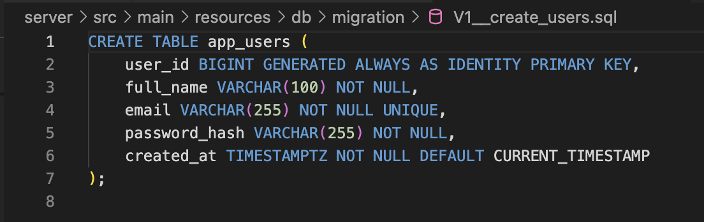

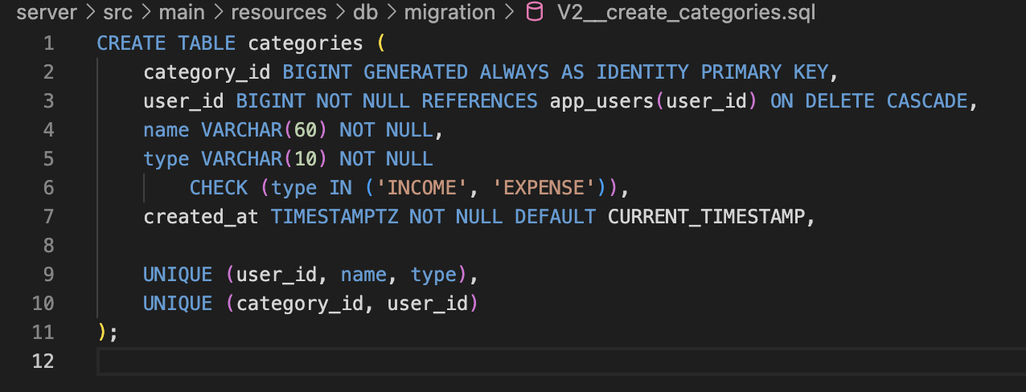

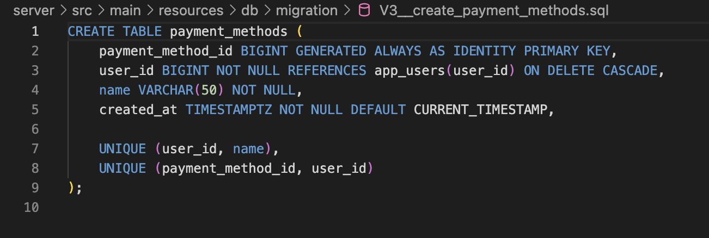

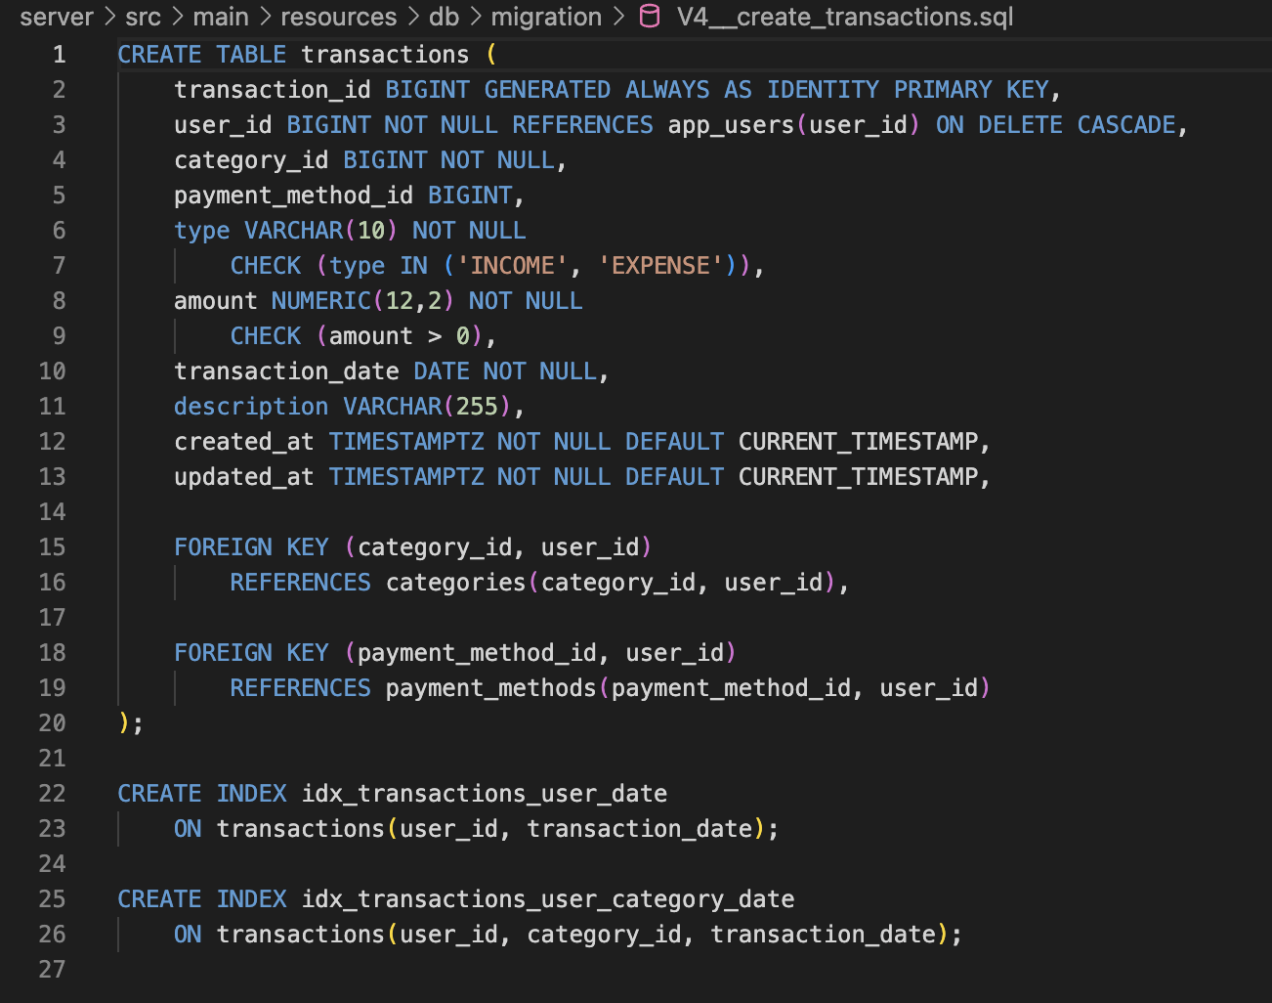
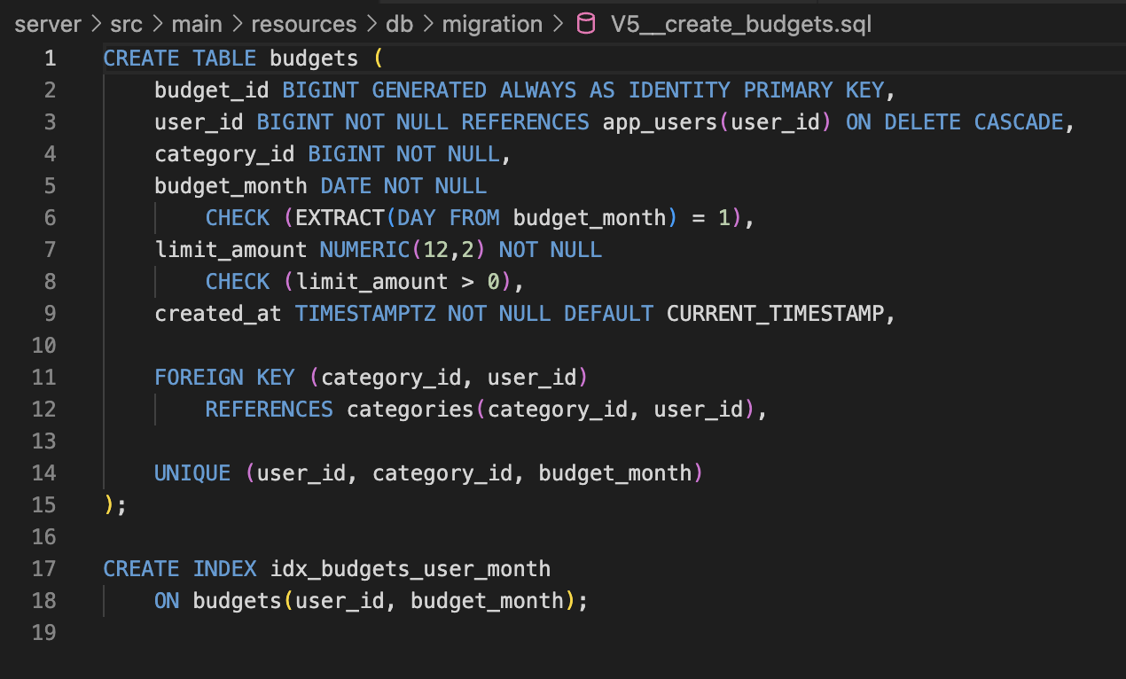

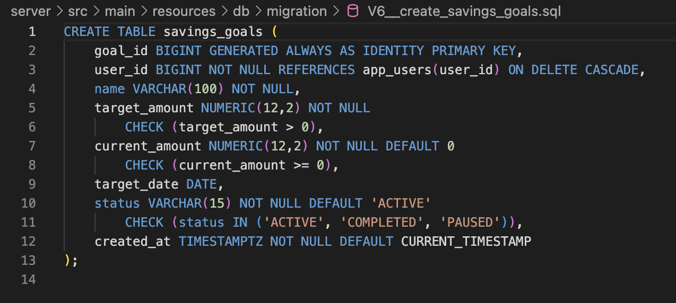

11.8 Implementation

11.8.1 Backend
The backend is implemented using Spring Boot and follows a layered structure.
The main backend packages include:
com.jenitaroselin.personalfinancemanagement
├── config
├── controller
├── service
├── repository
├── entity
├── dto
├── enums
├── exception
└── util
The controller layer exposes REST endpoints to the frontend. Controllers are responsible for receiving requests and delegating processing to the corresponding service classes.
The service layer contains business logic. For example, PaymentMethodService handles operations related to creating, retrieving, updating, and deleting payment methods rather than placing this logic directly inside the controller.
The repository layer provides the persistence interface used to communicate with PostgreSQL through Spring Data JPA.
The entity layer represents the persistent domain objects used by the application.
The DTO layer separates the data received from and returned to the client from the internal persistence entities.
[Insert package-structure screenshot here.]
[Insert selected controller/service/entity screenshots here.]

11.8.2 Database Integration
The financial summary functionality aggregates stored financial records to provide a consolidated view of the user's finances.
The summary is derived from transaction data rather than requiring separate manually maintained balance values. The relevant financial measures include:
- Total income
- Total expense
- Net balance
The net balance can be represented as:
Net Balance = Total Income - Total Expense
This approach avoids maintaining a duplicated static balance value and allows the summary to reflect changes when transactions are added, modified, or deleted.
[Insert Financial Summary implementation screenshot here.]
[Insert Financial Summary API response screenshot here.]
Payment methods are represented as a separate domain component of the system. This allows users to maintain the methods through which financial transactions are made.
The PaymentMethodService is responsible for the business operations associated with payment methods. The implementation includes functionality for:
- Creating a payment method.
- Retrieving payment methods.
- Retrieving a specific payment method.
- Updating a payment method.
- Deleting a payment method.
The corresponding controller exposes these operations through REST endpoints, while the repository layer handles persistence.
Examples of payment methods include Cash, UPI, Debit Card, and Credit Card.
[Insert PaymentMethodService screenshot here.]
[Insert PaymentMethodController screenshot here.]
The Spring Boot backend communicates with PostgreSQL through the persistence layer. Spring Data JPA provides repository abstractions for database operations, while entity classes map application objects to relational database tables.
Flyway manages schema creation and subsequent database changes through versioned migration scripts. The use of ddl-auto=validate ensures that the database schema is validated against the application's entity mappings instead of allowing Hibernate to automatically create the schema.
The database integration therefore involves:
Spring Boot
|
Spring Data JPA
|
Repository
|
Entity Mapping
|
PostgreSQL
[Insert relevant database connection/configuration screenshot here.]
[Insert Flyway migration screenshot here.]

11.8.3 Security
Spring Security is included in the application to provide security-related configuration and protect application resources.
The implemented security mechanism should be documented according to the current source code. Where JWT-based authentication is implemented, the report should describe token generation, authentication filtering, and protected endpoint access based on the actual implementation.
Password handling should similarly be described according to the actual security configuration rather than the intended design.
[Insert SecurityConfig screenshot here.]
[Insert authentication-related implementation screenshot here.]

11.8.4 User Interface
The frontend is implemented as a separate React client. It communicates with the Spring Boot backend through HTTP requests.
The client-side application is organized into pages, reusable components, services, authentication context, hooks, and utility functions.
The planned application interface includes areas for:
- Authentication
- Dashboard
- Transactions
- Budgets
- Reports
- Savings Goals
- Categories
- Settings
[Insert screenshots of the implemented interface here.]

11.9 Testing and Results
Testing should verify the actual behaviour of the completed system. Suggested cases include application startup, database connectivity, valid input, invalid input, access to protected endpoints, and supported database operations.
Test case | Expected behaviour | Actual result
Application startup | Starts with the configured environment | To be recorded
Database connectivity | Connects to the configured database | To be recorded
Valid input | Processed according to application rules | To be recorded
Invalid input | Validation or error handling is triggered | To be recorded
Protected endpoint | Access follows configured security rules | To be recorded
Database operation | Supported operation returns the expected result | To be recorded

The table contains suggested tests, not completed test results. Replace each status after running the test and preserve screenshots or logs as supporting evidence.

11.10 Java Concepts Applied
The project provides a practical context for applying several Java and backend-development concepts.
- Classes and Objects: Entity, service, controller, repository, DTO, and configuration classes demonstrate the use of Java classes to model different responsibilities within the application.
- Encapsulation: Application data and operations are organized within appropriate classes. Business operations are exposed through service methods instead of allowing controllers to directly manipulate persistence logic.
- Inheritance and Framework-Based Programming: The project uses Spring Boot and Spring Data JPA abstractions, allowing application classes to integrate with framework-provided functionality.
- Exception Handling: Custom exception classes and centralized exception handling are used to provide structured responses when invalid operations or missing resources are encountered.
- Enumerations: Enumerations such as transaction type and category type provide controlled sets of valid values rather than relying entirely on unrestricted strings.
- Collections: Java collections are used when retrieving and processing groups of database records, such as transactions, categories, and payment methods.
- Database Connectivity: The project demonstrates how a Java application communicates with a relational database through Spring Data JPA and repository abstractions.
- Validation: Request DTOs and validation annotations can be used to ensure that incoming data satisfies application requirements before business operations are performed.
- Modularity: The separation into controllers, services, repositories, entities, DTOs, configuration, and exception handling demonstrates modular application design.

11.11 Challenges
The challenges documented in this section should correspond to problems actually encountered during development.
Examples of relevant challenges include:
- Configuring the Java 17 development environment.
- Resolving compatibility between the Java version and Spring Boot project configuration.
- Establishing PostgreSQL connectivity.
- Configuring Flyway migrations.
- Ensuring that the database schema and JPA entity mappings remain consistent.
- Organizing the backend into controller, service, repository, and entity layers.
- Implementing and debugging Spring Security.
- Handling validation and exception responses.
- Debugging database-backed financial summary calculations.
- Implementing payment-method CRUD operations.
For each challenge, the report should describe the problem, the investigation performed, the solution attempted, and the final outcome.

11.12 Future Enhancements
The following features can be considered for future development where they are not part of the verified implementation:
- Expansion of financial reports and visual analytics.
- More advanced transaction filtering and searching.
- Automated financial insights.
- Budget monitoring and spending alerts.
- Savings-goal tracking.
- Data export and backup.
- More comprehensive automated testing.
- Improved responsive frontend design.
- Deployment of the application to a production environment.

11.13 Conclusion
The Personal Finance Management System demonstrates the application of Java and Spring Boot concepts to a practical financial-management problem. The project combines a layered backend architecture with PostgreSQL-based relational persistence and Flyway database migration.
The implementation provides a foundation for managing financial information and includes functionality such as financial summary processing and payment-method management. The project also demonstrates the separation of concerns between REST controllers, service-layer business logic, repository-based persistence, and database entities.
The completed implementation and test results provide evidence of the practical application of Java programming, backend development, relational database concepts, validation, security, and software organization. Further enhancements can extend the system with richer analytics, budgeting, financial insights, and improved user experience.
CHAPTER 12
LEARNING EXPERIENCE AND CONCLUSION

12.1 Learning Experience
The course offered a structured overview of Java SE 17, moving from syntax and primitive types to object-oriented design and more advanced platform capabilities. The sequence helped connect individual language features with the broader responsibilities of application development.
The independent Personal Finance Management System provides a separate context in which selected concepts can be explored in a backend application. Keeping the course learning and independent project clearly distinguished helps present the work accurately.

12.2 Key Topics Learned
- Java syntax, primitive data types, operators, and control flow.
- Classes, objects, constructors, encapsulation, inheritance, and polymorphism.
- Strings, date/time APIs, numeric wrappers, and decimal arithmetic.
- Arrays, collections, generics, lambdas, and streams.
- Exception handling, logging, debugging, I/O, and concurrency.
- Modules, annotations, JDBC, transactions, and secure coding.
- Application packaging, runtime compatibility, and cloud deployment principles.

12.3 Challenges and Areas for Improvement
Java includes a broad set of language features and libraries, and understanding when to use each feature requires continued practice. Areas for further improvement include independent problem solving, writing and testing code without overreliance on generated examples, and strengthening knowledge of database transactions, security, and software testing.

12.4 Future Learning Plans
Future learning can focus on reinforcing Java fundamentals through independent exercises, improving backend development skills, expanding automated testing, and refining the Personal Finance Management System based on verified requirements. Additional study of application architecture, API design, database transactions, and secure deployment would provide a stronger foundation for larger projects.

12.5 Conclusion
The Oracle Java Foundations Associate Certification course provides a broad foundation in Java programming and application-development concepts. The topics covered in this report span basic language constructs, object-oriented programming, standard APIs, functional programming, error handling, concurrency, database connectivity, security, and deployment. The separate Personal Finance Management System project provides an opportunity to connect selected concepts to a practical application. Continued implementation, testing, and documentation will strengthen both technical understanding and software development practice.

REFERENCES
- https://mylearn.oracle.com/ou/course/java-se-17-programming-complete/145108/
- https://docs.oracle.com/javase/tutorial/
- https://docs.oracle.com/en/java/javase/17/
- https://docs.oracle.com/en/java/javase/17/docs/api/
- https://docs.spring.io/spring-boot/
- https://docs.spring.io/spring-security/reference/
- https://www.postgresql.org/docs/
- https://documentation.red-gate.com/flyway
- https://docs.oracle.com/en-us/iaas/

