Week 13:
ROLL NO.:240801134
Name: Jenith Amala Sweety.A
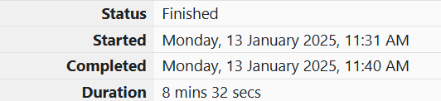
Q1) Given an array of numbers, find the index of the smallest array element (the pivot), for which the sums of all elements to the left and to the right are equal. The array may not be reordered.
Example
arr=[1,2,3,4,6]
· the sum of the first three elements, 1+2+3=6. The value of the last element is 6.
· Using zero based indexing, arr[3]=4 is the pivot between the two subarrays.
· The index of the pivot is 3.
Function Description
Complete the function balancedSum in the editor below.
balancedSum has the following parameter(s):
int arr[n]: an array of integers
Returns:
int: an integer representing the index of the pivot
Constraints
· 3 ≤ n ≤ 105
· 1 ≤ arr[i] ≤ 2 × 104, where 0 ≤ i < n
· It is guaranteed that a solution always exists.
Input Format for Custom Testing
Input from stdin will be processed as follows and passed to the function.
The first line contains an integer n, the size of the array arr.
Each of the next n lines contains an integer, arr[i], where 0 ≤ i < n.
Sample Case 0
Sample Input 0
STDIN Function Parameters
----- -------------------
4 → arr[] size n = 4
1 → arr = [1, 2, 3, 3]
2
3
3
Sample Output 0
2
Explanation 0
· The sum of the first two elements, 1+2=3. The value of the last element is 3.
· Using zero based indexing, arr[2]=3 is the pivot between the two subarrays.
· The index of the pivot is 2.
Sample Case 1
Sample Input 1
STDIN Function Parameters
----- -------------------
3 → arr[] size n = 3
1 → arr = [1, 2, 1]
2
1
Sample Output 1
1
Explanation 1
· The first and last elements are equal to 1.
· Using zero based indexing, arr[1]=2 is the pivot between the two subarrays.
· The index of the pivot is 1.

Code:
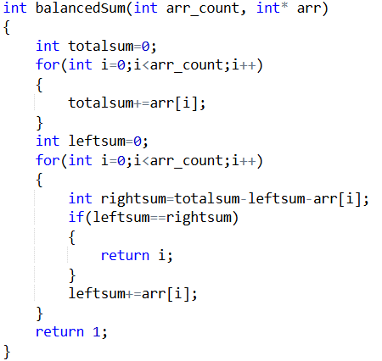

OUTPUT:
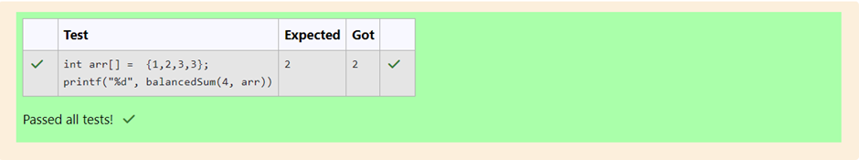
Q2) Calculate the sum of an array of integers.
Example
numbers = [3, 13, 4, 11, 9]
The sum is 3 + 13 + 4 + 11 + 9 = 40.
Function Description
Complete the function arraySum in the editor below
arraySum has the following parameter(s):
int numbers[n]: an array of integers
Returns
int: integer sum of the numbers array
Constraints
1 ≤ n ≤ 104
1 ≤ numbers[i] ≤ 104
Input Format for Custom Testing
Input from stdin will be processed as follows and passed to the function.
The first line contains an integer n, the size of the array numbers.
Each of the next n lines contains an integer numbers[i] where 0 ≤ i < n.
Sample Case 0
Sample Input 0
STDIN Function
----- --------
5 → numbers[] size n = 5
1 → numbers = [1, 2, 3, 4, 5]
2
3
4
5
Sample Output 0
15
Explanation 0
1 + 2 + 3 + 4 + 5 = 15.
Sample Case 1
Sample Input 1
STDIN Function
----- --------
2 → numbers[] size n = 2
12 → numbers = [12, 12]
12
Sample Output 1
24
Explanation 1
12 + 12 = 24.

Code:
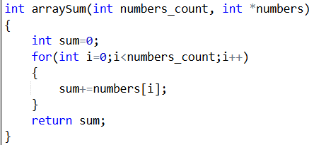
OUTPUT:
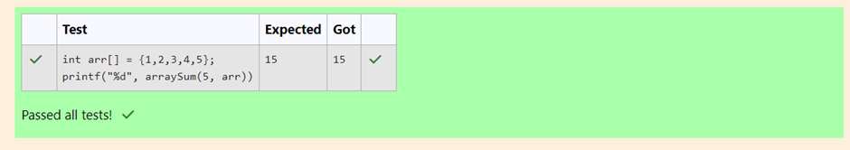
Q3) Given an array of n integers, rearrange them so that the sum of the absolute differences of all adjacent elements is minimized. Then, compute the sum of those absolute differences. Example n = 5 arr = [1, 3, 3, 2, 4] If the list is rearranged as arr' = [1, 2, 3, 3, 4], the absolute differences are |1 - 2| = 1, |2 - 3| = 1, |3 - 3| = 0, |3 - 4| = 1. The sum of those differences is 1 + 1 + 0 + 1 = 3. Function Description Complete the function minDiff in the editor below. minDiff has the following parameter: arr: an integer array Returns: int: the sum of the absolute differences of adjacent elements Constraints 2 ≤ n ≤105 0 ≤ arr[i] ≤ 109, where 0 ≤ i < n Input Format For Custom Testing The first line of input contains an integer, n, the size of arr. Each of the following n lines contains an integer that describes arr[i] (where 0 ≤ i < n) . Sample Case 0 Sample Input For Custom Testing STDIN Function ----- -------- 5 → arr[] size n = 5 5 → arr[] = [5, 1, 3, 7, 3] 1 3 7 3 Sample Output 6 Explanation n = 5 arr = [5, 1, 3, 7, 3] If arr is rearranged as arr' = [1, 3, 3, 5, 7], the differences are minimized. The final answer is |1 - 3| + |3 - 3| + |3 - 5| + |5 - 7| = 6. Sample Case 1 Sample Input For Custom Testing STDIN Function ----- -------- 2 → arr[] size n = 2 3 → arr[] = [3, 2] 2 Sample Output 1 Explanation n = 2 arr = [3, 2] There is no need to rearrange because there are only two elements. The final answer is |3 - 2| = 1.
Code:
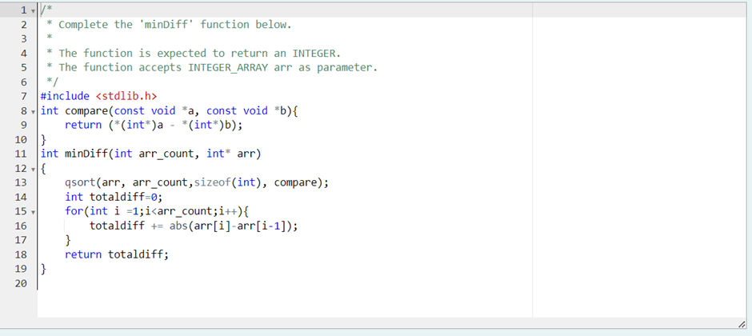

OUTPUT:
