Week 3 – 2:
Coding-C-Language Features-Optional.
ROLL NO.:240801134
Name: Jenith Amala Sweety.A
Q1) Write a program that determines the name of a shape from its number of sides. Read the
number of sides from the user and then report the appropriate name as part of a
meaningful message. Your program should support shapes with anywhere from 3 up to
(and including) 10 sides. If a number of sides outside of this range is entered then your
program should display an appropriate error message.
Sample Input 1
3
Sample Output 1
Triangle
Sample Input 2
7
Sample Output 2
Heptagon
Sample Input 3
11
Sample Output 3
The number of sides is not supported.

Code:
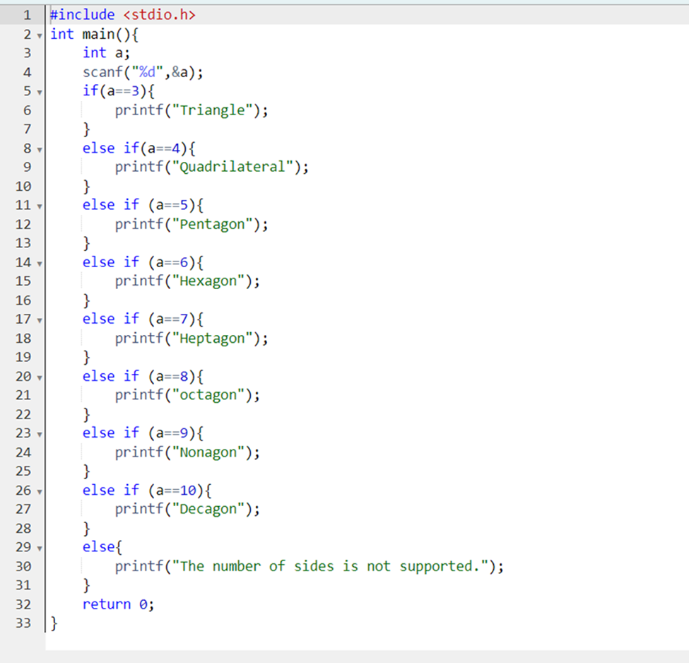

OUTPUT:
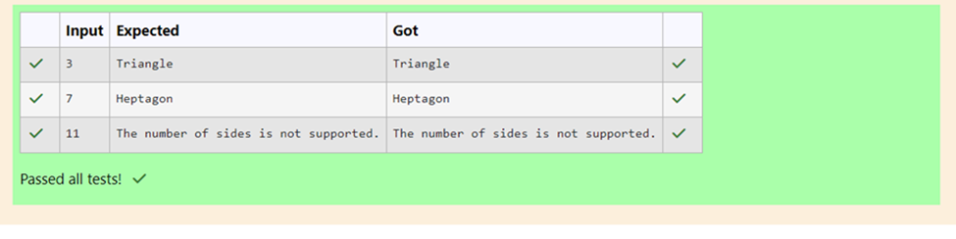
Q2) The Chinese zodiac assigns animals to years in a 12-year cycle. One 12-year cycle is
shown in the table below. The pattern repeats from there, with 2012 being another year of
the Dragon, and 1999 being another year of the Hare.
Year Animal
2000 Dragon
2001 Snake
2002 Horse
2003 Sheep
2004 Monkey
2005 Rooster
2006 Dog
2007 Pig
2008 Rat
2009 Ox
2010 Tiger
2011 Hare
Write a program that reads a year from the user and displays the animal associated with
that year. Your program should work correctly for any year greater than or equal to zero,
not just the ones listed in the table.
Sample Input 1
2004
Sample Output 1
Monkey
Sample Input 2
2010
Sample Output 2
Tiger

Code:
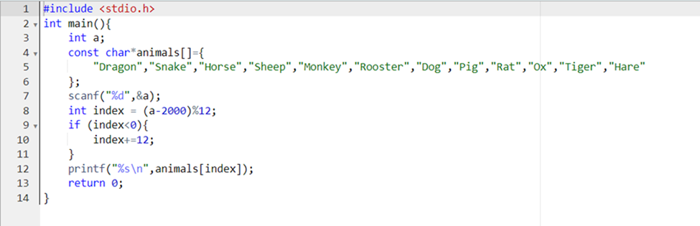

OUTPUT:
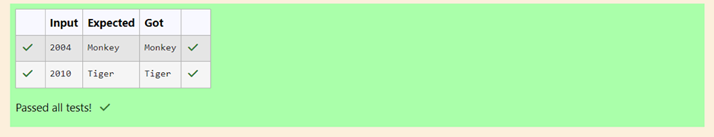

Q3)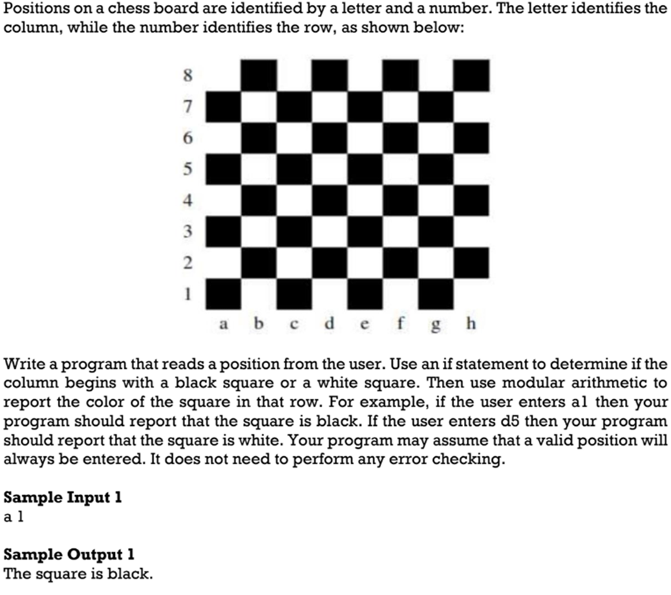

Code:
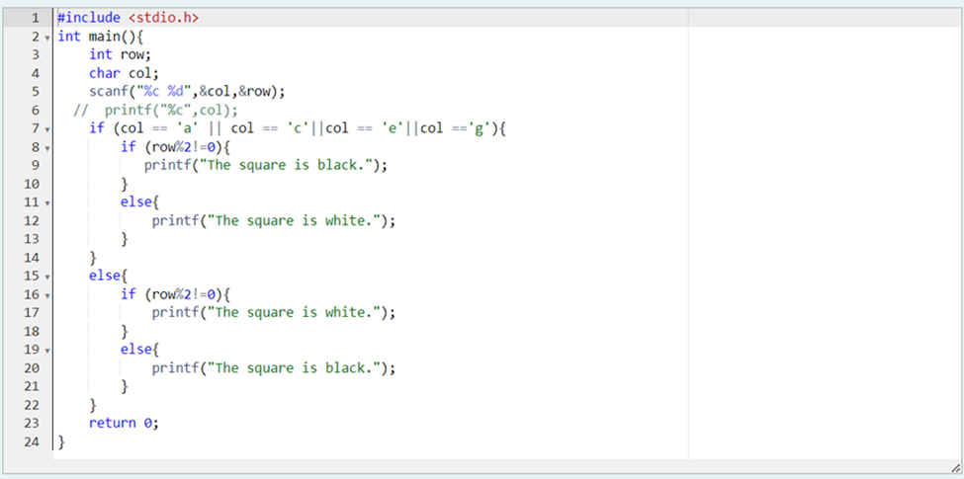

OUTPUT:
