Exercise 1: Control Structures

**Question:**

Write a PL/SQL block that accepts a number and checks whether it is EVEN or ODD.

**PL/SQL Code:**

DECLARE

num NUMBER := &enter_number;

BEGIN

IF MOD(num, 2) = 0 THEN

DBMS_OUTPUT.PUT_LINE('The number ' || num || ' is EVEN.');

ELSE

DBMS_OUTPUT.PUT_LINE('The number ' || num || ' is ODD.');

END IF;

END;

/

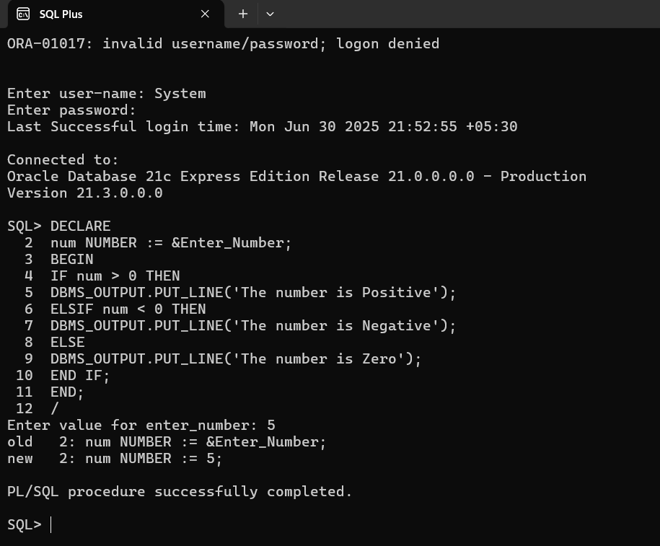

Exercise 3: Stored Procedures

**Question:**

Write a stored procedure that accepts an employee ID and prints the employee name and salary.

**Explanation:**

- Use IN parameter

- Use SELECT INTO to fetch data

- Use DBMS_OUTPUT to display

- Add exception handling for safe execution

**Table Setup:**

CREATE TABLE employees (

emp_id NUMBER PRIMARY KEY,

emp_name VARCHAR2(100),

salary NUMBER

);

**Sample Data:**

INSERT INTO employees VALUES (101, 'John', 50000);

INSERT INTO employees VALUES (102, 'Alice', 60000);

COMMIT;

Stored Procedure Code:

CREATE OR REPLACE PROCEDURE get_employee_details (

p_emp_id IN employees.emp_id%TYPE

)

IS

v_name employees.emp_name%TYPE;

v_salary employees.salary%TYPE;

BEGIN

SELECT emp_name, salary

INTO v_name, v_salary

FROM employees

WHERE emp_id = p_emp_id;

DBMS_OUTPUT.PUT_LINE('Employee Name: ' || v_name);

DBMS_OUTPUT.PUT_LINE('Salary: ' || v_salary);

EXCEPTION

WHEN NO_DATA_FOUND THEN

DBMS_OUTPUT.PUT_LINE('No employee found with ID ' || p_emp_id);

WHEN OTHERS THEN

DBMS_OUTPUT.PUT_LINE('Error: ' || SQLERRM);

END;

/

**Execution:**

SET SERVEROUTPUT ON;

EXEC get_employee_details(101);

