**7PAM2000-0901-2022- Applied Data Science 1**

**Statistics And Trends**

**Assignment 2**

Submitted By:

21076452

Jenivia Lobo

**Analysis of statistics on climate change based on World Bank data**

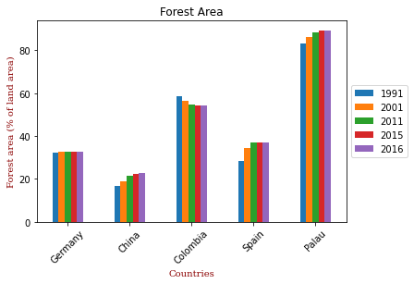Data Analysis on 5 nations from various countries was chosen, and the interactions between the following variables about climate change were examined: total greenhouse gas emissions, forested areas, Electric Consumption and GDP. Investigating the causes behind them led to the discovery of some correlations between the factors.

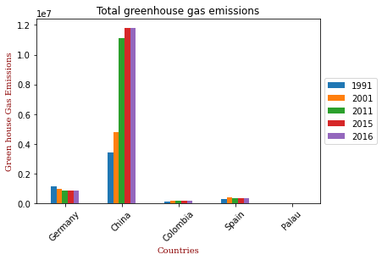

The bar graph above displays all greenhouse gas emissions (CO2 equivalent), and as can be seen, China is the country with the highest emissions due to its large urban population. The gas emissions were lower in 2015–2016 than in 1991, but they peaked in the same years, impacting the forest area as well. As we can infer from the fact that Palau has the lowest gas emissions, it is followed by Spain and Colombia in terms of forest area.

As we can infer from the fact that Palau has the lowest gas emissions, it is followed by Spain and Colombia in terms of forest area. As the greenhouse effect and climate change affect the ecosystem and the growth of trees in forests, lower gas emissions increase the extent of forests.

Statistical Data for Greenhouse gas emissions and Forest Land Area for the following years

|  |  |  |  |  |  |
| --- | --- | --- | --- | --- | --- |
| Stats | 1991 | 2001 | 2011 | 2015 | 2016 |
| Mean | 9.79E+00 | 1.25E+00 | 2.49E+06 | 2.63E+06 | 2.63E+06 |
| std | 1.41E+06 | 2.00E+06 | 4.82E+06 | 5.14E+06 | 5.14E+06 |

Forest Land Area:

|  |  |  |  |  |  |
| --- | --- | --- | --- | --- | --- |
| Stats | 1991 | 2001 | 2011 | 2015 | 2016 |
| Mean | 4.39E+01 | 4.58E+01 | 4.69E+01 | 4.71E+01 | 4.71E+01 |
| std | 2.67E+01 | 2.63E+01 | 2.61E+01 | 2.62E+01 | 2.62E+01 |

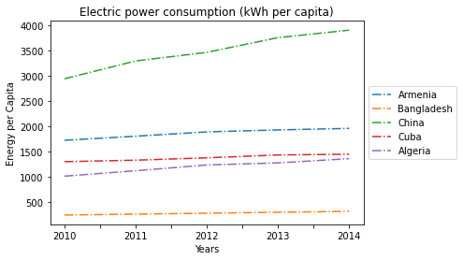

The aforementioned graph shows the amount of electricity used over five years, from 2010 to 2014. Based on the country's high urban population, China had the highest electricity consumption, followed by Armenia and Cuba, which had relatively similar electricity consumption levels. The least-power-intensive country is Bangladesh. Energy dictates a country's economic and social development and rising GDP results in rising energy demand. As a result, the production and consumption of energy affect GDP. This is where China's annual GDP growth was strongest, but it has now dropped below 2%. Armenia's GDP also increased a little before declining somewhat, whereas Bangladesh's GDP has been growing steadily with a slight increase in 2014. Consequently, there is sometimes a

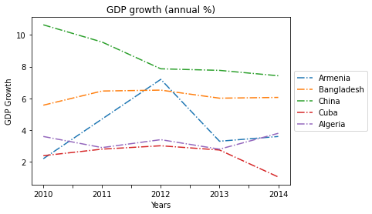

relationship between GDP and electric consumption but not always.

This is where China's annual GDP growth was strongest, but it has now dropped below 2%. Armenia's GDP also increased a little before declining somewhat, whereas Bangladesh's GDP has been growing steadily with a slight increase in 2014. Consequently, there is sometimes a relationship between GDP and electric consumption but not always.

Statistical Data for Electric Consumption and GDP for the following years

|  |  |  |  |  |  |
| --- | --- | --- | --- | --- | --- |
| Stats | 2010 | 2011 | 2012 | 2013 | 2014 |
| Mean | 1447.382 | 1564.86 | 1651.73 | 1740.97 | 1800.17 |
| std | 995.369 | 1117.1 | 1169.07 | 1272.67 | 1319.2 |

|  |  |  |  |  |  |
| --- | --- | --- | --- | --- | --- |
| Stats | 2010 | 2011 | 2012 | 2013 | 2014 |
| Mean | 4.879 | 5.283502 | 5.600019 | 4.525472 | 4.38688 |
| std | 3.486681 | 2.818798 | 2.239215 | 2.255903 | 2.457247 |