AI Usage, this document includes the one prompt I used to verify and review my code. Hindsight 20/20 I honestly don’t know if it was really worth it, it did find a large number of errors but I am not certain how much it really enhanced my learning. For this activity I built a mobile sign-up form in Expo with TypeScript. React Hook Form manages the form state, a Zod schema holds the validation rules, and Expo Router moves to a confirmation screen after a valid submit, and while my learning was probably slightly bettered by doing all of the bug and issue fixes, however I am not certain if this depth was particularly beneficial. I attached a screen shot of the rubric for checking that it met requirements and a screenshot of the AI usage guidelines with my prompt. 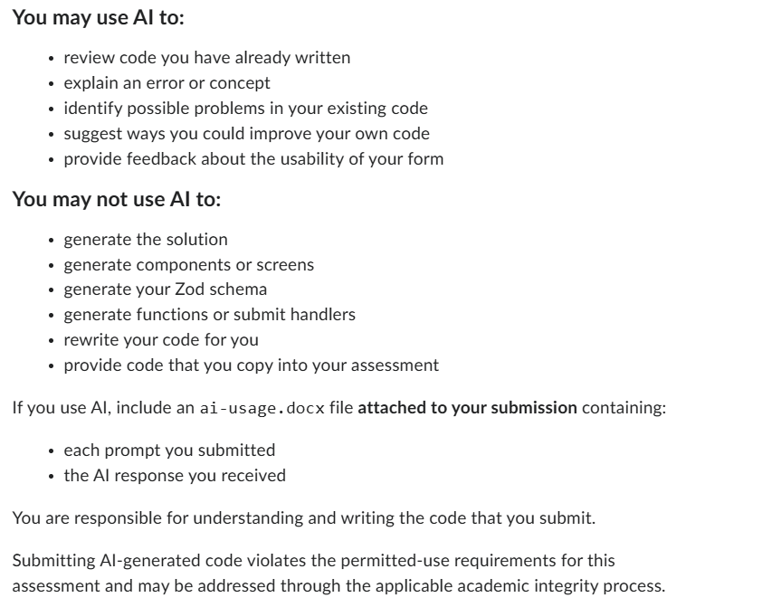
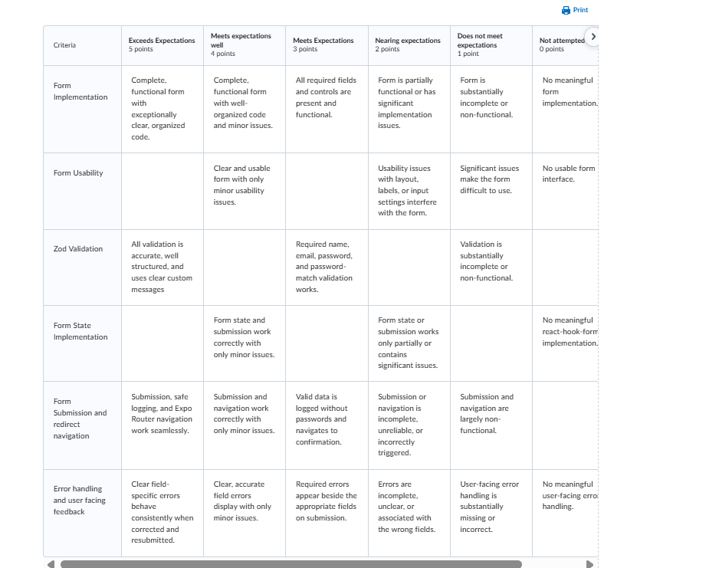
------------------------------------------------------------------------------------------------------------------
Give an in depth complete review of this project from top to bottom, try to identify any bugs, missing or incomplete sections or anything else that would otherwise lead to problems in the code. Provide feedback for how to fix these problems if there are any and suggestions for implementing ways to make the form more useable.
Show more
6:19 PM
I'll start by reading the project.
Globpattern: "src/**/*"
Found 14 files
Read c:\Users\Isaac\OneDrive\Documents\SAITSem3\CPRG 303 Mobile App Dev\inclassactivities\signup-form\package.json
Read c:\Users\Isaac\OneDrive\Documents\SAITSem3\CPRG 303 Mobile App Dev\inclassactivities\signup-form\src\app\index.tsx
Read c:\Users\Isaac\OneDrive\Documents\SAITSem3\CPRG 303 Mobile App Dev\inclassactivities\signup-form\src\app\confirmation.tsx
Read c:\Users\Isaac\OneDrive\Documents\SAITSem3\CPRG 303 Mobile App Dev\inclassactivities\signup-form\src\app\_layout.tsx
Read c:\Users\Isaac\OneDrive\Documents\SAITSem3\CPRG 303 Mobile App Dev\inclassactivities\signup-form\src\schemas\sign-up-schema.ts
PowerShell Show uncommitted changes and root files
IN
git diff; git status --short; Get-ChildItem -Force | Select-Object Name
OUT
Name
----
.claude
.expo
.git
.vscode
assets
node_modules
src
.gitignore
AGENTS.md
app.json
expo-env.d.ts
LICENSE
package-lock.json
package.json
README.md
tsconfig.json
Read C:\Users\Isaac\OneDrive\Documents\SAITSem3\CPRG 303 Mobile App Dev\inclassactivities\signup-form\src\components\themed-view.tsx
Read C:\Users\Isaac\OneDrive\Documents\SAITSem3\CPRG 303 Mobile App Dev\inclassactivities\signup-form\src\components\themed-text.tsx
Read C:\Users\Isaac\OneDrive\Documents\SAITSem3\CPRG 303 Mobile App Dev\inclassactivities\signup-form\src\constants\theme.ts
Read C:\Users\Isaac\OneDrive\Documents\SAITSem3\CPRG 303 Mobile App Dev\inclassactivities\signup-form\src\components\animated-icon.tsx
Read C:\Users\Isaac\OneDrive\Documents\SAITSem3\CPRG 303 Mobile App Dev\inclassactivities\signup-form\app.json
Read C:\Users\Isaac\OneDrive\Documents\SAITSem3\CPRG 303 Mobile App Dev\inclassactivities\signup-form\README.md
6:20 PM
Now the typecheck, plus a check for leftover template files.
PowerShell Typecheck and inspect project files
IN
npx tsc --noEmit; "TSC EXIT: $LASTEXITCODE"; Test-Path scripts/reset-project.js; Get-ChildItem assets/images | Where-Object { $_.FullName -notmatch "node_modules" } | Select-Object FullName; git diff --stat HEAD; git log --oneline -1 --format="%H %ad"
OUT
npm notice run signup-form@1.0.0 npx
npm notice run tsc --noEmit
TSC EXIT: 0
False

da86e7e23253588430e2b868de4cb7c114f7d304 Thu Oct 29 18:18:05 2026 -0600
Name
----
android-icon-background.png
android-icon-foreground.png
android-icon-monochrome.png
expo-logo.png
favicon.png
icon.png
logo-glow.png
splash-icon.png
6:21 PM
Typecheck passes. Next I'll check which template leftovers are still used and confirm two behaviours: Zod 4 object refinements and Android keyboard handling.
Grep "from ['"](@expo/ui|expo-glass-effect|expo-symbols|expo-web-browser|expo-device|expo-constants|expo-linking|expo-system-ui|expo-font)|AnimatedIcon\b|use-color-scheme" (in C:\Users\Isaac\OneDrive\Documents\SAITSem3\CPRG 303 Mobile App Dev\inclassactivities\signup-form\src)
3 lines of output
Web Fetchhttps://zod.dev/api
Fetched from https://zod.dev/api
Web Fetchhttps://docs.expo.dev/guides/keyboard-handling/
Fetched from https://docs.expo.dev/guides/keyboard-handling/
6:23 PM
I found no blocking bugs. tsc --noEmit passes. There are a few real issues, mostly about navigation and edge cases, and some usability improvements worth making. The assignment's AI policy doesn't allow AI to write code for you, so I've explained each fix rather than giving you code to paste in.
Requirements check
Requirement | Status | Where
All 5 fields, labelled Sign Up button | ✅ | index.tsx
secureTextEntry on both passwords, keyboardType="email-address" | ✅ | index.tsx:139, 166, 195
Names: required, 2–30 chars, not only whitespace | ✅ .trim() runs before .min(1), so a blank name gets the "required" message | sign-up-schema.ts:8-20
Email: required, valid, trimmed | ✅ | sign-up-schema.ts:22-26
Password min 8, confirm must match (in the schema) | ✅, with one caveat (issue 2 below) | sign-up-schema.ts:28-39
react-hook-form + zodResolver | ✅ | index.tsx:25-38
Errors shown next to their field, only on submit | ✅ the default mode: "onSubmit" matches the spec exactly
Logs first name, last name and email only, no password | ✅ | index.tsx:42-46
Expo Router to a confirmation screen showing the first name | ✅ | index.tsx:47, confirmation.tsx
Because zodResolver passes the parsed values to onSubmit, the names and email you log and send to the confirmation screen are already trimmed. That's correct.
Bugs and problems
1. The first invalid field doesn't get focus, even though React Hook Form tries to focus it. index.tsx:84
- Problem: By default, React Hook Form moves focus to the first invalid field on submit. To do that it needs a ref to each input. Your render functions take onChange, onBlur and value from field, but not ref, so the focus silently fails.
- Fix: Also take ref from field and pass it to the TextInput's ref prop, in all five Controllers.
2. "Passwords do not match" can stay hidden until every other field is valid. sign-up-schema.ts:36
- Problem: Zod 4 doesn't run an object-level .refine() while any field in that object has an error. The Zod docs use this exact password-confirm case as their example.
- What the user sees: They leave the last name blank and mistype the confirm password, then press Sign Up. Only the last-name error shows. They fix it and submit again, and only then does "Passwords do not match" appear.
- Fix: Look up the when option for refinements on zod.dev/api. It lets the match check run whenever password and confirmPassword are valid, whatever state the other fields are in.
3. The Back button returns to a filled-in form, and a double tap can open the confirmation screen twice. index.tsx:47
- Problem: router.push adds the confirmation screen on top of the form. Pressing Back (the header button or Android's back button) shows the form with both passwords still filled in, ready to submit again. A fast double tap on Sign Up runs the submit twice and stacks two confirmation screens.
- Fix: Do one or both of these:
  - Use router.replace so there's no form to go back to, or add a "Back to sign up" button on the confirmation screen.
  - Call reset() (from useForm) after a successful submit.
4. Opening the confirmation screen directly shows "Account created for !". confirmation.tsx:11-16
- Problem: This happens on a web refresh, a deep link (signupform://confirmation), or anything else that skips the form, because firstName is then undefined.
- Fix: Check for a missing name and either show a fallback message or redirect to / using Expo Router's Redirect component. Also note that useLocalSearchParams can return a string[], so your { firstName: string } type is slightly optimistic.
5. The error colour is too faint in dark mode. index.tsx:261-266
- Problem: The app follows the system light/dark setting (userInterfaceStyle: "automatic"). #cc0000 text on the black dark-mode background has a contrast ratio of about 3.6:1. The accessibility minimum (WCAG AA) for 14px text is 4.5:1. In light mode it's fine at about 5.9:1.
- Fix: Add an error colour (and a primary colour for the button) to Colors.light and Colors.dark in theme.ts. Use it through theme instead of hard-coding the hex values. A lighter red such as #ff6b6b works on black.
Leftovers from the project template
- "reset-project" in package.json:39 points to scripts/reset-project.js, which doesn't exist, so npm run reset-project will crash. Remove the script.
- README.md is still the default create-expo-app text. A short README describing the form, how to run it and the validation rules would help your "Form implementation" rubric score.
- Unused template code: AnimatedIcon and logo-glow.png. Several dependencies aren't imported anywhere in src/: @expo/ui, expo-glass-effect, expo-symbols, expo-web-browser, expo-device. They don't break anything. If you remove dependencies, use npm uninstall and then run npx expo install --fix.
- The splash screen still shows the Expo logo animation. That's fine, but it isn't your app's branding.
- Lint is not set up: there's no ESLint config, so npx expo lint will install eslint-config-expo the first time you run it. I didn't run it because it changes package.json. Run it yourself before your final commit.
Code quality and organization (the "well-organized code" criterion)
- Repeated code: each field's label, Controller, TextInput and error message is written out five times, about 25 lines each. Pulling that into a reusable component would cut index.tsx roughly in half. Put it in src/components/, because files in src/app/ become routes. Its props would be the field name, label, control, the error, and the TextInput options.
- Field wrappers: each field is wrapped in a ThemedView (index.tsx:79). Each one just repaints the same background, so a plain View is enough.
- Submit handler: onPress={() => handleSubmit(onSubmit)()} (index.tsx:213) works, but onPress={handleSubmit(onSubmit)} is the usual form.
- Comments:
  - "fromat" is a typo for "format" (sign-up-schema.ts:4).
  - "IOS subtle annoyances" (index.tsx:63) is vague. Say what it does, e.g. "pushes content above the keyboard on iOS".
  - index.tsx and the schema start with an // Import Statements header, but confirmation.tsx doesn't, and its imports are grouped differently. Pick one style.
Usability suggestions
- Move to the next field with the keyboard's Return key:
  - Set returnKeyType="next" on the first four inputs and "done" on the last.
  - In onSubmitEditing, call setFocus("lastName") and so on; setFocus comes from useForm and needs fix 1 to work.
  - On the last field, call the submit handler, so the user can finish without dismissing the keyboard.
  - Add submitBehavior="submit" (or blurOnSubmit={false}) so the keyboard doesn't flicker between fields.
- Show/hide password: add a toggle that flips secureTextEntry. It makes typos much less likely before the confirm field.
- Keep the password rule visible: the "At least 8 characters" placeholder disappears as soon as the user types. Show it as small helper text under the field instead.
- Validate as the user types after the first submit: you already get this. The default reValidateMode: "onChange" clears each error as it's fixed. Mention it in your write-up, since it's a deliberate usability benefit.
- Accessibility:
  - Give each input an accessibilityLabel that matches its visible label.
  - Put accessibilityLiveRegion="polite" (Android) or accessibilityRole="alert" on the error text so screen readers announce errors.
  - Add textContentType (givenName, familyName, emailAddress, newPassword) next to autoComplete for better iOS autofill.
- Dismiss the keyboard by scrolling: add keyboardDismissMode="on-drag" to the ScrollView.
- Polish the confirmation screen: add a success icon or heading and a "Sign up another account" button (router.replace("/")). That button also covers fix 3.
- Optional name check: the schema currently accepts names like "12" or "@@". This isn't required, but .regex() with a friendly message (letters, spaces, hyphens, apostrophes) would make the validation stronger.
Before you submit
The assignment requires an ai-usage.docx listing every prompt and every response you received. I couldn't find one in the project, and this session counts, along with any earlier sessions where AI helped with the code. The policy also forbids AI-generated components, schemas and submit handlers. Check that the submitted code is code you wrote and make the fixes above yourself.
The working tree is clean and your latest commit (da86e7e, 18:18 today) is before the deadline. If you only have time for a few fixes, do issues 1–4: they're small changes that affect what a grader sees when they test the form.
------------------------------------------------------------------------------------------------------------------
I did not complete everything that was mentioned in this thread and purposed by the Claude AI, some things I determined to be unnecessary and some things I simply did not feel I had enough time or will power to want to complete.

