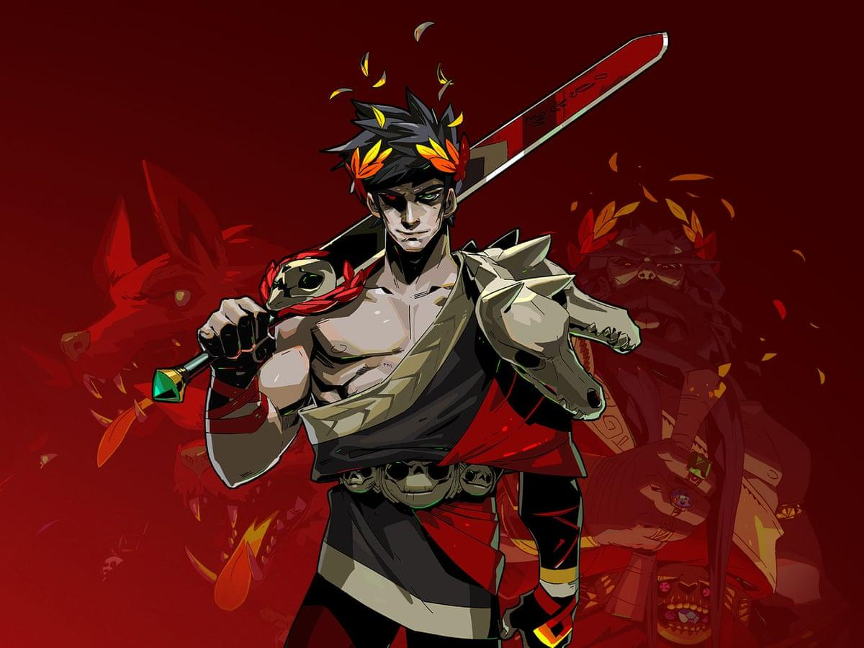

Zacharias

A game of redemption

Designed by Ryan Jenkins and Ben Kernot

1/01/2021

For Xbox Series X and Playstation 5 and PC

Ages: 12-up

Ship Date: TBD

Zacharias: A game of redemption Contact information [20088363@wit.ie](mailto:20088363@wit.ie)

**Story:**

Zacharias has always been a very competitive and mischievous young man, this behaviour has since got him into serious trouble with his father Ares and he has been banished never to be seen again and feels he needs to undergo a dangerous journey in his mortal form in order to earn back the respect of his father. Throughout the game Zacharias realises that he didn’t need his father’s power as much as he thought he needed and we see this during his adventure.

**Setting:**

This heavily contrasts throughout the game. The setting in Mount Olympus is very posh, they’re pillar the size of towers and most things are made from marble and gold.

The men and female warriors are dressed in the finest armour’s in the land. The residents are dressed in the most amazing tunics and dresses as according with their upper class reputation.

This type of décor is flipped upside down when in the wastelands. Everyone is wearing rags and cracked armour that they have obviously been wearing for a long time. The structures in the wastelands are all worn down and barely standing and there are very few building that Zacharias comes across.

The lighting contrasts in Mount Olympus and the wastelands are very significant. The lighting in Mount Olympus are very bright and glimmering. Which sets a real happy and calm atmosphere. Then in the wastelands its very dark and misty which makes the setting to be very uncertain and the player is constantly bewildered.

**Game Flow**

We are developing an adventure game that requires trial and error in order to progress. In this game, failure to be able to advance on and progress gives the player valuable information to be able to do so. The further the player goes into game they will unlock further abilities.

Abilities:

Basic abilities:

* Our player will start with the very basic abilities to be able to walk, sprint, climb and jump. There will be plenty of opportunity for the player to get used to the player movement

Fight:

* Our player will be given the ability to use the sword of Zacharias once the very first enemy appears, I find that this is a good way to ease our character into the game instead of just throwing them into the deep end straight away

Stealth:

* This will be introduced when the player is put into a situation where they have the opportunity to fight an enemy or to sneak past them.

**Characters and controls:**

The player in this game plays entirely as Zacharias, I find that this gives the player the best chance to develop empathy for Zacharias. Usually games that effectively do this succeed.

The player will be introduced to other characters such as Zeus, Athena and Ares but not in much detail.

**Controls:**

This game will have standard movement controls with regards to consoles and with PC it will have recommended settings to use w, a, s and d however it will allow the player to change these settings.

There will be an adviser popping up every time the player learns a new skill.

This adviser will instruct the player how to use this new skill and where they can use it.

For example if there is an enemy it will show the player how to sneak past them etc.

 

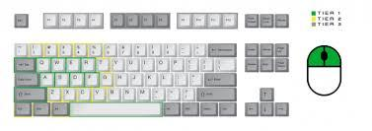

**Main Gameplay Concepts:**

The player engages in combat with enemies ranging from orcs to wolves, puzzle solving different routes and pathways and dialogue with other characters in the game along with making important choices that will eventually decide your fate.

The game genre is a mix of Puzzle, Action and Adventure.

It is broken up into different levels with different environments leading up to a final boss fight at the end.

**Gameplay Overview**

Game World:

The gameplay takes place starting in a bright Mount Olympus Zacharias’ home city filled with wealthy men and women and their families, leading on to the wastelands outside of the city filled with poverty ridden villages and slaves to the caves in the underworld.

The story begins with Zacharias being banished from his home of Mount Olympus by his father forcing him to leave and find his own way, this leaves him no choice but to fight his way through the dangerous wasteland filled with enemies.

Mount Olympus gives off a bright charm to it while the wasteland gives off a dangerous and treacherous vibe. They are connected story-wise because of the banishing of Zacharias from his home forcing him to trek through here.

Interface:

When you start the game it loads to the home screen where you have three options: new game, load game, options. New game creates a new save file while the load game opens up the previously saved file. The options button leads you to where you can select your audio, video and game settings.

The mood we wanted to evoke in the player as they open the game is one of mystery and suspense, we have eerie music playing giving off an unusual feeling in the player before they set off on this journey. We would have a slideshow of the different levels in the background showcasing the player what is to come.

**Gameplay experience**



The game is based on a storytelling and multichoice experience where the players are primarily driven by the narrative of the story and your imagination of the world. 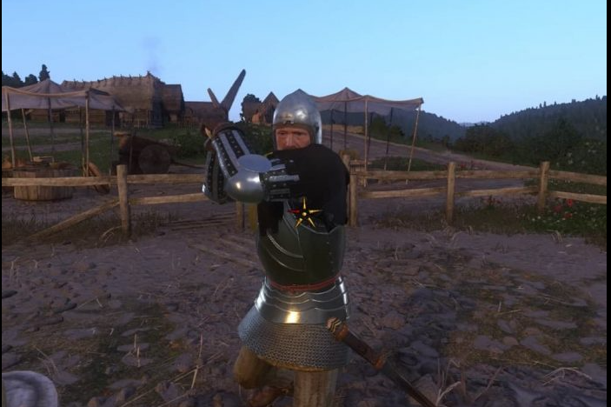There are some illustrations to help immerse the player into the ambiance of the game and story to help them feel like they are part of the game better. The simplicity of the mechanics and ui allow the player to focus solely on the story and their gameplay thus allowing everyone to enjoy the story and imagine the possibilities.

**Mechanics and modes**



Game mechanics involves the player deciding the direction of which the story will take him where he is presented with choices of what to do and each result will output a certain scenario allowing the player to see the consequences or rewards of his actions.

There is health in the game which means the choices the player makes may have a negative impact on the player and chance of losing the game. There is only one game mode for the moment so the game difficulty will not increase or decrease in consecutive playthroughs

**Planned expansions and bonus material**

Bonus material: the pictures are easter eggs referencing things that inspired partially the game.



Possible expansions: adding more choices for player to offer more freedom of options and possibly bad endings early on to punish player for too many bad choices

**Enemies and bosses**

Wolves:

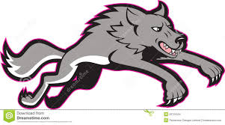

The main enemies in our game are wolves.

**Wolf mechanics:**

* They can jump
* They can attack
* Their movement speed is faster than the players
* Once the enemy wolf spots the player they will immediately hunt and try to kill them

**Final Boss:**

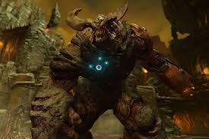 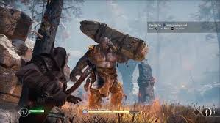

Our final boss in this game is an orc type creature that has been created by Zacharias’s father Ares. This creature uses brute force to kill enemies

**Boss Mechanics:**

* The enemy boss can let out a thunderous roar which can blow back the enemy
* The orc is very slow and relies on the player making a mistake in order to kill them
* Once the orc spots the player it will immediately try to kill them

**Zacharias Playtest session:**

Tester: Simon Williams

When: 12/01/2021

Procedures, rules, interface and controls

|  |  |
| --- | --- |
| Q1: Were the procedures and rules easy to understand? | Answer: Yes the procedures and rules were very easy to understand |
| Q2: How did the choices feel? Did they make sense? | Answer: The choices felt okay and they were very simple to understand |
| Q3: Could you find the information you needed on the interface | Answer: Everything seemed straight forward and it was very easy to follow with the information that was given |
| Q4: Was there anything about the interface you would change? | Answer: No, I liked the interface with regards to this game |
| Q5: Did anything feel clunky or awkward? | Answer: No, it felt natural and easy to understand |
| Q6: Are there any controls or interfaces you would like to add? | Answer: I would like to see more choices and to make it more visually appealing |

End of session:

Tester: Simon Williams

|  |  |  |
| --- | --- | --- |
| Q1: How much time did you feel like you were playing for? | Answer: 10 minutes, I took time to make decisions which made the experience longer | My response: Yes, we hoped that the decision making would make the experience longer so I’m glad it made you have to think about it more |
| Q2: Were you happy with the outcome? | Answer: Yes, I learned a lot of lessons on the way and I made it back to Zacharias’s home in mount Olympus | My response: I’m happy you liked the ending |
| Q3: To what extent did you feel like you were in control of the outcome of the game? | Answer: I feel like I was in control with most of the decisions which proved very well with the character development | My response: This is key because we know how important this was to get the player invested in the character |
| Q4: Which elements took you out of the game’s theme? | Answer: When Zacharias met his friends it felt like he almost forgot the place and situation he was in, it made me remember that he’s just a young man | My response: I thought it was very important to remind the player the element of realism in the game |
| Q5: What kind of emotions or feelings did you feel / notice as you played? | Answer: A rollercoaster of emotions, I started off by being banished by my father, there were times of fear and struggle but overall I had a feeling of redemption | My response: I understand exactly what you mean and it doesn’t seem like the player gets a chance to stop thinking until the end of the game |
| Q6: What was your favourite moment or aspect of what you just played? | Answer: I thought that the highlight of the game was finding friends and slaying the orc to show how far Zacharias has come | My response: This was my favourite part as well involving the friends, because I find Zacharias took motivation in this |
| Q7: Was there anything you wanted to do that you couldn’t? | Answer: I wish that I could’ve confronted Ares and question as to why I was banished | My response: This is something that I agreed with especially if you went with the decision to return to Mount Olympus, however due to lack of time in creating the game unfortunately this wasn’t added |
| Q8: If you had a magic wand to wave, and you could change, add, or remove anything from the experience, what would it be? | Answer: Add more things to build up to the final boss, Get to know the area and what danger Zacharias is really in. | My response: Thank you for this feedback, I will definitely remember importance of building up an enemy boss for future games that I create |