VENDOR PERFORMANCE & PROFITABILITY ANALYSIS
A Data-Driven Study of Vendor Sales, Purchasing Efficiency and Machine-Learning-Based Vendor Segmentation for a Retail Inventory Business
By – Jennica David

Table of Contents
1. Executive Summary
2. Project Overview and Objectives
3. Data Source and Ingestion Pipeline
4. Data Cleaning and Feature Engineering
5. Exploratory Data Analysis
6. Machine Learning — Vendor Segmentation
7. Business Recommendations
8. Conclusion

1. Executive Summary
This report documents an end-to-end vendor performance analysis built on a retail alcoholic-beverage inventory dataset. The project follows a complete analytics pipeline: raw data ingestion into a relational database, exploratory data analysis, feature engineering, statistical hypothesis testing, and unsupervised machine learning for vendor segmentation, finishing with a lightweight web application that predicts a vendor's segment on demand.
The dataset covers 119 to 128 distinct vendors (the exact count depends on the aggregation stage) and over 10,600 vendor-brand purchase-and-sales records. After data cleaning, 8,565 valid transaction-level records were used for the exploratory analysis, and a final set of 126 vendors was used to train a K-Means clustering model.
Three headline findings drive the recommendations in this report:
- Vendor concentration is high — the top 10 vendors account for 65.69% of total purchase spend, which creates supply-chain risk if any of them experience disruption.
- Sales volume and profit margin move in opposite directions — vendors with the highest sales volumes operate on materially thinner margins (≈31%) than low-volume vendors (≈42%), and this difference is statistically significant (p < 0.0001).
- Roughly $2.71 million of purchase capital is currently tied up in unsold inventory, concentrated among a handful of large vendors, representing an opportunity for working-capital recovery.
A K-Means clustering model (K = 3) was trained on standardized sales, profit margin and stock turnover features and grouped vendors into three actionable segments — Strategic Vendors, High-Margin Growth Vendors, and Underperforming Vendors — which were then deployed behind a simple Flask web form so a non-technical user can classify a vendor by entering three numbers.

2. Project Overview and Objectives
The purpose of this project was to simulate a realistic business analytics workflow: take raw operational data sitting in flat files, move it into a proper database, understand it, clean it, engineer meaningful business metrics, and use those metrics to answer concrete business questions and to build a predictive tool. The two guiding business questions set at the start of the project were:
- Which vendors should the business prioritise for profitability, and which should be reviewed or renegotiated?
- Is there an opportunity to optimise product pricing based on how sales volume and profit margin relate to each other?
To answer these questions the project was split into four notebooks and one small application, summarised below.
Stage | File | Purpose
1. Ingestion | ingestion.ipynb | Loads raw CSV files into a MySQL database in chunks, with logging.
2. Cleaning & Feature Engineering | vendor_analysis_cleaning_and_feature_engineering.ipynb | Joins raw tables into a single vendor-brand summary table and engineers profitability metrics.
3. Exploratory & Statistical Analysis | vendor_performance_analysis.ipynb | Answers the business questions using descriptive statistics, visual EDA and hypothesis testing.
4. Machine Learning | vendor_segmentation_ml.ipynb | Trains a K-Means model to segment vendors into performance tiers.
5. Deployment | app.py / index.html | A Flask web application that serves the trained model for live vendor classification.

3. Data Source and Ingestion Pipeline
The underlying data originates from five raw tables representing a distributor's inventory operations: begin_inventory, purchases, purchase_prices, vendor_invoice and sales. Each CSV file was ingested into a local MySQL database named inventory using SQLAlchemy and PyMySQL.

3.1 Ingestion Method
Rather than loading each file into memory in a single pass, the ingestion script reads every CSV in 5,000-row chunks and writes each chunk to its corresponding MySQL table, replacing the table on the first chunk and appending on every chunk after that. Every ingestion event — start, per-chunk row counts, and completion — is written to a rotating log file (ingestion_db.log), which is good practice for auditing a data pipeline and for diagnosing failures on large files.
Table | Business Meaning
purchases | Actual purchase transactions: brand, vendor, quantity purchased and dollars spent.
purchase_prices | Vendor-brand reference price list, unique per vendor and brand.
vendor_invoice | Invoice-level aggregation of purchases with freight cost, unique per vendor and PO number.
sales | Actual sales transactions: brand, quantity sold, selling price, revenue and excise tax.

3.2 From Raw Tables to a Vendor Summary
Because the information needed for vendor analysis was spread across four separate tables, the second notebook joins purchases, purchase_prices, vendor_invoice and sales through a multi-CTE SQL query to produce one wide table, vendor_sales_summary, with one row per vendor-brand combination. This pre-aggregated table was written back into MySQL and exported to CSV so that every later notebook could query it directly instead of re-running expensive joins — a standard practice for keeping dashboards and repeated analysis fast.

4. Data Cleaning and Feature Engineering
The raw vendor_sales_summary table contained 10,692 vendor-brand rows and needed several rounds of cleaning before it was analysis-ready.

4.1 Cleaning Steps
- Volume was stored as text and was cast to a numeric (float) type.
- Missing values arising from the LEFT JOIN (vendors with purchases but no matching sales, or no freight record) were filled with 0.
- Vendor names contained inconsistent leading and trailing whitespace and were stripped.
- Profit margin produced infinite values wherever total sales dollars were zero (division by zero); these were converted to NaN rather than being incorrectly treated as 0 or an extreme number, which keeps the statistics honest.

4.2 Engineered Business Metrics
Four new columns were derived from the raw purchase and sales figures — these four metrics are the backbone of every insight in the rest of the report:
Metric | Formula | Business Meaning
Gross Profit | TotalSalesDollars − TotalPurchaseDollars | Absolute profit earned per vendor-brand.
Profit Margin (%) | (GrossProfit / TotalSalesDollars) × 100 | Profitability efficiency, independent of scale.
Stock Turnover | TotalSalesQuantity / TotalPurchaseQuantity | How quickly purchased stock is sold; values above 1 indicate sales are being fulfilled partly from older stock.
Sales-to-Purchase Ratio | TotalSalesDollars / TotalPurchaseDollars | Revenue generated per dollar of inventory purchased.

5. Exploratory Data Analysis
Before answering any business question, the cleaned dataset was profiled to understand distributions, outliers, and relationships between variables.

5.1 Distribution and Outlier Screening (Raw Data)
Histograms and box plots were generated for all 16 numeric columns on the unfiltered dataset.
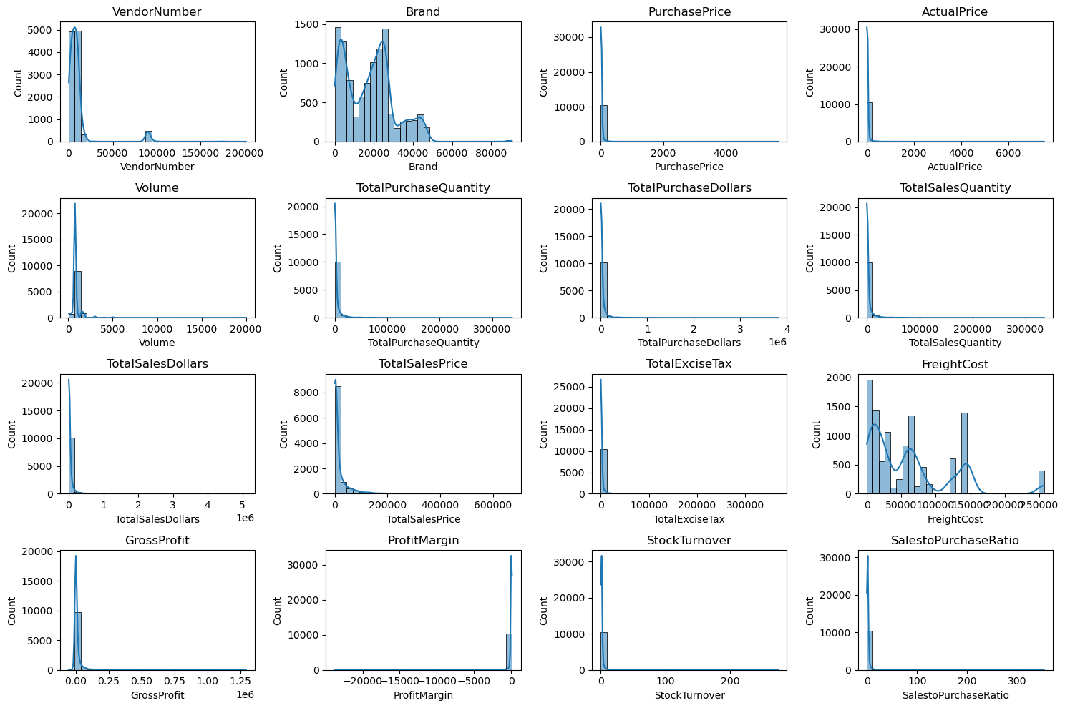
Figure 1 — Distribution plots of all numeric columns, raw vendor_sales_summary table.
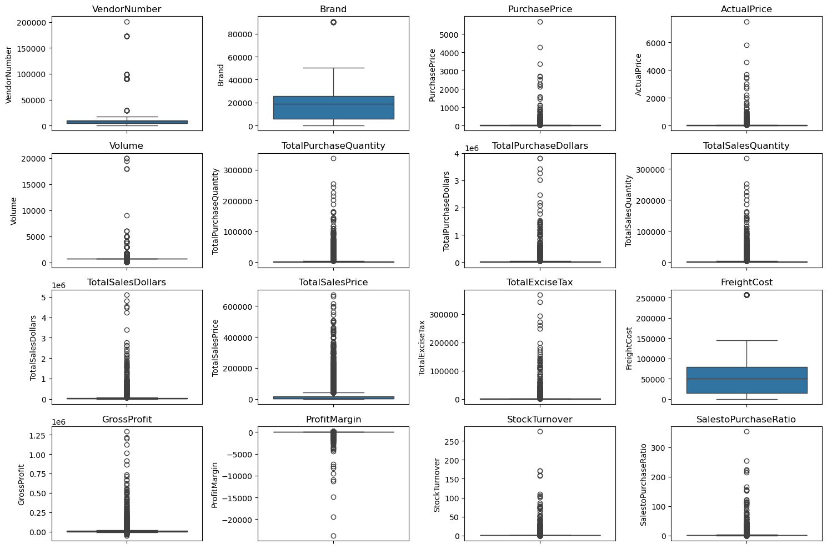
Figure 2 — Box plots highlighting outliers across all numeric columns, raw data.
Three data-quality problems stood out immediately:
- Gross profit had a minimum of −$52,002.78 — some vendor-brand combinations were sold at a loss.
- Total sales quantity and total sales dollars had a minimum of 0 — some products were purchased but never sold at all (dead stock).
- Freight cost ranged from $0.09 to $275,032.07, and stock turnover ranged from 0 to 274.5 — both signal logistics inefficiency and highly uneven vendor behaviour that later needed to be capped rather than deleted.
Based on these findings, the dataset was filtered to rows where GrossProfit > 0, ProfitMargin > 0 and TotalSalesQuantity > 0, which removed loss-making and dead-stock rows and left 8,565 usable transaction-level records for the analysis that follows.
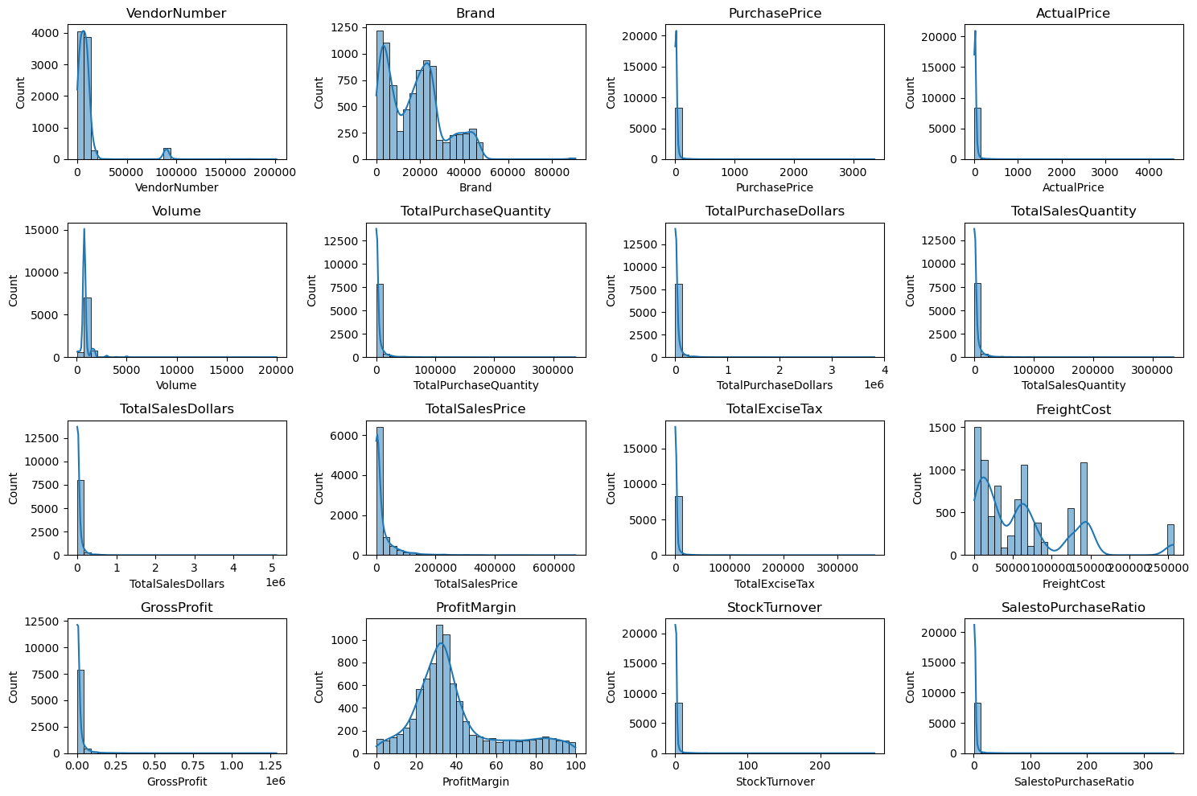
Figure 3 — Distribution plots after removing loss-making and zero-sales rows.

5.2 Categorical Overview and Correlation Structure
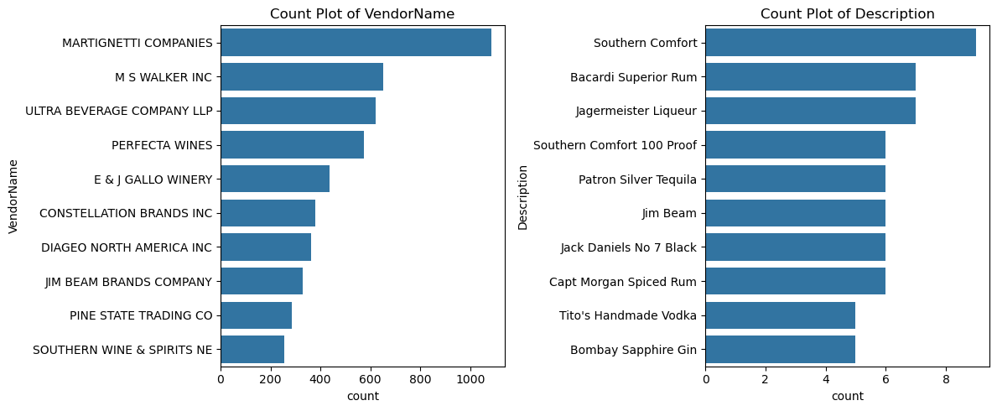
Figure 4 — Top 10 most frequently occurring vendors and brand descriptions in the cleaned data.
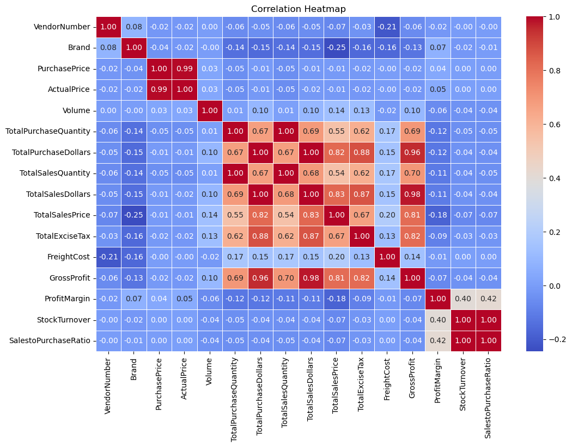
Figure 5 — Correlation heatmap across all numeric variables.
Key correlation findings:
- Purchase price has almost no correlation with total sales dollars (−0.01) or gross profit (−0.02) — price alone does not explain how well a product sells.
- Total purchase quantity and total sales quantity are almost perfectly correlated (0.999), which is expected in a well-functioning supply chain and is a useful sanity check on the data itself.
- Profit margin has a mild negative correlation with sales price (−0.18), hinting that higher-priced items are sold at comparatively tighter margins, likely due to competitive pricing pressure.
- Stock turnover is only weakly related to gross profit or margin at the individual transaction level (around −0.04 to −0.06) — this weak relationship is revisited later at the vendor level, where the picture changes substantially.

5.3 Business Question 1 — Brands That Need Promotional or Pricing Attention
The first business question asked which brands combine low sales volume with high profit margin — these are brands that are already profitable per unit sold but are not selling in meaningful quantity, which typically points to a marketing or distribution gap rather than a pricing problem. Brands in the bottom 15% of total sales dollars ($560.30 or less) and top 15% of profit margin (64.97% or higher) were flagged.
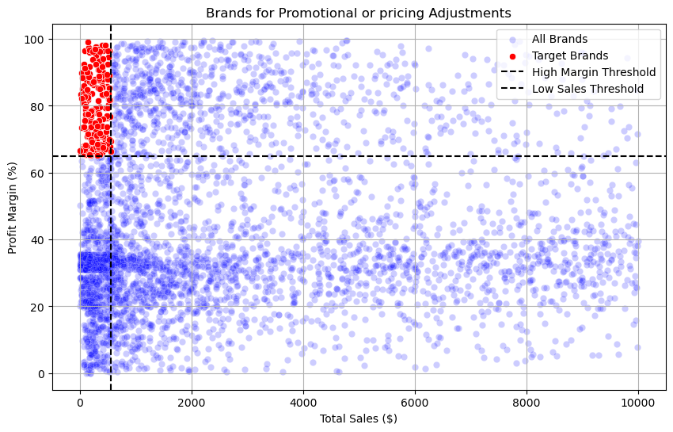
Figure 6 — Brands flagged for promotional or pricing adjustment (red) against the full brand population (blue).
198 brands met this criteria. These are strong candidates for increased marketing spend, better shelf placement, or bundling — the profitability is already proven per unit, so the priority is driving volume rather than protecting margin.

5.4 Business Question 2 — Highest-Performing Vendors and Brands by Sales
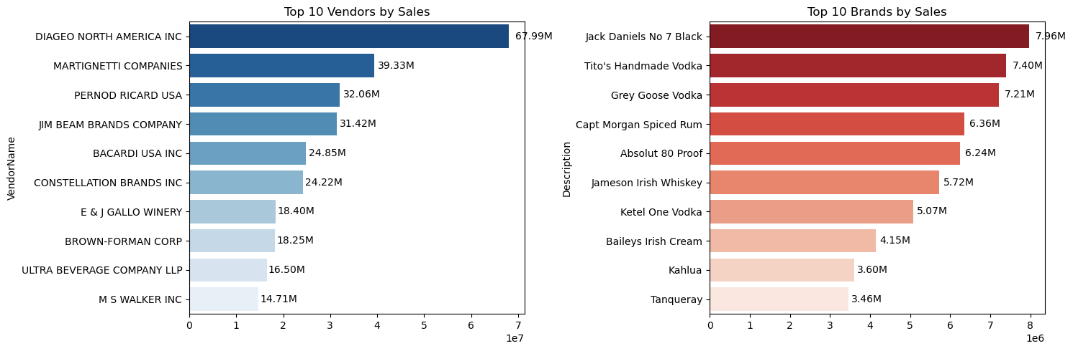
Figure 7 — Top 10 vendors and top 10 brands ranked by total sales dollars.
Diageo North America Inc leads all vendors with $67.99M in sales, almost double the second-placed Martignetti Companies ($39.33M). Jack Daniels No 7 Black is the single highest-selling brand at $7.96M, closely followed by Tito's Handmade Vodka ($7.40M) and Grey Goose Vodka ($7.21M) — all three are premium spirit brands from the largest vendors, confirming that scale in this business is concentrated in a small number of household-name spirit brands.

5.5 Business Questions 3 & 4 — Vendor Concentration in Purchasing
Vendors were ranked by their share of total purchase dollars to understand how dependent the business is on its largest suppliers.
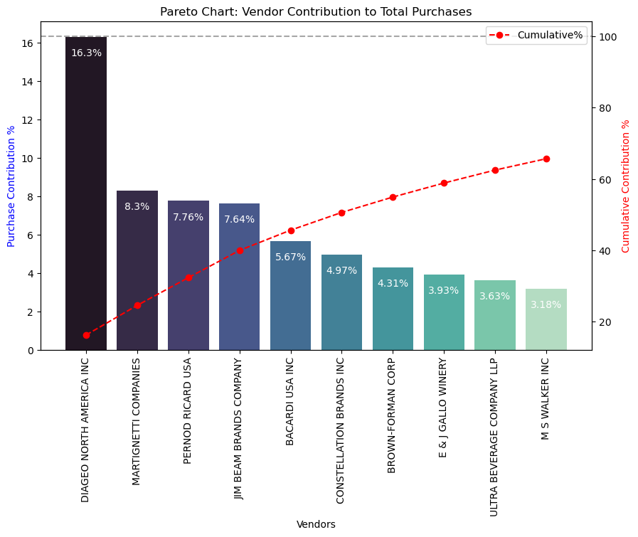
Figure 8 — Pareto chart of vendor contribution to total purchase spend.
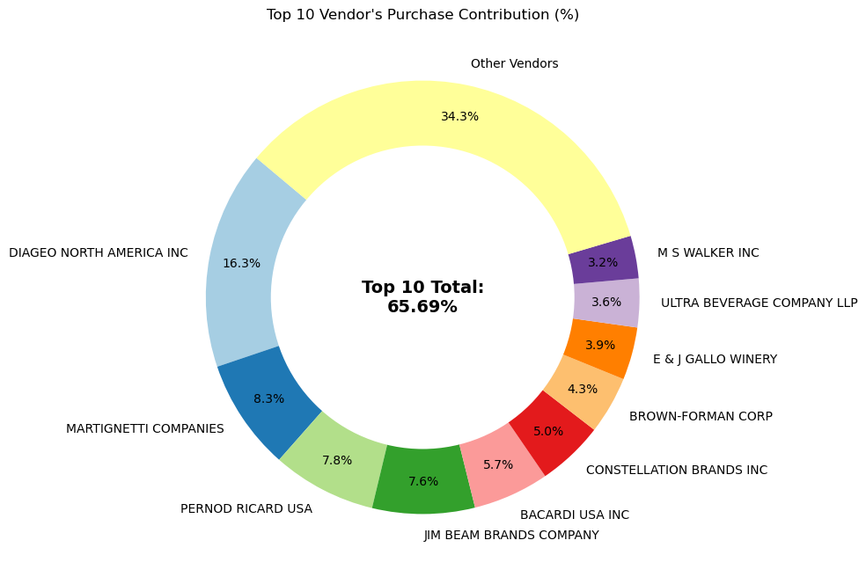
Figure 9 — Share of total purchase spend held by the top 10 vendors versus all other vendors.
Out of 119 unique vendors, the top 10 alone account for 65.69% of all purchase spend, and every vendor outside the top 10 buys comparatively small and irregular volumes. This is a textbook Pareto pattern (a small fraction of vendors driving the large majority of spend) and it carries real supply-chain risk: a disruption at even one or two of the top vendors — Diageo, Martignetti, Pernod Ricard, Jim Beam or Bacardi — would materially affect the business.

5.6 Business Question 5 — Does Buying in Bulk Reduce Unit Price?
Purchase orders were split into three equal-sized groups (Small, Medium, Large) by total quantity purchased, and the average unit purchase price was compared across the groups.
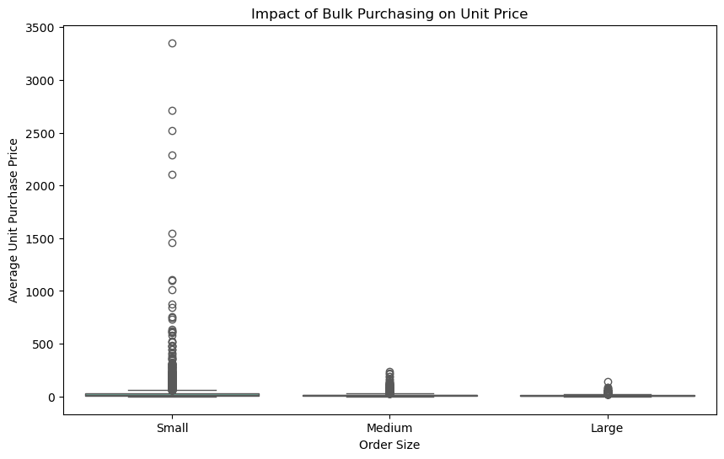
Figure 10 — Effect of order size on average unit purchase price.
Order Size | Average Unit Purchase Price
Small | $39.06
Medium | $15.49
Large | $10.78
Buying in bulk clearly reduces the price paid per unit — large orders cost roughly 72% less per unit than small orders. This confirms that consolidating purchase orders with high-volume vendors, where inventory space allows, is a legitimate lever for improving gross margin.

5.7 Slow-Moving Vendors and Capital Locked in Unsold Inventory
Vendors with a stock turnover below 1 (meaning less was sold than was purchased) were isolated to identify excess or slow-moving stock, and the dollar value of unsold inventory was calculated per vendor as (TotalPurchaseQuantity − TotalSalesQuantity) × PurchasePrice.
Vendor | Unsold Inventory Value
Diageo North America Inc | $722,210
Jim Beam Brands Company | $554,670
Pernod Ricard USA | $470,630
William Grant & Sons Inc | $401,960
E & J Gallo Winery | $228,280
Across the whole business, roughly $2.71 million of purchase capital is currently sitting in inventory that has not yet been sold. Notably, this capital is concentrated among the same large vendors that dominate purchasing — which means the largest vendors are both the biggest revenue drivers and the biggest source of tied-up working capital, and both facts need to be weighed together when planning purchase orders with them.

5.8 Business Questions 7 & 8 — Do High-Sales Vendors Really Earn Lower Margins?
Vendors were split into a high-sales group (top quartile of total sales dollars) and a low-sales group (bottom quartile), and a 95% confidence interval was calculated for the profit margin of each group, followed by a formal two-sample t-test.
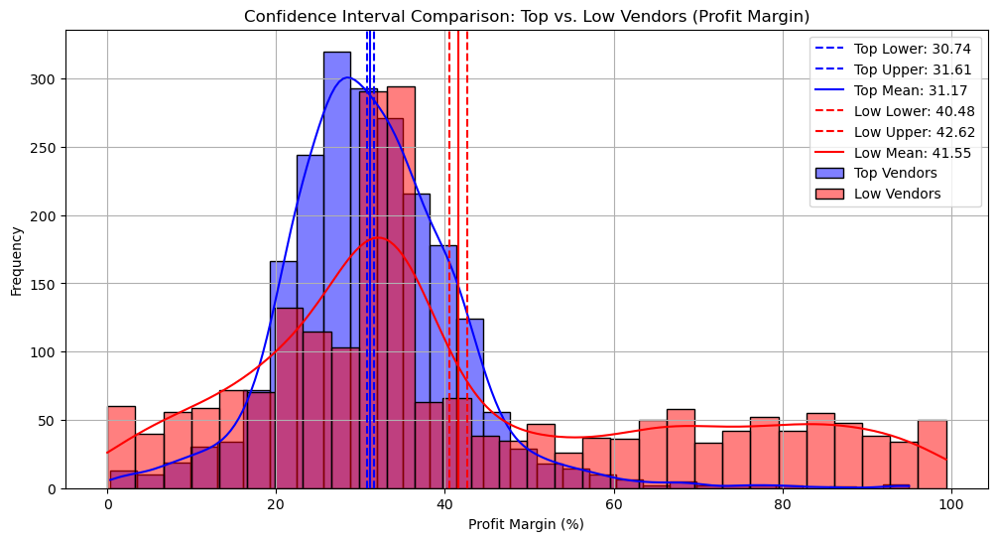
Figure 11 — Distribution and 95% confidence intervals of profit margin, high-sales vendors versus low-sales vendors.
Group | Mean Profit Margin | 95% Confidence Interval
High-Sales Vendors | 31.17% | 30.74% – 31.61%
Low-Sales Vendors | 41.55% | 40.48% – 42.62%
The confidence intervals do not overlap, and a Welch's t-test confirms this is not chance: t = −17.64, p < 0.0001. The null hypothesis of no difference is firmly rejected. In plain terms — vendors that sell the most also tend to run noticeably thinner margins, most likely because their large volume comes from competitively priced, well-known brands, while low-volume vendors can charge a premium on more specialised or niche products.

5.9 Vendor-Level View: Performance Quadrants
The transaction-level data was rolled up to one row per vendor (119 vendors) and each vendor was placed into one of four quadrants based on whether their sales and profit margin were above or below the vendor-level median.
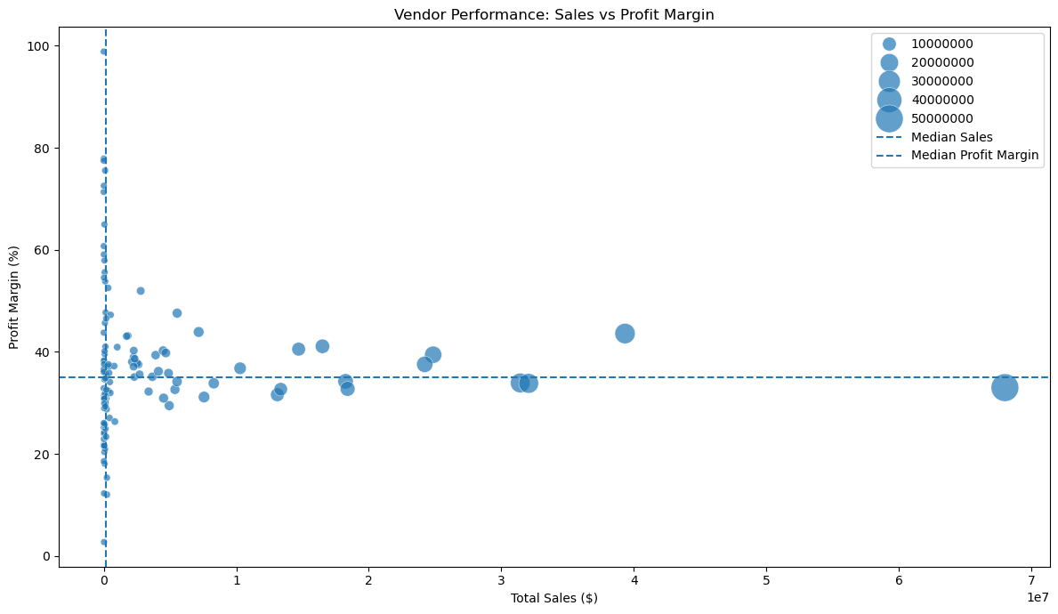
Figure 12 — Vendor sales versus profit margin, bubble size represents purchase spend.
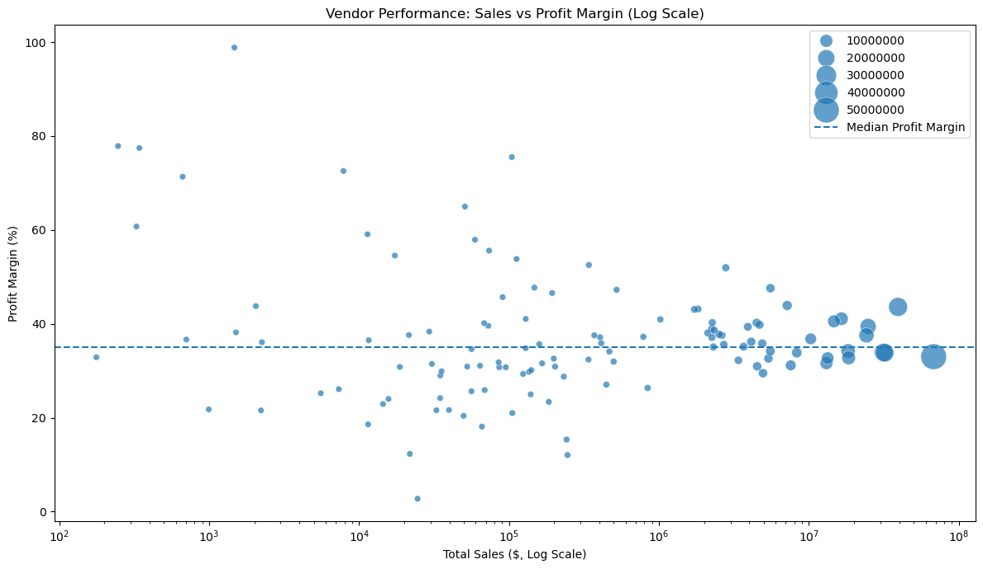
Figure 13 — Same relationship shown on a logarithmic sales axis to better separate small and mid-sized vendors.
Quadrant | Number of Vendors | Interpretation
High-Value Vendors | 34 | Above-median sales and above-median margin — the healthiest vendor group.
High-Volume / Lower-Margin Vendors | 26 | Drive revenue but on thinner margins — includes most of the largest brands.
High-Margin / Lower-Sales Vendors | 26 | Profitable per unit but under-sold — overlaps with the promotional-adjustment brand list.
Low Performers | 33 | Below median on both dimensions — priority candidates for review.

5.10 Does Faster Inventory Turnover Really Mean Higher Profit?
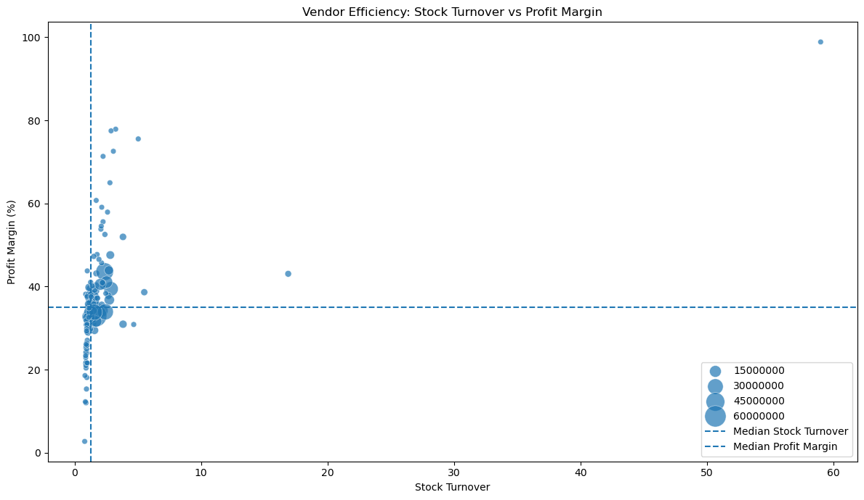
Figure 14 — Vendor-level stock turnover versus profit margin, bubble size represents total sales.
At the individual transaction level, stock turnover showed almost no relationship with profitability. But once the same data is aggregated to one row per vendor, a Spearman correlation of 0.782 emerges between stock turnover and profit margin — a strong positive relationship. This is an important lesson from the analysis: the level at which data is aggregated changes the story it tells. Noisy, transaction-level effects can average out to reveal a much clearer pattern once viewed vendor-by-vendor: vendors who consistently move inventory efficiently do, in fact, tend to be the more profitable ones overall.

6. Machine Learning — Vendor Segmentation
The exploratory analysis pointed to three intuitive vendor tiers — strong all-round performers, high-margin niche vendors, and consistently weak vendors. Rather than defining these tiers with manual, arbitrary thresholds, an unsupervised K-Means clustering model was trained to let the data define the segments objectively.

6.1 Preparing the Modelling Dataset
The vendor-brand data was re-aggregated to one row per vendor (128 vendors). During this step two vendor numbers were each found attached to two different vendor names representing genuinely different businesses in the source data (for example, Vendor 1587 covered both 'Vineyard Brands Inc' and 'Vineyard Brands LLC' with very different sales figures). Rather than merging them — which would have destroyed real business information — new unused vendor numbers (1588 and 2001) were assigned to keep every vendor uniquely and correctly identified, while leaving the original source data untouched. Two vendors with zero recorded sales (undefined profit margin) were then removed, leaving a final modelling dataset of 126 vendors.

6.2 Feature Selection and Scaling
Three features were selected to represent a vendor's commercial profile: sales scale, profitability and inventory efficiency.
- LogSales — the natural log of total sales dollars (log1p), used because raw sales values ranged from a few dollars to $68.7 million and would otherwise dominate the clustering distance calculation.
- ProfitMargin_Capped — profit margin winsorized at the 2nd and 98th percentiles, to prevent a handful of extreme loss-making vendors (margins below −250%) from distorting the cluster centroids.
- StockTurnover_Capped — stock turnover winsorized the same way, for the same reason.
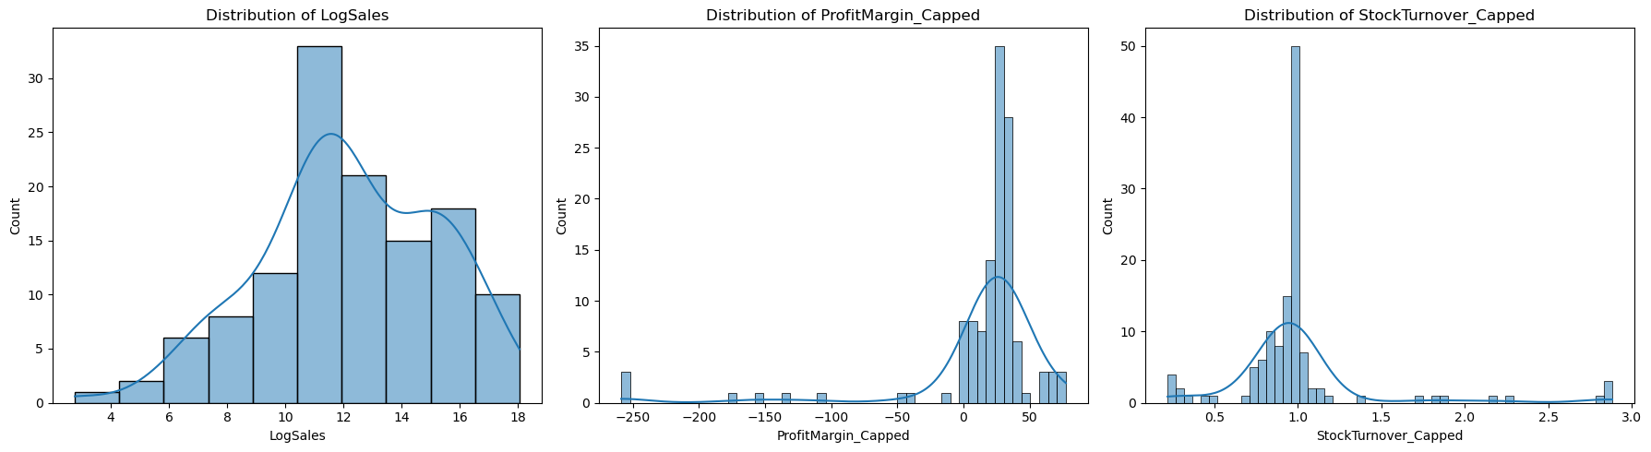
Figure 15 — Distribution of the three engineered clustering features after capping extreme values.
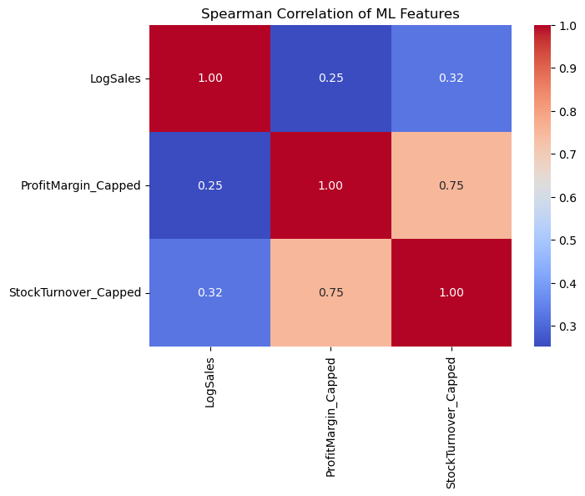
Figure 16 — Spearman correlation between the three clustering features.
All three features were standardized (zero mean, unit variance) using scikit-learn's StandardScaler before clustering, since K-Means relies on Euclidean distance and is sensitive to features measured on different scales.

6.3 Choosing the Number of Clusters
K-Means requires the number of clusters to be chosen in advance, so values of K from 2 to 6 were tested using two complementary diagnostics: inertia (the Elbow Method) and the Silhouette Score, which measures how well-separated the resulting clusters are.
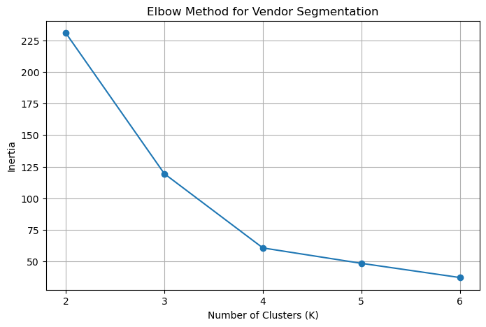
Figure 17 — Elbow plot of inertia across candidate values of K.
K | Inertia | Silhouette Score
2 | 230.84 | 0.676
3 | 119.46 | 0.684
4 | 60.70 | 0.548
5 | 48.50 | 0.485
6 | 37.25 | 0.496

K = 3 was selected as the final number of clusters. It achieves the highest Silhouette Score of the range tested (0.684), and while inertia continues to fall beyond K = 3, the improvement flattens out noticeably — the textbook 'elbow' — meaning additional clusters beyond three add complexity without meaningfully improving separation.

6.4 Final Model and Cluster Profiles
Cluster | Business Name | Vendors | Avg. Sales | Avg. Profit Margin | Avg. Stock Turnover
0 | Strategic Vendor | 110 | $4.10M | 22.82% | 0.93
1 | High-Margin Growth Vendor | 9 | $22.6K | 68.98% | 2.36
2 | Underperforming Vendor | 7 | $2.2K | -191.57% | 0.26
A K-Means model with K = 3 (random_state = 42, n_init = 20) was trained on the standardized features. The resulting clusters were profiled by their average sales, profit margin and stock turnover, and given business-friendly names.

Cluster 0 (Strategic Vendors) contains the large majority of vendors — 110 out of 126 — and represents the stable backbone of the business: healthy sales, solid double-digit margins, and turnover close to 1 (stock is sold at roughly the same pace it is purchased). Cluster 1 (High-Margin Growth Vendors) is a small group of 9 vendors with modest sales but exceptional margins and the fastest inventory turnover of any group — these are high-potential vendors that are currently under-scaled relative to their profitability. Cluster 2 (Underperforming Vendors) is a small group of 7 vendors with negligible sales, deeply negative average margins, and the slowest turnover — these vendors are actively losing the business money on the products they supply.

6.5 Model Persistence and Deployment
The trained KMeans model and the StandardScaler used to prepare its inputs were both serialized with joblib (kmeans_vendor_model.pkl and vendor_scaler.pkl) so that they could be reused without retraining. A minimal Flask application (app.py) loads both files, accepts a vendor number, vendor name, total sales, profit margin and stock turnover through a plain HTML form (index.html), applies the same log1p transform and scaling used during training, and returns the predicted segment — Strategic Vendor, High-Margin Growth Vendor, or Underperforming Vendor — for that vendor. This closes the loop from raw data to a usable, interactive business tool that a procurement or category manager could genuinely use to screen a new or existing vendor in seconds.

7. Business Recommendations
The recommendations below are grounded directly in the findings above, organised by the vendor segment or issue they address.

7.1 Strategic Vendors
- Protect these relationships first — they generate the overwhelming majority of revenue and gross profit and should receive priority in inventory allocation and contract renewal.
- Because the top 10 vendors alone represent 65.69% of purchase spend, formalise a supplier-risk review (backup suppliers, safety stock, or renegotiated lead times) for at least the top 3–5 vendors to reduce concentration risk.
- Push large vendors toward consolidated, bulk purchase orders where storage capacity allows — the data shows a roughly 72% reduction in unit cost between small and large order sizes.

7.2 High-Margin Growth Vendors
- These vendors are the clearest growth opportunity in the dataset: margins near 69% and the fastest turnover, but very low absolute sales. Increase purchase volume and marketing support for these vendors' products.
- Extend this logic to the 198 brands separately identified with low sales but high margin (Section 5.3) — prioritise promotion, better shelf placement or bundling for these SKUs, since the profitability per unit is already proven.

7.3 Underperforming Vendors
- Open a formal contract and pricing review with these vendors; if margins remain negative after renegotiation, plan a phased exit or replacement.
- Cap or pause future purchase orders with these vendors until root causes (pricing, demand, or product-market fit) are understood, to avoid compounding further losses.

7.4 Working Capital and Inventory Efficiency
- Target the $2.71M currently locked in unsold inventory with clearance pricing, vendor buy-back negotiations, or reduced reorder quantities — starting with the five largest holders identified in Section 5.7 (Diageo, Jim Beam, Pernod Ricard, William Grant & Sons, E & J Gallo).
- Introduce a minimum stock-turnover threshold in future purchase-planning decisions, since turnover below 1 is a reliable early signal of a vendor becoming a candidate for Cluster 2.

7.5 Pricing and Portfolio Strategy
- Because high-sales vendors run significantly thinner margins (31.17% vs 41.55%, statistically confirmed), avoid a one-size-fits-all discounting strategy — protect margin on lower-volume, specialised products rather than pressuring them to match the pricing of high-volume brands.
- Use the deployed segmentation tool as a lightweight, repeatable screening step whenever a new vendor is being evaluated or an existing vendor's numbers are updated, so vendor-tiering decisions are consistent rather than ad hoc.

8. Conclusion
This project took a set of raw purchase and sales files and turned them into a structured, evidence-based view of vendor performance — first through SQL-driven data engineering, then through statistical exploratory analysis that answered eight specific business questions, and finally through a machine-learning model that distilled all of that analysis into three clear, actionable vendor segments. The resulting Flask application demonstrates that the output of the analysis is not just a set of static charts, but a small working tool that could plausibly support real procurement decisions. Overall, the exercise reflects the full life cycle of a practical data analytics project: ingest, clean, explore, test, model, and deploy.

