Project – commodity price rise during Covid, do data analysis, graphs.

**[CORONAVIRUS](https://www.washingtonpost.com/coronavirus/)**

[**For the unemployed, rising grocery prices strain budgets even more**](https://www.washingtonpost.com/business/2020/08/04/grocery-prices-unemployed/)

[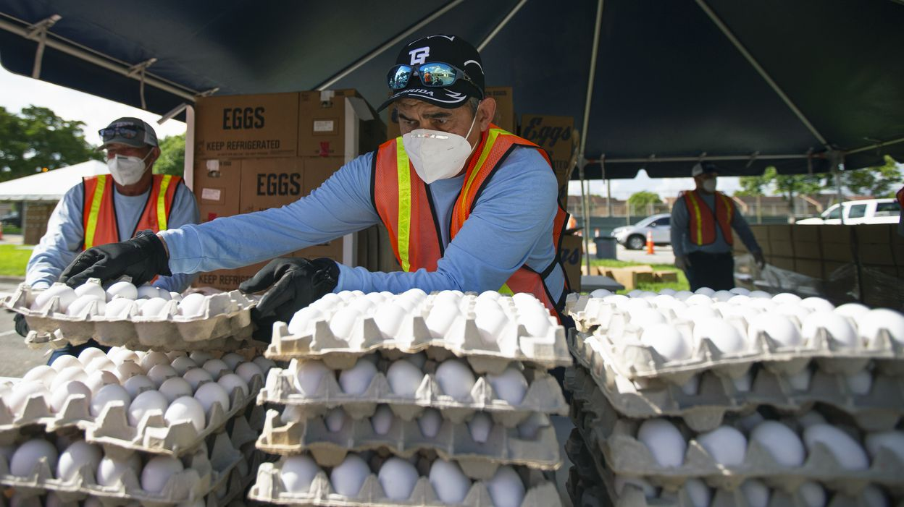](https://www.washingtonpost.com/business/2020/08/04/grocery-prices-unemployed/)

A city employee stacks egg cartons during a drive-through food distribution in Hialeah, Fla., last week. (AP)

The cost of groceries has been rising at the fastest pace in decades since the coronavirus pandemic seized the U.S. economy, leading to sticker shock for basic staples like beef and eggs and forcing struggling households to rethink how to put enough food on the table.