[How to split an Excel workbook by worksheet while preserving grouping](https://stackoverflow.com/questions/56601242/how-to-split-an-excel-workbook-by-worksheet-while-preserving-grouping)

[Ask Question](https://stackoverflow.com/questions/ask)

1

I am doing some excel reports for work and am given a book exported from SSRS daily. The book is nicely set up, with groupings applied to every sheet for an effect similar to pivot tables.

However the book comes with 32 sheets, and I eventually need to send out each sheet individually as a distinct report. Right now I am splitting them up manually, but I am wondering if there is a way to automate this while preserving the grouping.

I previously tried something like:

import xlrd

import pandas as pd

targetWorkbook = xlrd.open_workbook(r'report.xlsx', on_demand=True)

xlsxDoc = pd.ExcelFile('report.xlsx')

for sheet in targetWorkbook.sheet_names():

reportDF = pd.read_excel(xlsxDoc, sheet)

reportDF.to_excel("report - {}.xlsx".format(sheet))

However since I'm converting each sheet to a pandas datagrams, the grouping is lost.

There are multiple ways to read/interact with excel docs in python, but I can't find a clear way to pick out a sheet and save it as its own document without losing the grouping.

[python](https://stackoverflow.com/questions/tagged/python) [excel](https://stackoverflow.com/questions/tagged/excel) [pandas](https://stackoverflow.com/questions/tagged/pandas) [xlrd](https://stackoverflow.com/questions/tagged/xlrd" \o "show questions tagged 'xlrd')

[share](https://stackoverflow.com/q/56601242/4693491)[edit](https://stackoverflow.com/posts/56601242/edit)[flag](https://stackoverflow.com/questions/56601242/how-to-split-an-excel-workbook-by-worksheet-while-preserving-grouping)

asked 2 days ago

[[](https://stackoverflow.com/users/3861467/josh-kraushaar)](https://stackoverflow.com/users/3861467/josh-kraushaar)

[Josh Kraushaar](https://stackoverflow.com/users/3861467/josh-kraushaar)

**112**12

* for reference, I have 'solved' this problem by automating it with vba and using python to inject the macro into new books. I am wondering if there is a pure python alternative however. – [Josh Kraushaar](https://stackoverflow.com/users/3861467/josh-kraushaar) [49 mins ago](https://stackoverflow.com/questions/56601242/how-to-split-an-excel-workbook-by-worksheet-while-preserving-grouping#comment99817223_56601242)

add a comment

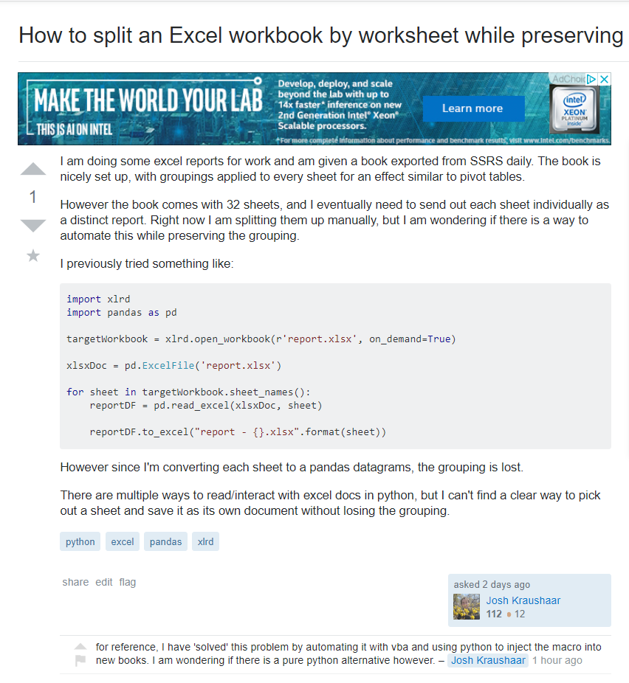

# 

# [Python: Open Excel Workbook using Win32 COM Api](https://stackoverflow.com/questions/39877278/python-open-excel-workbook-using-win32-com-api)

[Ask Question](https://stackoverflow.com/questions/ask)

4

5

I'm using the following code to open and display a workbook within Excel:

import win32com.client as win32

excel = win32.gencache.EnsureDispatch('Excel.Application')

wb = excel.Workbooks.Open('my_sheet.xlsm')

ws = wb.Worksheets('blaaaa')

excel.Visible = True

When the File 'my_sheet.xlsm' is already opened, Excel asks me whether I want to re-open it without saving.

How could I check in advance whether the workbook is already opened up and in case it is, just bring it to the front?

**EDIT**: Found out by now:

if excel.Workbooks.Count > 0:

for i in range(1, excel.Workbooks.Count+1):

if excel.Workbooks.Item(i).Name is 'my_sheet.xlsm':

wb = excel.Workbooks.Item(i)

break

**And one more question**: My worksheet contains some headers where I enabled some filtering. So when the filters are set, and when I open the Workbook from Python, it sometimes asks me to enter a unique name to save the filter. Why is that? This is the dialogue:

