Home page (bold border = consistent across all pages)

|  |  |  |  |  |  |
| --- | --- | --- | --- | --- | --- |
|  | Font-size: | Color: | Background | Text-shadow | Border-color |
| wrapper | NA | #ffbf00 | Img, dark blue | NA | NA |
| Header (H1) | 32px | #ffbf00 | NA | 2px 1px 2px #005da4 | NA |
| Address | 12px | #ffbf00 | NA | 2px 1px 2px #005da4 | NA |
| Nav links | Inherit: 16px | #ffbf00 | rgb(0, 75, 133) | 2px 2px 2px #cf7600 | NA |
| Nav links:hover | Inherit: 16px | rgb(0, 75, 133) | #ffbf00 | 2px 2px 2px #cf7600 | NA |
| Main | NA | #ffbf00 | rgb(0, 75, 133) | NA | White |
| previous / next | 48px | white | rgb(0, 75, 133) | NA | rgb(0, 75, 133) |
| previous/next:hover | 48px | rgb(0, 75, 133) | white | NA | white |
| gallery | NA | NA | Inherit:  rgb(0, 75, 133) | None | White |
| <h2> | 26px | rgb(255, 217, 24) | NA | None | NA |
| <p> | Inherit: 16px |  | NA | NA | NA |

wrapper

Header

Main

previous

Nav links

<h2>

<p>

gallery

next

Address

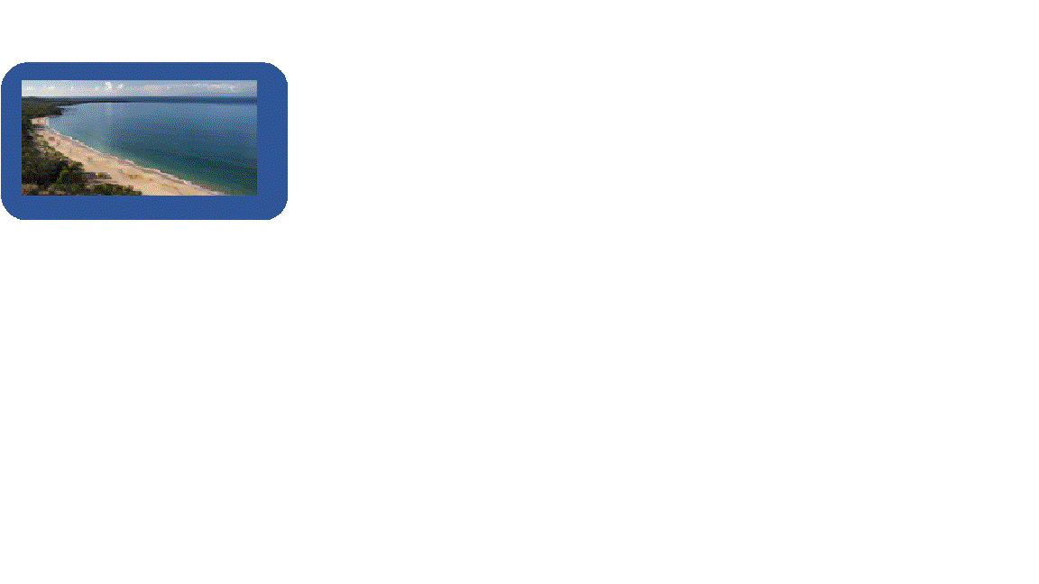

Welcome to the Travel Emporium

Are you aching to get away? We can help.

>>

<<

Order

Contact Us

Home

20000 68th Ave. W  
Lynnwood, WA 98036  
425.222.1234

Jennifer Stratman’s Travel Emporium

Contact page

|  |  |  |  |  |  |
| --- | --- | --- | --- | --- | --- |
|  | Font-size: | Color: | Background | Text-shadow | Border-color |
| Article | NA | white | None | NA | None |
| <h2> | 26px | rgb(255, 217, 24) | NA | None | NA |
| button | 0.83em | black | #dfdfdf | None | #888 |
| Legends | Inherit: 16px | White  White  White | None | None | white |
| Labels | None |
| Text, textarea, radio | None |

<h2>

Order

Contact Us

Home

20000 68th Ave. W  
Lynnwood, WA 98036  
425.222.1234

Jennifer Stratman’s Travel Emporium

textarea

Submit your feedback

button

labels

radio

select

text

Legend

Personal Info

Background

Comments

Your email:

Your name:

dropdown

No

Yes

Current customer?

Instructions here

**Questions? Comments? We would love to hear from you. Give us a call or fill out the form below.**

Order page

|  |  |  |  |  |  |
| --- | --- | --- | --- | --- | --- |
|  | Font-size: | Color: | Background | Text-shadow | Border-color |
| Article | NA | White | None | NA | None |
| Label | Inherit: 16px | White | None | NA | NA |
| Radio | 0.83em | White | None | NA | NA |
| Checkboxes | 0.83em | White | None | NA | NA |
| Selections | Inherit: 16px | White | None | NA | White |
| Button | 0.83em | Black | #dfdfdf | None | #888 |
| Aside | Inherit: 16px | #ffbf00 | rgba(0,75,133,0.3) | None | NA |

Label

Order

Contact Us

Home

20000 68th Ave. W  
Lynnwood, WA 98036  
425.222.1234

Jennifer Stratman’s Travel Emporium

button

Submit your order

Selections

Aside

Order Summary:

3 days / 2 nights in Maui

Move

Water

Adventure

Pamper

Hiking

Spa

Surfing

Golf

**Or select from one of our specialty packages**

**Build your own adventures:**

Orlando, FL

Maui, HI

Baja California, Mexico

**Pick your destination:**

9 days / 8 nights

6 days / 5 nights

3 days / 2 nights

**Select the duration of your stay:**

Subtotal: $999.95

Tax: 95.00

Total: $1094.95

Radio

Checkboxes

Customer Info page

|  |  |  |  |  |  |
| --- | --- | --- | --- | --- | --- |
|  | Font-size: | Color: | Background | Text-shadow | Border-color |
| Summary | NA | White | None | (border-shadow)  2px 2px 2px rgb(210, 118, 105) | White |
| <h3> | 24px | White | None | NA | None |
| Form | 24px | White | None | NA | white |
| Label | 16px | White | None | None | None |
| Text | 0.83em | White | None | None | None |
| Button | 0.83em | White | #dfdfdf | None | #888 |
| Validation | Smaller, bold(weight) | Rgb(255,255,0) | None | None | None |

Order

Contact Us

Home

20000 68th Ave. W  
Lynnwood, WA 98036  
425.222.1234

Jennifer Stratman’s Travel Emporium

Summary

button

text

Order your vacation package

Form

Label

<h3>

Apartment:

Phone: * (XXX-XXX-XXXX)

City, State, Zip: *

Address: *

Email: *

Last Name: *

First Name: *

**Delivery Information (* required information)**

Subtotal: $1354.95

Tax: 128.72

Total: $1483.67

3 days / 2 nights stay in Maui, HI Pamper Me Package, which includes:

Golf

Spa

Winery Tour

Beach Party

Your current Order Summary:

Validation

**Required Field**

Thank You page

|  |  |  |  |  |  |
| --- | --- | --- | --- | --- | --- |
|  | Font-size: | Color: | Background | Text-shadow | Border-color |
| <h1> | 32px | #ffbf00 | None | NA | None |
| <h2> | 26px | rgb(255, 217, 24) | None | NA | None |

Order

Contact Us

Home

20000 68th Ave. W  
Lynnwood, WA 98036  
425.222.1234

Jennifer Stratman’s Travel Emporium

<h1>

**Thank You!**

<h2>

We appreciate your feedback!

Error page

|  |  |  |  |  |  |
| --- | --- | --- | --- | --- | --- |
|  | Font-size: | Color: | Background | Text-shadow | Border-color |
| <h1> | 32px | #ffbf00 | None | NA | None |
| <h2> | 26px | rgb(255, 217, 24) | None | NA | None |

Order

Contact Us

Home

20000 68th Ave. W  
Lynnwood, WA 98036  
425.222.1234

Jennifer Stratman’s Travel Emporium

<h1>

**Error**

<h2>

We’re sorry, there seems to have been an error with your submission. Please try again.

Summary page

|  |  |  |  |  |  |
| --- | --- | --- | --- | --- | --- |
|  | Font-size: | Color: | Background | Text-shadow | Border-color |
| <h2> | 26px | rgb(255, 217, 24) | None | NA | None |
| Summary | Inherit: 16px | White | None | NA | None |

Order

Contact Us

Home

20000 68th Ave. W  
Lynnwood, WA 98036  
425.222.1234

Jennifer Stratman’s Travel Emporium

<h2>

Francine Miller

[FranMiller@marvelous.com](mailto:FranMiller@marvelous.com)

555 Any Street F4

Bobbytown, GA 50023

The vacation you ordered: Order Summary:

3 days / 2 nights stay in Maui, HI Pamper Me Package, which includes:

Golf

Spa

Winery Tour

Beach Party

Your confirmation package will be delivered to:

14 Minutes 59 Seconds

Your confirmation package will be to you within

**Thank you for ordering from Jennifer Stratman’s Travel Emporium**

Summary

All pages (Address centered, navigation to top)

Jennifer Stratman’s Travel Emporium

20000 68th Ave. W  
Lynnwood, WA 98036  
425.222.1234

Home

Order

Contact Us



Welcome to the Travel Emporium

Are you aching to get away? We can help.

>>

<<

All pages (Address centered, navigation to top)

Jennifer Stratman’s Travel Emporium

___

___

___

20000 68th Ave. W  
Lynnwood, WA 98036  
425.222.1234

Home

>>



Welcome to the Travel Emporium

Are you aching to get away? We can help.

<<