Jenna Ficula

Lab 8

1. ER Diagram

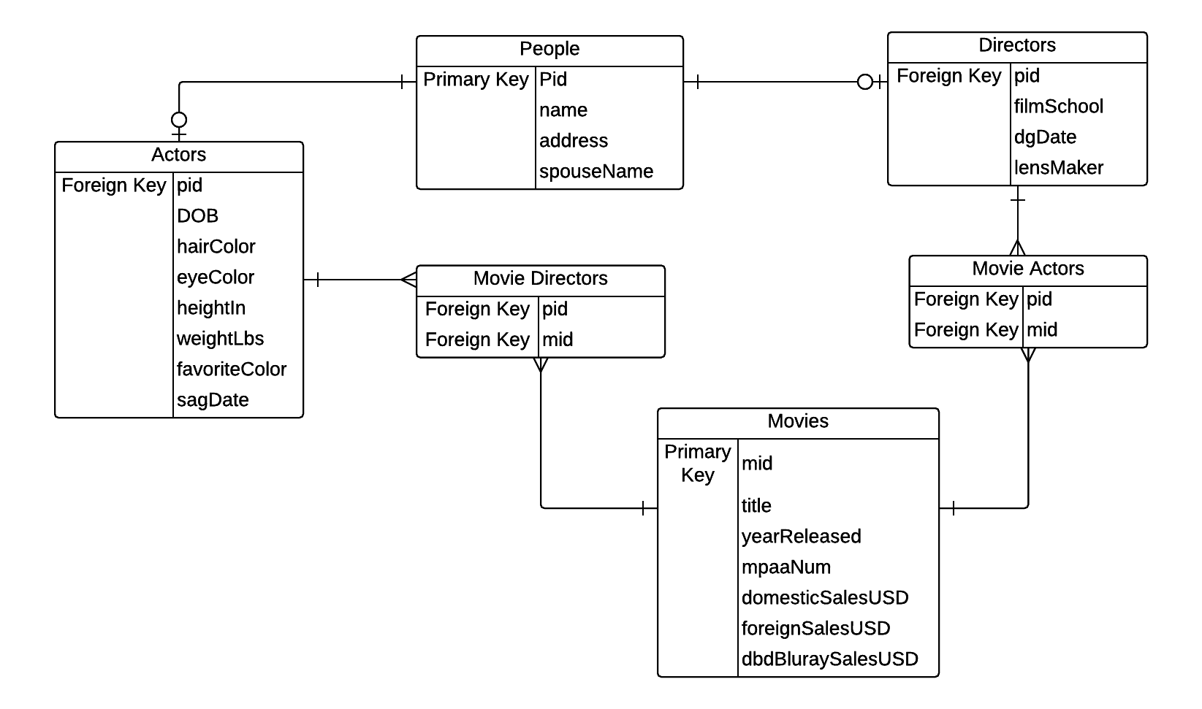

2. SQL create statements:

create table people(

pid TEXT NOT NULL PRIMARY KEY

name TEXT  
address TEXT

spouseNAME TEXT

);

create table actors(

pid TEXT NOT NULL REFERENCES people(pid)

DOB DATE

hairColor TEXT

eyeColor TEXT

heightIn INT

weightLbs INT

favoriteColor TEXT

sagDate DATE

);

create table movies(

mid TEXT NOT NULL PRIMARY KEY

title TEXT NOT NULL

yearReleased INT

mpaaNum INT

domesticSalesUSD FLOAT

foreignSalesUSD FLOAT

dvdBluraySalesUSD FLOAT

);

create table directors(

pid TEXT NOT NULL REFERENCES people(pid)

filmSchool TEXT

dgDate DATE

lensMaker TEXT

);

create table movieDirectors(

mid TEXT NOT NULL REFERENCES movies(mid)

pid TEXT NOT NULL REFERENCES people (pid)

primary key (mid, pid)

);

create table movieActors(

mid TEXT NOT NULL REFERENCES movies(mid)

pid TEXT NOT NULL REFERENCES people (pid)

primary key (mid, pid)

);

3. Functional Dependencies:

(People) pid 🡪 (name, address, spouseName)

(Actors) pid 🡪 (DOB, hairColor, eyeColor, heightIn, weightLbs, favoriteColor, sagDate)

(Directors) pid 🡪 (filmSchool, dgDate, lensMaker)

mid 🡪 (name, yearReleased, mpaaNum, domesticSalesUSD, foreignSalesUSD, dvdBluraySalesUSD)

4. Query:

SELECT directors.name

FROM Directors d INNER JOIN movieDirectors ON d.pid = movieDirectors.pid

WHERE mid in (SELECT mid

FROM movieDirectors c INNER JOIN People p ON p.pid = movieActors.pid

WHERE name = "Sean Connery");