I analyzed these data together with my colleagues Victor Keller and William Chopik last summer/this fall, with the goal of publishing a scientific article about our findings. The data were publically available from a web study measuring various types of prejudice.

The data were pretty messy, for a number of reasons: the web study went on for over 13 years and the response options of some questions changed over that period; some numerical information needed to be extracted from string variables; etc. The R Markdown file included in this folder walks you through some of the data cleaning decisions and the R code I used to perform the cleaning. The dataset had a lot of variables which we used in various analyses, and it would take a long time to read through the whole process; so I’ve limited this to just a few of the variables I cleaned as part of this work.

I’ve also included a Word document version of the R Markdown file, as well as the data (split into three zipped files, because github limits file sizes to 25 MB).

When time allows (it may not be soon), I’ll update this to include the code I used to perform the analysis (pretty simple: we just used multivariate linear regressions for this) and to make pretty visualizations of prejudice over time (a little more complicated) like the one on the next page.

At the time of this writing (December 2018) I have been accepted to give a talk about these findings at the Society for Personality and Social Psychology Conference in February, and our manuscript is under review at the *Journal of Social Issues.*

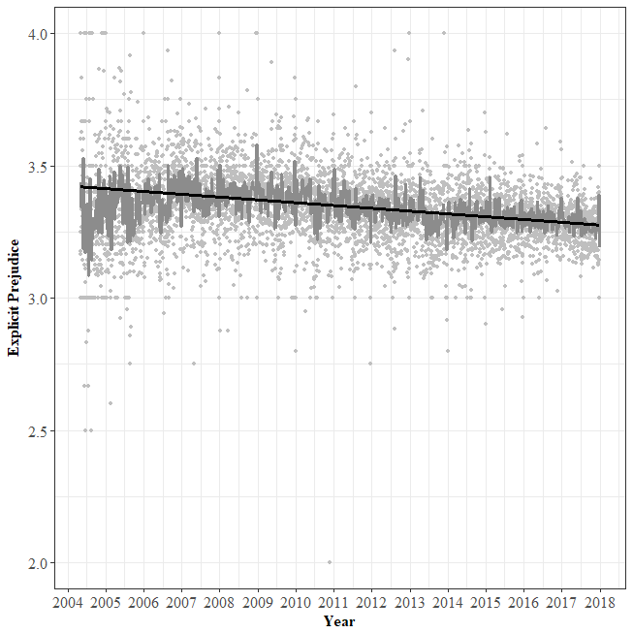

*Figure 1.* Trends overtime in explicit (self-reported) prejudice. Prejudice is measured on a scale from 1 to 5, with greater numbers indicating greater prejudice against people with disabilities. Dark black trend line represents overall trend; dark gray line represents weekly averages; gray points represent daily averages.