## --- title: Basics of project/resource (0.2.1b)

Paratext allows you to view several projects or resources at the same time.

Each project or resource is shown in a window, with its own title bar and menu. Projects can be editable but resources are never editable.

### To open a project or resource

* Click the **main Paratext menu ≡**, and then click **Open**.  
  *The Open Project/Resource dialog box appears*.  
  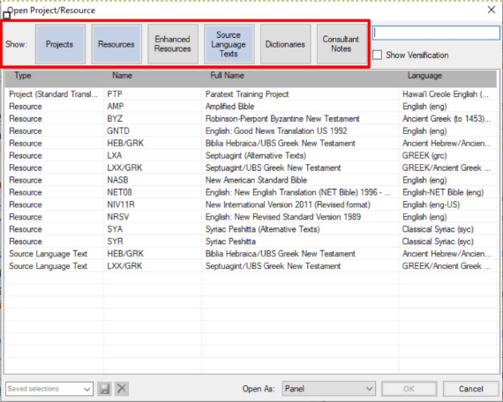
* Filter or search for the files you want
* The row of buttons along the top allows you to **filter** which types of files you see displayed in the list below.
* Alternatively, you can use the **search box** to find the file you need to open.
* To open a file,
* Click the filename in the list
* Choose the type of window (panel, tab, floating window, etc)
* Click **OK**.
  + *A new window opens*.

:::tip

When you start Paratext it will re-open the projects and resources you had open when you last closed Paratext. It also places your cursor in the verse where you last had your cursor. :::