## --- title: Keyboard (0.2.3b)

Paratext can be set to turn on a keyboard automatically when the cursor is in a project that needs it.

* Click the **Project** menu
* Move the mouse over **Project Settings**.
* In the submenu, select **Keyboard**.
  + The Keyboard dialog for this project opens.  
    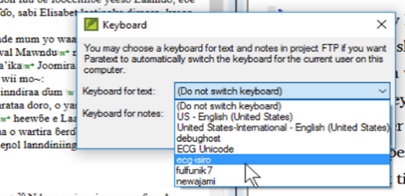
* Choose the Keyman keyboard for typing text.
* Choose the Keyboard for typing notes.
* Click **OK**.