## --- title: Further tips on Arranging Windows (0.2.3d)

### Tip1: How to swap windows

Swapping two windows may involve two or more steps. [For example, drag one to the left edge and end up with an extra column, then drag the other to the lower right corner (back to original number of columns).]

An alternative way to swap these two texts is by using the project list.

### Tip 2: How to undo moving a window

If you make a mistake with a drag,

* Click on the main Paratext menu.
* Click Undo Tab move.

### Tip 3: How to unpin floating windows

* When the thumbtack is slanted, this window no longer stays on top all the time.  
  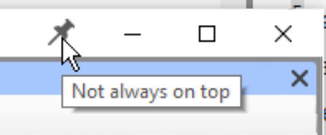
* If you want it to always stay on top again, click the thumbtack icon to pin it.  
  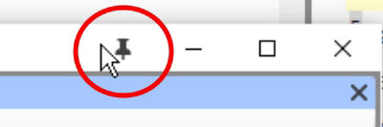

### Tip 4: How to widen the autohide column

The autohide column can be made a little wider if desired.

* Click the arrow at the top of the column.  
  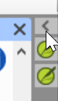

### Tip 5: How to undo closing a window

* Click the main Paratext menu
* Choose Undo Tab Close