## --- title: Send/Receive for the first time (0.4.1)

When you hear that the administrator has added you to the project, use the Send/Receive command to get a copy of the project on your computer.  
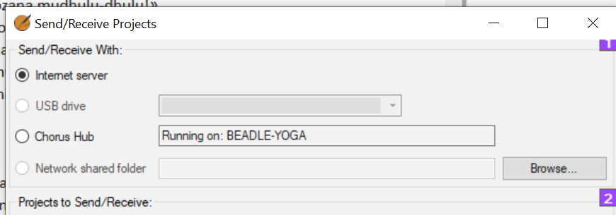

### Send/receive by Internet

* Open the main Paratext menu **≡.**
* Click **Send/receive projects**
* Choose the appropriate method (**Internet** or **USB** see below)
* Choose the project (**New** means new to my computer)
* Click **Send/receive** button
  + *Project will open*.

### Send/receive by USB

* **Insert USB** into computer
* Open the main Paratext menu.
* Click **Send/receive projects**
* Choose **USB drive**
  + *If it is greyed out, cancel and insert USB*
* Choose project (**New** means new to my computer)
* Click **Send/receive** button
  + *Project will open*.

### Send/receive by Network folder

* File > Send/receive projects
* Choose Network Shared folder
* Click browse and choose the network folder
* Choose project (New means new to my computer)
* Click Send/receive button
  + *Project will open*.