## --- title: Working in a shared project (0.4c)

In this video, you learnt about using send/receive regularly to keep sharing your work with your colleagues, and to receive their changes.

### Send/receive – icon on taskbar

Use the shortcut icon on taskbar to do the same type of send/receive.

### Send/receive – project menu ≡

* Click the project **≡ menu**
* Choose Send/Receive this project

### Schedule Send/Receive

* Click the main **≡ menu** Paratext
* Choose **Send/Receive projects**
* 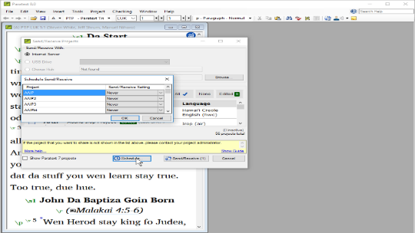
* Click **Schedule**
* Select the project
* Choose schedule setting (hourly, every four hours, daily, or on startup and shutdown)
* Click **OK** to set the schedule
* Click **Cancel** to close Send/receive dialog.