## title: Paratext Conflict Notes (1.6b)

## What they look like and how to deal with them

In this video we will see what conflict notes look like and how to deal with them. This is the same in Paratext 8 and 9.

* Do a Send/Receive
* Click link Open unresolved conflict notes list window.

**Open note and resolve conflict**

* **Open** note
* If the note is assigned to you, or you are an administrator, there will be a dropdown list
* Click the Dropdown the list at the top  
  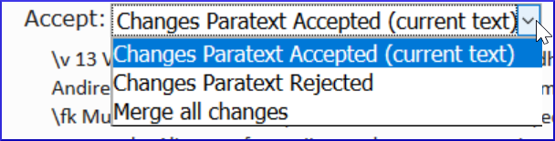
* Choose an option as appropriate
* **Accept** the changes Paratext **accepted** (leave it as is)
* **Accept** the changes Paratext **rejected** (and reject the other change)
* **Merge** all changes (accept both changes)
* Click **OK**
* **Resolve** the note to make the flag go away.
* Do a Send/Receive

:::tip

Special warning flag for conflict notes are either at the very beginning of the book or at the verse number. :::

**Complex conflicts**

If there are many conflicts, your administrator may need to **revert** the book(s).