title: My Tasks - Project Plan (1.1)

The administrator of your project can assign tasks to you in Paratext. The task assignments control what you can edit.

## View tasks assigned to you

* Click on the blue button to open Assignments and progress.
  + *The Assignments and Progress window opens, showing* ***My Tasks*** *in the* ***Current Priority*** *or the last view*.
* 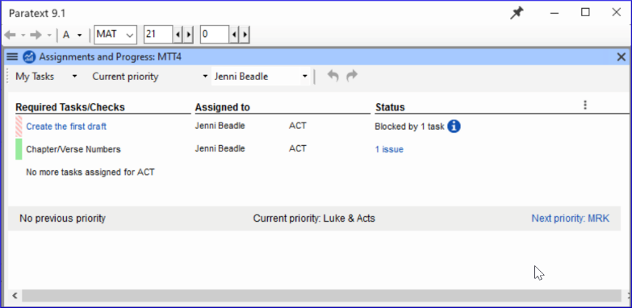

## Next/Previous Links

* **Prev priority** – previous book with tasks
* **Next priority**- next book with tasks
* Change to **All Tasks** – to see tasks waiting

## View tasks by book

* Where it says **Current Priority**, click to view the menu.
* Click **Current Book**.
  + *This is the default filter if your administrator has not set up Priorities*.
* View tasks in another book by clicking **Next book** or **Previous book**.

## State of tasks

* **Green**: Tasks that can be started right away are marked with **green**.
* **Striped green**: Waiting on you to finish another task.
* **Red:** Tasks are dependent on earlier tasks being finished by others.
* **Grey**: Task is complete

**See more information**

* Hover the mouse over the **information icon** to find out what is blocking it.
* Click **Show more tasks** to see hidden tasks.