title: How to Mark Tasks as Complete (1.5)

[Watch video](https://vimeo.com/461793250)

As you work on the tasks assigned to you in Paratext, you need to record what you have finished. This allows the team to see your progress, and **most importantly** allows other team members, who are waiting for your task to be finished, to get started on their tasks.

**Open Assignments and progress**

* Click on the blue button .

**Mark tasks as complete**

* Mark **project task** or **book task** as complete: click the check box
* 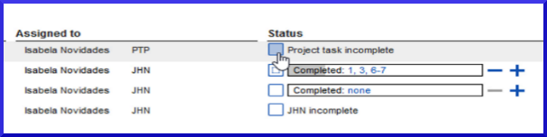
* Mark **chapter task** as complete: click blue **+**, or unmark click blue **-**
* For more control, click none (or chapter numbers), click the chapter numbers
* 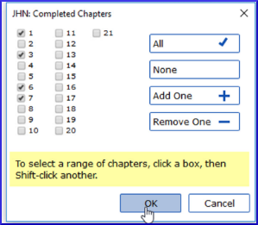
* Click **OK**

**Useful links:**  
Prev (Book or Priority), Next (Book or Priority), All tasks

**Send/Receive**  
Remember to Send/Receive so that other team members receive the progress status information.