## --- title: Find and Replace (5.2)

To search for a particular word in a project or resource,

* Open the **menu** for the window.
* Under **Edit**, click **Find**.
  + *The Find/Replace dialog box opens*.
* Type the word you want to look for, and click **Find**.
  + *Paratext displays the matches in a list window*.
* Double click a reference in the list window
  + *The matched text is shown in context*.

## Other ways of opening the find dialog

**Find icon** in the toolbar, or  
**Ctrl-F** the keyboard shortcut.  
**Menu** > **Edit** > **Find**.

:::tip

It’s helpful if the window you want to search in is active first. :::

## The Find dialog box

* **Find** text box shows your previous search
* **Match in**
  + All text - everywhere
  + or Verse text
* Limit search to **current book** **current chapter** or choose a range of books using **Choose** button
* **More** button gives additional options.
* **Restrictions**
  + **No restriction** means matches can be any part of a word or a whole word.
  + **whole word only**,
  + at the **beginning of the word** or
  + at the **end of the word** or
* **Match Case**–match whether the characters are uppercase or lowercase.
* **Show Verse Context** means the list shows the matching word or string, with some adjacent words in the verse as well.
* To hide the additional options, click **Less**.
* To carry out the search click **Find**.
  + *The list is updated to show the results*. 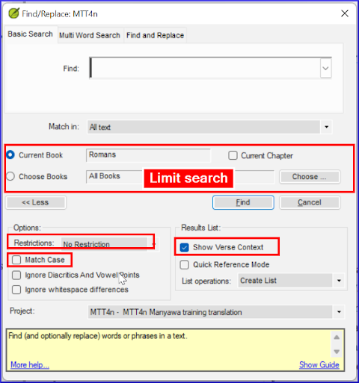

## Replace

There are three ways of opening the Replace tab

* From the Find/Replace dialog – click the **Replace** tab
* **Ctrl-H** the keyboard shortcut.
* **Menu** > **Edit** > **Replace**.
* Open the Find and Replace dialog.
* Change the text in the **Find** box if needed.
* Type the text you want to replace it with in the **Replace with** box.
* Click **Replace** button.
  + *Instead of showing you a list of matches, Paratext opens the Replace dialog and shows you one match at a time*.

## Replacing matches

* **Yes** or **No** approve each change individually.
* **Yes to all** will approve all the remaining proposed changes, so this needs to be **used with care**.
  + *Make absolutely sure it is a change you want to make everywhere (e.g. review with Find first)*.
* If you want to stop the process completely, click **Cancel**.
  + *Please note, any changes you have already clicked Yes for will not be cancelled*.
  + *Paratext will inform you how many matches were not changed because you did not have the permission to edit them*.

:::note

Find and Replace Yes to all only makes changes in places you have permission to edit. :::