|  |  |  |  |  |  |
| --- | --- | --- | --- | --- | --- |
| **学 期** | 2020-2021第一学期 | **班 级** | 190741 | **组 号** | 24 |
| **学 院** | 计算机学院 | **学 号** | 19030419 | **姓 名** | 王昕 |
| **专 业** | 计算机类 | **学 号** | 19074104 | **姓 名** | 王佳玮 |
| **题 目** | 实验12：实用电路 | | | | |

1. **原理**

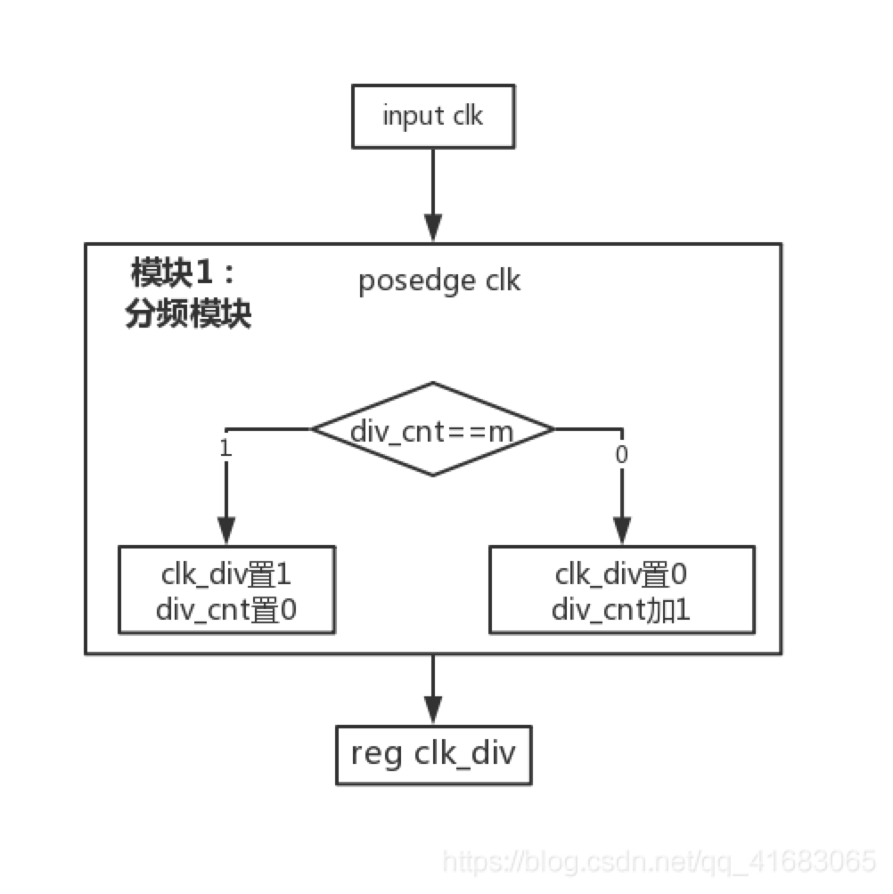

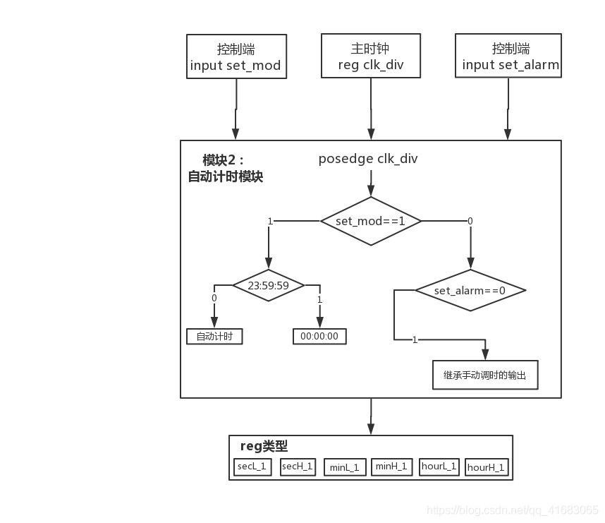

1. **电路实现（电路图或Verilog程序）**

Verilog程序代码：

module clock_074124(clk_50mhz,en,set,clr,swc,swr,a,b,c,d,e,f,g,ds

,s0,s1,m0,m1,h0,h1,data,s,m,h,s_in,m_in,h_in

);

output [3:0]s0,s1,m0,m1,h0,h1,data;

output [5:0]s,m,h,s_in,m_in,h_in;

input clk_50mhz,en,set,clr;

input [3:0]swc;

output a,b,c,d,e,f,g;

output [3:0]swr;

output [7:0]ds;

wire clk_1hz,clk_50hz;

wire [2:0]select;

wire [3:0]s0,s1,m0,m1,h0,h1,data,data_time,data_set,key,key_temp,swr,key0,key1,key2,key3,key4,key5,key6,key7;

wire [5:0]s,m,h,s_in,m_in,h_in,s_set,m_set,h_set,s_last,m_last,h_last;

wire [7:0]ds;

parameter zero=0;

frequency_divider_074124 (clk_50mhz,en,clk_1hz,,clk_50hz,);

jpsm_074124 (clk_50hz,set,swc,key_temp,swr,);

jpfd_074124 (clk_50hz,set,key_temp,key,flag);

shift_register_8_074124 (flag,set,key,,1'b0,1'b1,,,,,,,,,key0,key1,key2,key3,key4,key5,key6,key7);

multiplexers_074124(data_set,set,select,key0,key1,key2,key3,key4,key5,zero,zero);

decoder_074124 (key4,key5,h_set);

decoder_074124 (key2,key3,m_set);

decoder_074124 (key0,key1,s_set);

assign s_in=(set?s_set:s_last);

assign m_in=(set?m_set:m_last);

assign h_in=(set?h_set:h_last);

timecounter_074124 (en,clr,s,m,h,clk_50mhz,s_in,m_in,h_in);//实验用1hz

assign s_last=s;

assign m_last=m;

assign h_last=h;

encoder_074124 (s,s0,s1);

encoder_074124 (m,m0,m1);

encoder_074124 (h,h0,h1);

multiplexers_074124(data_time,en&(~set),select,s0,s1,m0,m1,h0,h1,zero,zero);

dtsm_074124(clk_50mhz,ds,select);//实验用1khz

assign data=(set?data_set:data_time);

led_g074124 (data,a,b,c,d,e,f,g);

endmodule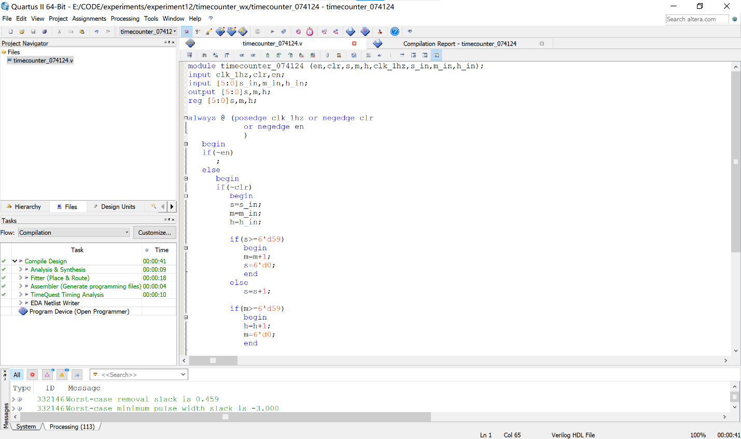

顶层模块