* Q1 - show all data of the faculty table

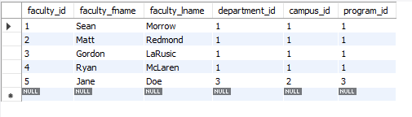

* Q2 show all data from the faculty table where first name contains the letter "n"

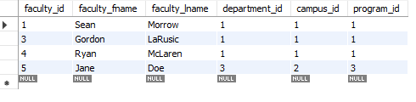

* Q3 using the faculty and campus table, show the faculty first name, last name, along with their campus name - HINT you will need a join

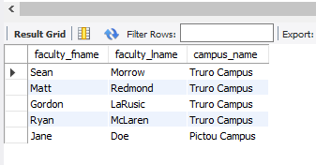

* Q4 modify Q4 to order results by faculty last name

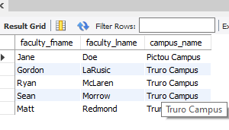

* Q5 show the faculty id, first name, lastname, campus name, and program name

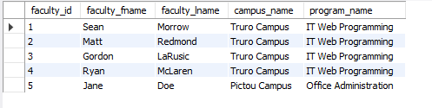

* Q6 modify the last query with the faculty first name and last concatenated under a column called Faculty Name

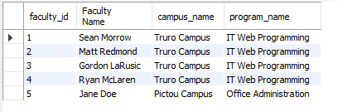

* Q7 using the join method, display a table that lists each course along with their program name  
  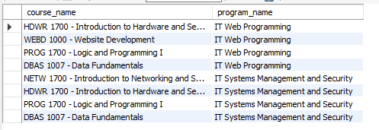

* Q8 using the department table, display the minimum, maximum and average budget  
  
* Q9 using the department table, display the sum of the deparmtent budgets  
  
* Q10 using the join method display the faculty last name, first name, their campus name, department name, and program name ordered by faculty last name, and then first name  
  