https://jennifer-rogers.github.io/web-project/final/index.html
https://jennifer-rogers.github.io/web-project/final/html/about.html
https://jennifer-rogers.github.io/web-project/final/html/products.html
https://jennifer-rogers.github.io/web-project/final/html/blog.html
https://jennifer-rogers.github.io/web-project/final/html/contacts.html
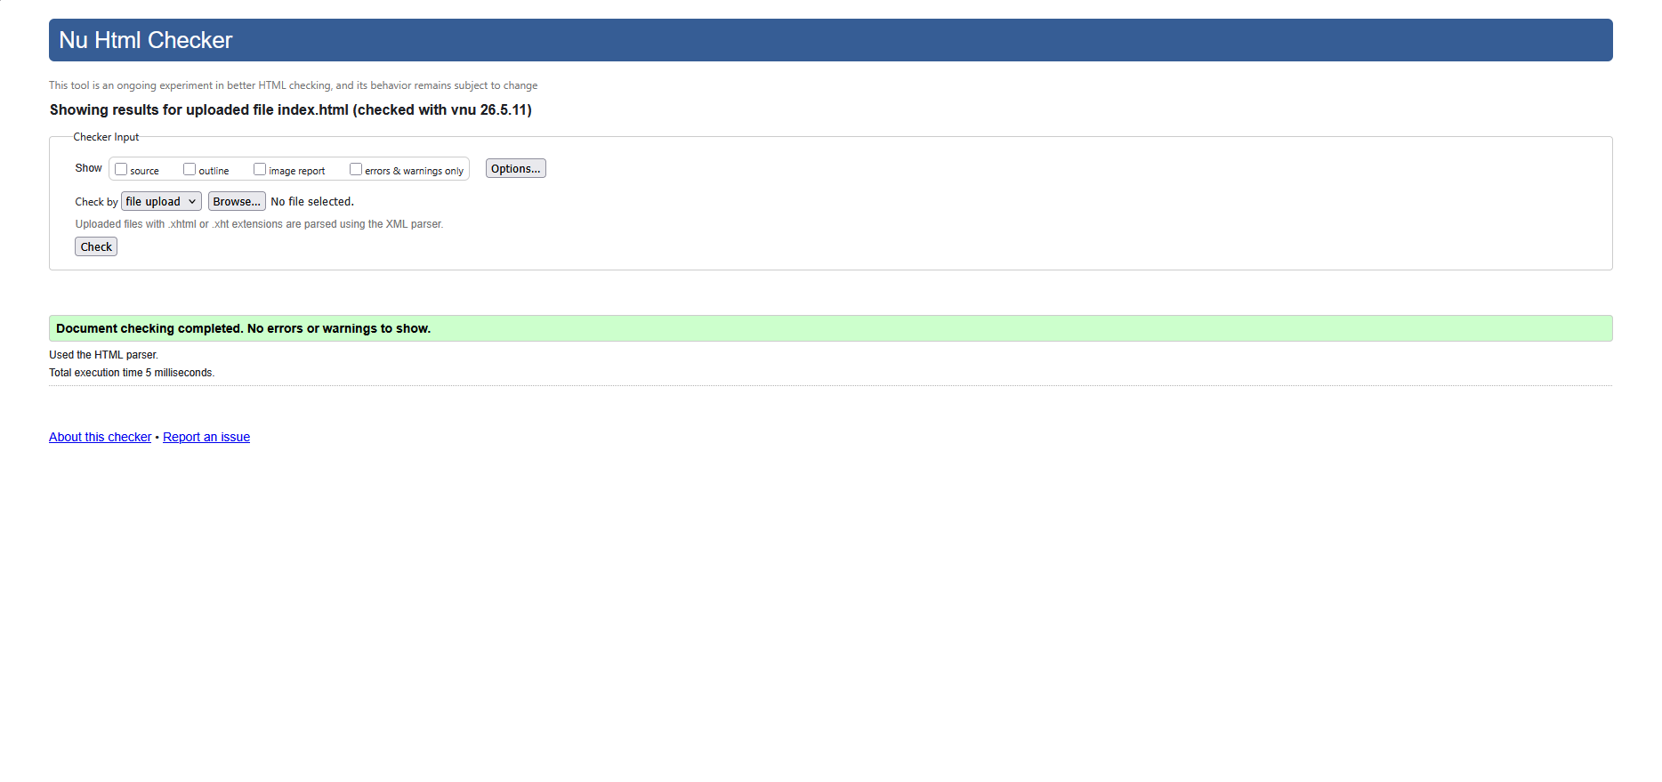
Figure 1. Index.html checked with W3C Code Validator
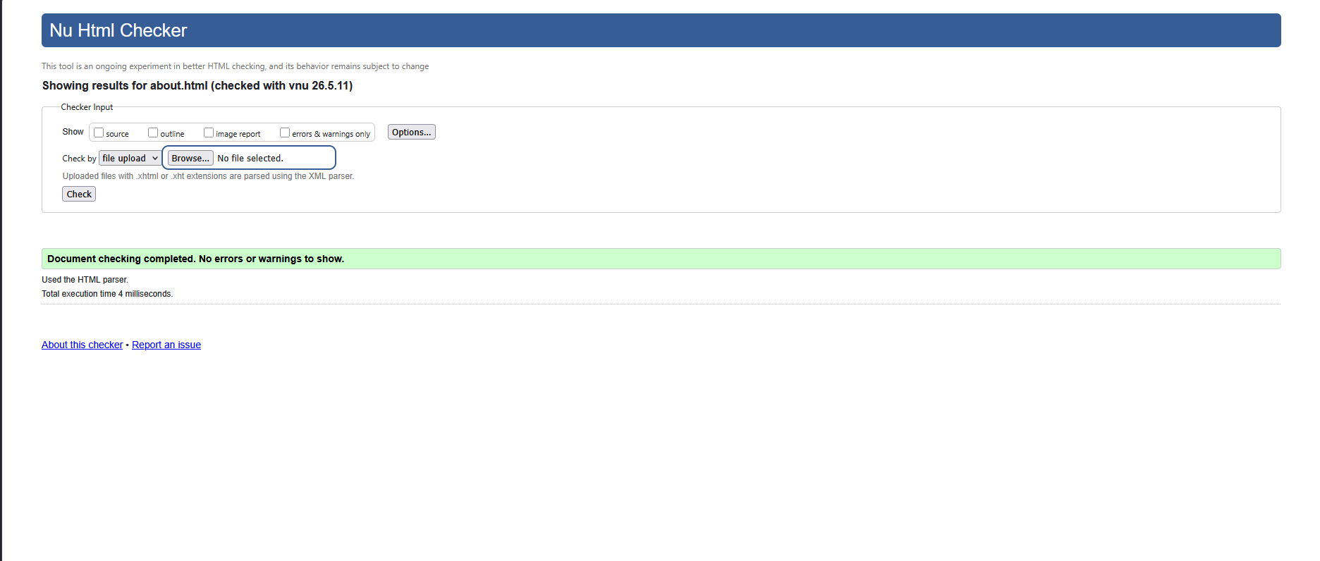
Figure 2. About.html checked with W3C Code Validator
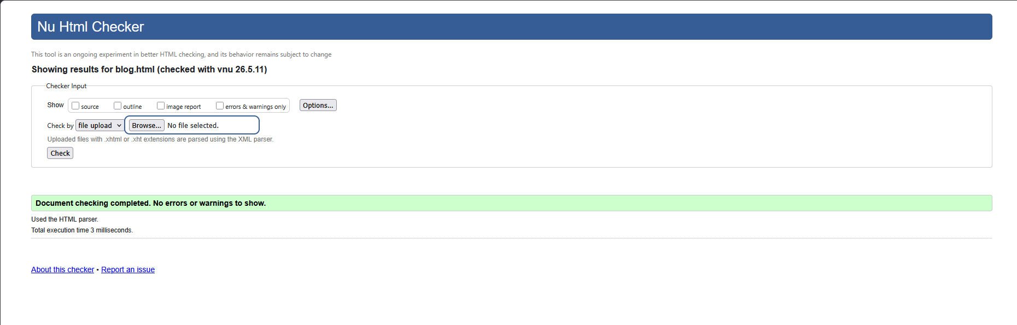
Figure 3. Blog.html checked with W3C Code Validator
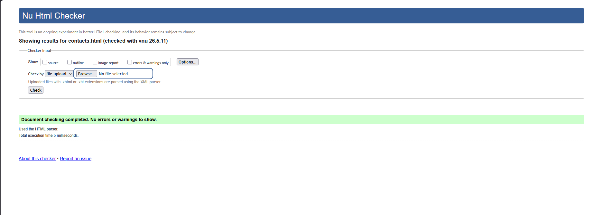
Figure 4. Contacts.html checked with W3C Code Validator
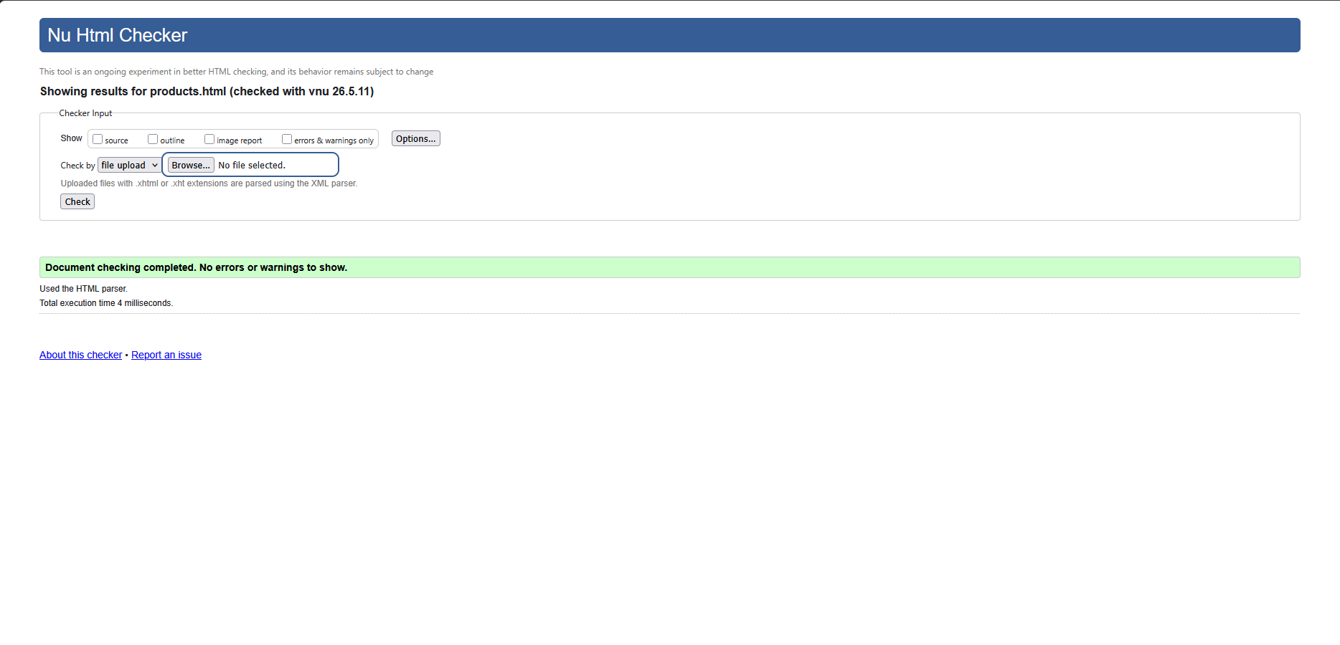
Figure 5. Product. html checked with W3C Code Validator
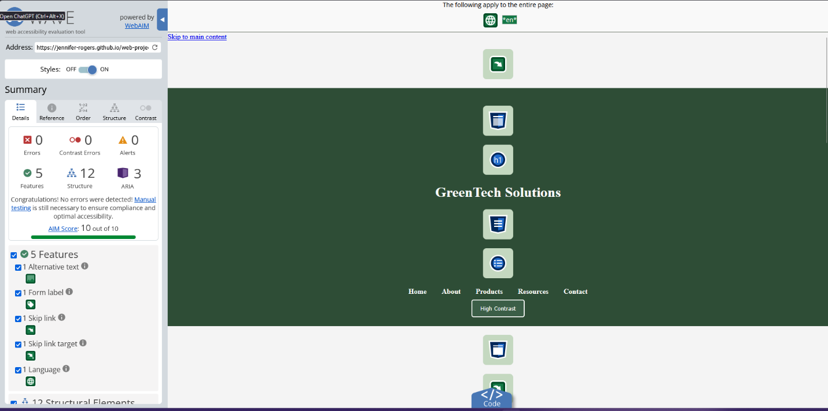
Figure 6. Index.html checked with WAVE Accessibility Evaluation Tools.
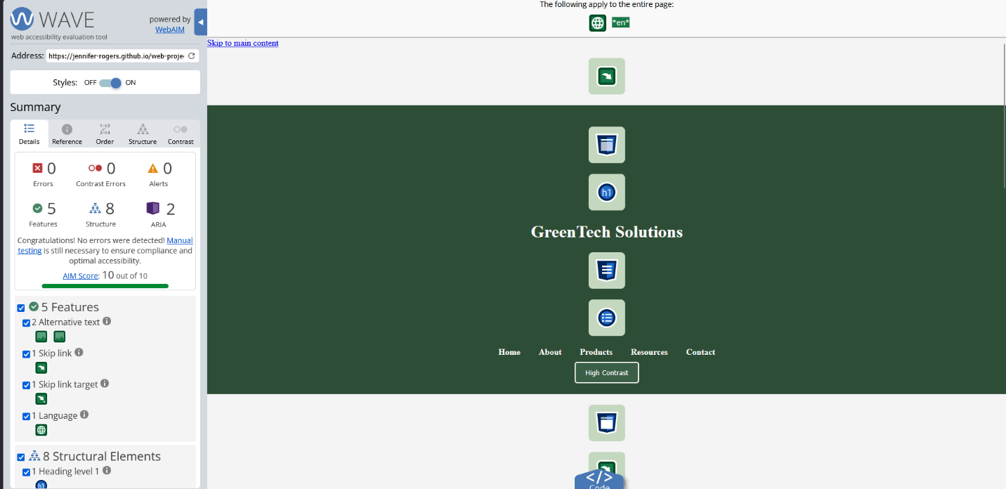
Figure 7. Figure 6. About.html checked with WAVE Accessibility Evaluation Tools.
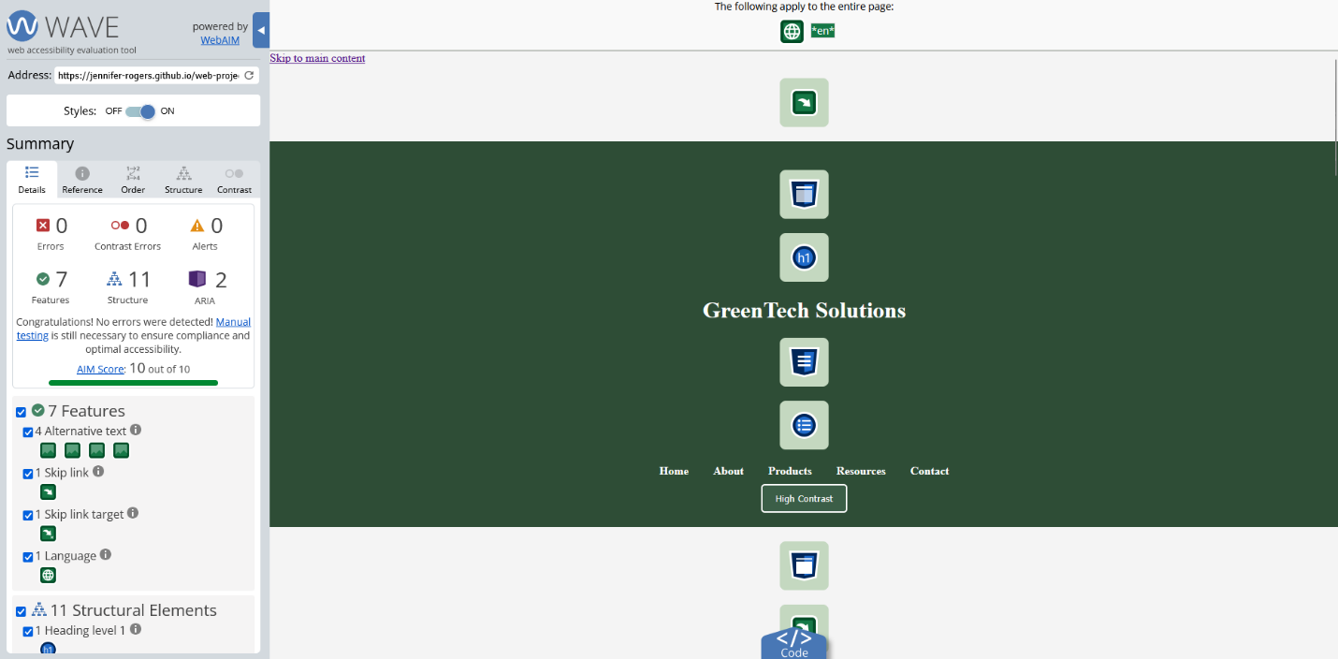
Figure 8. Figure 6. Blog.html checked with WAVE Accessibility Evaluation Tools.
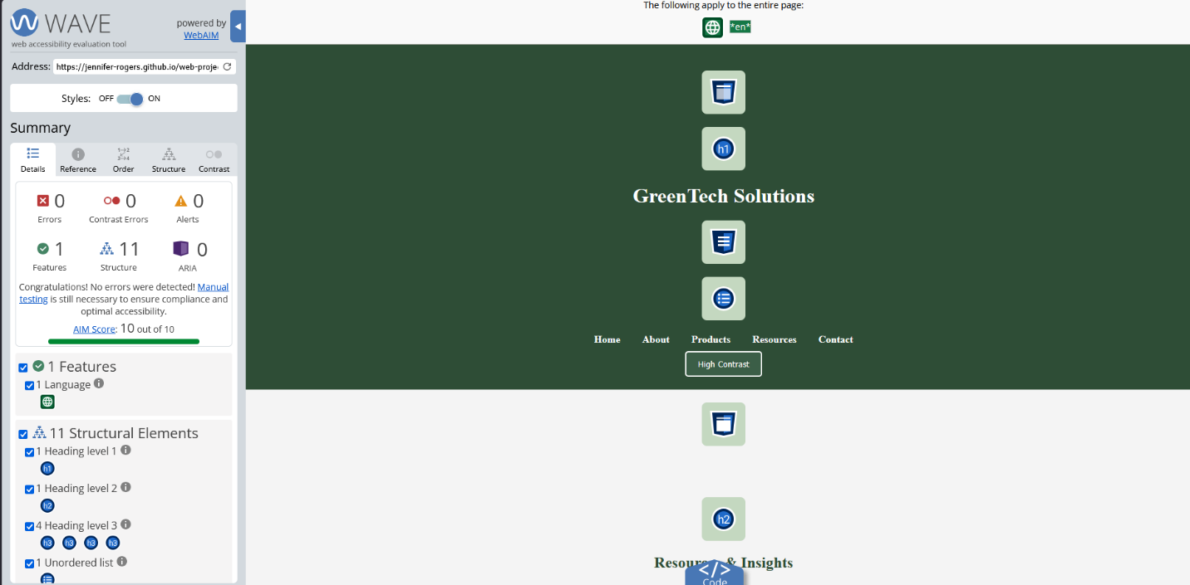
Figure 9. Contacts Figure 6. Contacts.html checked with WAVE Accessibility Evaluation Tools.
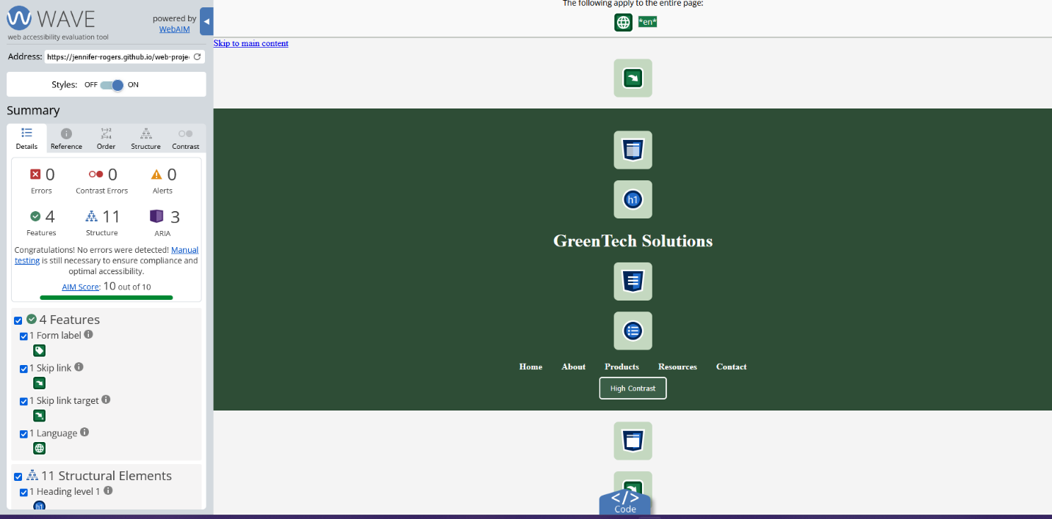
Figure 10. Figure 6. Products.html checked with WAVE Accessibility Evaluation Tools.

