The codes that show during the validation are all CSS-related, which we are not allowed to use. I have copied and pasted them here for review. As well as the working links.
https://jennifer-rogers.github.io/web-project/
https://jennifer-rogers.github.io/web-project/html/project2.html
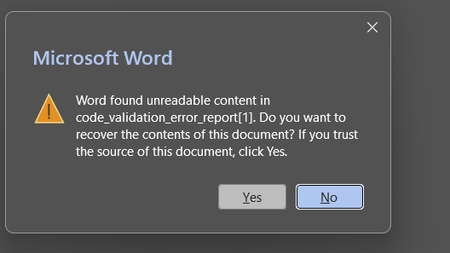
Figure 1. With the report copy and pasted canvas would not let report open.
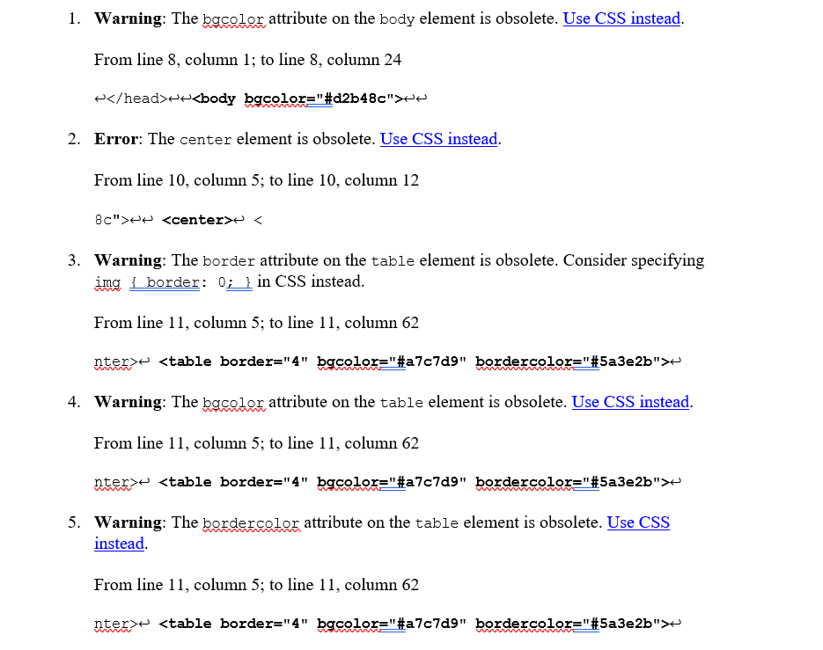
Figure 2. Begin Validation Report. All related to CSS not used.
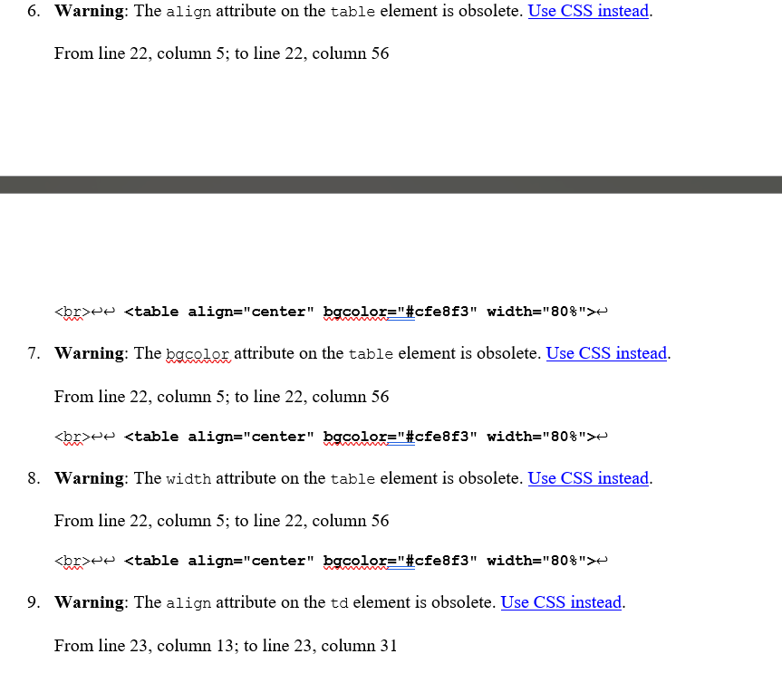
Figure 3. Validation Report cont. All CSS recommended.
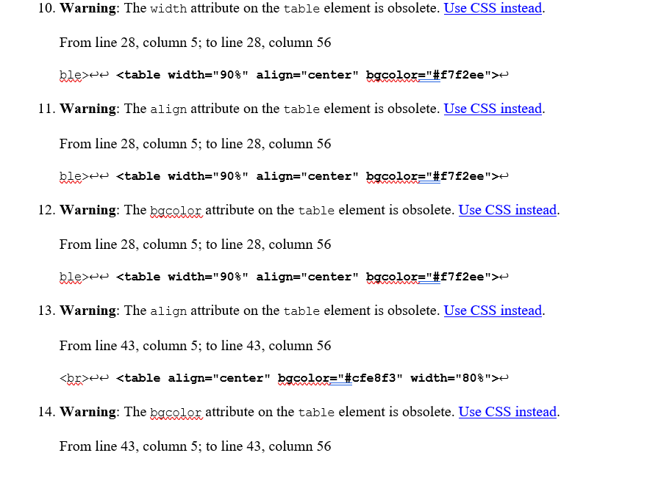
Figure 4. Validation Report cont. All CSS recommended.
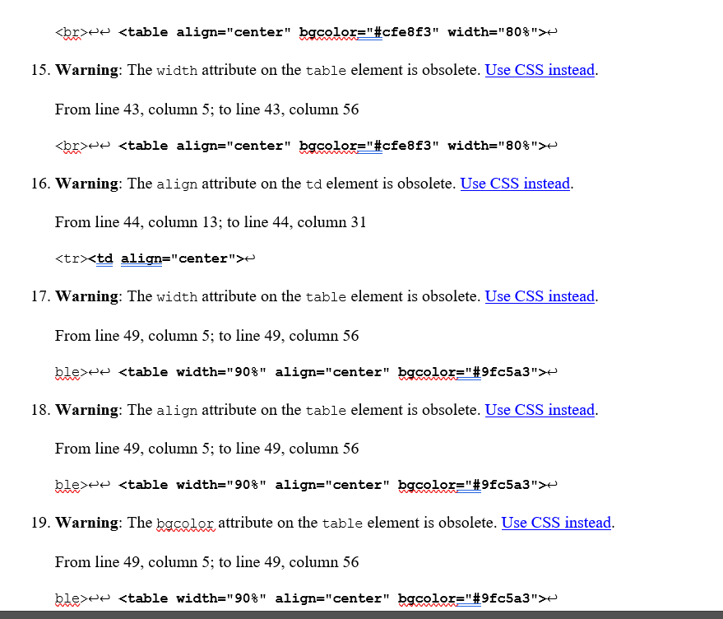
Figure 5. Validation Report cont. All CSS recommended.
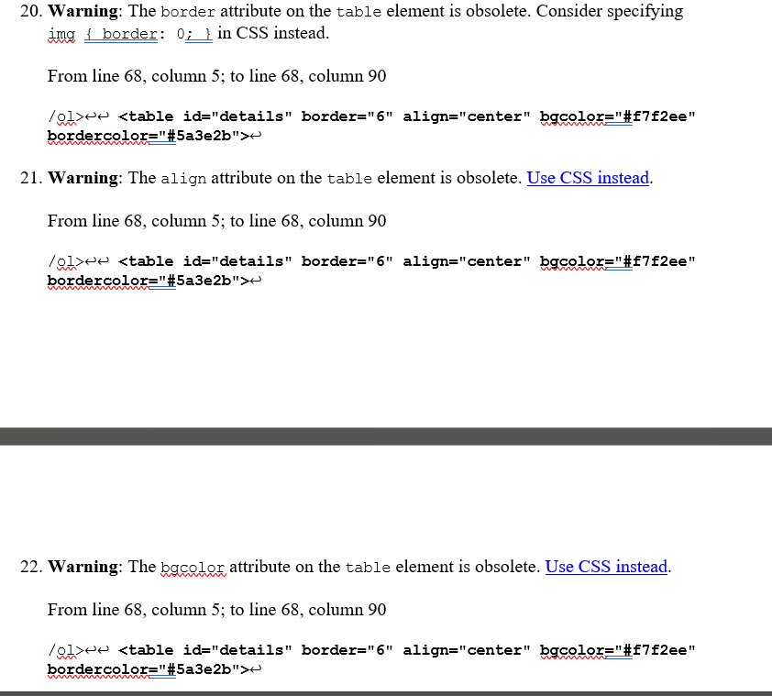
Figure 6. Validation Report cont. All CSS recommended.
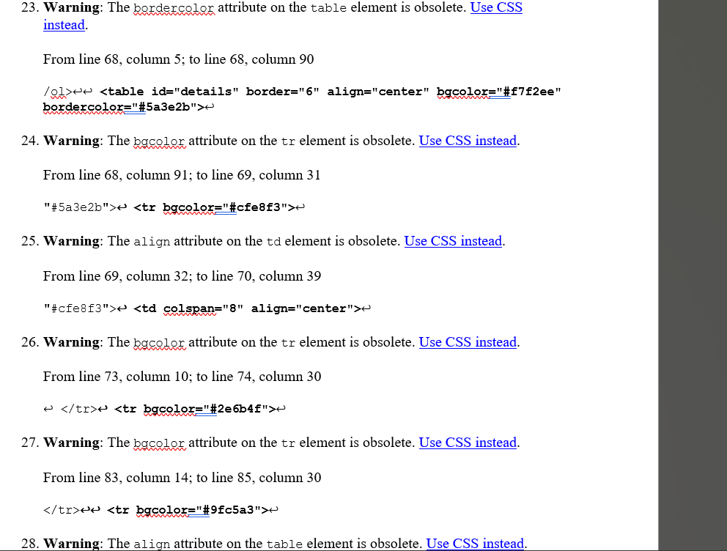
Figure 7. Validation Report cont. All CSS recommended.
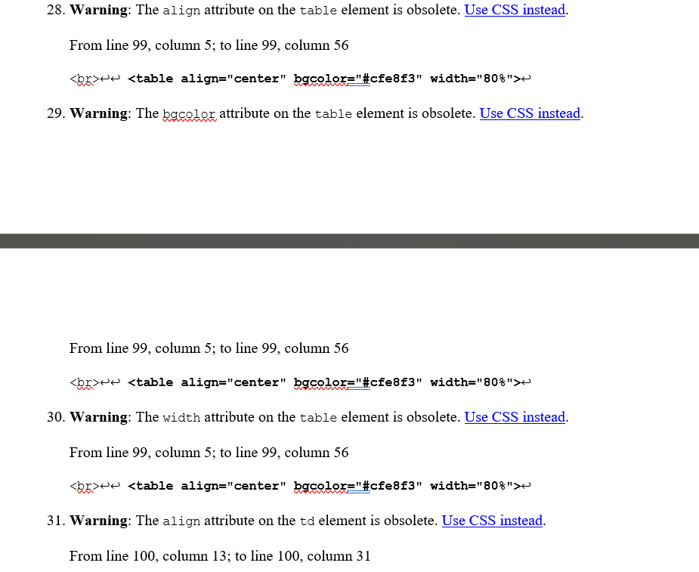
Figure 8. Validation Report cont. All CSS recommended.
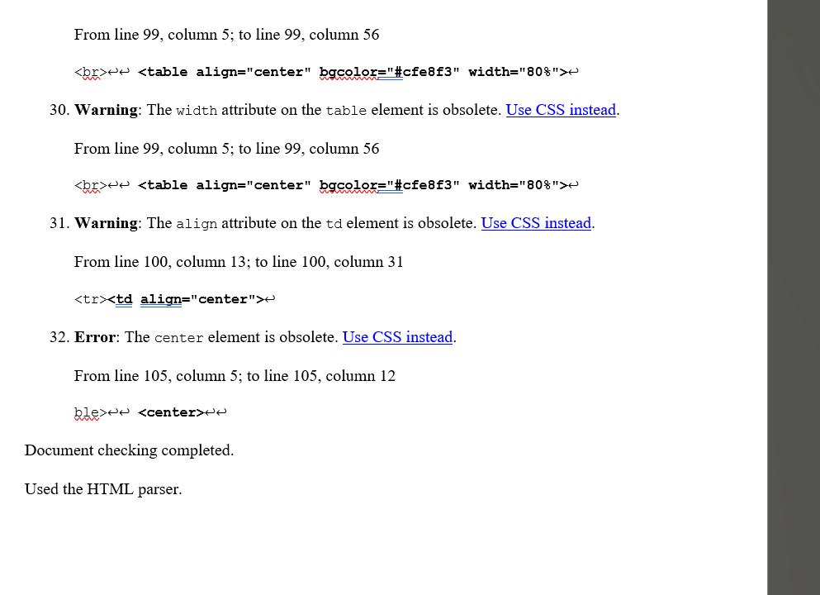
Figure 9. End of validation report.

