https://jennifer-rogers.github.io/web-project/
https://jennifer-rogers.github.io/web-project/html/project3.html
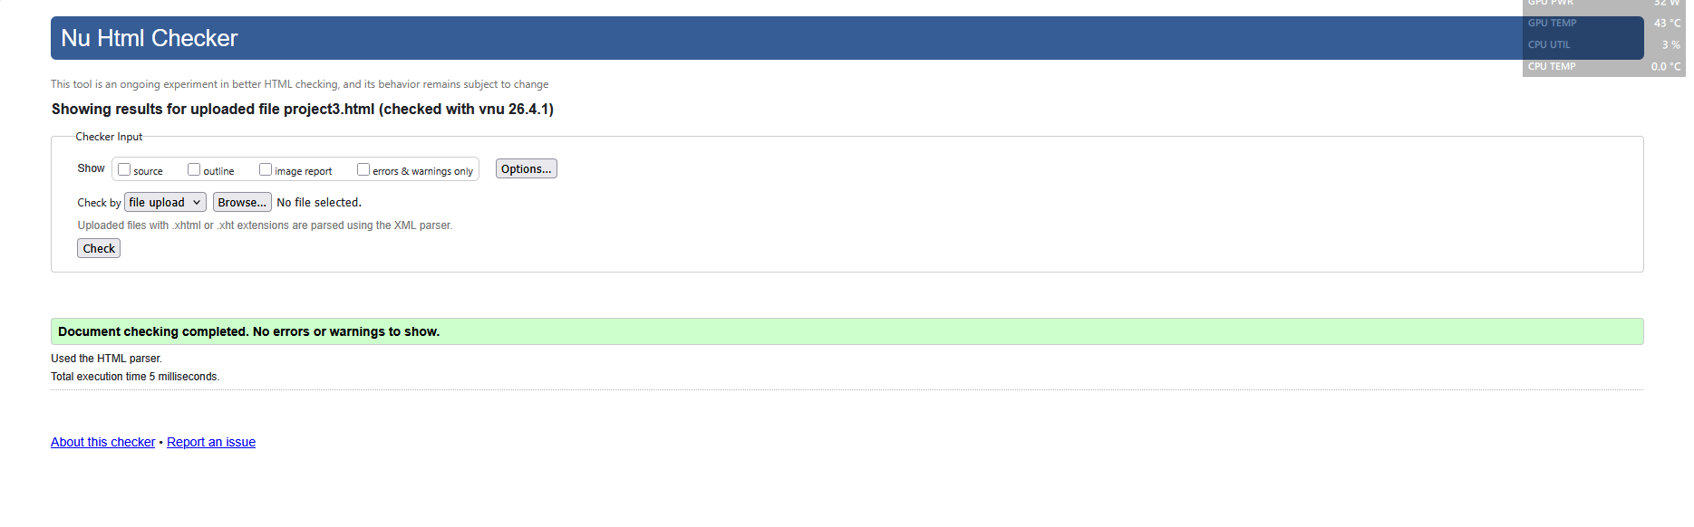
Figure 1. Code validator.
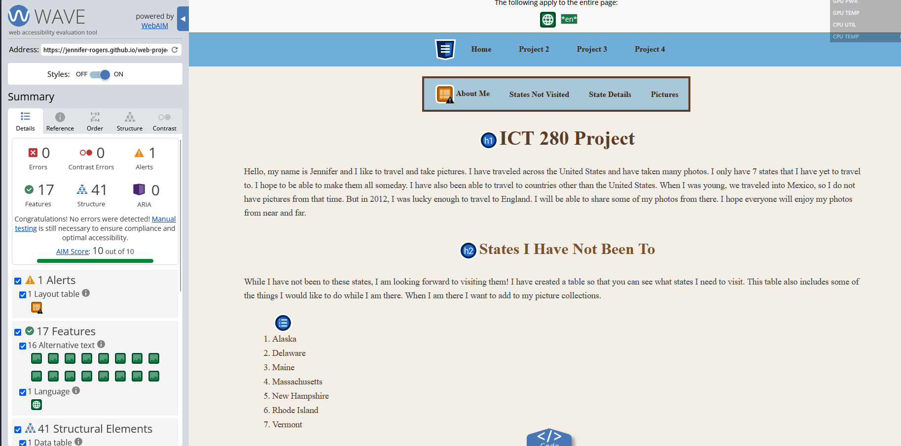
Figure 2. Web accessibility

