https://github.com/Jennifer-Rogers/web-project.git

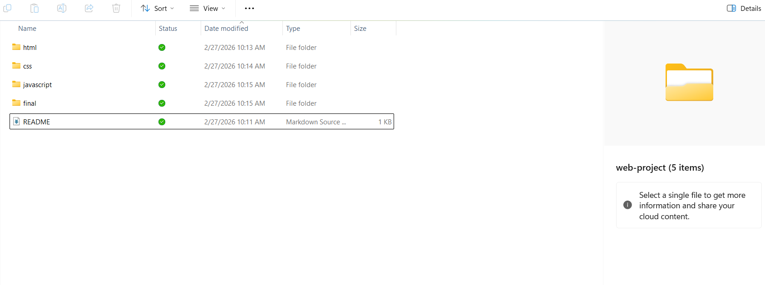
Figure 1. Local file structure.
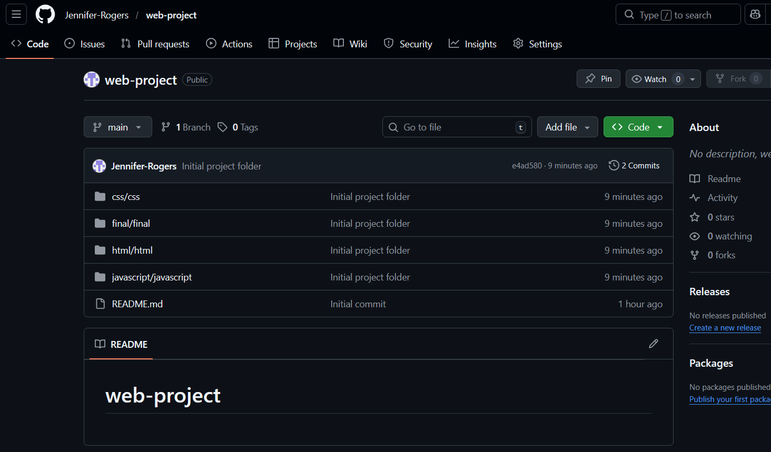
Figure 2. GitHub snip.

