https://jennifer-rogers.github.io/web-project/
https://jennifer-rogers.github.io/web-project/html/project4.html
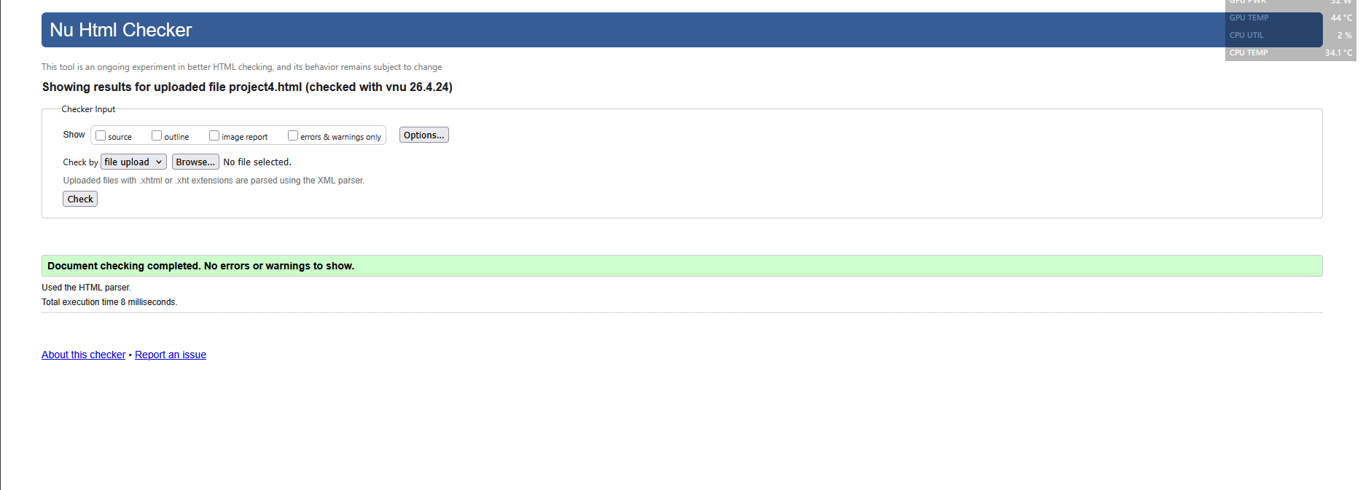
Figure 1. W3C Code Validator
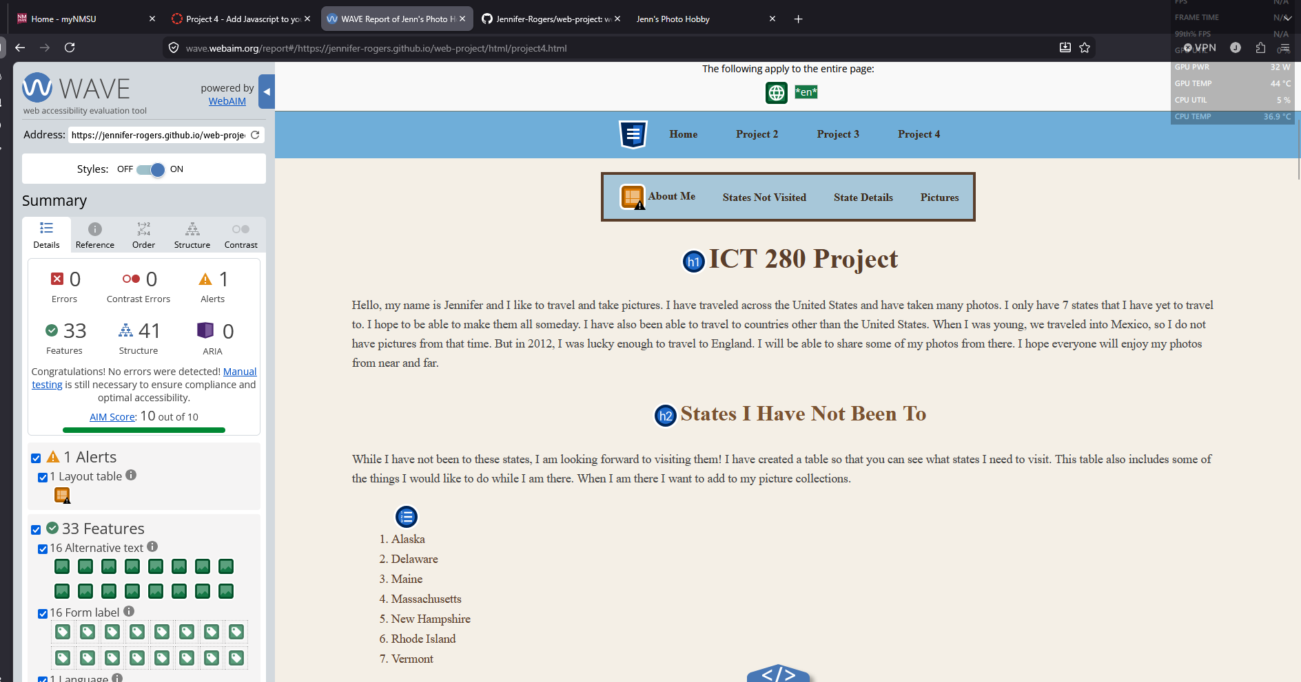
Figure 2. WAVE Accessibility Tool

