全民英檢初級寫作｜三格連環圖
GEPT Elementary Writing: 3-Picture Stories
49 topics · 每題含實用單字、實用句型、句型表、範文 · CEFR A1–A2
寫作公式 Story Formula
1 人物介紹 Who | S is a 年齡-year-old 職業.
2 喜好/個性 Hobby | S likes to V / S is adj.
3 圖一 Picture 1 | 時間 + 地點 + 動作 + 心情 because
4 圖二 Picture 2 | When S Ved, ... / S found that ...
5 圖三 Picture 3 | When S arrived ..., / As a result, ...
6 萬用結尾 Ending | S has learned an important lesson. / For him, it was the 最高級 ...
目錄 Contents
No. | 題目 | Title
主題 1｜睡過頭・上學遲到 Oversleeping & Being Late
1 | 上學遲到被罵篇 | Late for School
2 | 睡過頭遲到篇 | Justin Is Late Again
3 | 關掉鬧鐘睡過頭篇 | Anna Oversleeps
4 | 睡過頭錯過公車篇 | Missing the School Bus
主題 2｜倒楣的一天 Bad-Luck Days
5 | 倒楣的一天 | Mei-ling's Terrible Day
6 | 倒楣透頂的一天篇 | My Unlucky Day
主題 3｜校園生活與考試 School Life & Tests
7 | 熬夜打瞌睡考不及格篇 | Up All Night
8 | 作弊被抓篇 | Caught Cheating
9 | 上課偷玩手機篇 | Jack's Phone Games
10 | Tom 忘了帶作業篇 | Tom's Forgotten Homework
主題 4｜颱風天 Typhoon Days
11 | 颱風天篇 | The Typhoon
12 | 颱風天大賣場搶購篇 | Shopping Before the Typhoon
13 | 颱風停電篇 | The Typhoon Night
14 | 颱風假逛百貨篇 | A Typhoon Day Surprise
主題 5｜下雨天 Rainy Days
15 | 家庭出遊塞車篇 | A Family Trip in the Rain
16 | 雨天改變計畫篇 | A Rainy Saturday
17 | 淋雨感冒請病假 | Caught in the Rain
18 | 中秋烤肉遇雨篇 | A Rainy Mid-Autumn Barbecue
主題 6｜購物 Shopping
19 | 購物烏龍篇 | The Wrong Shoes
20 | 網購烏龍篇 | Online Shopping Gone Wrong
21 | 百貨公司特賣篇 | The Big Shoe Sale
22 | 打破花瓶篇 | The Broken Vase
23 | 百貨公司走失 | Lost in the Department Store
24 | 和媽媽逛市場篇 | A Trip to the Market
主題 7｜意外與安全 Accidents & Safety
25 | 滑手機出車禍篇 | Eyes on the Phone
26 | 邊走邊滑手機篇 | Eric and the Sleeping Dog
27 | 河邊溺水驚魂（第一人稱） | Saved from the River
主題 8｜公德心與鄰居 Manners & Neighbors
28 | 插隊被PO網公審篇 | Cutting in Line
29 | 鄰居派對噪音 | The Noisy Neighbor
30 | 樓上麻將聲篇 | Mahjong at Midnight
31 | 登山撿垃圾 | Cleaning Up the Mountain
主題 9｜寵物狗狗 Dogs & Pets
32 | 養寵物照顧篇 | Lucky the Dog
33 | 狗狗走失篇 | Where Is Lucky?
34 | 棒球打到狗篇 | The Angry Dog
主題 10｜生日派對 Birthday Parties
35 | 驚喜生日派對 | The Surprise Party
36 | 十五歲生日派對篇 | Betty's Birthday Party
主題 11｜出遊旅行 Trips & Outings
37 | 動物園校外教學 | A Day at the Zoo
38 | 動物園家庭日篇 | A Fun Day at the Zoo
39 | 海邊快樂的一天篇 | A Happy Day at the Beach
40 | 台東度假篇 | Summer Vacation in Taitung
41 | 高雄親戚家遊記篇 | My Trip to Kaohsiung
42 | 帶外國朋友遊台南篇 | My Weekend with Tom
43 | 單車環島（第一人稱） | Cycling Around Taiwan
主題 12｜工作與日常作息 Work & Daily Routines
44 | 週六加班忙碌篇 | A Busy Saturday
45 | 夜班Jeff的作息篇 | Jeff's Night Shift
46 | 放學後不得閒篇 | Alice's Busy Afternoon
47 | 暑假打工篇 | Ben's Summer Job
48 | 馬克夏日消暑篇 | Mark's Cool Summer
49 | 未來的計畫（未來式） | David's Future Plans
主題 1｜睡過頭・上學遲到 Oversleeping & Being Late
Topic 1｜上學遲到被罵篇 Late for School
題目：上週四 Ben 熬夜打電動、看漫畫，隔天週五睡過頭，趕不上公車，上學遲到被老師罵。
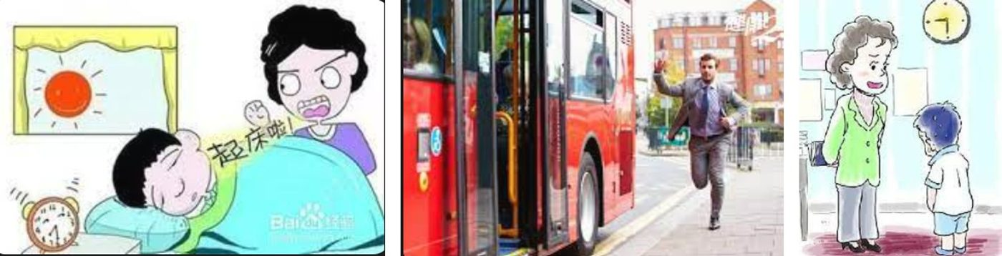
Useful Words & Phrases 實用單字片語
Word / Phrase | 中文 | Word / Phrase | 中文
junior high school student | 國中生 | upset | 沮喪
video games | 電動 | walk | 走路
comic books | 漫畫 | late for | 遲到
stayed up late | 熬夜 | math class | 數學課
slept in | 睡過頭 | yelled at | 對…吼
shouted | 大喊 | in front of | 在…面前
bus stop | 公車站 | said sorry | 道歉
as fast as he could | 盡全力快 | embarrassed | 丟臉
leaving | 正要開走 | lesson | 教訓
missed the bus | 錯過公車 | not to stay up late | 不熬夜
Useful Sentence Patterns 實用句型
1. S + likes + Ving and Ving
→ He likes playing video games and reading comic books.
2. The next morning, S + Ved, and S + Ved, "..."
→ The next morning, he slept in, and his mother shouted, "Get up!"
3. S + Ved to + 地方 + as fast as S could.
→ He ran to the bus stop as fast as he could.
4. S was + adj. + because + S had to V
→ He was upset because he had to walk to school.
5. S was so + adj. + that + 句子
→ The teacher was so angry that she yelled at him in front of the class.
6. S has learned an important lesson. From now on, S decides not to V
→ He has learned an important lesson. From now on, he decides not to stay up late again.
Sentence Patterns 句型表
Column 1｜元素 & 關鍵字 | Column 2｜句型 | Column 3｜例句
人物介紹 Who  junior high school student 國中生 | S + is + a + 職業. S + is + 年齡 + years old. | Ben is a junior high school student. He is 14 years old.
喜好 Hobby  video games 電動; comic books 漫畫 | S + likes + Ving and Ving | He likes playing video games and reading comic books.
背景 Background  stayed up late 熬夜 | Last + 時間, S stayed up late + Ving | Last Thursday, he stayed up late playing games and reading comic books.
圖一 動作  slept in 睡過頭; shouted 大喊 | The next morning, S + Ved, and S + Ved, "..." | The next morning, he slept in, and his mother shouted, "Get up!"
時間 Time  already 已經; eight o'clock | When S + Ved, it was already + 時間. | When he woke up, it was already eight o'clock.
圖二 動作  bus stop 公車站; as fast as he could 盡全力快 | S + Ved to + 地方 + as fast as S could. | He ran to the bus stop as fast as he could.
錯過 Missed  leaving 正要開走; missed the bus 錯過公車 | When S arrived at ..., S saw + 句子. It was too late, so S + Ved | When he arrived at the bus stop, he saw the bus was leaving. It was too late, so he missed the bus.
心情 + 原因  upset 沮喪; walk 走路 | S was + adj. + because + S had to V | He was upset because he had to walk to school.
圖三 時間地點  late for 遲到; math class 數學課 | When S arrived at ..., it was already + 時間. S was late for + N. | When he arrived at school, it was already nine o'clock. He was late for the math class.
被罵 Scolded  yelled at 對…吼; in front of 在…面前 | S was so + adj. + that + 句子 | The teacher was so angry that she yelled at him in front of the class.
道歉 Apology  said sorry 道歉; embarrassed 丟臉 | S said sorry to + 人 + and felt + adj. | He said sorry to his teacher and felt embarrassed.
萬用結尾  lesson 教訓; not to stay up late 不熬夜 | S has learned an important lesson. From now on, S decides not to V | He has learned an important lesson. From now on, he decides not to stay up late again.
範文 Model Essay (155 words)
Ben is a junior high school student. He is 14 years old. He likes playing video games and reading comic books. Last Thursday, he stayed up late playing games and reading comic books. The next morning, he slept in, and his mother shouted, "Get up!" When he woke up, it was already eight o'clock. He ran to the bus stop as fast as he could. When he arrived at the bus stop, he saw the bus was leaving. It was too late, so he missed the bus. He was upset because he had to walk to school. When he arrived at school, it was already nine o'clock. He was late for the math class. The teacher was so angry that she yelled at him in front of the class. He said sorry to his teacher and felt embarrassed. He has learned an important lesson. From now on, he decides not to stay up late again.
主題 1｜睡過頭・上學遲到 Oversleeping & Being Late
Topic 2｜睡過頭遲到篇 Justin Is Late Again
題目：Justin 因為睡過頭而上學遲到了。請根據這些圖片寫一篇約 50 字的短文。
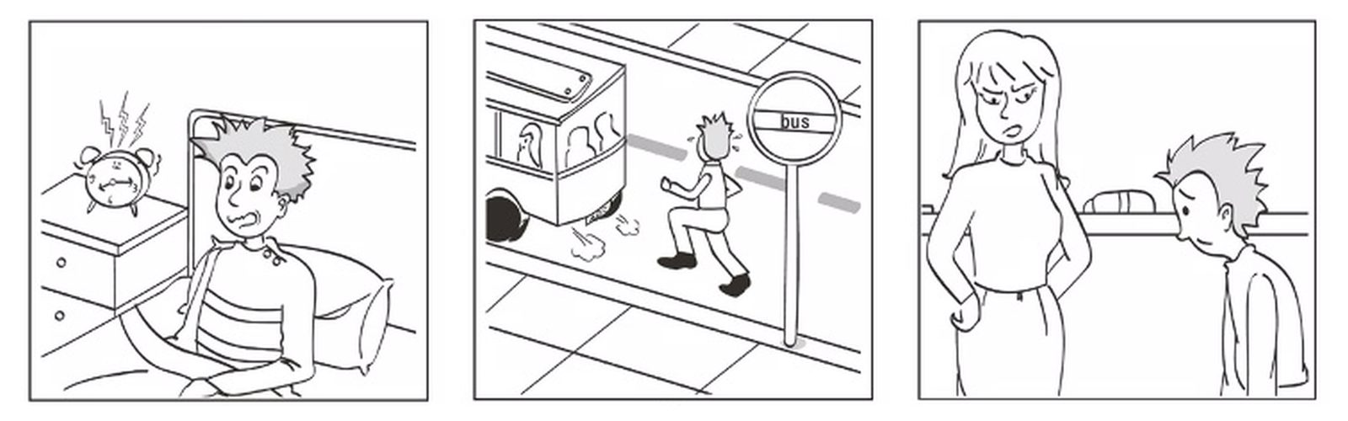
Useful Words & Phrases 實用單字片語
Word / Phrase | 中文 | Word / Phrase | 中文
junior high school student | 國中生 | bus stop | 公車站
lazy | 懶惰 | leaving | 正在離開
stays up late | 熬夜 | ran after | 追趕
alarm clock | 鬧鐘 | catch | 趕上
didn't hear | 沒聽到 | walk to school | 走路上學
woke up | 醒來 | arrived at | 抵達
shocked | 震驚 | angry | 生氣
late for school | 上學遲到 | on time | 準時
jumped out of bed | 跳下床 | sorry | 抱歉
got dressed | 穿衣服 | looked down | 低頭
had no time | 沒時間 | important lesson | 重要的教訓
breakfast | 早餐 | go to bed early | 早睡
Useful Sentence Patterns 實用句型
1. S is a + adj. + N, and S often + Vs.
→ He is a lazy boy, and he often stays up late at night.
2. When S + Ved, it was already + 時間.
→ When he woke up, it was already eight o'clock.
3. S had no time to V.
→ He had no time to eat breakfast.
4. S + Ved, but S couldn't V.
→ He ran after the bus, but he couldn't catch it.
5. S told + 人 + to V.
→ She told him to come to school on time in the future.
6. S has learned an important lesson: S should V.
→ He has learned an important lesson: he should go to bed early and get up on time.
Sentence Patterns 句型表
Column 1｜元素 & 關鍵字 | Column 2｜句型 | Column 3｜例句
人物介紹 Who  junior high school student 國中生 | S + is + a + 年齡-year-old + 職業. | Justin is a 13-year-old junior high school student.
個性 Personality  lazy 懶惰; stays up late 熬夜 | S is a + adj. + N, and S often + Vs. | He is a lazy boy, and he often stays up late at night.
圖一 時間 + 動作  alarm clock 鬧鐘; didn't hear 沒聽到 | This morning, S didn't V + N. | This morning, he didn't hear his alarm clock.
發現 Discovery  woke up 醒來; already 已經 | When S + Ved, it was already + 時間. | When he woke up, it was already eight o'clock.
心情 + 原因 Feeling  shocked 震驚; late for school 上學遲到 | S felt + adj. + because + 句子. | He felt shocked because he was going to be late for school.
動作 Action  jumped out of bed 跳下床; got dressed 穿衣服 | S + Ved and Ved + adv. | He jumped out of bed and got dressed quickly.
早餐 Breakfast  had no time 沒時間; breakfast 早餐 | S had no time to V. | He had no time to eat breakfast.
圖二 時間地點  bus stop 公車站; leaving 正在離開 | When S + Ved, S was already Ving. | When he ran to the bus stop, the bus was already leaving.
錯過 Missed  ran after 追趕; catch 趕上 | S + Ved, but S couldn't V. | He ran after the bus, but he couldn't catch it.
結果 Result  walk to school 走路上學 | In the end, S had to V. | In the end, he had to walk to school.
圖三 時間地點  arrived at 抵達; angry 生氣 | When S arrived at + 地點, S + Ved + adj. | When he arrived at school, his teacher looked very angry with him.
老師 Teacher  on time 準時 | S told + 人 + to V. | She told him to come to school on time in the future.
心情 Feeling  sorry 抱歉; looked down 低頭 | S felt + adj., so S + Ved. | Justin felt sorry, so he looked down and said nothing.
萬用結尾 Lesson  important lesson 重要的教訓; go to bed early 早睡 | S has learned an important lesson: S should V. | He has learned an important lesson: he should go to bed early and get up on time.
範文 Model Essay (148 words)
Justin is a 13-year-old junior high school student. He is a lazy boy, and he often stays up late at night. This morning, he didn't hear his alarm clock. When he woke up, it was already eight o'clock. He felt shocked because he was going to be late for school. He jumped out of bed and got dressed quickly. He had no time to eat breakfast. When he ran to the bus stop, the bus was already leaving. He ran after the bus, but he couldn't catch it. In the end, he had to walk to school. When he arrived at school, his teacher looked very angry with him. She told him to come to school on time in the future. Justin felt sorry, so he looked down and said nothing. He has learned an important lesson: he should go to bed early and get up on time.
主題 1｜睡過頭・上學遲到 Oversleeping & Being Late
Topic 3｜關掉鬧鐘睡過頭篇 Anna Oversleeps
題目：昨天早上 Anna 聽到鬧鐘的聲響後直接伸手關掉，因此睡過頭了。請根據以下的圖片寫一篇約 50 字的短文。注意：未依提示作答者，將予扣分。
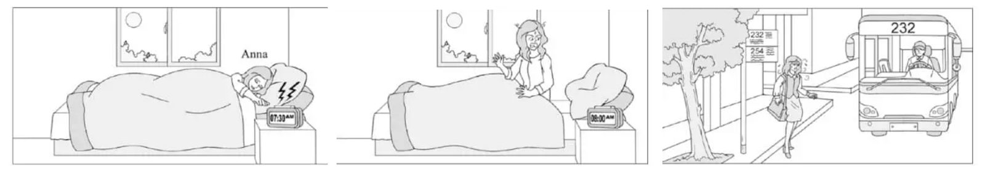
Useful Words & Phrases 實用單字片語
Word / Phrase | 中文 | Word / Phrase | 中文
senior high school student | 高中生 | in a hurry | 匆忙地
get up early | 早起 | ran out of | 跑出
morning | 早上 | have time | 有時間
yesterday morning | 昨天早上 | breakfast | 早餐
alarm clock | 鬧鐘 | bus stop | 公車站
rang | 響 | coming | 來了
turned off | 關掉 | hurried | 趕快
went back to sleep | 繼續睡 | catch | 趕上
woke up | 醒來 | tired | 累
overslept | 睡過頭 | sweating | 流汗
shocked | 震驚 | luckily | 幸運地
screamed | 尖叫 | just in time | 剛好及時
Useful Sentence Patterns 實用句型
1. S doesn't like to V because + 句子.
→ She doesn't like to get up early in the morning because she always feels sleepy.
2. S + Ved + N + and + Ved.
→ She turned it off and went back to sleep.
3. S was so + adj. + that + 句子.
→ She was so shocked that she screamed.
4. S didn't even have time to V.
→ She didn't even have time to eat breakfast.
5. S was + adj., and S was Ving.
→ She was very tired, and she was sweating a lot.
6. S has learned an important lesson. S will never V again.
→ She has learned an important lesson. She will never turn off her alarm clock and go back to sleep again.
Sentence Patterns 句型表
Column 1｜元素 & 關鍵字 | Column 2｜句型 | Column 3｜例句
人物介紹 Who  senior high school student 高中生 | S + is + a + 年齡-year-old + 職業. | Anna is a 16-year-old senior high school student.
習慣 Habit  get up early 早起; morning 早上 | S doesn't like to V because + 句子. | She doesn't like to get up early in the morning because she always feels sleepy.
圖一 時間地點  yesterday morning 昨天早上; alarm clock 鬧鐘; rang 響 | Yesterday morning, at + 時間, S + Ved. | Yesterday morning, at 7:30, her alarm clock rang.
圖一 動作  turned off 關掉; went back to sleep 繼續睡 | S + Ved + N + and + Ved. | She turned it off and went back to sleep.
圖二 時間  woke up 醒來; already 已經 | When S + Ved, it was already + 時間. | When she woke up again, it was already 8:00.
發現 Discovery  overslept 睡過頭 | S found that + 句子. | She found that she had overslept.
心情 Feeling  shocked 震驚; screamed 尖叫 | S was so + adj. + that + 句子. | She was so shocked that she screamed.
動作 Action  in a hurry 匆忙地; ran out of 跑出 | S + Ved + in a hurry and Ved. | She got dressed in a hurry and ran out of the house.
早餐 Breakfast  have time 有時間; breakfast 早餐 | S didn't even have time to V. | She didn't even have time to eat breakfast.
圖三 時間地點  bus stop 公車站; coming 來了 | When S arrived at + 地點, S saw that + 句子. | When she arrived at the bus stop, she saw that Bus 232 was coming.
動作 Action  hurried 趕快; catch 趕上 | S + Ved as fast as S could to V. | She hurried as fast as she could to catch it.
心情 Feeling  tired 累; sweating 流汗 | S was + adj., and S was Ving. | She was very tired, and she was sweating a lot.
結局 Ending  luckily 幸運地; just in time 剛好及時 | Luckily, S + Ved + just in time. | Luckily, she got on the bus just in time.
萬用結尾 Lesson  never 絕不; again 再 | S has learned an important lesson. S will never V again. | She has learned an important lesson. She will never turn off her alarm clock and go back to sleep again.
範文 Model Essay (147 words)
Anna is a 16-year-old senior high school student. She doesn't like to get up early in the morning because she always feels sleepy. Yesterday morning, at 7:30, her alarm clock rang. She turned it off and went back to sleep. When she woke up again, it was already 8:00. She found that she had overslept. She was so shocked that she screamed. She got dressed in a hurry and ran out of the house. She didn't even have time to eat breakfast. When she arrived at the bus stop, she saw that Bus 232 was coming. She hurried as fast as she could to catch it. She was very tired, and she was sweating a lot. Luckily, she got on the bus just in time. She has learned an important lesson. She will never turn off her alarm clock and go back to sleep again.
主題 1｜睡過頭・上學遲到 Oversleeping & Being Late
Topic 4｜睡過頭錯過公車篇 Missing the School Bus
題目：請依據下面的圖片，寫一篇約 50 字的短文，描寫圖片的情節。
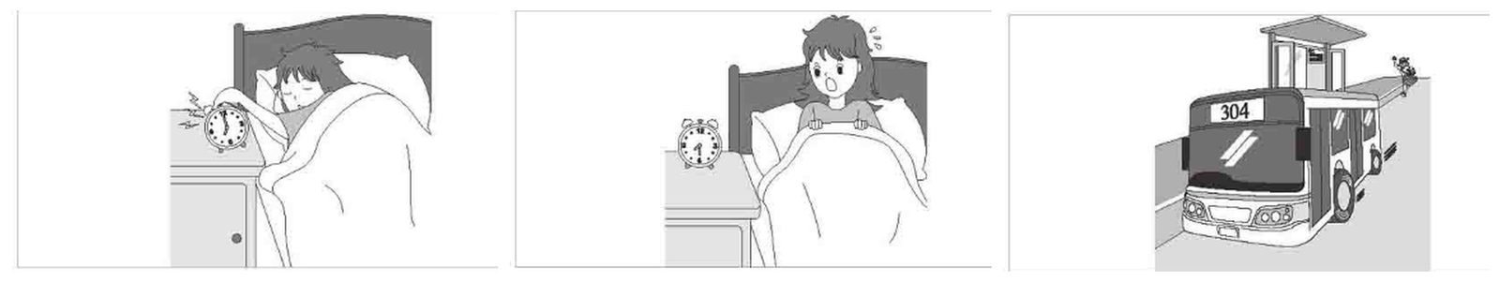
Useful Words & Phrases 實用單字片語
Word / Phrase | 中文 | Word / Phrase | 中文
junior high school student | 國中生 | jumped out of bed | 跳下床
kind | 善良的 | got dressed | 穿好衣服
stays up late | 熬夜 | bus stop | 公車站
computer games | 電腦遊戲 | leaving | 正要離開
midnight | 午夜 | ran after | 追趕
alarm clock | 鬧鐘 | shouted | 大喊
rang | 響了 | driver | 司機
sleepy | 想睡的 | walk to school | 走路上學
turned it off | 關掉 | late for school | 上學遲到
went back to sleep | 又睡著 | upset | 沮喪的
woke up | 醒來 | important lesson | 重要的教訓
shocked | 震驚的 | school nights | 上學日前一晚
school bus | 校車
Useful Sentence Patterns 實用句型
1. S is a + adj. + N, but S often + Vs
→ She is a kind girl, but she often stays up late.
2. At + 時間 + this morning, S + Ved.
→ At 6:30 this morning, her alarm clock rang.
3. When S + Ved, it was already + 時間.
→ When she woke up again, it was already 7:30.
4. When S arrived at + 地點, S found that + 句子
→ When she arrived at the bus stop, she found that Bus 304 was already leaving.
5. However, S didn't V, so S had to V
→ However, the driver didn't see her, so she had to walk to school.
6. S has learned an important lesson: 句子
→ She has learned an important lesson: never stay up late on school nights.
Sentence Patterns 句型表
Column 1｜元素 & 關鍵字 | Column 2｜句型 | Column 3｜例句
人物介紹 Who  junior high school student 國中生 | S + is + a + 年齡-year-old + 職業. | Amy is a 13-year-old junior high school student.
個性 Personality  kind 善良的; stays up late 熬夜 | S is a + adj. + N, but S often + Vs | She is a kind girl, but she often stays up late.
前因 Cause  computer games 電腦遊戲; midnight 午夜 | Last night, S + Ved until + 時間. | Last night, she played computer games until midnight.
圖一 時間地點  alarm clock 鬧鐘; rang 響了 | At + 時間 + this morning, S + Ved. | At 6:30 this morning, her alarm clock rang.
圖一 動作  sleepy 想睡的; turned it off 關掉; went back to sleep 又睡著 | S was so + adj. + that + 句子 | She was so sleepy that she turned it off and went back to sleep.
圖二 時間  woke up 醒來; already 已經 | When S + Ved, it was already + 時間. | When she woke up again, it was already 7:30.
心情 + 原因 Feeling  shocked 震驚的; school bus 校車 | S felt + adj. + because + 句子 | She felt shocked because her school bus came at 7:40.
動作 Action  jumped out of bed 跳下床; got dressed 穿好衣服 | S + Ved and Ved as + adv. + as possible. | She jumped out of bed and got dressed as quickly as possible.
圖三 時間地點  bus stop 公車站; leaving 正要離開 | When S arrived at + 地點, S found that + 句子 | When she arrived at the bus stop, she found that Bus 304 was already leaving.
動作 Action  ran after 追趕; shouted 大喊 | S + Ved and Ved, "..." | She ran after the bus and shouted, "Wait for me!"
結局 Ending  driver 司機; walk to school 走路上學 | However, S didn't V, so S had to V | However, the driver didn't see her, so she had to walk to school.
心情 Feeling  late for school 上學遲到; upset 沮喪的 | As a result, S was + adj., and S felt + adj. | As a result, she was late for school, and she felt very upset.
萬用結尾 Lesson  important lesson 重要的教訓; school nights 上學日前一晚 | S has learned an important lesson: 句子 | She has learned an important lesson: never stay up late on school nights.
範文 Model Essay (147 words)
Amy is a 13-year-old junior high school student. She is a kind girl, but she often stays up late. Last night, she played computer games until midnight. At 6:30 this morning, her alarm clock rang. She was so sleepy that she turned it off and went back to sleep. When she woke up again, it was already 7:30. She felt shocked because her school bus came at 7:40. She jumped out of bed and got dressed as quickly as possible. When she arrived at the bus stop, she found that Bus 304 was already leaving. She ran after the bus and shouted, "Wait for me!" However, the driver didn't see her, so she had to walk to school. As a result, she was late for school, and she felt very upset. She has learned an important lesson: never stay up late on school nights.
主題 2｜倒楣的一天 Bad-Luck Days
Topic 5｜倒楣的一天 Mei-ling's Terrible Day
題目：美鈴 (Mei-ling) 今天早上睡太晚，沒趕上校車，接著在學校也不怎麼順利，放學回到家門口時，又發現自己進不了門。請依據下面的圖片，寫一篇短文，描述美鈴倒楣的一天。
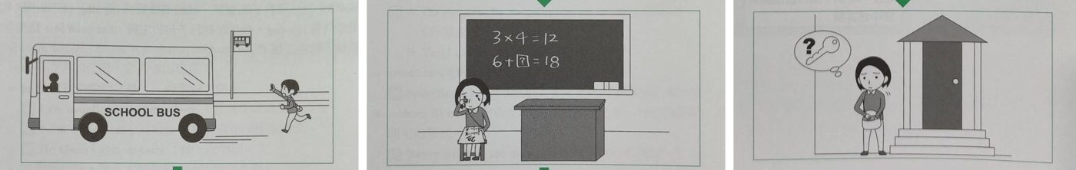
Useful Words & Phrases 實用單字片語
Word / Phrase | 中文 | Word / Phrase | 中文
elementary school student | 小學生 | sad | 難過
nice | 友善 | study harder | 更用功
gets up late | 晚起 | after school | 放學後
woke up too late | 太晚起床 | looked for | 尋找
school bus | 校車 | key | 鑰匙
missed | 錯過 | forgot to bring | 忘了帶
walk | 走路 | get into | 進入
took a math test | 考數學 | wait outside | 在外面等
didn't do well | 考不好 | dark | 天黑
nervous | 緊張 | cold | 冷
easy questions | 簡單題 | bad things happen in threes | 禍不單行
bad grade | 壞成績
Useful Sentence Patterns 實用句型
1. S is a + adj. + N, but S often + Vs
→ She is a nice girl, but she often gets up late.
2. S + Ved, so S had to V
→ She missed the bus, so she had to walk to school.
3. S was too + adj. + to V
→ She was too nervous to answer even the easy questions.
4. After school, when S got home, S + Ved
→ After school, when she got home, she looked for her key in her bag.
5. S couldn't V, so S had to V
→ She couldn't get into the house, so she had to wait outside for her mother.
6. S thought to herself, "..."
→ She thought to herself, "Bad things happen in threes. What a terrible day!"
Sentence Patterns 句型表
Column 1｜元素 & 關鍵字 | Column 2｜句型 | Column 3｜例句
人物介紹 Who  elementary school student 小學生 | S + is + a + 年齡-year-old + 職業. | Mei-ling is a 12-year-old elementary school student.
個性 Personality  nice 友善; gets up late 晚起 | S is a + adj. + N, but S often + Vs | She is a nice girl, but she often gets up late.
圖一 時間 + 動作  woke up too late 太晚起床; school bus 校車 | This morning, S + Ved. When S + Ved, S was already Ving. | This morning, she woke up too late. When she ran to the bus stop, the school bus was already leaving.
錯過 Missed  missed 錯過; walk 走路 | S + Ved, so S had to V | She missed the bus, so she had to walk to school.
圖二 學校  took a math test 考數學; didn't do well 考不好 | At school, S + Ved, but S didn't do well on it. | At school, she took a math test, but she didn't do well on it.
細節 Details  nervous 緊張; easy questions 簡單題 | S was too + adj. + to V | She was too nervous to answer even the easy questions.
心情 Feeling  bad grade 壞成績; sad 難過 | S got + N, and S felt + adj. | She got a bad grade, and she felt very sad.
老師 Teacher  study harder 更用功 | S told + 人 + to V | Her teacher told her to study harder for the next test.
圖三 時間地點  after school 放學後; looked for 尋找; key 鑰匙 | After school, when S got home, S + Ved | After school, when she got home, she looked for her key in her bag.
發現 Discovery  forgot to bring 忘了帶 | S found that + 句子 | She found that she forgot to bring the key with her.
結果 Result  get into 進入; wait outside 在外面等 | S couldn't V, so S had to V | She couldn't get into the house, so she had to wait outside for her mother.
天氣 Weather  dark 天黑; cold 冷 | It was + adj. and adj. | It was dark and cold outside.
萬用結尾  bad things happen in threes 禍不單行 | S thought to herself, "..." | She thought to herself, "Bad things happen in threes. What a terrible day!"
範文 Model Essay (153 words)
Mei-ling is a 12-year-old elementary school student. She is a nice girl, but she often gets up late. This morning, she woke up too late. When she ran to the bus stop, the school bus was already leaving. She missed the bus, so she had to walk to school. At school, she took a math test, but she didn't do well on it. She was too nervous to answer even the easy questions. She got a bad grade, and she felt very sad. Her teacher told her to study harder for the next test. After school, when she got home, she looked for her key in her bag. She found that she forgot to bring the key with her. She couldn't get into the house, so she had to wait outside for her mother. It was dark and cold outside. She thought to herself, "Bad things happen in threes. What a terrible day!"
主題 2｜倒楣的一天 Bad-Luck Days
Topic 6｜倒楣透頂的一天篇 My Unlucky Day
題目：昨天你一整天的運氣都很壞，請根據圖片以約 50 字敘述其中過程。
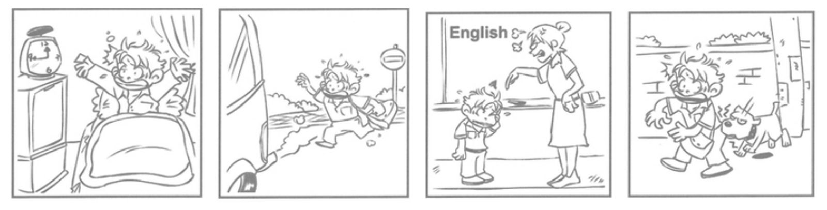
Useful Words & Phrases 實用單字片語
Word / Phrase | 中文 | Word / Phrase | 中文
junior high school student | 國中生 | English teacher | 英文老師
friendly | 友善的 | angry | 生氣的
set my alarm clock | 設定鬧鐘 | pointed at | 指著
woke up | 醒來 | scolded | 責罵
shocked | 震驚的 | embarrassed | 丟臉的
late for school | 上學遲到 | almost cried | 差點哭了
grabbed | 抓起 | on my way home | 在回家的路上
bus stop | 公車站 | ran after | 追趕
was already leaving | 已經要開走了 | barked at | 對…吠叫
waved | 揮手 | bit | 咬
shouted | 大喊 | as fast as I could | 盡全力快跑
driver | 司機 | the worst | 最糟的
Useful Sentence Patterns 實用句型
1. S am a + adj. + N, but S often + V
→ I am a friendly boy, but I often forget to set my alarm clock.
2. S felt + adj. + because + 句子
→ I felt shocked because I was going to be late for school.
3. When S got there, N was already Ving.
→ When I got there, the bus was already leaving.
4. S + Ved at + 人 and Ved + 人 + for + V-ing.
→ She pointed at me and scolded me for being late.
5. After school, on S's way home, S + Ved
→ After school, on my way home, an angry dog suddenly ran after me.
6. For S, it was the 最高級 + N + of + N.
→ For me, it was the worst day of my life.
Sentence Patterns 句型表
Column 1｜元素 & 關鍵字 | Column 2｜句型 | Column 3｜例句
人物介紹 Who  junior high school student 國中生 | S + am + a + 年齡-year-old + 職業. | I am a 13-year-old junior high school student.
個性 Personality  friendly 友善的; set my alarm clock 設定鬧鐘 | S am a + adj. + N, but S often + V | I am a friendly boy, but I often forget to set my alarm clock.
圖一 時間  woke up 醒來; already 已經 | Yesterday morning, when S woke up, it was already + 時間. | Yesterday morning, when I woke up, it was already nine o'clock.
心情 + 原因 Feeling  shocked 震驚的; late for school 上學遲到 | S felt + adj. + because + 句子 | I felt shocked because I was going to be late for school.
圖二 動作  grabbed 抓起; bus stop 公車站 | S + Ved + N and ran to + 地點. | I quickly grabbed my school bag and ran to the bus stop.
錯過 Missed  was already leaving 已經要開走了 | When S got there, N was already Ving. | When I got there, the bus was already leaving.
細節 Details  waved 揮手; shouted 大喊; driver 司機 | S + Ved and Ved, but S didn't V | I waved and shouted, but the driver didn't stop.
圖三 時間地點  English teacher 英文老師; angry 生氣的 | When S arrived at + 地點, S was very + adj. with + 人. | When I arrived at school, my English teacher was very angry with me.
圖三 動作  pointed at 指著; scolded 責罵 | S + Ved at + 人 and Ved + 人 + for + V-ing. | She pointed at me and scolded me for being late.
心情 Feeling  embarrassed 丟臉的; almost cried 差點哭了 | S was so + adj. + that + 句子 | I was so embarrassed that I almost cried.
圖四 時間地點  on my way home 在回家的路上; ran after 追趕 | After school, on S's way home, S + Ved | After school, on my way home, an angry dog suddenly ran after me.
結局 Ending  barked at 對…吠叫; bit 咬; as fast as I could 盡全力快跑 | S + Ved at + 人 and almost Ved + N, so S + Ved as + adv. + as S could. | It barked at me and almost bit my leg, so I ran home as fast as I could.
萬用結尾 Lesson  the worst 最糟的 | For S, it was the 最高級 + N + of + N. | For me, it was the worst day of my life.
範文 Model Essay (147 words)
I am a 13-year-old junior high school student. I am a friendly boy, but I often forget to set my alarm clock. Yesterday morning, when I woke up, it was already nine o'clock. I felt shocked because I was going to be late for school. I quickly grabbed my school bag and ran to the bus stop. When I got there, the bus was already leaving. I waved and shouted, but the driver didn't stop. When I arrived at school, my English teacher was very angry with me. She pointed at me and scolded me for being late. I was so embarrassed that I almost cried. After school, on my way home, an angry dog suddenly ran after me. It barked at me and almost bit my leg, so I ran home as fast as I could. For me, it was the worst day of my life.
主題 3｜校園生活與考試 School Life & Tests
Topic 7｜熬夜打瞌睡考不及格篇 Up All Night
題目：上週二打電動熬夜到半夜，上課打瞌睡、沒帶作業被老師罵，最後數學考試不及格。

Useful Words & Phrases 實用單字片語
Word / Phrase | 中文 | Word / Phrase | 中文
junior high school student | 國中生 | homework | 作業
online games | 線上遊戲 | test back | 考卷發回
stayed up | 熬夜 | 59 points 59 | 分
midnight | 半夜 | failed | 不及格
exciting | 刺激的 | study for | 準備
too tired | 太累 | sad | 難過
listen | 聽課 | tell | 告訴
dozed off | 打瞌睡 | scolded | 責罵
pay attention to | 注意 | terrible week | 糟糕的一週
forgot | 忘記 | study harder | 更用功
Useful Sentence Patterns 實用句型
1. S + likes to V
→ He likes to play online games with his friends.
2. S did not V + because + 句子
→ He did not go to bed early because the game was too exciting.
3. S + Ved and did not V
→ He dozed off at his desk and did not pay attention to the teacher.
4. When S got ..., S only got + N.
→ On Friday, when he got his math test back, he only got 59 points.
5. S felt so + adj. + that + 句子
→ He felt so sad that he did not want to tell his parents.
6. S thought to himself, "..." From now on, S decides to V
→ He thought to himself, "It was a terrible week." From now on, he decides to go to bed early and study harder.
Sentence Patterns 句型表
Column 1｜元素 & 關鍵字 | Column 2｜句型 | Column 3｜例句
人物介紹 Who  junior high school student 國中生 | S + is + a + 年齡-year-old + 職業. | Tom is a 15-year-old junior high school student.
喜好 Hobby  online games 線上遊戲 | S + likes to V | He likes to play online games with his friends.
圖一 時間地點  stayed up 熬夜; midnight 半夜 | Last + 時間, S stayed up until + 時間 + Ving | Last Tuesday night, he stayed up until midnight playing video games.
原因 Reason  exciting 刺激的 | S did not V + because + 句子 | He did not go to bed early because the game was too exciting.
圖二 動作  too tired 太累; listen 聽課 | S was too + adj. + to V | The next day, he was too tired to listen in math class.
細節 Details  dozed off 打瞌睡; pay attention to 注意 | S + Ved and did not V | He dozed off at his desk and did not pay attention to the teacher.
補充 Besides  forgot 忘記; homework 作業 | Besides, S forgot to V, so + 句子 | Besides, he forgot to bring his homework, so the teacher was angry at him.
圖三 時間地點  test back 考卷發回; 59 points 59分 | When S got ..., S only got + N. | On Friday, when he got his math test back, he only got 59 points.
結果 Result  failed 不及格; study for 準備 | S + Ved + because + 句子 | He failed the test because he did not study for it.
心情 Feeling  sad 難過; tell 告訴 | S felt so + adj. + that + 句子 | He felt so sad that he did not want to tell his parents.
被罵 Scolded  scolded 責罵 | S scolded + 人 + for + Ving | His mother scolded him for playing games too late at night.
萬用結尾  terrible week 糟糕的一週; study harder 更用功 | S thought to himself, "..." From now on, S decides to V | He thought to himself, "It was a terrible week." From now on, he decides to go to bed early and study harder.
範文 Model Essay (152 words)
Tom is a 15-year-old junior high school student. He likes to play online games with his friends. Last Tuesday night, he stayed up until midnight playing video games. He did not go to bed early because the game was too exciting. The next day, he was too tired to listen in math class. He dozed off at his desk and did not pay attention to the teacher. Besides, he forgot to bring his homework, so the teacher was angry at him. On Friday, when he got his math test back, he only got 59 points. He failed the test because he did not study for it. He felt so sad that he did not want to tell his parents. His mother scolded him for playing games too late at night. He thought to himself, "It was a terrible week." From now on, he decides to go to bed early and study harder.
主題 3｜校園生活與考試 School Life & Tests
Topic 8｜作弊被抓篇 Caught Cheating
題目：和同學出去玩都沒有讀書，考試時偷瞄隔壁答案，結果被老師抓到。
圖一 Picture 1  和同學出去玩，都沒有讀書 | 圖二 Picture 2  考試時偷瞄隔壁同學的答案 | 圖三 Picture 3  被老師抓到，考卷零分
Useful Words & Phrases 實用單字片語
Word / Phrase | 中文 | Word / Phrase | 中文
junior high school student | 國中生 | peek at | 偷瞄
outgoing | 外向 | copied | 抄
studying | 讀書 | saw him cheating | 看到他作弊
hung out | 出去玩 | was caught | 被抓到
went to a movie | 看電影 | took away | 拿走
so much fun | 玩得很開心 | zero points | 零分
study for | 準備考試 | called his parents | 打給家長
did not know how to | 不知道如何 | sorry | 抱歉
answer | 作答 | parents | 父母
nervous | 緊張 | ashamed | 羞愧
bad grade | 壞成績 | never cheat again | 不再作弊
Useful Sentence Patterns 實用句型
1. S is + adj., but S does not like + Ving
→ He is outgoing, but he does not like studying.
2. S had so much fun that + 句子
→ He had so much fun that he did not study for the English test.
3. S was + adj. + because + 句子
→ He was very nervous because he did not want to get a bad grade.
4. However, S saw + 人 + Ving
→ However, the teacher saw him cheating on the test.
5. As a result, S + Ved, and S + Ved
→ As a result, he got zero points, and the teacher called his parents.
6. S felt + adj. From now on, S decides to V
→ He felt ashamed. From now on, he decides to study hard and never cheat again.
Sentence Patterns 句型表
Column 1｜元素 & 關鍵字 | Column 2｜句型 | Column 3｜例句
人物介紹 Who  junior high school student 國中生; Grade 8 | S + is + a + 職業. S + is in Grade + 數字. | Kevin is a junior high school student. He is in Grade 8.
個性 Personality  outgoing 外向; studying 讀書 | S is + adj., but S does not like + Ving | He is outgoing, but he does not like studying.
圖一 時間地點  hung out 出去玩; went to a movie 看電影 | Last + 時間, S + Ved with ... They + Ved and Ved together. | Last Sunday, he hung out with his friends. They went shopping and went to a movie together.
結果 Result  so much fun 玩得很開心; study for 準備考試 | S had so much fun that + 句子 | He had so much fun that he did not study for the English test.
圖二 時間地點  did not know how to 不知道如何; answer 作答 | When S got ..., S did not know how to V | On Monday, when he got the test, he did not know how to answer the questions.
心情 + 原因  nervous 緊張; bad grade 壞成績 | S was + adj. + because + 句子 | He was very nervous because he did not want to get a bad grade.
決定 Decision  peek at 偷瞄; copied 抄 | S decided to V and + Ved | He decided to peek at his classmate's answers and copied them.
圖三 被看到  saw him cheating 看到他作弊 | However, S saw + 人 + Ving | However, the teacher saw him cheating on the test.
被抓 Caught  was caught 被抓到; took away 拿走 | S was caught + Ving, and + 句子 | He was caught cheating, and the teacher took his test away.
影響 Result  zero points 零分; called his parents 打給家長 | As a result, S + Ved, and S + Ved | As a result, he got zero points, and the teacher called his parents.
心情 + 原因  sorry 抱歉; parents 父母 | S felt + adj. + because + 句子 | He felt very sorry because his parents were sad and angry.
萬用結尾  ashamed 羞愧; never cheat again 不再作弊 | S felt + adj. From now on, S decides to V | He felt ashamed. From now on, he decides to study hard and never cheat again.
範文 Model Essay (152 words)
Kevin is a junior high school student. He is in Grade 8. He is outgoing, but he does not like studying. Last Sunday, he hung out with his friends. They went shopping and went to a movie together. He had so much fun that he did not study for the English test. On Monday, when he got the test, he did not know how to answer the questions. He was very nervous because he did not want to get a bad grade. He decided to peek at his classmate's answers and copied them. However, the teacher saw him cheating on the test. He was caught cheating, and the teacher took his test away. As a result, he got zero points, and the teacher called his parents. He felt very sorry because his parents were sad and angry. He felt ashamed. From now on, he decides to study hard and never cheat again.
主題 3｜校園生活與考試 School Life & Tests
Topic 9｜上課偷玩手機篇 Jack's Phone Games
題目：在上課時，Jack 總是在偷偷玩手機遊戲。他在測驗中的表現非常不理想。爸爸很生氣，不允許他用電腦或手機。請根據這些圖片寫一篇約 50 字的短文。注意：未依提示作答者，將予扣分。
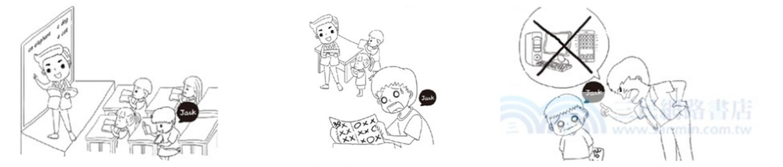
Useful Words & Phrases 實用單字片語
Word / Phrase | 中文 | Word / Phrase | 中文
elementary school student | 小學生 | got home | 到家
phone games | 手機遊戲 | showed | 給…看
in class | 上課時 | angry | 生氣的
secretly | 偷偷地 | shouted at | 對…大吼
teaching | 教課 | computer | 電腦
listening | 聽講 | anymore | 不再
gave back | 發回 | sad | 難過的
test papers | 考卷 | cried | 哭了
looked at | 看 | made a big mistake | 犯了大錯
bad grade | 爛成績 | important lesson | 重要的教訓
shocked | 震驚的 | carefully | 專心地
wrong | 錯的
Useful Sentence Patterns 實用句型
1. S loves + V-ing + N very much, and S + Vs + every day.
→ He loves playing phone games very much, and he plays them every day.
2. While S was Ving, S wasn't Ving at all.
→ While the teacher was teaching English, Jack wasn't listening at all.
3. When S + Ved, S found that + 句子
→ When Jack looked at his paper, he found that he got a very bad grade.
4. S was very + adj. + with + 人 and + Ved
→ His father was very angry with him and shouted at him.
5. S felt + adj. and + Ved.
→ Jack felt very sad and cried.
6. S has learned an important lesson: 句子
→ He has learned an important lesson: he should listen carefully in class and stop playing games.
Sentence Patterns 句型表
Column 1｜元素 & 關鍵字 | Column 2｜句型 | Column 3｜例句
人物介紹 Who  elementary school student 小學生 | S + is + a + 年齡-year-old + 職業. | Jack is a 12-year-old elementary school student.
喜好 Hobby  phone games 手機遊戲 | S loves + V-ing + N very much, and S + Vs + every day. | He loves playing phone games very much, and he plays them every day.
圖一 時間地點  in class 上課時; secretly 偷偷地 | In class, S always + Ved + adv. | In class, he always played games on his phone secretly.
圖一 動作  teaching 教課; listening 聽講 | While S was Ving, S wasn't Ving at all. | While the teacher was teaching English, Jack wasn't listening at all.
圖二 時間  gave back 發回; test papers 考卷 | One day, S gave back + N. | One day, the teacher gave back the English test papers to the students.
發現 Discovery  looked at 看; bad grade 爛成績 | When S + Ved, S found that + 句子 | When Jack looked at his paper, he found that he got a very bad grade.
心情 + 原因 Feeling  shocked 震驚的; wrong 錯的 | S felt + adj. + because + 句子 | He felt shocked because most of his answers were wrong.
圖三 時間地點  got home 到家; showed 給…看 | When S got home, S + Ved + N + to + 人. | When he got home, he showed the test paper to his father.
心情 Feeling  angry 生氣的; shouted at 對…大吼 | S was very + adj. + with + 人 and + Ved | His father was very angry with him and shouted at him.
結局 Ending  computer 電腦; anymore 不再 | S told + 人 + that + 句子 | He told Jack that he couldn't use the computer or his phone anymore.
心情 Feeling  sad 難過的; cried 哭了 | S felt + adj. and + Ved. | Jack felt very sad and cried.
反省 Reflection  made a big mistake 犯了大錯 | S knew that + 句子 | He knew that he made a big mistake.
萬用結尾 Lesson  important lesson 重要的教訓; carefully 專心地 | S has learned an important lesson: 句子 | He has learned an important lesson: he should listen carefully in class and stop playing games.
範文 Model Essay (145 words)
Jack is a 12-year-old elementary school student. He loves playing phone games very much, and he plays them every day. In class, he always played games on his phone secretly. While the teacher was teaching English, Jack wasn't listening at all. One day, the teacher gave back the English test papers to the students. When Jack looked at his paper, he found that he got a very bad grade. He felt shocked because most of his answers were wrong. When he got home, he showed the test paper to his father. His father was very angry with him and shouted at him. He told Jack that he couldn't use the computer or his phone anymore. Jack felt very sad and cried. He knew that he made a big mistake. He has learned an important lesson: he should listen carefully in class and stop playing games.
主題 3｜校園生活與考試 School Life & Tests
Topic 10｜Tom 忘了帶作業篇 Tom's Forgotten Homework
題目：這是 Tom 今天到學校去上課的情景。請根據以下三張圖片，描寫出一篇約 50 字的「Tom 的一日記事」。注意：未依提示作答者，將予以扣分。
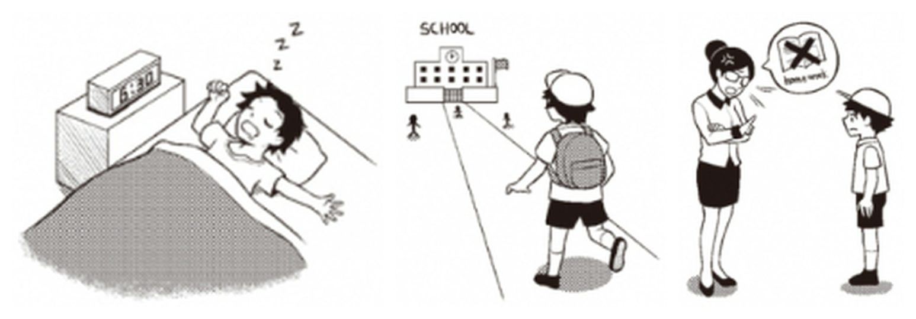
Useful Words & Phrases 實用單字片語
Word / Phrase | 中文 | Word / Phrase | 中文
elementary school student | 小學生 | see his friends | 見到朋友
friendly | 友善 | first class | 第一堂課
forgetful | 健忘 | hand in | 繳交
alarm clock | 鬧鐘 | forgot to bring | 忘了帶
rang | 響 | homework | 作業
sleepy | 想睡 | angry | 生氣
get up | 起床 | scolded | 責罵
in a hurry | 匆忙 | embarrassed | 尷尬
packed | 收拾 | said sorry | 道歉
walked to school | 走路上學 | check | 檢查
backpack | 背包 | the night before | 前一晚
happy | 開心
Useful Sentence Patterns 實用句型
1. S is a + adj. + N, but S is often + adj.
→ He is a friendly boy, but he is often forgetful.
2. S was so + adj. + that + 句子
→ He was so sleepy that he didn't want to get up.
3. Then S + Ved to + 地點 with + N.
→ Then he walked to school with his backpack.
4. When S + Ved, S asked + 人 + to V
→ When the first class started, his teacher asked the students to hand in their homework.
5. S was very + adj., and S + Ved + 人.
→ His teacher was very angry, and she scolded him in front of the whole class.
6. S has learned an important lesson: S will always V
→ He has learned an important lesson: he will always check his schoolbag the night before.
Sentence Patterns 句型表
Column 1｜元素 & 關鍵字 | Column 2｜句型 | Column 3｜例句
人物介紹 Who  elementary school student 小學生 | S + is + a + 年齡-year-old + 職業. | Tom is a 12-year-old elementary school student.
個性 Personality  friendly 友善; forgetful 健忘 | S is a + adj. + N, but S is often + adj. | He is a friendly boy, but he is often forgetful.
圖一 時間地點  alarm clock 鬧鐘; rang 響 | This morning, S + Ved at + 時間, but S was still Ving. | This morning, his alarm clock rang at 6:30, but he was still sleeping.
圖一 動作  sleepy 想睡; get up 起床 | S was so + adj. + that + 句子 | He was so sleepy that he didn't want to get up.
圖一 結果  in a hurry 匆忙; packed 收拾 | In the end, S + Ved and Ved + N in a hurry. | In the end, he got up and packed his schoolbag in a hurry.
圖二 時間地點  walked to school 走路上學; backpack 背包 | Then S + Ved to + 地點 with + N. | Then he walked to school with his backpack.
心情 + 原因 Feeling  happy 開心; see his friends 見到朋友 | S felt + adj. + because + 句子 | He felt happy because he could see his friends and play with them at school.
圖三 時間地點  first class 第一堂課; hand in 繳交 | When S + Ved, S asked + 人 + to V | When the first class started, his teacher asked the students to hand in their homework.
發現 Discovery  forgot to bring 忘了帶; homework 作業 | S found that + 句子 | Tom found that he forgot to bring his homework.
結局 Ending  angry 生氣; scolded 責罵 | S was very + adj., and S + Ved + 人. | His teacher was very angry, and she scolded him in front of the whole class.
心情 Feeling  embarrassed 尷尬; said sorry 道歉 | S felt + adj., and S said sorry to + 人. | He felt embarrassed, and he said sorry to his teacher again and again.
萬用結尾 Lesson  check 檢查; the night before 前一晚 | S has learned an important lesson: S will always V | He has learned an important lesson: he will always check his schoolbag the night before.
範文 Model Essay (145 words)
Tom is a 12-year-old elementary school student. He is a friendly boy, but he is often forgetful. This morning, his alarm clock rang at 6:30, but he was still sleeping. He was so sleepy that he didn't want to get up. In the end, he got up and packed his schoolbag in a hurry. Then he walked to school with his backpack. He felt happy because he could see his friends and play with them at school. When the first class started, his teacher asked the students to hand in their homework. Tom found that he forgot to bring his homework. His teacher was very angry, and she scolded him in front of the whole class. He felt embarrassed, and he said sorry to his teacher again and again. He has learned an important lesson: he will always check his schoolbag the night before.
主題 4｜颱風天 Typhoon Days
Topic 11｜颱風天篇 The Typhoon
題目：氣象預報颱風快來了 → 颱風登陸，強風豪雨 → 颱風帶來災害。
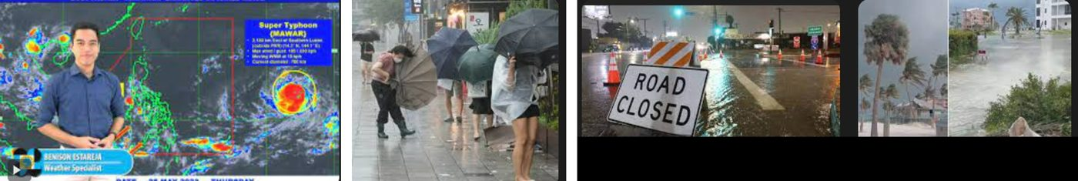
Useful Words & Phrases 實用單字片語
Word / Phrase | 中文 | Word / Phrase | 中文
student | 學生 | dangerous | 危險
lives in | 住在 | go out | 出門
weather forecast | 氣象預報 | damage | 損害
typhoon | 颱風 | flood | 淹水
worried about | 擔心 | fell down | 倒下
stayed at home | 待在家 | road closed | 道路封閉
flashlights | 手電筒 | blackout | 停電
candles | 蠟燭 | scared | 害怕
hit | 侵襲 | sleep | 睡覺
heavy rain | 豪雨 | two days later | 兩天後
strong wind | 強風 | cleaned up | 清理
umbrellas | 雨傘 | the scariest | 最可怕的
blown away | 被吹走
Useful Sentence Patterns 實用句型
1. Last + 時間, the weather forecast said that + 句子
→ Last July, the weather forecast said that a strong typhoon was coming to Taiwan.
2. S prepared + A, B, and C.
→ They prepared flashlights, candles, and some water.
3. S saw that + 句子
→ She saw that many people's umbrellas were blown away on the street.
4. S brought a lot of damage. For example, there was + N, and + 句子
→ The typhoon brought a lot of damage. For example, there was a flood on the street, and some trees fell down.
5. S was so + adj. + that + 句子
→ Lisa was so scared that she could not sleep at night.
6. For + 人, it was the + 最高級 + N + of + one's life.
→ For her, it was the scariest typhoon of her life.
Sentence Patterns 句型表
Column 1｜元素 & 關鍵字 | Column 2｜句型 | Column 3｜例句
人物介紹 Who  student 學生; lives in 住在 | S + is + a + 年齡-year-old + 職業. S lives in + 地方. | Lisa is a 12-year-old student. She lives in Taipei with her family.
圖一 預報 Forecast  weather forecast 氣象預報; typhoon 颱風 | Last + 時間, the weather forecast said that + 句子 | Last July, the weather forecast said that a strong typhoon was coming to Taiwan.
心情 Feeling  worried about 擔心; stayed at home 待在家 | S was worried about + N, so + 句子 | Lisa was worried about the typhoon, so her family stayed at home.
準備 Preparation  flashlights 手電筒; candles 蠟燭 | S prepared + A, B, and C. | They prepared flashlights, candles, and some water.
圖二 颱風來襲  hit 侵襲; heavy rain 豪雨; strong wind 強風 | S hit + 地方. It brought + N and N. | The next day, the typhoon hit Taipei. It brought heavy rain and strong wind.
細節 Details  umbrellas 雨傘; blown away 被吹走 | S saw that + 句子 | She saw that many people's umbrellas were blown away on the street.
不能出門  dangerous 危險; go out 出門 | It was too + adj. + to V | It was too dangerous to go out.
圖三 災害 Damage  damage 損害; flood 淹水; fell down 倒下 | S brought a lot of damage. For example, there was + N, and + 句子 | The typhoon brought a lot of damage. For example, there was a flood on the street, and some trees fell down.
補充 Besides  road closed 道路封閉; blackout 停電 | Besides, + 句子, and there was + N. | Besides, the road was closed, and there was a blackout at her home.
心情 Feeling  scared 害怕; sleep 睡覺 | S was so + adj. + that + 句子 | Lisa was so scared that she could not sleep at night.
結局 Ending  two days later 兩天後; cleaned up 清理 | 時間 + later, + 句子. S + Ved to V | Two days later, the typhoon left. Lisa and her family went outside to help clean up the street.
萬用結尾  the scariest 最可怕的 | For + 人, it was the + 最高級 + N + of + one's life. | For her, it was the scariest typhoon of her life.
範文 Model Essay (151 words)
Lisa is a 12-year-old student. She lives in Taipei with her family. Last July, the weather forecast said that a strong typhoon was coming to Taiwan. Lisa was worried about the typhoon, so her family stayed at home. They prepared flashlights, candles, and some water. The next day, the typhoon hit Taipei. It brought heavy rain and strong wind. She saw that many people's umbrellas were blown away on the street. It was too dangerous to go out. The typhoon brought a lot of damage. For example, there was a flood on the street, and some trees fell down. Besides, the road was closed, and there was a blackout at her home. Lisa was so scared that she could not sleep at night. Two days later, the typhoon left. Lisa and her family went outside to help clean up the street. For her, it was the scariest typhoon of her life.
主題 4｜颱風天 Typhoon Days
Topic 12｜颱風天大賣場搶購篇 Shopping Before the Typhoon
題目：氣象預報颱風快來了，Tom 一家人去大賣場，都是搶購人潮；貨架都空了，回家路上淹水、車拋錨、塞車。
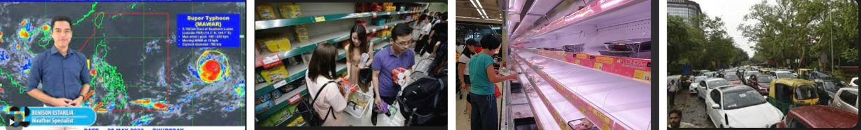
Useful Words & Phrases 實用單字片語
Word / Phrase | 中文 | Word / Phrase | 中文
student | 學生 | afraid | 擔心
parents | 父母 | shelves | 貨架
weather forecast | 氣象預報 | empty | 空的
coming soon | 即將來 | on the way home | 回家路上
worried about | 擔心 | flood | 淹水
supermarket | 大賣場 | broke down | 拋錨
by car | 開車 | traffic jam | 塞車
crowded with | 擠滿 | two hours | 兩小時
customers | 顧客 | upset | 沮喪
instant noodles | 泡麵 | tired | 累
canned food | 罐頭 | earlier | 提早
nervous | 緊張 | before | 在…之前
Useful Sentence Patterns 實用句型
1. Last + 時間, the weather forecast said that + 句子
→ Last Friday, the weather forecast said that a typhoon was coming soon.
2. That + 時間, S went to + 地方 + with ... by 交通 + to V
→ That afternoon, Tom went to the supermarket with his family by car to buy food.
3. S bought many kinds of things, such as A, B, C, and D.
→ People bought many kinds of things, such as vegetables, instant noodles, canned food, and water.
4. On the way home, there was + N.
→ On the way home, there was a flood on the street.
5. It took + 人 + 時間 + to V
→ It took them two hours to get home.
6. From now on, S decide to V
→ From now on, they decide to buy food earlier before a typhoon comes.
Sentence Patterns 句型表
Column 1｜元素 & 關鍵字 | Column 2｜句型 | Column 3｜例句
人物介紹 Who  student 學生; parents 父母 | S + is + a + 年齡-year-old + 職業. S lives with + 人. | Tom is a 13-year-old student. He lives with his parents.
圖一 預報 Forecast  weather forecast 氣象預報; coming soon 即將來 | Last + 時間, the weather forecast said that + 句子 | Last Friday, the weather forecast said that a typhoon was coming soon.
心情 + 原因  worried about 擔心 | S was worried about + N + because + 句子 | Tom was worried about the typhoon because it was very strong.
圖二 時間地點  supermarket 大賣場; by car 開車 | That + 時間, S went to + 地方 + with ... by 交通 + to V | That afternoon, Tom went to the supermarket with his family by car to buy food.
擁擠 Crowded  crowded with 擠滿; customers 顧客 | When S arrived, it was crowded with + N. | When they arrived, it was crowded with customers.
舉例 Examples  instant noodles 泡麵; canned food 罐頭 | S bought many kinds of things, such as A, B, C, and D. | People bought many kinds of things, such as vegetables, instant noodles, canned food, and water.
心情 + 原因  nervous 緊張; afraid 擔心 | S was + adj. + because + S was afraid that + 句子 | Tom was nervous because he was afraid that they could not buy enough food.
圖三 貨架空  shelves 貨架; empty 空的 | However, + 句子, so S + did not V | However, the shelves were almost empty, so they did not buy many things.
圖四 回家路上  on the way home 回家路上; flood 淹水 | On the way home, there was + N. | On the way home, there was a flood on the street.
塞車 Traffic jam  broke down 拋錨; traffic jam 塞車 | There was + N + because + 句子 | There was a terrible traffic jam because some cars broke down in the water.
花時間 Time spent  two hours 兩小時 | It took + 人 + 時間 + to V | It took them two hours to get home.
心情 Feeling  upset 沮喪; tired 累 | S were very + adj. and adj. | They were very upset and tired.
萬用結尾  earlier 提早; before 在…之前 | From now on, S decide to V | From now on, they decide to buy food earlier before a typhoon comes.
範文 Model Essay (150 words)
Tom is a 13-year-old student. He lives with his parents. Last Friday, the weather forecast said that a typhoon was coming soon. Tom was worried about the typhoon because it was very strong. That afternoon, Tom went to the supermarket with his family by car to buy food. When they arrived, it was crowded with customers. People bought many kinds of things, such as vegetables, instant noodles, canned food, and water. Tom was nervous because he was afraid that they could not buy enough food. However, the shelves were almost empty, so they did not buy many things. On the way home, there was a flood on the street. There was a terrible traffic jam because some cars broke down in the water. It took them two hours to get home. They were very upset and tired. From now on, they decide to buy food earlier before a typhoon comes.
主題 4｜颱風天 Typhoon Days
Topic 13｜颱風停電篇 The Typhoon Night
題目：某天颱風來了，我便去便利商店買了些東西以做準備，回家後果然停電。請依照下面的圖片，寫一篇約 50 字的故事。注意：未依提示作答者，將予扣分。
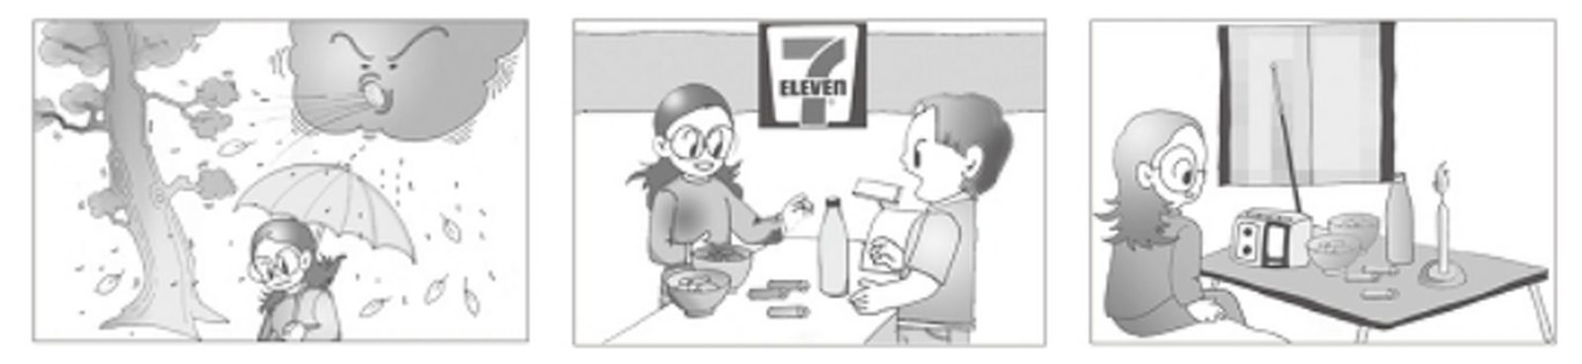
Useful Words & Phrases 實用單字片語
Word / Phrase | 中文 | Word / Phrase | 中文
junior high school student | 國中生 | batteries | 電池
careful | 細心 | paid | 付錢
plan ahead | 事先計畫 | clerk | 店員
typhoon | 颱風 | that night | 那天晚上
strong | 強烈的 | went out | 熄滅
wind | 風 | dark | 暗
heavily | 大量地 | anything | 任何東西
umbrella | 雨傘 | lit a candle | 點蠟燭
convenience store | 便利商店 | radio | 收音機
worried | 擔心 | ate | 吃
power | 電力 | listened to | 聽
go out | 停電 | glad | 高興
instant noodles | 泡麵 | prepared | 做好準備
Useful Sentence Patterns 實用句型
1. I am a + adj. + person, and I always + V.
→ I am a careful person, and I always plan ahead.
2. The wind was + adj., and it + Ved + adv.
→ The wind was very strong, and it rained heavily.
3. I felt + adj. + because + 句子.
→ I felt worried because the power might go out at night.
4. That night, after I got home, S + Ved.
→ That night, after I got home, the power went out suddenly.
5. Luckily, I + Ved + N and Ved + N.
→ Luckily, I lit a candle and turned on my radio.
6. I was glad that + 句子. It is + adj. + to V.
→ I was glad that I was ready. It is important to be prepared for a typhoon.
Sentence Patterns 句型表
Column 1｜元素 & 關鍵字 | Column 2｜句型 | Column 3｜例句
人物介紹 Who  junior high school student 國中生 | I + am + a + 年齡-year-old + 職業. | I am a 14-year-old junior high school student.
個性 Personality  careful 細心; plan ahead 事先計畫 | I am a + adj. + person, and I always + V. | I am a careful person, and I always plan ahead.
圖一 時間  typhoon 颱風; strong 強烈的 | One day, S + Ved + to + 地點. | One day, a strong typhoon came to Taiwan.
天氣 Weather  wind 風; heavily 大量地 | The wind was + adj., and it + Ved + adv. | The wind was very strong, and it rained heavily.
圖一 動作  umbrella 雨傘; convenience store 便利商店 | I took + N and went to + 地點. | I took my umbrella and went to a convenience store.
心情 + 原因 Feeling  worried 擔心; power 電力; go out 停電 | I felt + adj. + because + 句子. | I felt worried because the power might go out at night.
圖二 地點 + 動作  instant noodles 泡麵; batteries 電池 | At + 地點, I bought + N, N, and N. | At the store, I bought instant noodles, a bottle of water, and some batteries.
動作 Action  paid 付錢; clerk 店員 | I + Ved + N, and then I + Ved. | I paid the clerk, and then I went home quickly.
圖三 時間  that night 那天晚上; went out 熄滅 | That night, after I got home, S + Ved. | That night, after I got home, the power went out suddenly.
發現 Discovery  dark 暗; anything 任何東西 | It was so + adj. + that I couldn't V. | It was so dark that I couldn't see anything in my room.
行動 Action  lit a candle 點蠟燭; radio 收音機 | Luckily, I + Ved + N and Ved + N. | Luckily, I lit a candle and turned on my radio.
結局 Ending  ate 吃; listened to 聽 | I + Ved + N while I + Ved + N. | I ate my instant noodles while I listened to the news about the typhoon.
萬用結尾 Lesson  glad 高興; prepared 做好準備 | I was glad that + 句子. It is + adj. + to V. | I was glad that I was ready. It is important to be prepared for a typhoon.
範文 Model Essay (143 words)
I am a 14-year-old junior high school student. I am a careful person, and I always plan ahead. One day, a strong typhoon came to Taiwan. The wind was very strong, and it rained heavily. I took my umbrella and went to a convenience store. I felt worried because the power might go out at night. At the store, I bought instant noodles, a bottle of water, and some batteries. I paid the clerk, and then I went home quickly. That night, after I got home, the power went out suddenly. It was so dark that I couldn't see anything in my room. Luckily, I lit a candle and turned on my radio. I ate my instant noodles while I listened to the news about the typhoon. I was glad that I was ready. It is important to be prepared for a typhoon.
主題 4｜颱風天 Typhoon Days
Topic 14｜颱風假逛百貨篇 A Typhoon Day Surprise
題目：10 月 23 日颱風假，Mia、她的雙胞胎妹妹 Nina 和爸媽發生了一件事。請根據以下三張圖片寫一篇短文。請用過去式描述。注意：未依提示作答者，將予扣分。
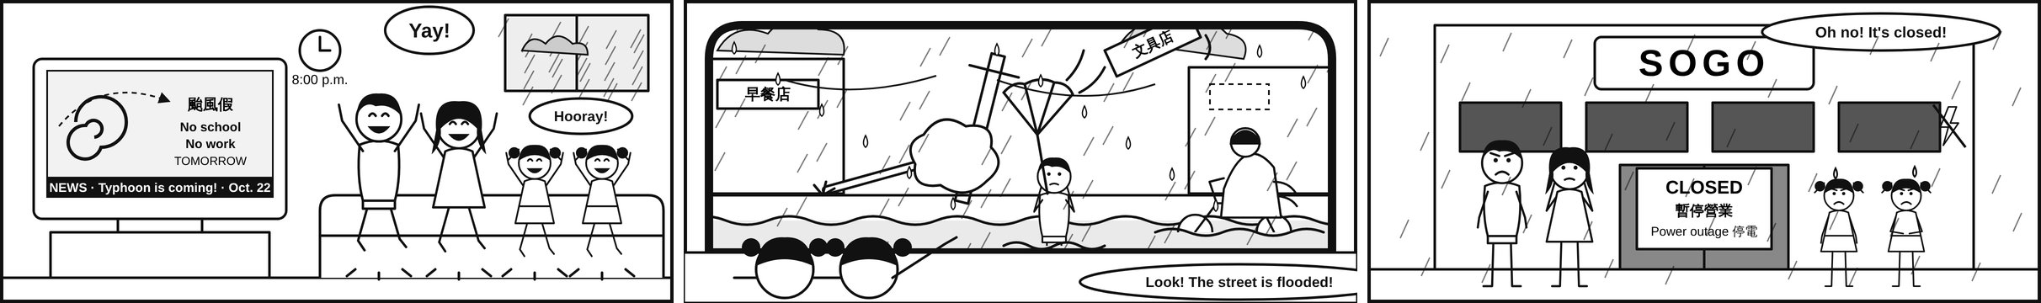
Useful Words & Phrases 實用單字片語
Word / Phrase | 中文 | Word / Phrase | 中文
typhoon day | 颱風假 | department store | 百貨公司
pedestrian | 行人 | utility pole | 電線桿
reporter / the news | 記者／新聞 | power outage | 停電
wade through the water | 涉水而行 | tilt | 傾斜
jump up and down | 跳上跳下 | closed | 關門的；暫停營業
umbrella turned inside out | 雨傘開花（被吹翻） | shop sign | 招牌
flooded | 淹水的 | disappointed | 失望的
motorcyclist / raincoat | 騎機車的人／雨衣 | blow away (blew) | 吹走
fall down / fallen tree | 倒下／倒下的樹 | dark | 黑暗的
Useful Sentence Patterns 實用句型
1. The reporter said that + S + V.
→ The reporter said that a strong typhoon was coming.
2. S + was/were + V-ing (when …)
→ We were watching TV when the news came on.
3. S + had trouble + V-ing
→ People had trouble walking in the water.
4. S + told + sb. + not to + V
→ Mom told us not to open the windows.
5. S + kept + V-ing
→ We kept looking at the dark doors.
6. S + hope to + V
→ I hope to stay home next time.
Sentence Patterns 句型表
Column 1｜元素 & 關鍵字 | Column 2｜句型 | Column 3｜例句
圖一 時間地點 Time & Place  Thursday evening 星期四晚上; TV news 電視新聞 | On + 時間, S + was/were + V-ing + 地點. | On Thursday evening, October 22, my family was watching the TV news at home.
新聞內容 The News  reporter 記者; strong typhoon 強颱 | The reporter said that + S + V. | The reporter said that a strong typhoon was coming.
宣布 Announcement  mayor 市長; no school 停課; no work 停班 | Then S said, "There will be + N!" | Then the mayor said, "There will be no school and no work tomorrow!"
心情 Feeling  jump up and down 跳上跳下; excited 興奮的; typhoon day 颱風假 | S + Ved. S + was/were so + adj. + to V. | My twin sister and I jumped up and down. We were so excited to have a typhoon day off!
圖二 時間 + 決定 Decision  the next afternoon 隔天下午; decide to 決定 | The next afternoon, 句子, so S decided to V. | The next afternoon, the rain was not so heavy, so Dad decided to drive us to the department store.
看見 What We Saw  look out of the car window 往車窗外看; surprising 令人驚訝的 | S looked out of + N and saw + N. | We looked out of the car window and saw many surprising things.
街景 The Street  flooded 淹水的; fall down 倒下; utility pole 電線桿; tilt 傾斜 | S was + adj. Some N + Ved, and N + was V-ing. | The street was a little flooded. Some trees fell down, and a utility pole was tilting.
強風 The Wind  shop sign 招牌; blow away (blew) 吹走 | S + Ved + in the strong wind. | A shop sign blew away in the strong wind.
路人 People  pedestrian 行人; wade through the water 涉水而行; umbrella turned inside out 雨傘開花 | S had trouble + V-ing. | People had trouble walking in the water, and their umbrellas turned inside out.
騎士 Riders  motorcyclist 騎機車的人; raincoat 雨衣 | Some N + were + V-ing + adv. | Some motorcyclists were riding slowly in their raincoats.
媽媽叮嚀 Warning  open the windows 開窗; step out 下車 | S told + sb. + not to V. | Mom told us not to open the windows and not to step out.
圖三 時間地點 + 心情  department store 百貨公司; disappointed 失望的 | When S got to + 地點, S was/were + adj. + that + 句子. | When we got to SOGO, we were very disappointed that the department store was not open.
原因 Reason  closed 關門的; power outage 停電; dark 黑暗的 | All N were + adj. + because there was + N. | All stores were closed because there was a power outage.
結局 Ending  kept 一直; instant noodles 泡麵 | S kept + V-ing. Then S + Ved. | We kept looking at the dark doors for a minute. Then we drove home and ate instant noodles.
萬用結尾 Lesson  next time 下次 | Next time, S hope(s) to + V. | Next time, I hope to stay home on a typhoon day!
範文 Model Essay (218 words)
On Thursday evening, October 22, my family was watching the TV news at home. The reporter said that a strong typhoon was coming. Then the mayor said, "There will be no school and no work tomorrow!" My twin sister and I jumped up and down. Mom and Dad jumped, too. We were so excited to have a typhoon day off! The next afternoon, the rain was not so heavy, so Dad decided to drive us to the department store. We looked out of the car window and saw many surprising things. The street was a little flooded. Some trees fell down on the sidewalk, and a utility pole was tilting. A shop sign blew away in the strong wind. People had trouble walking in the water, and their umbrellas turned inside out. Some motorcyclists were riding slowly in their raincoats. Mom told us not to open the windows and not to step out. When we got to SOGO, we were very disappointed that the department store was not open. All stores were closed because there was a power outage. All the lights were off. My sister said, "Oh no!" We kept looking at the dark doors for a minute. Then we drove home and ate instant noodles. Next time, I hope to stay home on a typhoon day!
50-word version 英檢初級字數版
On October 22, the TV news said there was no school the next day. My family jumped happily. The next afternoon, we drove to SOGO Department Store. The street was flooded, and trees fell down. People's umbrellas turned inside out. When we finally arrived, we were sad to see the store closed. All stores on the street were closed because of a power outage. We were very disappointed. We went home and ate instant noodles and bread.
主題 5｜下雨天 Rainy Days
Topic 15｜家庭出遊塞車篇 A Family Trip in the Rain
題目：Jennifer 一家人上週六出遊，路上遇到一些問題，請描述。

Useful Words & Phrases 實用單字片語
Word / Phrase | 中文 | Word / Phrase | 中文
elementary school student | 小學生 | get to | 抵達
go out | 出門 | bored | 無聊
family | 家人 | tired | 累
drove | 開車載 | cried | 哭
for a trip | 去旅行 | arrived | 抵達
excited | 興奮 | started to rain | 開始下雨
amusement park | 遊樂園 | rides | 遊樂設施
snacks | 零食 | closed | 關閉
drinks | 飲料 | sad | 難過
highway | 高速公路 | in the rain | 在雨中
traffic jam | 塞車 | went home early | 提早回家
too many cars | 太多車 | the worst day | 最糟的一天
three hours | 三小時
Useful Sentence Patterns 實用句型
1. S + likes to V
→ She likes to go out with her family on weekends.
2. S was + adj. + because + 句子
→ She was excited because they wanted to go to an amusement park.
3. S found that + 句子
→ She found that there were too many cars on the road.
4. S was so + adj. + that + 句子
→ She was so bored and tired that she almost cried.
5. S was + adj. + because + it was not + adj. + to V
→ She was sad because it was not fun to play in the rain.
6. For + 人, it was the + 最高級 + N + of + one's life.
→ For her, it was the worst day of her life.
Sentence Patterns 句型表
Column 1｜元素 & 關鍵字 | Column 2｜句型 | Column 3｜例句
人物介紹 Who  elementary school student 小學生; Grade 3 | S + is + an + 職業. S + is in Grade + 數字. | Jennifer is an elementary school student. She is in Grade 3.
喜好 Hobby  go out 出門; family 家人 | S + likes to V | She likes to go out with her family on weekends.
圖一 時間地點  drove 開車載; for a trip 去旅行 | Last + 時間, S + Ved + 人 + to + 地方 + for a trip. | Last Saturday, her father drove the family to Taipei for a trip.
心情 + 原因  excited 興奮; amusement park 遊樂園 | S was + adj. + because + 句子 | She was excited because they wanted to go to an amusement park.
準備 Preparation  snacks 零食; drinks 飲料 | Before S + Ved, S + Ved | Before they left, she put some snacks and drinks in the car.
圖二 時間地點  highway 高速公路; traffic jam 塞車 | When S were on ..., there was + N. | When they were on the highway, there was a terrible traffic jam.
發現 Discovery  too many cars 太多車 | S found that + 句子 | She found that there were too many cars on the road.
花時間 Time spent  three hours 三小時; get to 抵達 | It took + 人 + 時間 + to V | It took them three hours to get to Taipei.
心情 Feeling  bored 無聊; tired 累; cried 哭 | S was so + adj. + that + 句子 | She was so bored and tired that she almost cried.
圖三 時間地點  arrived 抵達; started to rain 開始下雨 | When S finally + Ved, it started to V | When they finally arrived at the amusement park, it started to rain very hard.
結果 Result  rides 遊樂設施; closed 關閉 | 句子, so S could not V | Most of the rides were closed, so they could not have fun.
心情 + 原因  sad 難過; in the rain 在雨中 | S was + adj. + because + it was not + adj. + to V | She was sad because it was not fun to play in the rain.
結局 Ending  went home early 提早回家 | In the end, S had to V | In the end, they had to go home early.
萬用結尾  the worst day 最糟的一天 | For + 人, it was the + 最高級 + N + of + one's life. | For her, it was the worst day of her life.
範文 Model Essay (157 words)
Jennifer is an elementary school student. She is in Grade 3. She likes to go out with her family on weekends. Last Saturday, her father drove the family to Taipei for a trip. She was excited because they wanted to go to an amusement park. Before they left, she put some snacks and drinks in the car. When they were on the highway, there was a terrible traffic jam. She found that there were too many cars on the road. It took them three hours to get to Taipei. She was so bored and tired that she almost cried. When they finally arrived at the amusement park, it started to rain very hard. Most of the rides were closed, so they could not have fun. She was sad because it was not fun to play in the rain. In the end, they had to go home early. For her, it was the worst day of her life.
主題 5｜下雨天 Rainy Days
Topic 16｜雨天改變計畫篇 A Rainy Saturday
題目：今天 Mary 原本要去打籃球，不過因為下大雨而取消了，下面是接下來所發生的事，請根據這些圖片寫一篇短文。
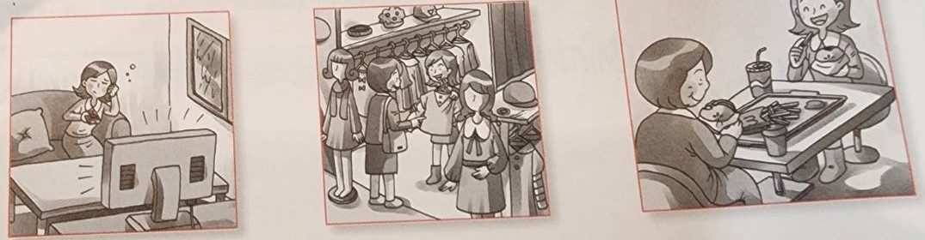
Useful Words & Phrases 實用單字片語
Word / Phrase | 中文 | Word / Phrase | 中文
junior high school student | 國中生 | say sorry | 道歉
play basketball | 打籃球 | went shopping | 逛街
planned | 計畫 | department store | 百貨公司
park | 公園 | T-shirt T | 恤
raining heavily | 下大雨 | color | 顏色
cancel | 取消 | fast-food restaurant | 速食店
rainy | 下雨 | took photos | 拍照
windy | 颳風 | excited | 興奮
instead | 反而 | spend time | 共度時光
watch TV | 看電視 | wonderful | 美好
bored | 無聊
Useful Sentence Patterns 實用句型
1. S likes to V
→ She likes to play basketball on weekends.
2. But it was + Ving, so S had to V
→ But it was raining heavily, so she had to cancel her plan.
3. Instead, S decided to V
→ Instead, she decided to stay at home and watch TV.
4. S bought + N and felt + adj. + because + 句子
→ Mary bought a new T-shirt and felt very happy because she liked the color.
5. After Ving, S + Ved
→ After finishing lunch, they took some photos together.
6. S thought it was a + adj. + N. S wanted to V again.
→ She thought it was a wonderful day. She wanted to go shopping with her mother again next weekend.
Sentence Patterns 句型表
Column 1｜元素 & 關鍵字 | Column 2｜句型 | Column 3｜例句
人物介紹 Who  junior high school student 國中生 | S + is + a + 年齡-year-old + 職業. | Mary is a 15-year-old junior high school student.
喜好 Hobby  play basketball 打籃球 | S likes to V | She likes to play basketball on weekends.
原計畫 Plan  planned 計畫; park 公園 | On + 時間, S planned to V | On Saturday morning, she planned to play basketball with her friends at the park.
取消 Cancel  raining heavily 下大雨; cancel 取消 | But it was + Ving, so S had to V | But it was raining heavily, so she had to cancel her plan.
天氣 Weather  rainy 下雨; windy 颳風 | It was + adj. and adj., and S could not V | It was rainy and windy, and they could not play outside.
圖一 轉折  instead 反而; watch TV 看電視 | Instead, S decided to V | Instead, she decided to stay at home and watch TV.
心情 Feeling  bored 無聊; say sorry 道歉 | S felt + adj., so S + Ved | She felt bored, so she called her friends to say sorry.
圖二 地點交通  went shopping 逛街; department store 百貨公司 | After that, S went + Ving with ... They went to + 地點 + by 交通. | After that, she went shopping with her mother. They went to a department store by bus.
購物 + 感受  T-shirt T恤; color 顏色 | S bought + N and felt + adj. + because + 句子 | Mary bought a new T-shirt and felt very happy because she liked the color.
圖三 活動  fast-food restaurant 速食店 | Then, S went to + 地點 + for + N. | Then, they went to a fast-food restaurant for lunch.
After Ving  took photos 拍照 | After Ving, S + Ved | After finishing lunch, they took some photos together.
Although  excited 興奮; spend time 共度時光 | Although it was still + Ving, S felt + adj. + because + 句子 | Although it was still raining, Mary felt excited because she could spend time with her mother.
萬用結尾  wonderful 美好; again 再一次 | S thought it was a + adj. + N. S wanted to V again. | She thought it was a wonderful day. She wanted to go shopping with her mother again next weekend.
範文 Model Essay (154 words)
Mary is a 15-year-old junior high school student. She likes to play basketball on weekends. On Saturday morning, she planned to play basketball with her friends at the park. But it was raining heavily, so she had to cancel her plan. It was rainy and windy, and they could not play outside. Instead, she decided to stay at home and watch TV. She felt bored, so she called her friends to say sorry. After that, she went shopping with her mother. They went to a department store by bus. Mary bought a new T-shirt and felt very happy because she liked the color. Then, they went to a fast-food restaurant for lunch. After finishing lunch, they took some photos together. Although it was still raining, Mary felt excited because she could spend time with her mother. She thought it was a wonderful day. She wanted to go shopping with her mother again next weekend.
主題 5｜下雨天 Rainy Days
Topic 17｜淋雨感冒請病假 Caught in the Rain
題目：昨天突然下大雨，Janice 沒帶傘，只好淋雨回家。請依據下面的圖片，寫一篇短文。
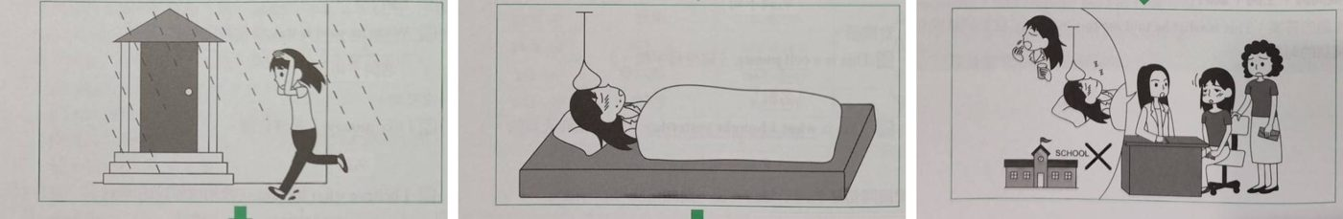
Useful Words & Phrases 實用單字片語
Word / Phrase | 中文 | Word / Phrase | 中文
junior high school student | 國中生 | stay in bed | 躺在床上
walk home | 走路回家 | see a doctor | 看醫生
suddenly | 突然 | take medicine | 吃藥
on her way home | 在回家路上 | get enough sleep | 睡飽
umbrella | 雨傘 | asked for sick leave | 請病假
run home | 跑回家 | see her friends | 見朋友
terribly wet | 濕透 | rested | 休息
caught a cold | 感冒 | felt better | 好轉
had a fever | 發燒 | bring an umbrella | 帶傘
sick | 不舒服
Useful Sentence Patterns 實用句型
1. S likes to V + after school.
→ She likes to walk home with her friends after school.
2. S didn't V, so all S could do was V
→ She didn't bring an umbrella, so all she could do was run home quickly.
3. Later that night, S + Ved and Ved
→ Later that night, she caught a cold and had a fever.
4. S told + 人 + to V and V
→ The doctor told her to take some medicine and get enough sleep.
5. S felt + adj. + because + S couldn't V
→ Janice felt sad because she couldn't go to school and see her friends.
6. S has learned an important lesson. From now on, S decides to V
→ She has learned an important lesson. From now on, she decides to bring an umbrella with her every day.
Sentence Patterns 句型表
Column 1｜元素 & 關鍵字 | Column 2｜句型 | Column 3｜例句
人物介紹 Who  junior high school student 國中生 | S + is + a + 年齡-year-old + 職業. | Janice is a 14-year-old junior high school student.
喜好 Hobby  walk home 走路回家 | S likes to V + after school. | She likes to walk home with her friends after school.
圖一 時間 + 天氣  suddenly 突然; on her way home 在回家路上 | Yesterday afternoon, it suddenly + Ved when S was on her way home. | Yesterday afternoon, it suddenly rained heavily when she was on her way home.
沒帶傘  umbrella 雨傘; run home 跑回家 | S didn't V, so all S could do was V | She didn't bring an umbrella, so all she could do was run home quickly.
淋濕 Wet  terribly wet 濕透 | When S got home, S was + adj. | When she got home, she was terribly wet.
圖二 生病  caught a cold 感冒; had a fever 發燒 | Later that night, S + Ved and Ved | Later that night, she caught a cold and had a fever.
感受 Feeling  sick 不舒服; stay in bed 躺在床上 | S felt so + adj. + that + S had to V | She felt so sick that she had to stay in bed.
圖三 看醫生  see a doctor 看醫生 | The next morning, S took + 人 + to V | The next morning, her mother took her to see a doctor.
醫囑 Advice  take medicine 吃藥; get enough sleep 睡飽 | S told + 人 + to V and V | The doctor told her to take some medicine and get enough sleep.
請假 Sick leave  asked for sick leave 請病假 | S + Ved and asked for + N + for + 人. | Her mother called the school and asked for sick leave for her.
心情 + 原因  see her friends 見朋友 | S felt + adj. + because + S couldn't V | Janice felt sad because she couldn't go to school and see her friends.
休息 Rest  rested 休息; felt better 好轉 | S + Ved at home for + 時間. | She rested at home for three days and then felt better.
萬用結尾  bring an umbrella 帶傘 | S has learned an important lesson. From now on, S decides to V | She has learned an important lesson. From now on, she decides to bring an umbrella with her every day.
範文 Model Essay (153 words)
Janice is a 14-year-old junior high school student. She likes to walk home with her friends after school. Yesterday afternoon, it suddenly rained heavily when she was on her way home. She didn't bring an umbrella, so all she could do was run home quickly. When she got home, she was terribly wet. Later that night, she caught a cold and had a fever. She felt so sick that she had to stay in bed. The next morning, her mother took her to see a doctor. The doctor told her to take some medicine and get enough sleep. Her mother called the school and asked for sick leave for her. Janice felt sad because she couldn't go to school and see her friends. She rested at home for three days and then felt better. She has learned an important lesson. From now on, she decides to bring an umbrella with her every day.
主題 5｜下雨天 Rainy Days
Topic 18｜中秋烤肉遇雨篇 A Rainy Mid-Autumn Barbecue
題目：Dorothy 和家人中秋節在公園烤肉，突然下起了大雨。爸爸靈機一動，搭了帳篷讓大家繼續烤肉。請依據下面的圖片，寫一篇短文。
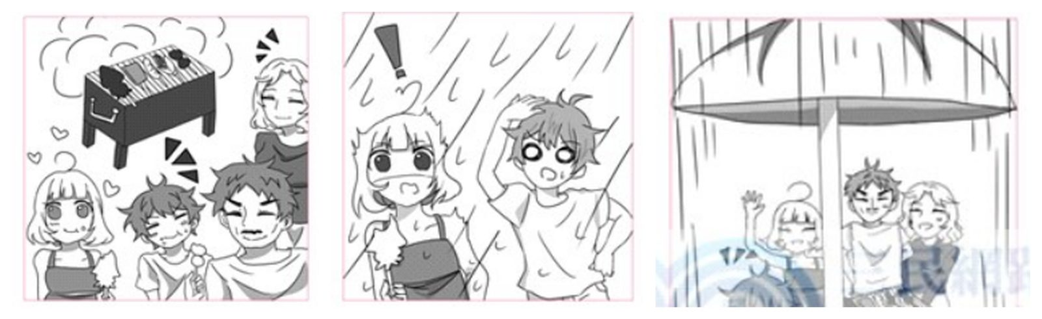
Useful Words & Phrases 實用單字片語
Word / Phrase | 中文 | Word / Phrase | 中文
elementary school student | 小學生 | shouted | 大叫
spend time | 花時間 | food | 食物
family | 家人 | get wet | 淋濕
Mid-Autumn Festival | 中秋節 | ran | 跑
had a barbecue | 烤肉 | tree | 樹
park | 公園 | wet | 濕
grilled | 烤 | had a good idea | 想到好主意
meat | 肉 | put up a tent | 搭帳篷
meat stick | 肉串 | under the tent | 在帳篷下
happy | 開心 | keep | 繼續
delicious | 好吃 | waved | 揮手
suddenly | 突然 | laughed | 笑
heavily | 大量地 | smart | 聰明
surprised | 驚訝 | best | 最好的
Useful Sentence Patterns 實用句型
1. S likes to V + with + 人.
→ She likes to spend time with her family on holidays.
2. S + Ved + N, and S + Ved + N.
→ Her father grilled some meat and corn, and her little brother ate a meat stick happily.
3. S was so + adj. + that + 句子.
→ Dorothy was so surprised that she shouted, "Oh no!"
4. S + Ved + to + 地點, but S still + Ved.
→ Everyone ran to a big tree, but they still got wet.
5. S + Ved and Ved + adv.
→ Dorothy waved and laughed happily.
6. For S, it was the + 最高級 + N + S had ever had.
→ For her, it was the best Mid-Autumn Festival she had ever had.
Sentence Patterns 句型表
Column 1｜元素 & 關鍵字 | Column 2｜句型 | Column 3｜例句
人物介紹 Who  elementary school student 小學生 | S + is + a + 年齡-year-old + 職業. | Dorothy is a 12-year-old elementary school student.
喜好 Hobby  spend time 花時間; family 家人 | S likes to V + with + 人. | She likes to spend time with her family on holidays.
圖一 時間地點  Mid-Autumn Festival 中秋節; had a barbecue 烤肉; park 公園 | On + 節日, S + Ved + in + 地點. | On Mid-Autumn Festival, she and her family had a barbecue in the park.
圖一 動作  grilled 烤; meat 肉; meat stick 肉串 | S + Ved + N, and S + Ved + N. | Her father grilled some meat and corn, and her little brother ate a meat stick happily.
心情 + 原因 Feeling  happy 開心; delicious 好吃 | S felt + adj. + because + 句子. | They felt very happy because the food was so delicious.
圖二 時間 Suddenly  suddenly 突然; heavily 大量地 | Suddenly, it started to V. | Suddenly, it started to rain very heavily.
反應 Reaction  surprised 驚訝; shouted 大叫 | S was so + adj. + that + 句子. | Dorothy was so surprised that she shouted, "Oh no!"
問題 Problem  food 食物; get wet 淋濕 | S didn't want + N + to V. | They didn't want the food to get wet.
行動 Action  ran 跑; tree 樹; wet 濕 | S + Ved + to + 地點, but S still + Ved. | Everyone ran to a big tree, but they still got wet.
圖三 好主意 Idea  had a good idea 想到好主意; put up a tent 搭帳篷 | Then S had a good idea. S + Ved + N. | Then her father had a good idea. He quickly put up a big tent.
結局 Ending  under the tent 在帳篷下; keep 繼續 | As a result, S could keep Ving. | As a result, everyone could keep having the barbecue under the tent.
心情 Feeling  waved 揮手; laughed 笑 | S + Ved and Ved + adv. | Dorothy waved and laughed happily.
想法 Thought  smart 聰明 | S thought that + 句子. | She thought that her father was very smart.
萬用結尾 Lesson  best 最好的 | For S, it was the + 最高級 + N + S had ever had. | For her, it was the best Mid-Autumn Festival she had ever had.
範文 Model Essay (142 words)
Dorothy is a 12-year-old elementary school student. She likes to spend time with her family on holidays. On Mid-Autumn Festival, she and her family had a barbecue in the park. Her father grilled some meat and corn, and her little brother ate a meat stick happily. They felt very happy because the food was so delicious. Suddenly, it started to rain very heavily. Dorothy was so surprised that she shouted, "Oh no!" They didn't want the food to get wet. Everyone ran to a big tree, but they still got wet. Then her father had a good idea. He quickly put up a big tent. As a result, everyone could keep having the barbecue under the tent. Dorothy waved and laughed happily. She thought that her father was very smart. For her, it was the best Mid-Autumn Festival she had ever had.
主題 6｜購物 Shopping
Topic 19｜購物烏龍篇 The Wrong Shoes
題目：陳小姐去百貨公司買了一雙漂亮的鞋子，回家後卻發現兩隻鞋尺寸不同。請依據圖片寫一篇短文。
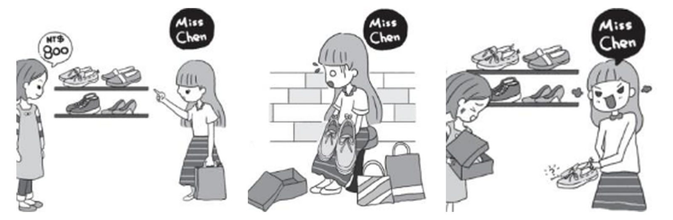
Useful Words & Phrases 實用單字片語
Word / Phrase | 中文 | Word / Phrase | 中文
business woman | 女商人 | opened the box | 打開盒子
forty | 四十歲 | different sizes | 尺寸不同
go shopping | 逛街 | angry | 生氣
on weekends | 週末 | cried | 哭
department store | 百貨公司 | went back | 回去
by taxi | 搭計程車 | clerk | 店員
a pair of shoes | 一雙鞋 | said sorry | 道歉
bought | 買 | changed | 換
excited | 興奮 | happy again | 再度開心
on sale | 特價 | lesson | 教訓
got home | 到家 | check | 檢查
Useful Sentence Patterns 實用句型
1. S + likes to V, and S + often + Vs
→ She likes to go shopping, and she often buys clothes on weekends.
2. When S saw ..., S + Ved
→ When she saw a pair of red shoes, she bought them right away.
3. After S + Ved, S + Ved
→ After she got home, she opened the box happily.
4. S found that + 句子. One was ..., and the other was ...
→ She found that the two shoes were in different sizes. One was size 7, and the other was size 9.
5. The next day, when S + Ved, S + Ved
→ The next day, when she went back to the store, the clerk said sorry and changed the shoes for her.
6. S has learned an important lesson. From now on, S decides to V
→ She has learned an important lesson. From now on, she decides to check her shoes before she leaves the store.
Sentence Patterns 句型表
Column 1｜元素 & 關鍵字 | Column 2｜句型 | Column 3｜例句
人物介紹 Who  business woman 女商人; forty 四十歲 | S + is + a/an + 職業. S + is + 年齡 + years old. | Miss Chen is a business woman. She is forty years old.
喜好 Hobby  go shopping 逛街; on weekends 週末 | S + likes to V, and S + often + Vs | She likes to go shopping, and she often buys clothes on weekends.
圖一 時間地點 Time & Place  department store 百貨公司; by taxi 搭計程車 | One day, S went to + 地方 + to V + by 交通工具. | One day, she went to the department store to buy new shoes by taxi.
圖一 動作 Action  a pair of shoes 一雙鞋; bought 買 | When S saw ..., S + Ved | When she saw a pair of red shoes, she bought them right away.
心情 + 原因 Feeling  excited 興奮; on sale 特價 | S was + adj. + because + 句子 | She was very excited because the shoes were beautiful and on sale.
圖二 時間地點  got home 到家; opened the box 打開盒子 | After S + Ved, S + Ved | After she got home, she opened the box happily.
發現 Discovery  different sizes 尺寸不同; size 7 / size 9 | S found that + 句子. One was ..., and the other was ... | She found that the two shoes were in different sizes. One was size 7, and the other was size 9.
心情 Feeling  angry 生氣; cried 哭 | S was so + adj. + that + 句子 | She was so angry that she almost cried. She could not wear them to work.
圖三 時間地點  went back 回去; clerk 店員; said sorry 道歉; changed 換 | The next day, when S + Ved, S + Ved | The next day, when she went back to the store, the clerk said sorry and changed the shoes for her.
結局 Ending  happy again 再度開心 | In the end, S felt + adj. | In the end, she felt happy again.
萬用結尾 Lesson  lesson 教訓; check 檢查 | S has learned an important lesson. From now on, S decides to V | She has learned an important lesson. From now on, she decides to check her shoes before she leaves the store.
範文 Model Essay (153 words)
Miss Chen is a business woman. She is forty years old. She likes to go shopping, and she often buys clothes on weekends. One day, she went to the department store to buy new shoes by taxi. When she saw a pair of red shoes, she bought them right away. She was very excited because the shoes were beautiful and on sale. After she got home, she opened the box happily. She found that the two shoes were in different sizes. One was size 7, and the other was size 9. She was so angry that she almost cried. She could not wear them to work. The next day, when she went back to the store, the clerk said sorry and changed the shoes for her. In the end, she felt happy again. She has learned an important lesson. From now on, she decides to check her shoes before she leaves the store.
主題 6｜購物 Shopping
Topic 20｜網購烏龍篇 Online Shopping Gone Wrong
題目：Mary 線上購物看到漂亮的褲子，打8折就下單；收到包裹時包裹有點受損，裡面的褲子款式和尺寸也不符合。
圖一 Picture 1  Mary 線上購物看到漂亮的褲子，打8折，她下單買了 | 圖二 Picture 2  Mary 收到包裹，包裹有點受損 | 圖三 Picture 3  裡面的褲子款式和尺寸不符合
Useful Words & Phrases 實用單字片語
Word / Phrase | 中文 | Word / Phrase | 中文
office worker | 上班族 | worried | 擔心
shop online | 網購 | quickly | 很快地
fast and easy | 快速方便 | not the same as | 和…不一樣
shopping website | 購物網站 | picture | 照片
pants | 褲子 | wrong style | 款式不對
20% off | 打8折 | wrong size | 尺寸不對
ordered | 下單 | disappointed | 失望
T-shirt T | 恤 | called | 打電話
excited | 興奮 | said sorry | 道歉
party | 派對 | gave her money back | 退錢
package | 包裹 | terrible experience | 糟糕的經驗
arrived | 送達 | reviews | 評價
broken | 破損
Useful Sentence Patterns 實用句型
1. S + likes to V + because + 句子
→ She likes to shop online because it is fast and easy.
2. S + was/were + 20% off, so S + Ved
→ The pants were 20% off, so she ordered them right away.
3. S was + adj. + because + S wanted to V
→ She was excited because she wanted to wear them to a party.
4. To one's surprise, + 句子
→ To her surprise, the pants were not the same as the picture.
5. S was so + adj. + that + 句子
→ She was so disappointed that she called the online store.
6. This was a + adj. + experience. From now on, S decides to V
→ This was a terrible experience. From now on, she decides to read the reviews before she buys anything online.
Sentence Patterns 句型表
Column 1｜元素 & 關鍵字 | Column 2｜句型 | Column 3｜例句
人物介紹 Who  office worker 上班族; 25-year-old | S + is + a + 年齡-year-old + 職業. | Mary is a 25-year-old office worker.
喜好 Hobby  shop online 網購; fast and easy 快速方便 | S + likes to V + because + 句子 | She likes to shop online because it is fast and easy.
圖一 時間地點  shopping website 購物網站; pants 褲子 | Last + 時間, while S was Ving, S + Ved | Last Monday, while she was using her phone, she saw a pair of beautiful pants on a shopping website.
圖一 動作  20% off 打8折; ordered 下單 | S + was/were + 20% off, so S + Ved | The pants were 20% off, so she ordered them right away.
加購 Extra  also 也; T-shirt T恤 | S also + Ved + N. | She also bought a white T-shirt with them.
心情 + 原因  excited 興奮; party 派對 | S was + adj. + because + S wanted to V | She was excited because she wanted to wear them to a party.
圖二 時間地點  package 包裹; arrived 送達; broken 破損 | Three days later, when S + Ved, S found that + 句子 | Three days later, when the package arrived, she found that the box was a little broken.
心情 Feeling  worried 擔心; quickly 很快地 | S was + adj., but S still + Ved | She was worried, but she still opened it quickly.
圖三 意外 Surprise  not the same as 和…不一樣; picture 照片 | To one's surprise, + 句子 | To her surprise, the pants were not the same as the picture.
細節 Details  wrong style 款式不對; wrong size 尺寸不對 | S was/were not only A but also B. | They were not only the wrong style but also the wrong size.
心情 + 行動  disappointed 失望; called 打電話 | S was so + adj. + that + 句子 | She was so disappointed that she called the online store.
結局 Ending  said sorry 道歉; gave her money back 退錢 | S said sorry and + Ved | The store said sorry and gave her money back.
萬用結尾  terrible experience 糟糕的經驗; reviews 評價 | This was a + adj. + experience. From now on, S decides to V | This was a terrible experience. From now on, she decides to read the reviews before she buys anything online.
範文 Model Essay (154 words)
Mary is a 25-year-old office worker. She likes to shop online because it is fast and easy. Last Monday, while she was using her phone, she saw a pair of beautiful pants on a shopping website. The pants were 20% off, so she ordered them right away. She also bought a white T-shirt with them. She was excited because she wanted to wear them to a party. Three days later, when the package arrived, she found that the box was a little broken. She was worried, but she still opened it quickly. To her surprise, the pants were not the same as the picture. They were not only the wrong style but also the wrong size. She was so disappointed that she called the online store. The store said sorry and gave her money back. This was a terrible experience. From now on, she decides to read the reviews before she buys anything online.
主題 6｜購物 Shopping
Topic 21｜百貨公司特賣篇 The Big Shoe Sale
題目：昨天你去逛百貨公司時，看到一張特賣會的海報。請根據以下的圖片寫一篇約 50 字的短文。注意：未依提示作答者，將予扣分。
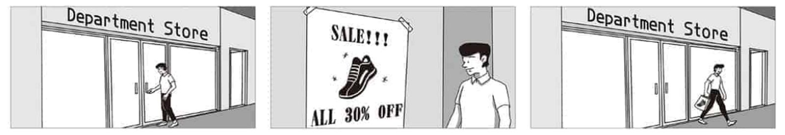
Useful Words & Phrases 實用單字片語
Word / Phrase | 中文 | Word / Phrase | 中文
college student | 大學生 | excited | 興奮
sports | 運動 | cheaper | 更便宜
sneakers | 運動鞋 | tried on | 試穿
department store | 百貨公司 | fit | 合身
downtown | 市中心 | decided | 決定
look around | 四處逛逛 | buy | 買
free | 有空 | paid for | 付錢
poster | 海報 | counter | 櫃台
wall | 牆 | right away | 立刻
sale | 特賣 | left | 離開
30% off | 打七折 | shopping bag | 購物袋
on sale | 特價 | couldn't wait | 等不及
black | 黑色 | wear | 穿
cool | 酷 | luckiest | 最幸運的
Useful Sentence Patterns 實用句型
1. I like + N, and I love + N.
→ I like sports, and I love sneakers.
2. When I + Ved, I saw + N.
→ When I walked inside, I saw a poster on the wall.
3. I found that + 句子.
→ I found that the sneakers were on sale.
4. I + Ved + N, and they + Ved + 人 + adv.
→ I tried on a pair of sneakers, and they fit me perfectly.
5. So I + Ved + N + at + 地點 + right away.
→ So I paid for them at the counter right away.
6. For me, it was the + 最高級 + N.
→ For me, it was the luckiest shopping day of the year.
Sentence Patterns 句型表
Column 1｜元素 & 關鍵字 | Column 2｜句型 | Column 3｜例句
人物介紹 Who  college student 大學生 | I + am + a + 年齡-year-old + 職業. | I am a 20-year-old college student.
喜好 Hobby  sports 運動; sneakers 運動鞋 | I like + N, and I love + N. | I like sports, and I love sneakers.
圖一 時間地點  department store 百貨公司; downtown 市中心 | Yesterday afternoon, I + Ved + to + 地點. | Yesterday afternoon, I went to a department store downtown.
圖一 原因 Reason  look around 四處逛逛; free 有空 | I wanted to V because + 句子. | I wanted to look around because I had nothing to do.
圖二 時間地點  poster 海報; wall 牆 | When I + Ved, I saw + N. | When I walked inside, I saw a poster on the wall.
海報 Poster  sale 特賣; 30% off 打七折 | It said, "..." | It said, "SALE! All 30% off!" in big letters.
發現 Discovery  on sale 特價 | I found that + 句子. | I found that the sneakers were on sale.
樣子 Look  black 黑色; cool 酷 | S were + adj. and adj. | They were black and very cool.
心情 + 原因 Feeling  excited 興奮; cheaper 更便宜 | I felt + adj. + because + 句子. | I felt excited because they were much cheaper than usual.
動作 Action  tried on 試穿; fit 合身 | I + Ved + N, and they + Ved + 人 + adv. | I tried on a pair of sneakers, and they fit me perfectly.
決定 Decision  decided 決定; buy 買 | I decided to V + N. | I decided to buy them.
圖三 結果  paid for 付錢; counter 櫃台; right away 立刻 | So I + Ved + N + at + 地點 + right away. | So I paid for them at the counter right away.
結局 Ending  left 離開; shopping bag 購物袋 | When I left + 地點, I was Ving + N. | When I left the department store, I was carrying a big shopping bag with my new shoes in it.
心情 Feeling  couldn't wait 等不及; wear 穿 | I couldn't wait to V. | I couldn't wait to wear them to school.
萬用結尾 Lesson  luckiest 最幸運的 | For me, it was the + 最高級 + N. | For me, it was the luckiest shopping day of the year.
範文 Model Essay (142 words)
I am a 20-year-old college student. I like sports, and I love sneakers. Yesterday afternoon, I went to a department store downtown. I wanted to look around because I had nothing to do. When I walked inside, I saw a poster on the wall. It said, "SALE! All 30% off!" in big letters. I found that the sneakers were on sale. They were black and very cool. I felt excited because they were much cheaper than usual. I tried on a pair of sneakers, and they fit me perfectly. I decided to buy them. So I paid for them at the counter right away. When I left the department store, I was carrying a big shopping bag with my new shoes in it. I couldn't wait to wear them to school. For me, it was the luckiest shopping day of the year.
主題 6｜購物 Shopping
Topic 22｜打破花瓶篇 The Broken Vase
題目：上星期一，Candy去百貨公司買花瓶（vase）。請根據以下的圖片寫一篇約50字的短文。注意：未依提示作答者，將予扣分。
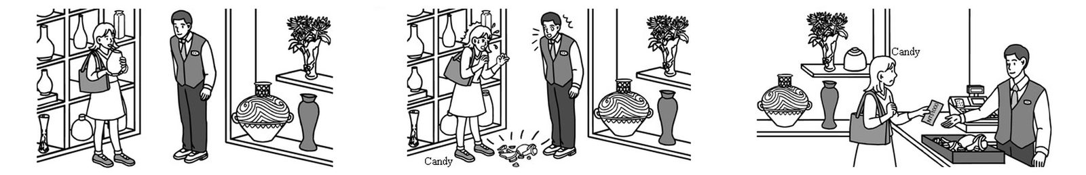
Useful Words & Phrases 實用單字片語
Word / Phrase | 中文 | Word / Phrase | 中文
office worker | 上班族 | fell | 掉落
flowers | 花 | broke into pieces | 碎成片
vases | 花瓶 | shocked | 震驚
department store | 百貨公司 | embarrassed | 尷尬
buy | 買 | came over | 走過來
shelf | 架子 | pay for | 賠償
picked up | 拿起 | pay | 付錢
pretty | 漂亮 | one thousand dollars | 一千元
wanted to | 想要 | terrible | 很糟
clerk | 店員 | didn't get | 沒得到
next to | 在旁邊 | be more careful | 更小心
careless | 粗心 | bad day | 倒楣的一天
dropped | 掉落
Useful Sentence Patterns 實用句型
1. S loves + N, and S often + Vs
→ She loves flowers, and she often puts them in vases at home.
2. There, S saw + N on + N and Ved it up.
→ There, she saw a beautiful vase on the shelf and picked it up.
3. S stood next to + 人 and Ved.
→ A clerk stood next to her and watched quietly.
4. S was + adj. and + adj.
→ Candy was shocked and embarrassed.
5. In the end, S had to V + 金額 + for + N.
→ In the end, she had to pay one thousand dollars for the broken vase.
6. S thought to herself, "..."
→ She thought to herself, "I should be more careful next time. What a bad day!"
Sentence Patterns 句型表
Column 1｜元素 & 關鍵字 | Column 2｜句型 | Column 3｜例句
人物介紹 Who  office worker 上班族 | S + is + a + 年齡-year-old + 職業. | Candy is a 25-year-old office worker.
喜好 Hobby  flowers 花; vases 花瓶 | S loves + N, and S often + Vs | She loves flowers, and she often puts them in vases at home.
圖一 時間地點  department store 百貨公司; buy 買 | Last Monday, S went to + 地點 to V. | Last Monday, she went to a department store to buy a vase.
圖一 動作  shelf 架子; picked up 拿起 | There, S saw + N on + N and Ved it up. | There, she saw a beautiful vase on the shelf and picked it up.
圖一 細節 Details  pretty 漂亮; wanted to 想要 | It was + adj. and + adj., and S wanted to V. | It was white and very pretty, and she wanted to buy it.
圖一 店員 Clerk  clerk 店員; next to 在旁邊 | S stood next to + 人 and Ved. | A clerk stood next to her and watched quietly.
圖二 意外 Accident  careless 粗心; dropped 掉落 | However, S was so + adj. + that + 句子 | However, she was so careless that she dropped the vase.
結果 Result  fell 掉落; broke into pieces 碎成片 | S fell onto + N and Ved into pieces. | It fell onto the floor and broke into pieces.
心情 Feeling  shocked 震驚; embarrassed 尷尬 | S was + adj. and + adj. | Candy was shocked and embarrassed.
店員 Clerk  came over 走過來; pay for 賠償 | S came over and said, "..." | The clerk came over and said, "Miss, you have to pay for it."
圖三 結局 Ending  pay 付錢; one thousand dollars 一千元 | In the end, S had to V + 金額 + for + N. | In the end, she had to pay one thousand dollars for the broken vase.
心情 + 原因 Feeling  terrible 很糟; didn't get 沒得到 | S felt + adj. + because + 句子 | She felt terrible because she spent money but didn't even get a new vase.
萬用結尾 Lesson  be more careful 更小心; bad day 倒楣的一天 | S thought to herself, "..." | She thought to herself, "I should be more careful next time. What a bad day!"
範文 Model Essay (144 words)
Candy is a 25-year-old office worker. She loves flowers, and she often puts them in vases at home. Last Monday, she went to a department store to buy a vase. There, she saw a beautiful vase on the shelf and picked it up. It was white and very pretty, and she wanted to buy it. A clerk stood next to her and watched quietly. However, she was so careless that she dropped the vase. It fell onto the floor and broke into pieces. Candy was shocked and embarrassed. The clerk came over and said, "Miss, you have to pay for it." In the end, she had to pay one thousand dollars for the broken vase. She felt terrible because she spent money but didn't even get a new vase. She thought to herself, "I should be more careful next time. What a bad day!"
主題 6｜購物 Shopping
Topic 23｜百貨公司走失 Lost in the Department Store
題目：Johnny 的媽媽昨天帶他去百貨公司購物，一不小心，Johnny 竟然差點走丟了。請依據下面的圖片，寫一篇短文來描述這個故事。
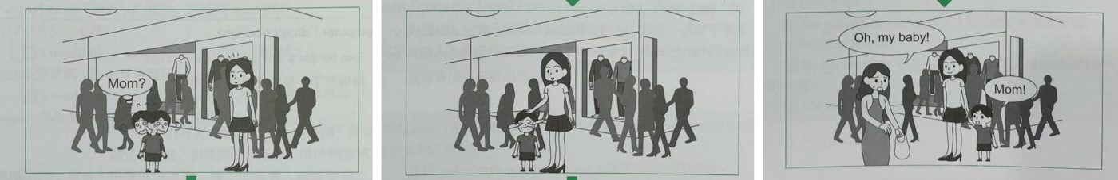
Useful Words & Phrases 實用單字片語
Word / Phrase | 中文 | Word / Phrase | 中文
five-year-old boy | 五歲男孩 | scared | 害怕
go out | 出門 | started to cry | 開始哭
curious | 好奇 | kind | 好心的
runs around | 到處跑 | came to help | 過來幫忙
took him to | 帶他去 | asked | 問
go shopping | 購物 | held his hand | 牽他的手
crowded with | 擠滿 | finally | 終於
big sale | 大特價 | in the crowd | 在人群中
got lost | 走丟 | hugged | 抱
looked for | 尋找 | see each other | 見到彼此
for a long time | 很久 | stay close to | 待在…旁邊
shouted | 大喊
Useful Sentence Patterns 實用句型
1. S likes to V
→ He likes to go out with his mother.
2. Yesterday, S took + 人 + to + 地方 + to V
→ Yesterday, Johnny's mother took him to a department store to go shopping.
3. S + Ved for a long time, but S couldn't V
→ He looked for his mother for a long time, but he couldn't find her.
4. S was so + adj. + that + 句子
→ He was so scared that he started to cry.
5. Finally, S + Ved
→ Finally, Johnny's mother found him in the crowd.
6. S has learned an important lesson. From now on, S decides to V
→ Johnny has learned an important lesson. From now on, he decides to stay close to his mother.
Sentence Patterns 句型表
Column 1｜元素 & 關鍵字 | Column 2｜句型 | Column 3｜例句
人物介紹 Who  five-year-old boy 五歲男孩 | S + is + a + 年齡-year-old + N. | Johnny is a five-year-old boy.
喜好 Hobby  go out 出門 | S likes to V | He likes to go out with his mother.
個性 Personality  curious 好奇; runs around 到處跑 | S is + adj., and S often + Vs | He is curious, and he often runs around.
圖一 時間地點  took him to 帶他去; go shopping 購物 | Yesterday, S took + 人 + to + 地方 + to V | Yesterday, Johnny's mother took him to a department store to go shopping.
擁擠 Crowded  crowded with 擠滿; big sale 大特價 | S was crowded with + N + because + 句子 | The store was crowded with people because there was a big sale.
走失 Lost  got lost 走丟 | While S was Ving, S + Ved | While his mother was looking at some clothes, Johnny got lost.
圖二 尋找  looked for 尋找; for a long time 很久 | S + Ved for a long time, but S couldn't V | He looked for his mother for a long time, but he couldn't find her.
呼喊 Shout  shouted 大喊 | S + Ved, "..." | He shouted, "Mom? Where are you?"
心情 Feeling  scared 害怕; started to cry 開始哭 | S was so + adj. + that + 句子 | He was so scared that he started to cry.
幫忙 Help  kind 好心的; came to help 過來幫忙 | S saw + 人 + Ving and came to V | A kind girl saw him crying and came to help him.
幫忙細節  asked 問; held his hand 牽他的手 | S asked + 人 + about + N | The girl asked him about his mother's name and held his hand.
圖三 找到  finally 終於; in the crowd 在人群中 | Finally, S + Ved | Finally, Johnny's mother found him in the crowd.
對話 + 心情  hugged 抱; see each other 見到彼此 | S + Ved and said, "..." S were very + adj. + to V | She hugged him and said, "Oh, my baby!" They were very happy to see each other again.
萬用結尾  stay close to 待在…旁邊 | S has learned an important lesson. From now on, S decides to V | Johnny has learned an important lesson. From now on, he decides to stay close to his mother.
範文 Model Essay (150 words)
Johnny is a five-year-old boy. He likes to go out with his mother. He is curious, and he often runs around. Yesterday, Johnny's mother took him to a department store to go shopping. The store was crowded with people because there was a big sale. While his mother was looking at some clothes, Johnny got lost. He looked for his mother for a long time, but he couldn't find her. He shouted, "Mom? Where are you?" He was so scared that he started to cry. A kind girl saw him crying and came to help him. The girl asked him about his mother's name and held his hand. Finally, Johnny's mother found him in the crowd. She hugged him and said, "Oh, my baby!" They were very happy to see each other again. Johnny has learned an important lesson. From now on, he decides to stay close to his mother.
主題 6｜購物 Shopping
Topic 24｜和媽媽逛市場篇 A Trip to the Market
題目：星期天，你和媽媽去市場買菜。市場好熱鬧喔！請根據這些圖片，寫一篇約 50 字的短文。
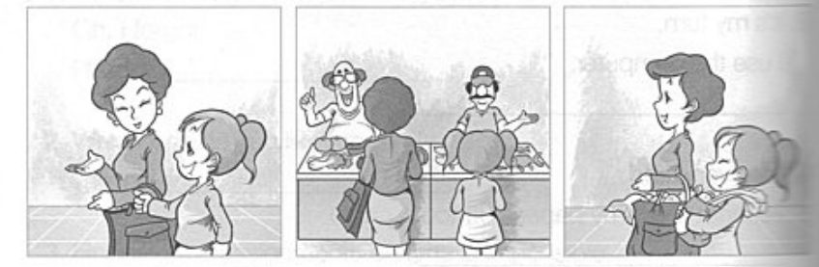
Useful Words & Phrases 實用單字片語
Word / Phrase | 中文 | Word / Phrase | 中文
elementary school student | 小學生 | friendly | 友善
helpful | 樂於助人 | fresh | 新鮮
housework | 家事 | waved | 揮手
last Sunday | 上星期天 | take a look | 看一看
market | 市場 | bought | 買
happy | 開心 | vegetables | 蔬菜
love | 喜愛 | fruit | 水果
lively | 熱鬧 | on the way home | 回家路上
arrived | 到達 | carried | 提
stalls | 攤位 | thanked | 謝謝
colorful | 色彩繽紛 | proud | 驕傲
sellers | 小販 | best | 最棒
shouting | 叫賣 | Sunday | 星期天
Useful Sentence Patterns 實用句型
1. I am + adj., and I often V
→ I am helpful, and I often help my mother with housework.
2. I felt + adj. + because + 句子
→ I felt happy because I love going to the market with her.
3. The stalls were full of + N.
→ The stalls were full of colorful vegetables, fruit, and meat.
4. Another + N + Ved at us and said, "..."
→ Another seller waved at us and said, "Come and take a look!"
5. On the way home, I + Ved + N for + 人.
→ On the way home, I carried a heavy bag for my mother.
6. For me, it was the + 最高級 + N.
→ For me, it was the best Sunday of the month.
Sentence Patterns 句型表
Column 1｜元素 & 關鍵字 | Column 2｜句型 | Column 3｜例句
人物介紹 Who  elementary school student 小學生 | I + am + a + 年齡-year-old + 職業. | I am a 10-year-old elementary school student.
個性 Personality  helpful 樂於助人; housework 家事 | I am + adj., and I often V | I am helpful, and I often help my mother with housework.
圖一 時間地點  last Sunday 上星期天; market 市場 | Last Sunday, S asked + 人 + to V with her. | Last Sunday morning, my mother asked me to go to the market with her.
心情 + 原因 Feeling  happy 開心; love 喜愛 | I felt + adj. + because + 句子 | I felt happy because I love going to the market with her.
圖二 時間地點  lively 熱鬧; arrived 到達 | When we arrived, S was very + adj. | When we arrived, the market was very lively.
圖二 景色 Scene  stalls 攤位; colorful 色彩繽紛 | The stalls were full of + N. | The stalls were full of colorful vegetables, fruit, and meat.
圖二 動作  sellers 小販; shouting 叫賣 | There were many + N, and S were Ving | There were many people and sellers, and some sellers were shouting loudly.
細節 Details  friendly 友善; fresh 新鮮 | One + N + Ved at us and said, "..." | One friendly seller smiled at us and said, "My vegetables are very fresh!"
細節 2 Details  waved 揮手; take a look 看一看 | Another + N + Ved at us and said, "..." | Another seller waved at us and said, "Come and take a look!"
購物 Shopping  bought 買; vegetables 蔬菜; fruit 水果 | We + Ved + N, N, and N. | We bought some fresh vegetables, meat, and fruit for dinner.
圖三 時間地點  on the way home 回家路上; carried 提 | On the way home, I + Ved + N for + 人. | On the way home, I carried a heavy bag for my mother.
心情 Feeling  thanked 謝謝; proud 驕傲 | S thanked me, and I felt + adj. | My mother thanked me, and I felt very proud of myself.
萬用結尾 Ending  best 最棒; Sunday 星期天 | For me, it was the + 最高級 + N. | For me, it was the best Sunday of the month.
範文 Model Essay (142 words)
I am a 10-year-old elementary school student. I am helpful, and I often help my mother with housework. Last Sunday morning, my mother asked me to go to the market with her. I felt happy because I love going to the market with her. When we arrived, the market was very lively. The stalls were full of colorful vegetables, fruit, and meat. There were many people and sellers, and some sellers were shouting loudly. One friendly seller smiled at us and said, "My vegetables are very fresh!" Another seller waved at us and said, "Come and take a look!" We bought some fresh vegetables, meat, and fruit for dinner. On the way home, I carried a heavy bag for my mother. My mother thanked me, and I felt very proud of myself. For me, it was the best Sunday of the month.
主題 7｜意外與安全 Accidents & Safety
Topic 25｜滑手機出車禍篇 Eyes on the Phone
題目：一邊走路一邊滑手機 → 被車子撞 → 路人打119，救護車送去醫院。
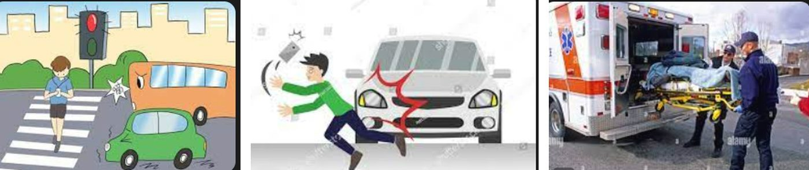
Useful Words & Phrases 實用單字片語
Word / Phrase | 中文 | Word / Phrase | 中文
senior high school student | 高中生 | hit | 撞
cell phone | 手機 | badly hurt | 傷得很重
at the same time | 同時 | called 119 | 打119
scroll through | 滑 | ambulance | 救護車
earphones | 耳機 | sent | 送
crossing the street | 過馬路 | stay | 待
pay attention to | 注意 | sorry | 抱歉
traffic light | 紅綠燈 | worried about | 擔心
turned red | 變紅燈 | lesson | 教訓
honked | 按喇叭 | while walking | 走路時
hear | 聽見
Useful Sentence Patterns 實用句型
1. S loves + N, and S often + Vs
→ He loves his cell phone, and he often watches YouTube videos on it.
2. S was Ving and Ving
→ He was scrolling through TikTok videos and listening to music with earphones.
3. At that moment, S + Ved, but S didn't notice it.
→ At that moment, the traffic light turned red, but he didn't notice it.
4. S hit + 人, and S was + adj.
→ The car hit him, and he was badly hurt.
5. S + Ved, and S had to V for + 時間
→ They sent him to the hospital, and he had to stay there for a month.
6. S has learned an important lesson. S will never V again.
→ He has learned an important lesson. He will never use his phone while he is walking again.
Sentence Patterns 句型表
Column 1｜元素 & 關鍵字 | Column 2｜句型 | Column 3｜例句
人物介紹 Who  senior high school student 高中生 | S + is + a + 年齡-year-old + 職業. | Tom is a 16-year-old senior high school student.
喜好 Hobby  cell phone 手機; YouTube videos | S loves + N, and S often + Vs | He loves his cell phone, and he often watches YouTube videos on it.
圖一 時間地點  at the same time 同時 | Last + 時間, S + Ved and Ved at the same time. | Last Monday, he walked home and used his phone at the same time.
細節 Details  scroll through 滑; earphones 耳機 | S was Ving and Ving | He was scrolling through TikTok videos and listening to music with earphones.
圖二 過馬路  crossing the street 過馬路; pay attention to 注意 | When S was Ving, S did not V | When he was crossing the street, he did not pay attention to the cars.
紅燈 Red light  traffic light 紅綠燈; turned red 變紅燈 | At that moment, S + Ved, but S didn't notice it. | At that moment, the traffic light turned red, but he didn't notice it.
喇叭 Honk  honked 按喇叭; hear 聽見 | S + Ved, but S did not V + because + 句子 | A driver honked, but Tom did not hear it because he was listening to music.
被撞 Hit  hit 撞; badly hurt 傷得很重 | S hit + 人, and S was + adj. | The car hit him, and he was badly hurt.
圖三 求救  called 119 打119; ambulance 救護車 | 時間 + later, S + Ved. | Someone called 119 for help. Ten minutes later, the ambulance arrived.
送醫 Hospital  sent 送; stay 待 | S + Ved, and S had to V for + 時間 | They sent him to the hospital, and he had to stay there for a month.
心情 + 原因  sorry 抱歉; worried about 擔心 | S felt + adj. + because + 句子 | He felt very sorry because his parents were worried about him.
萬用結尾  lesson 教訓; while walking 走路時 | S has learned an important lesson. S will never V again. | He has learned an important lesson. He will never use his phone while he is walking again.
範文 Model Essay (151 words)
Tom is a 16-year-old senior high school student. He loves his cell phone, and he often watches YouTube videos on it. Last Monday, he walked home and used his phone at the same time. He was scrolling through TikTok videos and listening to music with earphones. When he was crossing the street, he did not pay attention to the cars. At that moment, the traffic light turned red, but he didn't notice it. A driver honked, but Tom did not hear it because he was listening to music. The car hit him, and he was badly hurt. Someone called 119 for help. Ten minutes later, the ambulance arrived. They sent him to the hospital, and he had to stay there for a month. He felt very sorry because his parents were worried about him. He has learned an important lesson. He will never use his phone while he is walking again.
主題 7｜意外與安全 Accidents & Safety
Topic 26｜邊走邊滑手機篇 Eric and the Sleeping Dog
題目：昨天 Eric 走路回家時邊走邊使用手機。請根據以下的圖片寫一篇約 50 字的短文。注意：未依提示作答者，將予扣分。
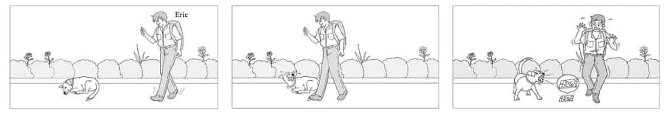
Useful Words & Phrases 實用單字片語
Word / Phrase | 中文 | Word / Phrase | 中文
senior high school student | 高中生 | cried out | 叫出來
phone | 手機 | stood up | 站起來
all the time | 一直 | barked at | 對…吠叫
walking home | 走路回家 | scared | 害怕
looking at | 看著 | jumped back | 往後跳
sleeping | 睡覺 | dropped | 掉落
sidewalk | 人行道 | screen | 螢幕
busy with | 忙於 | broken | 破掉的
notice | 注意到 | sad | 難過
suddenly | 突然 | picked up | 撿起
stepped on | 踩到 | carefully | 小心地
woke up | 醒來 | important lesson | 重要的教訓
angrily | 生氣地 | while walking | 走路時
hurt | 受傷
Useful Sentence Patterns 實用句型
1. S loves + N, and S + Vs + N + all the time.
→ He loves his phone, and he uses it all the time.
2. There was a + N + Ving + on + 地點.
→ There was a dog sleeping on the sidewalk near the bushes.
3. S + Ved and Ved + 人 + adv.
→ The dog woke up and looked at him angrily.
4. Then, S + Ved and Ved at + 人 + adv.
→ Then, it stood up and barked at Eric loudly and angrily.
5. S felt + adj. + because + 句子.
→ He felt sad because his phone was broken.
6. S has learned an important lesson: S should not V.
→ He has learned an important lesson: he should not use his phone while walking on the street.
Sentence Patterns 句型表
Column 1｜元素 & 關鍵字 | Column 2｜句型 | Column 3｜例句
人物介紹 Who  senior high school student 高中生 | S + is + a + 年齡-year-old + 職業. | Eric is a 16-year-old senior high school student.
喜好 Hobby  phone 手機; all the time 一直 | S loves + N, and S + Vs + N + all the time. | He loves his phone, and he uses it all the time.
圖一 時間 + 動作  walking home 走路回家; looking at 看著 | Yesterday, when S was Ving, S was Ving. | Yesterday, when he was walking home, he was looking at his phone.
圖一 細節  sleeping 睡覺; sidewalk 人行道 | There was a + N + Ving + on + 地點. | There was a dog sleeping on the sidewalk near the bushes.
原因 Reason  busy with 忙於; notice 注意到 | S was so + adj. + that + S didn't V. | He was so busy with his phone that he didn't notice the dog.
圖二 動作  suddenly 突然; stepped on 踩到 | Suddenly, S + Ved + N. | Suddenly, he stepped on the dog.
反應 Reaction  woke up 醒來; angrily 生氣地 | S + Ved and Ved + 人 + adv. | The dog woke up and looked at him angrily.
痛 Pain  hurt 受傷; cried out 叫出來 | S + Ved because + 句子. | It cried out because it was hurt.
圖三 動作  stood up 站起來; barked at 對…吠叫 | Then, S + Ved and Ved at + 人 + adv. | Then, it stood up and barked at Eric loudly and angrily.
心情 Feeling  scared 害怕; jumped back 往後跳 | S felt + adj., and S + Ved. | Eric felt very scared, and he jumped back with his hands up.
發現 Discovery  dropped 掉落; screen 螢幕; broken 破掉的 | S found that + 句子. | He found that he had dropped his phone, and the screen was broken.
心情 + 原因 Feeling  sad 難過 | S felt + adj. + because + 句子. | He felt sad because his phone was broken.
結局 Ending  picked up 撿起; carefully 小心地 | After that, S + Ved + N and Ved + adv. | After that, he picked up his phone and walked home carefully.
萬用結尾 Lesson  important lesson 重要的教訓; while walking 走路時 | S has learned an important lesson: S should not V. | He has learned an important lesson: he should not use his phone while walking on the street.
範文 Model Essay (149 words)
Eric is a 16-year-old senior high school student. He loves his phone, and he uses it all the time. Yesterday, when he was walking home, he was looking at his phone. There was a dog sleeping on the sidewalk near the bushes. He was so busy with his phone that he didn't notice the dog. Suddenly, he stepped on the dog. The dog woke up and looked at him angrily. It cried out because it was hurt. Then, it stood up and barked at Eric loudly and angrily. Eric felt very scared, and he jumped back with his hands up. He found that he had dropped his phone, and the screen was broken. He felt sad because his phone was broken. After that, he picked up his phone and walked home carefully. He has learned an important lesson: he should not use his phone while walking on the street.
主題 7｜意外與安全 Accidents & Safety
Topic 27｜河邊溺水驚魂（第一人稱） Saved from the River
題目：上個星期日，一個男孩到河裡游泳，但險些溺斃，幸好路人經過救了他。請依據下面的圖片，並用第一人稱的敘述，寫一篇短文來描述這個事件。
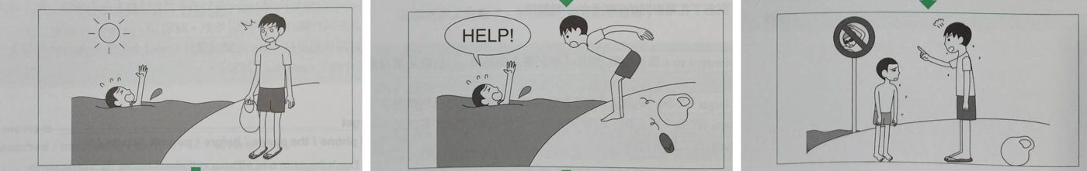
Useful Words & Phrases 實用單字片語
Word / Phrase | 中文 | Word / Phrase | 中文
junior high school student | 國中生 | saved my life | 救了我
swimming | 游泳 | safe | 安全
not good at | 不擅長 | thankful | 感激
very hot | 很熱 | got out of | 離開
river | 河 | angry | 生氣
alone | 獨自 | pointed at | 指著
busy | 忙 | "No Swimming" sign | 禁止游泳
cold | 冷 | deep | 深
legs couldn't move | 腿動不了 | fast | 湍急
sinking | 下沉 | sorry | 抱歉
shouted for help | 大聲呼救 | thanked | 道謝
luckily | 幸運地 | lesson | 教訓
walking along | 沿著…走 | never again | 不再
jumped into | 跳進
Useful Sentence Patterns 實用句型
1. I like + Ving, but I am not good at it.
→ I like swimming very much, but I am not good at it.
2. S + Ved alone because + 句子
→ I went there alone because my friends were busy that day.
3. Luckily, S was Ving, and S + Ved
→ Luckily, a man was walking along the river, and he heard me.
4. I was + adj., and I was very + adj.
→ I was safe, and I was very thankful.
5. S was + adj. + because + 句子
→ The river was dangerous because the water was deep and fast.
6. I have learned an important lesson. From now on, I will never V again.
→ I have learned an important lesson. From now on, I will never swim in a river again.
Sentence Patterns 句型表
Column 1｜元素 & 關鍵字 | Column 2｜句型 | Column 3｜例句
人物介紹 Who (第一人稱)  junior high school student 國中生 | I am a + 年齡-year-old + 職業. | I am a 13-year-old junior high school student.
喜好 Hobby  swimming 游泳; not good at 不擅長 | I like + Ving, but I am not good at it. | I like swimming very much, but I am not good at it.
圖一 時間地點  very hot 很熱; river 河 | Last + 時間, it was + adj., so I + Ved | Last Sunday, it was very hot, so I went swimming in a river.
原因 Reason  alone 獨自; busy 忙 | S + Ved alone because + 句子 | I went there alone because my friends were busy that day.
危險 Danger  cold 冷; legs couldn't move 腿動不了 | S was so + adj. + that + 句子 | The water was so cold that my legs couldn't move.
下沉 Sinking  sinking 下沉; shouted for help 大聲呼救 | While I was Ving, I + Ved | While I was sinking, I shouted for help.
圖二 救援  luckily 幸運地; walking along 沿著…走 | Luckily, S was Ving, and S + Ved | Luckily, a man was walking along the river, and he heard me.
救人 Rescue  jumped into 跳進; saved my life 救了我 | S quickly + Ved and Ved | He quickly jumped into the river and saved my life.
心情 Feeling  safe 安全; thankful 感激 | I was + adj., and I was very + adj. | I was safe, and I was very thankful.
圖三 生氣  got out of 離開; angry 生氣 | However, after S + Ved, S looked + adj. | However, after we got out of the water, he looked very angry.
標誌 Sign  pointed at 指著; "No Swimming" sign 禁止游泳 | S + Ved and said, "..." | He pointed at a "No Swimming" sign and said, "You shouldn't swim here. It's dangerous!"
原因 Reason  deep 深; fast 湍急 | S was + adj. + because + 句子 | The river was dangerous because the water was deep and fast.
心情 Feeling  sorry 抱歉; thanked 道謝 | I felt + adj., and I + Ved | I felt very sorry, and I thanked him again and again.
萬用結尾  lesson 教訓; never again 不再 | I have learned an important lesson. From now on, I will never V again. | I have learned an important lesson. From now on, I will never swim in a river again.
範文 Model Essay (158 words)
I am a 13-year-old junior high school student. I like swimming very much, but I am not good at it. Last Sunday, it was very hot, so I went swimming in a river. I went there alone because my friends were busy that day. The water was so cold that my legs couldn't move. While I was sinking, I shouted for help. Luckily, a man was walking along the river, and he heard me. He quickly jumped into the river and saved my life. I was safe, and I was very thankful. However, after we got out of the water, he looked very angry. He pointed at a "No Swimming" sign and said, "You shouldn't swim here. It's dangerous!" The river was dangerous because the water was deep and fast. I felt very sorry, and I thanked him again and again. I have learned an important lesson. From now on, I will never swim in a river again.
主題 8｜公德心與鄰居 Manners & Neighbors
Topic 28｜插隊被PO網公審篇 Cutting in Line
題目：上週末 Tom 去新開的餐廳，排隊時等得不耐煩而插隊，被罵還被錄影 PO 上網。
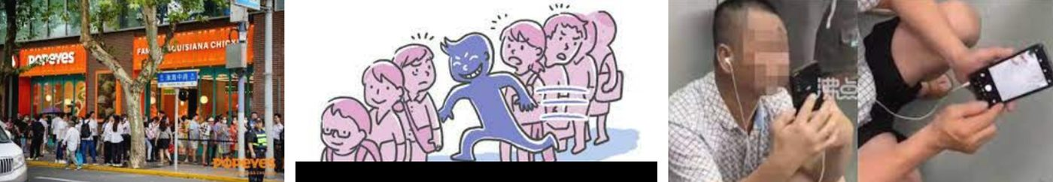
Useful Words & Phrases 實用單字片語
Word / Phrase | 中文 | Word / Phrase | 中文
college student | 大學生 | save time | 省時間
trying new food | 嘗試新食物 | behavior | 行為
fried chicken restaurant | 炸雞店 | shouted at | 對…大吼
opened | 開幕 | recorded | 錄影
lined up | 排隊 | posted | 上傳
a long line | 大排長龍 | social media | 社群媒體
waited in line | 排隊等 | left comments | 留言
hot and sunny | 又熱又晴 | shouldn't | 不應該
spent | 花 | embarrassed | 丟臉
impatient | 不耐煩 | famous | 出名
hungry | 餓 | Internet | 網路
breakfast | 早餐 | lesson | 教訓
cut in line | 插隊 | never again | 不再
Useful Sentence Patterns 實用句型
1. S likes + Ving
→ He likes trying new food.
2. Many people lined up to V, so there was a long line of + N.
→ Many people lined up to buy the food, so there was a long line of customers.
3. S was + adj. and adj. + because + 句子
→ He was hungry and tired because he did not eat breakfast.
4. S's behavior made + 人 + adj., and + 句子
→ His behavior made other people angry, and they shouted at him.
5. S felt so + adj. + that + 句子
→ Tom felt so embarrassed that he left right away.
6. S has learned an important lesson. S will never V again.
→ He has learned an important lesson. He will never cut in line again.
Sentence Patterns 句型表
Column 1｜元素 & 關鍵字 | Column 2｜句型 | Column 3｜例句
人物介紹 Who  college student 大學生 | S + is + a + 年齡-year-old + 職業. | Tom is a 20-year-old college student.
喜好 Hobby  trying new food 嘗試新食物 | S likes + Ving | He likes trying new food.
圖一 活動 Event  fried chicken restaurant 炸雞店; opened 開幕 | Last weekend, a new + N + opened in + 地方. | Last weekend, a new fried chicken restaurant opened in his town.
人潮 Crowd  lined up 排隊; a long line 大排長龍 | Many people lined up to V, so there was a long line of + N. | Many people lined up to buy the food, so there was a long line of customers.
圖二 等待  waited in line 排隊等; hot and sunny 又熱又晴 | S + Ved, but it was + adj. and adj. | Tom waited in line, but it was hot and sunny.
不耐煩 Impatient  spent 花; impatient 不耐煩 | After S spent + 時間 + Ving, S was + adj. | After he spent thirty minutes waiting, he was very impatient.
原因 Reason  hungry 餓; breakfast 早餐 | S was + adj. and adj. + because + 句子 | He was hungry and tired because he did not eat breakfast.
插隊 Cut in line  cut in line 插隊; save time 省時間 | S decided to V + to V (目的) | He decided to cut in line to save time.
圖三 別人反應  behavior 行為; shouted at 對…大吼 | S's behavior made + 人 + adj., and + 句子 | His behavior made other people angry, and they shouted at him.
錄影 PO網  recorded 錄影; posted 上傳; social media 社群媒體 | S + Ved + 人 + with ... and Ved + N + on ... | Someone recorded him with a phone and posted the video on social media.
留言 Comments  left comments 留言; shouldn't 不應該 | S left comments under ... and said + 句子 | Many people left comments under the post and said he shouldn't cut in line.
心情 Feeling  embarrassed 丟臉 | S felt so + adj. + that + 句子 | Tom felt so embarrassed that he left right away.
後果 Result  famous 出名; Internet 網路 | S became + adj. + for a bad reason. | The next day, Tom became famous on the Internet for a bad reason.
萬用結尾  lesson 教訓; never again 不再 | S has learned an important lesson. S will never V again. | He has learned an important lesson. He will never cut in line again.
範文 Model Essay (151 words)
Tom is a 20-year-old college student. He likes trying new food. Last weekend, a new fried chicken restaurant opened in his town. Many people lined up to buy the food, so there was a long line of customers. Tom waited in line, but it was hot and sunny. After he spent thirty minutes waiting, he was very impatient. He was hungry and tired because he did not eat breakfast. He decided to cut in line to save time. His behavior made other people angry, and they shouted at him. Someone recorded him with a phone and posted the video on social media. Many people left comments under the post and said he shouldn't cut in line. Tom felt so embarrassed that he left right away. The next day, Tom became famous on the Internet for a bad reason. He has learned an important lesson. He will never cut in line again.
主題 8｜公德心與鄰居 Manners & Neighbors
Topic 29｜鄰居派對噪音 The Noisy Neighbor
題目：Jenny 昨晚在準備期末考時，鄰居林先生 (Mr. Lin) 正好在舉行派對。請依據下面的圖片，寫一篇短文。
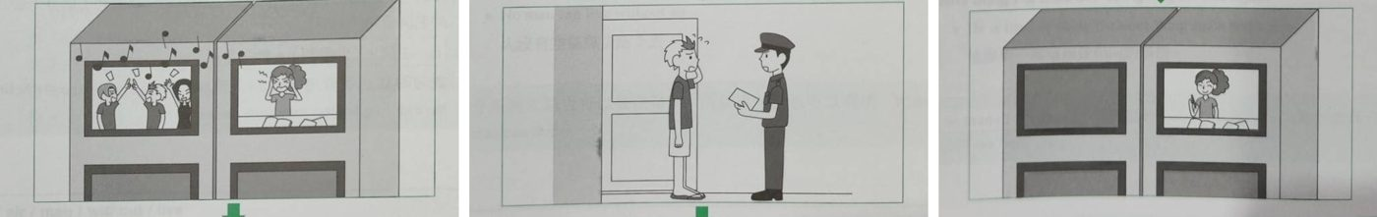
Useful Words & Phrases 實用單字片語
Word / Phrase | 中文 | Word / Phrase | 中文
junior high school student | 國中生 | knocked on | 敲門
hard-working | 用功 | nobody | 沒有人
preparing for | 準備 | called the police | 報警
final exam | 期末考 | after a while | 過了一會兒
neighbor | 鄰居 | stop the noise | 停止噪音
having a party | 開派對 | felt sorry | 感到抱歉
sang | 唱歌 | turned down | 調小聲
danced | 跳舞 | said sorry | 道歉
loud | 大聲 | became quiet | 變安靜
concentrate on | 專心於 | happily | 開心地
angry | 生氣 | good neighbor | 好鄰居
the next day | 隔天
Useful Sentence Patterns 實用句型
1. S is + adj., and S always + Vs
→ She is hard-working, and she always studies hard for her exams.
2. At the same time, S was Ving
→ At the same time, her neighbor, Mr. Lin, was having a party.
3. S felt + adj. + because + 句子
→ She felt angry because the exam was the next day.
4. So S + Ved. After a while, S + Ved
→ So she called the police. After a while, a police officer came to Mr. Lin's house.
5. S also said sorry to + 人.
→ He also said sorry to Jenny and her family.
6. S thought, "It is + adj. + to V."
→ She thought, "It is important to be a good neighbor."
Sentence Patterns 句型表
Column 1｜元素 & 關鍵字 | Column 2｜句型 | Column 3｜例句
人物介紹 Who  junior high school student 國中生 | S + is + a + 年齡-year-old + 職業. | Jenny is a 15-year-old junior high school student.
個性 Personality  hard-working 用功 | S is + adj., and S always + Vs | She is hard-working, and she always studies hard for her exams.
圖一 時間 + 動作  preparing for 準備; final exam 期末考 | Last night, S was Ving | Last night, she was preparing for her final exam at home.
鄰居 Neighbor  neighbor 鄰居; having a party 開派對 | At the same time, S was Ving | At the same time, her neighbor, Mr. Lin, was having a party.
派對細節  sang 唱歌; danced 跳舞 | S + Ved and Ved, and S played + N. | Many people sang and danced, and they played loud music.
噪音 Noise  loud 大聲; concentrate on 專心於 | S was so + adj. + that + 句子 | The music was so loud that Jenny couldn't concentrate on her studies.
心情 + 原因  angry 生氣; the next day 隔天 | S felt + adj. + because + 句子 | She felt angry because the exam was the next day.
行動 Action  knocked on 敲門; nobody 沒有人 | S + Ved, but nobody + Ved | She knocked on Mr. Lin's door, but nobody answered.
圖二 報警  called the police 報警; after a while 過了一會兒 | So S + Ved. After a while, S + Ved | So she called the police. After a while, a police officer came to Mr. Lin's house.
要求 Request  stop the noise 停止噪音 | S asked + 人 + to V | The police officer asked Mr. Lin to stop the noise.
圖三 結果  felt sorry 感到抱歉; turned down 調小聲 | S felt + adj., and S + Ved right away. | Mr. Lin felt sorry, and he turned down the music right away.
道歉 Apology  said sorry 道歉 | S also said sorry to + 人. | He also said sorry to Jenny and her family.
改變 Change  became quiet 變安靜; happily 開心地 | After that, S became + adj., and S could V | After that, the building became quiet again, and Jenny could study happily.
萬用結尾  good neighbor 好鄰居 | S thought, "It is + adj. + to V." | She thought, "It is important to be a good neighbor."
範文 Model Essay (152 words)
Jenny is a 15-year-old junior high school student. She is hard-working, and she always studies hard for her exams. Last night, she was preparing for her final exam at home. At the same time, her neighbor, Mr. Lin, was having a party. Many people sang and danced, and they played loud music. The music was so loud that Jenny couldn't concentrate on her studies. She felt angry because the exam was the next day. She knocked on Mr. Lin's door, but nobody answered. So she called the police. After a while, a police officer came to Mr. Lin's house. The police officer asked Mr. Lin to stop the noise. Mr. Lin felt sorry, and he turned down the music right away. He also said sorry to Jenny and her family. After that, the building became quiet again, and Jenny could study happily. She thought, "It is important to be a good neighbor."
主題 8｜公德心與鄰居 Manners & Neighbors
Topic 30｜樓上麻將聲篇 Mahjong at Midnight
題目：永明(Yung-ming)一直到今天凌晨兩點才睡覺，原因是他樓上的鄰居王太太(Mrs. Wang)在凌晨一點還在跟朋友打麻將(mahjong)。請依照下面的圖片，寫一篇約50字的故事。
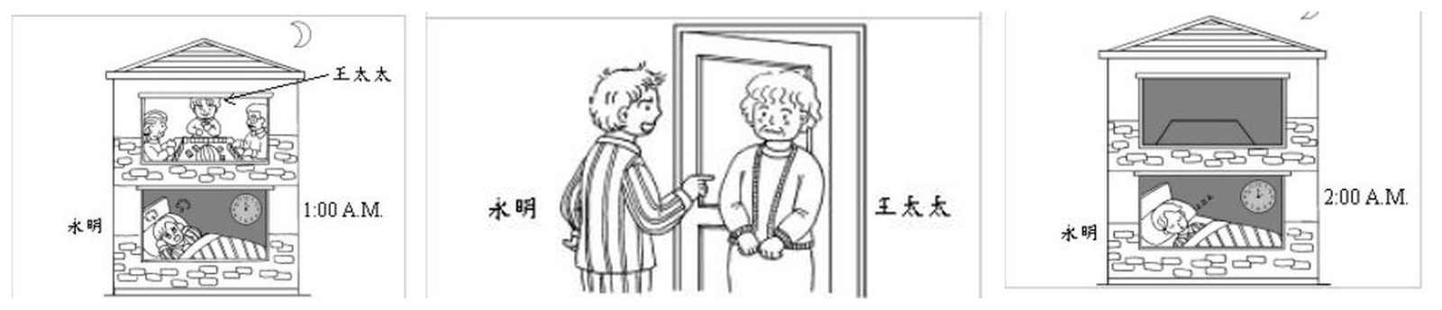
Useful Words & Phrases 實用單字片語
Word / Phrase | 中文 | Word / Phrase | 中文
office worker | 上班族 | knocked on | 敲
hard-working | 認真 | asked | 要求
go to bed early | 早睡 | stop | 停止
one o'clock in the morning | 凌晨一點 | felt bad | 感到抱歉
awake | 醒著 | right away | 立刻
neighbor | 鄰居 | said sorry | 道歉
upstairs | 樓上 | quiet | 安靜
mahjong | 麻將 | lights | 燈
noisy | 吵 | went back to bed | 回去睡
cover his ears | 摀住耳朵 | fell asleep | 睡著
angry | 生氣 | good neighbors | 好鄰居
work | 上班 | others | 別人
went upstairs | 上樓
Useful Sentence Patterns 實用句型
1. S is + adj., and S usually + Vs
→ He is hard-working, and he usually goes to bed early.
2. That was because S was Ving + N with + 人.
→ That was because his neighbor, Mrs. Wang, was playing mahjong upstairs with her friends.
3. S became + adj. + because + 句子
→ He became very angry because he had to work the next day.
4. S felt + adj., and S said S would V + right away.
→ Mrs. Wang felt bad, and she said she would stop playing right away.
5. Soon, S became + adj., and S + Ved.
→ Soon, the building became quiet, and the lights upstairs went off.
6. S thought, "S should always V."
→ He thought, "Good neighbors should always think of others."
Sentence Patterns 句型表
Column 1｜元素 & 關鍵字 | Column 2｜句型 | Column 3｜例句
人物介紹 Who  office worker 上班族 | S + is + a + 年齡-year-old + 職業. | Yung-ming is a 30-year-old office worker.
個性 Personality  hard-working 認真; go to bed early 早睡 | S is + adj., and S usually + Vs | He is hard-working, and he usually goes to bed early.
圖一 時間地點  one o'clock in the morning 凌晨一點; awake 醒著 | Last night, it was already + 時間, but S was still + adj. | Last night, it was already one o'clock in the morning, but Yung-ming was still awake.
圖一 原因 Reason  neighbor 鄰居; upstairs 樓上; mahjong 麻將 | That was because S was Ving + N with + 人. | That was because his neighbor, Mrs. Wang, was playing mahjong upstairs with her friends.
噪音 Noise  noisy 吵; cover his ears 摀住耳朵 | S were so + adj. + that + 句子 | They were so noisy that he couldn't sleep and had to cover his ears.
心情 + 原因 Feeling  angry 生氣; work 上班 | S became + adj. + because + 句子 | He became very angry because he had to work the next day.
圖二 動作  went upstairs 上樓; knocked on 敲 | Finally, S + Ved, Ved, and Ved on + N. | Finally, he got out of bed, went upstairs, and knocked on her door.
要求 Request  asked 要求; stop 停止 | S asked + 人 + to V | He asked Mrs. Wang to stop the game because it was too late.
圖二 反應 Reaction  felt bad 感到抱歉; right away 立刻 | S felt + adj., and S said S would V + right away. | Mrs. Wang felt bad, and she said she would stop playing right away.
道歉 Apology  said sorry 道歉 | S also said sorry to + 人. | She also said sorry to him.
圖三 時間地點  quiet 安靜; lights 燈 | Soon, S became + adj., and S + Ved. | Soon, the building became quiet, and the lights upstairs went off.
結局 Ending  went back to bed 回去睡; fell asleep 睡著 | So S + Ved and Ved at + 時間. | So Yung-ming went back to bed and fell asleep at two o'clock.
萬用結尾 Lesson  good neighbors 好鄰居; others 別人 | S thought, "S should always V." | He thought, "Good neighbors should always think of others."
範文 Model Essay (148 words)
Yung-ming is a 30-year-old office worker. He is hard-working, and he usually goes to bed early. Last night, it was already one o'clock in the morning, but Yung-ming was still awake. That was because his neighbor, Mrs. Wang, was playing mahjong upstairs with her friends. They were so noisy that he couldn't sleep and had to cover his ears. He became very angry because he had to work the next day. Finally, he got out of bed, went upstairs, and knocked on her door. He asked Mrs. Wang to stop the game because it was too late. Mrs. Wang felt bad, and she said she would stop playing right away. She also said sorry to him. Soon, the building became quiet, and the lights upstairs went off. So Yung-ming went back to bed and fell asleep at two o'clock. He thought, "Good neighbors should always think of others."
主題 8｜公德心與鄰居 Manners & Neighbors
Topic 31｜登山撿垃圾 Cleaning Up the Mountain
題目：上週日王先生 (Mr. Wang) 一家人開車去山上健行，山上到處都是垃圾的景象，讓他們決定為環保盡點力。請依據下面的圖片，寫一篇短文。
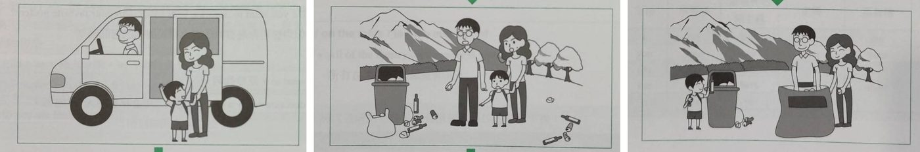
Useful Words & Phrases 實用單字片語
Word / Phrase | 中文 | Word / Phrase | 中文
lives in | 住在 | cans | 罐子
wife | 太太 | angry with | 對…生氣
children | 小孩 | clean up the mess | 清理髒亂
go hiking | 健行 | gloves | 手套
drove | 開車載 | bag | 袋子
mountains | 山上 | picked up | 撿起
excited | 興奮 | put it in | 放進
sunny | 晴朗 | hikers | 登山客
walked up | 走上山 | joined | 加入
view | 景色 | because of | 因為
a lot of trash | 很多垃圾 | much cleaner | 乾淨許多
everywhere | 到處 | proud of | 以…為榮
plastic bags | 塑膠袋 | environment | 環境
bottles | 瓶子 | everyone's business | 大家的事
Useful Sentence Patterns 實用句型
1. S like to V
→ They like to go hiking on weekends.
2. S + Ved and enjoyed + N.
→ They walked up the mountain and enjoyed the beautiful view.
3. There were + A, B, and C + on + 地方.
→ There were plastic bags, bottles, and cans on the ground.
4. S took + N + from + 地方.
→ Mr. Wang took some gloves and a big bag from his car.
5. S saw them and joined them.
→ Some other hikers saw them and joined them.
6. S told + 人, "..."
→ Mr. Wang told his kids, "Keeping the environment clean is everyone's business."
Sentence Patterns 句型表
Column 1｜元素 & 關鍵字 | Column 2｜句型 | Column 3｜例句
人物介紹 Who  lives in 住在; wife 太太; children 小孩 | S lives in + 地方 + with + 人. | Mr. Wang lives in Taichung with his wife and two children.
喜好 Hobby  go hiking 健行 | S like to V | They like to go hiking on weekends.
圖一 時間地點  drove 開車載; mountains 山上 | Last + 時間, S drove + 人 + to + 地方 + to V | Last Sunday, Mr. Wang drove his family to the mountains to go hiking.
心情 + 原因  excited 興奮; sunny 晴朗 | S were + adj. + because + 句子 | They were excited because the weather was sunny.
動作 Action  walked up 走上山; view 景色 | S + Ved and enjoyed + N. | They walked up the mountain and enjoyed the beautiful view.
圖二 發現  a lot of trash 很多垃圾; everywhere 到處 | When S + Ved, S saw that there was + N. | When they reached the top, they saw that there was a lot of trash everywhere.
舉例 Examples  plastic bags 塑膠袋; bottles 瓶子; cans 罐子 | There were + A, B, and C + on + 地方. | There were plastic bags, bottles, and cans on the ground.
心情 Feeling  angry with 對…生氣 | S was + adj. + with this, and S felt + adj. | Mr. Wang was very angry with this, and his children felt sad.
決定 Decision  clean up the mess 清理髒亂 | S decided to V | They decided to clean up the mess.
工具 Tools  gloves 手套; bag 袋子 | S took + N + from + 地方. | Mr. Wang took some gloves and a big bag from his car.
圖三 動作  picked up 撿起; put it in 放進 | S picked up + N and put it in + N. | They picked up the trash and put it in a big plastic bag.
其他人 Others  hikers 登山客; joined 加入 | S saw them and joined them. | Some other hikers saw them and joined them.
結果 Result  because of 因為; much cleaner 乾淨許多 | Because of + N, S became + 比較級. | Because of them, the place became much cleaner.
心情 Feeling  proud of 以…為榮 | S felt + adj., but S were + adj. + of themselves. | They felt tired, but they were proud of themselves.
萬用結尾  environment 環境; everyone's business 大家的事 | S told + 人, "..." | Mr. Wang told his kids, "Keeping the environment clean is everyone's business."
範文 Model Essay (155 words)
Mr. Wang lives in Taichung with his wife and two children. They like to go hiking on weekends. Last Sunday, Mr. Wang drove his family to the mountains to go hiking. They were excited because the weather was sunny. They walked up the mountain and enjoyed the beautiful view. When they reached the top, they saw that there was a lot of trash everywhere. There were plastic bags, bottles, and cans on the ground. Mr. Wang was very angry with this, and his children felt sad. They decided to clean up the mess. Mr. Wang took some gloves and a big bag from his car. They picked up the trash and put it in a big plastic bag. Some other hikers saw them and joined them. Because of them, the place became much cleaner. They felt tired, but they were proud of themselves. Mr. Wang told his kids, "Keeping the environment clean is everyone's business."
主題 9｜寵物狗狗 Dogs & Pets
Topic 32｜養寵物照顧篇 Lucky the Dog
題目：Tom 上週去流浪動物收容所收養流浪狗，本週開始每天幫狗洗澡、遛狗、照顧三餐。
圖一 Picture 1  上週去流浪動物收容所收養流浪狗 | 圖二 Picture 2  每天洗澡、遛狗、照顧三餐（現在簡單式） | 圖三 Picture 3  好狗狗：顧家，會對陌生人吠叫
Useful Words & Phrases 實用單字片語
Word / Phrase | 中文 | Word / Phrase | 中文
elementary school student | 小學生 | feeds | 餵
keep a pet dog | 養狗 | gives it a bath | 洗澡
animal shelter | 收容所 | tricks | 把戲
adopt | 收養 | sitting down | 坐下
stray dog | 流浪狗 | frisbee | 飛盤
cute | 可愛 | watch dog | 看門狗
take it home | 帶回家 | barks at strangers | 對陌生人吠
named | 取名 | plays with | 陪玩
hugged | 抱 | have a lot of fun | 玩得很開心
all the way home | 一路回家 | happy | 快樂
takes care of | 照顧 | best friend | 最好的朋友
walks | 遛 | best decision | 最好的決定
Useful Sentence Patterns 實用句型
1. S likes + N very much, and S always wanted to V
→ He likes dogs very much, and he always wanted to keep a pet dog.
2. When S saw ..., S decided to V
→ When he saw a cute little dog, he decided to take it home.
3. S was so + adj. + that + 句子
→ Tom was so excited that he hugged Lucky all the way home.
4. S also + Vs + N, such as A and B.
→ He also teaches Lucky some tricks, such as sitting down and catching a frisbee.
5. S also + Vs, and they have a lot of fun together.
→ It also plays with Tom, and they have a lot of fun together.
6. For + 人, S is ... It is the + 最高級 + N + of + one's life.
→ For Tom, Lucky is his best friend. Keeping a dog is the best decision of his life.
Sentence Patterns 句型表
Column 1｜元素 & 關鍵字 | Column 2｜句型 | Column 3｜例句
人物介紹 Who  elementary school student 小學生 | S + is + an + 年齡-year-old + 職業. | Tom is an 11-year-old elementary school student.
喜好 Hobby  keep a pet dog 養狗 | S likes + N very much, and S always wanted to V | He likes dogs very much, and he always wanted to keep a pet dog.
圖一 時間地點 (過去式)  animal shelter 收容所; adopt 收養; stray dog 流浪狗 | Last + 時間, S went to + 地方 + with ... to V | Last week, he went to the animal shelter with his parents to adopt a stray dog.
圖一 動作  cute 可愛; take it home 帶回家 | When S saw ..., S decided to V | When he saw a cute little dog, he decided to take it home.
取名 Name  named 取名 | S named + O + 名字. | He named the dog Lucky.
心情 Feeling  hugged 抱; all the way home 一路回家 | S was so + adj. + that + 句子 | Tom was so excited that he hugged Lucky all the way home.
圖二 現在習慣 (現在式)  takes care of 照顧 | Now, S + Vs + every day. | Now, Tom takes care of Lucky every day.
照顧細節 Care  walks 遛; feeds 餵; gives it a bath 洗澡 | S + Vs, Vs, and Vs. | He walks the dog, feeds it, and gives it a bath.
教招數 Tricks  tricks 把戲; sitting down 坐下; frisbee 飛盤 | S also + Vs + N, such as A and B. | He also teaches Lucky some tricks, such as sitting down and catching a frisbee.
圖三 好狗狗  watch dog 看門狗; barks at strangers 對陌生人吠 | S is a good + N. It + Vs and Vs. | Lucky is a good watch dog. It watches the house and barks at strangers.
陪伴 Fun  plays with 陪玩; have a lot of fun 玩得很開心 | S also + Vs, and they have a lot of fun together. | It also plays with Tom, and they have a lot of fun together.
心情 (現在式)  happy 快樂 | S feels + adj. + every day. | Tom feels very happy every day.
萬用結尾  best friend 最好的朋友; best decision 最好的決定 | For + 人, S is ... It is the + 最高級 + N + of + one's life. | For Tom, Lucky is his best friend. Keeping a dog is the best decision of his life.
範文 Model Essay (150 words)
Tom is an 11-year-old elementary school student. He likes dogs very much, and he always wanted to keep a pet dog. Last week, he went to the animal shelter with his parents to adopt a stray dog. When he saw a cute little dog, he decided to take it home. He named the dog Lucky. Tom was so excited that he hugged Lucky all the way home. Now, Tom takes care of Lucky every day. He walks the dog, feeds it, and gives it a bath. He also teaches Lucky some tricks, such as sitting down and catching a frisbee. Lucky is a good watch dog. It watches the house and barks at strangers. It also plays with Tom, and they have a lot of fun together. Tom feels very happy every day. For Tom, Lucky is his best friend. Keeping a dog is the best decision of his life.
主題 9｜寵物狗狗 Dogs & Pets
Topic 33｜狗狗走失篇 Where Is Lucky?
題目：上星期日Jack帶他的狗（Lucky）去公園。請根據以下的圖片寫一篇約50字的短文。
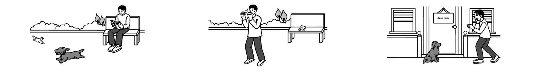
Useful Words & Phrases 實用單字片語
Word / Phrase | 中文 | Word / Phrase | 中文
college student | 大學生 | worried | 擔心
reading | 閱讀 | couldn't find | 找不到
named | 名叫 | called | 呼喊
last Sunday | 上星期日 | looked for | 尋找
took | 帶 | got home | 到家
bench | 長椅 | in front of | 在…前面
bird | 鳥 | glad | 高興
chased | 追 | ran to | 跑向
ran away | 跑走 | big smile | 大大的微笑
looked up | 抬頭 | keep an eye on | 注意
gone | 不見了 | pet | 寵物
Useful Sentence Patterns 實用句型
1. S likes + Ving, and S has a dog named + N.
→ He likes reading, and he has a dog named Lucky.
2. While S was Ving, S + Ved + N.
→ While he was reading a book on a bench, Lucky saw a bird.
3. Later, when S + Ved, S found that + 句子
→ Later, when Jack looked up from his book, he found that Lucky was gone.
4. S + Ved + N and Ved for + N for a long time.
→ He called Lucky's name again and again and looked for him for a long time.
5. S was so + adj. + to V
→ He was so glad and surprised to see his dog again.
6. S has learned an important lesson: S should always V
→ He has learned an important lesson: he should always keep an eye on his pet.
Sentence Patterns 句型表
Column 1｜元素 & 關鍵字 | Column 2｜句型 | Column 3｜例句
人物介紹 Who  college student 大學生 | S + is + a + 年齡-year-old + 職業. | Jack is a 20-year-old college student.
喜好 Hobby  reading 閱讀; named 名叫 | S likes + Ving, and S has a dog named + N. | He likes reading, and he has a dog named Lucky.
圖一 時間地點  last Sunday 上星期日; took 帶 | Last Sunday, S + Ved + N to + 地點. | Last Sunday, Jack took Lucky to the park near his home.
圖一 動作  bench 長椅; bird 鳥 | While S was Ving, S + Ved + N. | While he was reading a book on a bench, Lucky saw a bird.
圖一 動作 2  chased 追; ran away 跑走 | S + Ved + N and Ved away. | Lucky chased the bird and quickly ran away.
圖二 發現 Discovery  looked up 抬頭; gone 不見了 | Later, when S + Ved, S found that + 句子 | Later, when Jack looked up from his book, he found that Lucky was gone.
心情 + 原因 Feeling  worried 擔心; couldn't find 找不到 | S felt + adj. + because + 句子 | He felt very worried because he couldn't find his dog anywhere.
圖二 動作  called 呼喊; looked for 尋找 | S + Ved + N and Ved for + N for a long time. | He called Lucky's name again and again and looked for him for a long time.
圖三 時間地點  got home 到家; in front of 在…前面 | When S got home, S saw + 人 + Ving | When he got home, he saw Lucky waiting for him in front of the door.
心情 Feeling  glad 高興; again 再次 | S was so + adj. + to V | He was so glad and surprised to see his dog again.
結局 Ending  ran to 跑向; big smile 大大的微笑 | S + Ved to + N with a big smile. | He ran to Lucky with a big smile and took him into the house.
萬用結尾 Lesson  keep an eye on 注意; pet 寵物 | S has learned an important lesson: S should always V | He has learned an important lesson: he should always keep an eye on his pet.
範文 Model Essay (143 words)
Jack is a 20-year-old college student. He likes reading, and he has a dog named Lucky. Last Sunday, Jack took Lucky to the park near his home. While he was reading a book on a bench, Lucky saw a bird. Lucky chased the bird and quickly ran away. Later, when Jack looked up from his book, he found that Lucky was gone. He felt very worried because he couldn't find his dog anywhere. He called Lucky's name again and again and looked for him for a long time. When he got home, he saw Lucky waiting for him in front of the door. He was so glad and surprised to see his dog again. He ran to Lucky with a big smile and took him into the house. He has learned an important lesson: he should always keep an eye on his pet.
主題 9｜寵物狗狗 Dogs & Pets
Topic 34｜棒球打到狗篇 The Angry Dog
題目：上週六Jack和他的朋友在公園裡打棒球。請根據以下的圖片寫一篇約50字的短文。
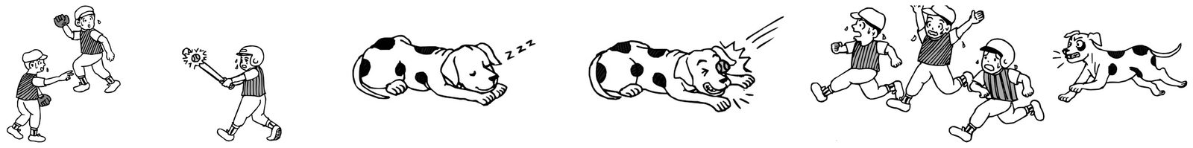
Useful Words & Phrases 實用單字片語
Word / Phrase | 中文 | Word / Phrase | 中文
elementary school student | 小學生 | on the grass | 在草地上
favorite sport | 最喜歡的運動 | didn't see | 沒看到
baseball | 棒球 | suddenly | 突然
last Saturday | 上週六 | eye | 眼睛
park | 公園 | woke up | 醒來
batter | 打擊者 | angry | 生氣
catch | 接 | ran after | 追趕
bat | 球棒 | barked | 吠叫
hit | 打擊 | afraid | 害怕
surprised | 驚訝 | as fast as they could | 盡快
flew far | 飛得很遠 | be careful | 小心
sleeping | 睡覺 | play ball | 打球
Useful Sentence Patterns 實用句型
1. S's favorite + N + is + N.
→ His favorite sport is baseball.
2. S was the + N, and S were ready to V.
→ Jack was the batter, and his two friends were ready to catch the ball.
3. S were + adj. + because + 句子
→ His friends were surprised because the ball flew very far and very fast.
4. Suddenly, S + Ved + N!
→ Suddenly, the ball hit the dog right in the eye!
5. S + Ved + 人 and Ved at + 人 loudly.
→ It ran after the boys and barked at them loudly.
6. S has learned an important lesson: S should V
→ Jack has learned an important lesson: he should be careful when he plays ball in the park.
Sentence Patterns 句型表
Column 1｜元素 & 關鍵字 | Column 2｜句型 | Column 3｜例句
人物介紹 Who  elementary school student 小學生 | S + is + a + 年齡-year-old + 職業. | Jack is a 12-year-old elementary school student.
喜好 Hobby  favorite sport 最喜歡的運動; baseball 棒球 | S's favorite + N + is + N. | His favorite sport is baseball.
圖一 時間地點  last Saturday 上週六; park 公園 | Last Saturday, S and S's friends went to + 地點 to V. | Last Saturday, Jack and his friends went to the park to play baseball.
圖一 角色 Roles  batter 打擊者; catch 接 | S was the + N, and S were ready to V. | Jack was the batter, and his two friends were ready to catch the ball.
圖一 動作  bat 球棒; hit 打擊 | S + Ved + N and Ved + N very hard. | Jack held the bat and hit the ball very hard.
心情 + 原因 Feeling  surprised 驚訝; flew far 飛得很遠 | S were + adj. + because + 句子 | His friends were surprised because the ball flew very far and very fast.
圖二 時間地點  sleeping 睡覺; on the grass 在草地上 | At that time, S was Ving + 地點. | At that time, a big dog was sleeping on the grass.
沒注意 Didn't see  didn't see 沒看到 | But S didn't V + N. | But the boys didn't see the dog at all.
圖三 意外 Accident  suddenly 突然; eye 眼睛 | Suddenly, S + Ved + N! | Suddenly, the ball hit the dog right in the eye!
圖三 反應  woke up 醒來; angry 生氣 | S woke up and was very + adj. | The dog woke up in pain and was very angry.
圖四 動作  ran after 追趕; barked 吠叫 | S + Ved + 人 and Ved at + 人 loudly. | It ran after the boys and barked at them loudly.
結局 Ending  afraid 害怕; as fast as they could 盡快 | S were so + adj. that S + Ved as fast as S could. | The boys were so afraid that they ran away as fast as they could.
萬用結尾 Lesson  be careful 小心; play ball 打球 | S has learned an important lesson: S should V | Jack has learned an important lesson: he should be careful when he plays ball in the park.
範文 Model Essay (143 words)
Jack is a 12-year-old elementary school student. His favorite sport is baseball. Last Saturday, Jack and his friends went to the park to play baseball. Jack was the batter, and his two friends were ready to catch the ball. Jack held the bat and hit the ball very hard. His friends were surprised because the ball flew very far and very fast. At that time, a big dog was sleeping on the grass. But the boys didn't see the dog at all. Suddenly, the ball hit the dog right in the eye! The dog woke up in pain and was very angry. It ran after the boys and barked at them loudly. The boys were so afraid that they ran away as fast as they could. Jack has learned an important lesson: he should be careful when he plays ball in the park.
主題 10｜生日派對 Birthday Parties
Topic 35｜驚喜生日派對 The Surprise Party
題目：上星期五是 John 的生日，他的朋友為他舉辦了一場驚喜派對。請依據下面的圖片，寫一篇短文。
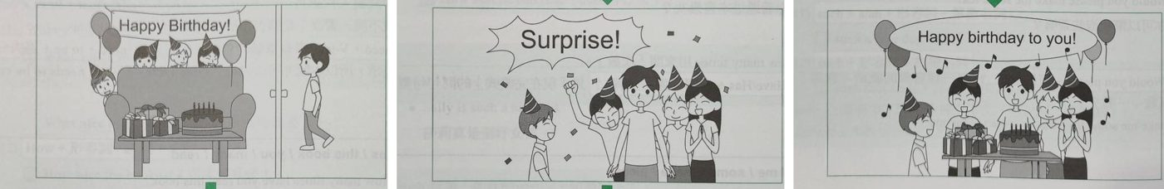
Useful Words & Phrases 實用單字片語
Word / Phrase | 中文 | Word / Phrase | 中文
senior high school student | 高中生 | presents | 禮物
friendly | 友善 | birthday cake | 生日蛋糕
good friends | 好朋友 | couldn't believe | 不敢相信
play basketball | 打籃球 | sang | 唱
surprise party | 驚喜派對 | together | 一起
planned | 策劃 | made a wish | 許願
decorated | 佈置 | cut the cake | 切蛋糕
balloons | 氣球 | shared | 分享
party hats | 派對帽 | moved | 感動
hid behind | 躲在…後面 | cried | 哭
as soon as | 一…就 | took photos | 拍照
jumped out | 跳出來 | played games | 玩遊戲
shouted | 大喊 | the best birthday | 最棒的生日
surprised | 驚訝
Useful Sentence Patterns 實用句型
1. S is + adj., and S has + N.
→ He is friendly, and he has many good friends.
2. S decorated + 地方 + with + N.
→ They decorated the living room with colorful balloons.
3. As soon as S + Ved, S + Ved
→ As soon as John opened the door, his friends jumped out.
4. S couldn't believe + 句子
→ John couldn't believe his friends did all this for him.
5. After S + Ved, S + Ved and Ved
→ After he made a wish, John cut the cake and shared it with everyone.
6. For + 人, it was the + 最高級 + N + of + one's life.
→ For him, it was the best birthday of his life.
Sentence Patterns 句型表
Column 1｜元素 & 關鍵字 | Column 2｜句型 | Column 3｜例句
人物介紹 Who  senior high school student 高中生 | S + is + a + 年齡-year-old + 職業. | John is a 16-year-old senior high school student.
個性 Personality  friendly 友善; good friends 好朋友 | S is + adj., and S has + N. | He is friendly, and he has many good friends.
喜好 Hobby  play basketball 打籃球 | S likes to V with + 人. | He likes to play basketball with his friends after school.
圖一 背景  surprise party 驚喜派對; planned 策劃 | Last + 時間 + was ..., so S planned + N + for + 人. | Last Friday was John's birthday, so his friends planned a surprise party for him.
佈置 Decorations  decorated 佈置; balloons 氣球 | S decorated + 地方 + with + N. | They decorated the living room with colorful balloons.
準備 Preparation  party hats 派對帽; hid behind 躲在…後面 | Before S + Ved, S + Ved and Ved | Before John came home, they wore party hats and hid behind the sofa.
圖二 驚喜  as soon as 一…就; jumped out 跳出來 | As soon as S + Ved, S + Ved | As soon as John opened the door, his friends jumped out.
喊 Shout  shouted 大喊; surprised 驚訝 | S shouted "..." to + 人, and S was + adj. | They shouted "Surprise!" to him, and John was very surprised.
禮物 Presents  presents 禮物; birthday cake 生日蛋糕 | S gave + 人 + N and N. | They gave him lots of presents and a big birthday cake.
心情 Feeling  couldn't believe 不敢相信 | S couldn't believe + 句子 | John couldn't believe his friends did all this for him.
圖三 唱歌  sang 唱; together 一起 | Then, S + Ved + to + 人 + together. | Then, they sang "Happy Birthday" to him together.
切蛋糕 Cake  made a wish 許願; cut the cake 切蛋糕; shared 分享 | After S + Ved, S + Ved and Ved | After he made a wish, John cut the cake and shared it with everyone.
心情 Feeling  moved 感動; cried 哭 | S was so + adj. + that + 句子 | John was so moved that he almost cried.
活動 Activities  took photos 拍照; played games 玩遊戲 | After that, S + Ved and Ved until + 時間. | After that, they took photos and played games until ten o'clock.
萬用結尾  the best birthday 最棒的生日 | For + 人, it was the + 最高級 + N + of + one's life. | For him, it was the best birthday of his life.
範文 Model Essay (155 words)
John is a 16-year-old senior high school student. He is friendly, and he has many good friends. He likes to play basketball with his friends after school. Last Friday was John's birthday, so his friends planned a surprise party for him. They decorated the living room with colorful balloons. Before John came home, they wore party hats and hid behind the sofa. As soon as John opened the door, his friends jumped out. They shouted "Surprise!" to him, and John was very surprised. They gave him lots of presents and a big birthday cake. John couldn't believe his friends did all this for him. Then, they sang "Happy Birthday" to him together. After he made a wish, John cut the cake and shared it with everyone. John was so moved that he almost cried. After that, they took photos and played games until ten o'clock. For him, it was the best birthday of his life.
主題 10｜生日派對 Birthday Parties
Topic 36｜十五歲生日派對篇 Betty's Birthday Party
題目：昨天是Betty十五歲的生日，她請了一些朋友到家裡玩。請依照下面的圖片，寫一篇約五十字的短文描述她過生日的情形。
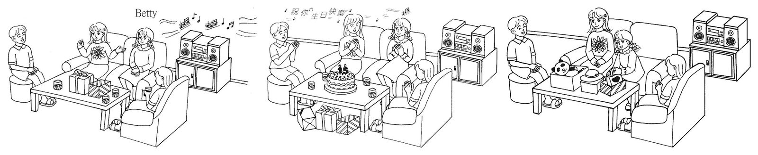
Useful Words & Phrases 實用單字片語
Word / Phrase | 中文 | Word / Phrase | 中文
junior high school student | 國中生 | made a wish | 許願
outgoing | 外向 | delicious | 美味
many friends | 很多朋友 | presents | 禮物
birthday | 生日 | panda doll | 熊貓玩偶
invited | 邀請 | hat | 帽子
chatted | 聊天 | bag | 包包
listened to music | 聽音樂 | liked | 喜歡
birthday cake | 生日蛋糕 | especially | 尤其
candles | 蠟燭 | thanked | 感謝
sang | 唱 | nice gifts | 好禮物
clapped | 拍手 | happiest | 最快樂
happy | 開心 | wonderful | 很棒
Useful Sentence Patterns 實用句型
1. S is + adj., and S has + N
→ She is outgoing, and she has many good friends.
2. At first, S + Ved, Ved, and Ved
→ At first, they sat on the sofa, chatted, and listened to music together.
3. S + Ved + N to + 人 and Ved + N.
→ Her friends sang the "Happy Birthday" song to her and clapped their hands happily.
4. After S + Ved, S + Ved
→ After they ate the delicious cake, Betty opened her presents one by one.
5. S liked + N, especially + N.
→ She liked all the presents, especially the small pink bag.
6. For S, it was the + 最高級 + N. What a + adj. + N!
→ For her, it was the happiest day of the year. What a wonderful birthday!
Sentence Patterns 句型表
Column 1｜元素 & 關鍵字 | Column 2｜句型 | Column 3｜例句
人物介紹 Who  junior high school student 國中生 | S + is + a + 年齡-year-old + 職業. | Betty is a 15-year-old junior high school student.
個性 Personality  outgoing 外向; many friends 很多朋友 | S is + adj., and S has + N | She is outgoing, and she has many good friends.
圖一 時間地點  birthday 生日; invited 邀請 | Yesterday was + N, and S + Ved + 人 + to + 地點. | Yesterday was her fifteenth birthday, and she invited three good friends to her home.
圖一 動作  chatted 聊天; listened to music 聽音樂 | At first, S + Ved, Ved, and Ved | At first, they sat on the sofa, chatted, and listened to music together.
圖二 時間地點  birthday cake 生日蛋糕; candles 蠟燭 | Then S + Ved + N with + N on + 地點. | Then they put a big birthday cake with fifteen candles on the table.
唱歌 Singing  sang 唱; clapped 拍手 | S + Ved + N to + 人 and Ved + N. | Her friends sang the "Happy Birthday" song to her and clapped their hands happily.
心情 Feeling  happy 開心; made a wish 許願 | S was very + adj., so S + Ved and Ved | She was very happy, so she closed her eyes and made a wish.
吃蛋糕 Cake  delicious 美味; presents 禮物 | After S + Ved, S + Ved | After they ate the delicious cake, Betty opened her presents one by one.
圖三 發現 Discovery  panda doll 熊貓玩偶; hat 帽子; bag 包包 | S found + N, N, and N in + N. | She found a panda doll, a hat, and a small pink bag in the boxes.
喜好 Favorite  liked 喜歡; especially 尤其 | S liked + N, especially + N. | She liked all the presents, especially the small pink bag.
感謝 Thanks  thanked 感謝; nice gifts 好禮物 | S thanked + 人 + for + N. | She thanked her friends for the nice gifts.
萬用結尾 Ending  happiest 最快樂; wonderful 很棒 | For S, it was the + 最高級 + N. What a + adj. + N! | For her, it was the happiest day of the year. What a wonderful birthday!
範文 Model Essay (144 words)
Betty is a 15-year-old junior high school student. She is outgoing, and she has many good friends. Yesterday was her fifteenth birthday, and she invited three good friends to her home. At first, they sat on the sofa, chatted, and listened to music together. Then they put a big birthday cake with fifteen candles on the table. Her friends sang the "Happy Birthday" song to her and clapped their hands happily. She was very happy, so she closed her eyes and made a wish. After they ate the delicious cake, Betty opened her presents one by one. She found a panda doll, a hat, and a small pink bag in the boxes. She liked all the presents, especially the small pink bag. She thanked her friends for the nice gifts. For her, it was the happiest day of the year. What a wonderful birthday!
主題 11｜出遊旅行 Trips & Outings
Topic 37｜動物園校外教學 A Day at the Zoo
題目：上週末明庭 (Ming-ting) 和同學搭公車去動物園玩，之後還去速食店飽餐一頓。請依據下面的圖片，寫一篇短文。
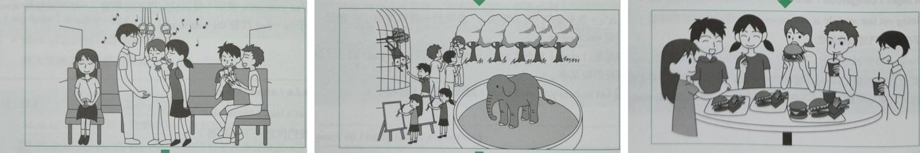
Useful Words & Phrases 實用單字片語
Word / Phrase | 中文 | Word / Phrase | 中文
elementary school student | 小學生 | favorite | 最喜歡的
animals | 動物 | funny | 有趣
took a bus | 搭公車 | sunny and warm | 晴朗溫暖
zoo | 動物園 | had a great time | 玩得很開心
singing | 唱歌 | fast-food restaurant | 速食店
playing cards | 玩牌 | big meal | 大餐
excited | 興奮 | Cokes | 可樂
first trip | 第一次出遊 | fries | 薯條
monkeys | 猴子 | hamburgers | 漢堡
elephant | 大象 | talked and laughed | 有說有笑
drew pictures | 畫畫 | wonderful | 美好
took photos | 拍照
Useful Sentence Patterns 實用句型
1. S loves + N very much.
→ She loves animals very much.
2. On the bus, some of S were Ving, while the others were Ving.
→ On the bus, some of them were singing happily, while the others were playing cards.
3. At + 地方, S + Ved and Ved
→ At the zoo, they played with the monkeys and saw a big elephant.
4. The weather was + adj., so S had a great time.
→ The weather was sunny and warm, so they had a great time.
5. S ordered + A, B, and C.
→ They ordered lots of Cokes, fries, and hamburgers.
6. S thought, "What a + adj. + N!" S wanted to V again.
→ Ming-ting thought, "What a wonderful day!" She wanted to go on a trip with her classmates again.
Sentence Patterns 句型表
Column 1｜元素 & 關鍵字 | Column 2｜句型 | Column 3｜例句
人物介紹 Who  elementary school student 小學生 | S + is + an + 年齡-year-old + 職業. | Ming-ting is an 11-year-old elementary school student.
喜好 Hobby  animals 動物 | S loves + N very much. | She loves animals very much.
圖一 時間地點交通  took a bus 搭公車; zoo 動物園 | Last weekend, S took a bus to + 地方. | Last weekend, Ming-ting and her classmates took a bus to the zoo.
車上 On the bus  singing 唱歌; playing cards 玩牌 | On the bus, some of S were Ving, while the others were Ving. | On the bus, some of them were singing happily, while the others were playing cards.
心情 + 原因  excited 興奮; first trip 第一次出遊 | S was + adj. + because + 句子 | Everyone was excited because it was their first trip together.
圖二 動物園  monkeys 猴子; elephant 大象 | At + 地方, S + Ved and Ved | At the zoo, they played with the monkeys and saw a big elephant.
活動 Activities  drew pictures 畫畫; took photos 拍照 | S + Ved ..., and S + Ved ... | Ming-ting drew pictures of the animals, and her friends took a lot of photos.
最愛 Favorite  favorite 最喜歡的; funny 有趣 | S's favorite + N + was + N + because + 句子 | Her favorite animal was the elephant because it was big and funny.
天氣 + 感受  sunny and warm 晴朗溫暖; had a great time 玩得很開心 | The weather was + adj., so S had a great time. | The weather was sunny and warm, so they had a great time.
圖三 時間地點  fast-food restaurant 速食店; big meal 大餐 | After that, S went to + 地方 + for + N. | After that, they went to a fast-food restaurant for a big meal.
點餐 Order  Cokes 可樂; fries 薯條; hamburgers 漢堡 | S ordered + A, B, and C. | They ordered lots of Cokes, fries, and hamburgers.
心情 Feeling  talked and laughed 有說有笑 | S were so + adj. + that + 句子 | They were so happy that they talked and laughed all the time.
萬用結尾  wonderful 美好 | S thought, "What a + adj. + N!" S wanted to V again. | Ming-ting thought, "What a wonderful day!" She wanted to go on a trip with her classmates again.
範文 Model Essay (149 words)
Ming-ting is an 11-year-old elementary school student. She loves animals very much. Last weekend, Ming-ting and her classmates took a bus to the zoo. On the bus, some of them were singing happily, while the others were playing cards. Everyone was excited because it was their first trip together. At the zoo, they played with the monkeys and saw a big elephant. Ming-ting drew pictures of the animals, and her friends took a lot of photos. Her favorite animal was the elephant because it was big and funny. The weather was sunny and warm, so they had a great time. After that, they went to a fast-food restaurant for a big meal. They ordered lots of Cokes, fries, and hamburgers. They were so happy that they talked and laughed all the time. Ming-ting thought, "What a wonderful day!" She wanted to go on a trip with her classmates again.
主題 11｜出遊旅行 Trips & Outings
Topic 38｜動物園家庭日篇 A Fun Day at the Zoo
題目：現在是星期天早上八點鐘，小芳（Shiau-fang）的媽媽叫她起床，因為爸爸打算帶全家出去玩。請根據下面的圖片寫一篇約50字的短文，描述小芳將如何與家人度過今天。
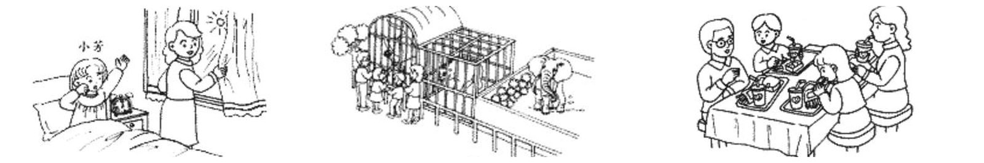
Useful Words & Phrases 實用單字片語
Word / Phrase | 中文 | Word / Phrase | 中文
elementary school student | 小學生 | monkeys | 猴子
loves animals | 喜愛動物 | bears | 熊
especially | 尤其 | elephants | 大象
Sunday | 星期天 | laugh at | 笑
eight o'clock | 八點 | funny | 好笑的
opened the curtains | 拉開窗簾 | cage | 籠子
woke up | 叫醒 | take pictures | 拍照
nice | 很好 | fast food restaurant | 速食店
shining | 照耀 | lunch | 午餐
is going to | 將要 | hamburgers | 漢堡
take | 帶 | French fries | 薯條
excited | 興奮 | have a good time | 玩得愉快
can't wait | 等不及 | happiest | 最快樂
at the zoo | 在動物園
Useful Sentence Patterns 實用句型
1. S loves + N, especially + N.
→ She loves animals, especially monkeys.
2. S + Vs + N and Vs + 人 + up.
→ Her mother opens the curtains and wakes her up with a smile.
3. S is going to V + 人 + to + 地點.
→ Her father is going to take the whole family to the zoo.
4. S will V + N in + 地點.
→ They will laugh at the funny monkeys in the big cage.
5. After that, S are going to V at + 地點.
→ After that, they are going to have lunch at a fast food restaurant.
6. S will have a good time. It will be the + 最高級 + N.
→ They will have a good time. It will be the happiest day of the week.
Sentence Patterns 句型表
Column 1｜元素 & 關鍵字 | Column 2｜句型 | Column 3｜例句
人物介紹 Who  elementary school student 小學生 | S + is + a + 年齡-year-old + 職業. | Shiau-fang is a 10-year-old elementary school student.
喜好 Hobby  loves animals 喜愛動物; especially 尤其 | S loves + N, especially + N. | She loves animals, especially monkeys.
圖一 時間地點  Sunday 星期天; eight o'clock 八點 | Today is + 星期, and it is + 時間 + in the morning. | Today is Sunday, and it is eight o'clock in the morning.
圖一 動作  opened the curtains 拉開窗簾; woke up 叫醒 | S + Vs + N and Vs + 人 + up. | Her mother opens the curtains and wakes her up with a smile.
天氣 Weather  nice 很好; shining 照耀 | The weather is very + adj., and the sun is Ving. | The weather is very nice, and the sun is shining.
計畫 Plan  is going to 將要; take 帶 | S is going to V + 人 + to + 地點. | Her father is going to take the whole family to the zoo.
心情 + 原因 Feeling  excited 興奮; can't wait 等不及 | S feels + adj. + because + 句子 | She feels very excited because she can't wait to see the animals.
圖二 時間地點  at the zoo 在動物園; monkeys 猴子; bears 熊; elephants 大象 | At + 地點, S will V + N, such as + N, N, and N. | At the zoo, they will see a lot of cute animals, such as monkeys, bears, and elephants.
圖二 細節 Details  laugh at 笑; funny 好笑的; cage 籠子 | S will V + N in + 地點. | They will laugh at the funny monkeys in the big cage.
圖二 動作 2  take pictures 拍照 | S will also V + N of + N. | They will also take many pictures of the animals.
圖三 時間地點  fast food restaurant 速食店; lunch 午餐 | After that, S are going to V at + 地點. | After that, they are going to have lunch at a fast food restaurant.
圖三 動作  hamburgers 漢堡; French fries 薯條 | S will V + N and V + N. | They will eat hamburgers and French fries and drink cola together.
萬用結尾 Ending  have a good time 玩得愉快; happiest 最快樂 | S will have a good time. It will be the + 最高級 + N. | They will have a good time. It will be the happiest day of the week.
範文 Model Essay (145 words)
Shiau-fang is a 10-year-old elementary school student. She loves animals, especially monkeys. Today is Sunday, and it is eight o'clock in the morning. Her mother opens the curtains and wakes her up with a smile. The weather is very nice, and the sun is shining. Her father is going to take the whole family to the zoo. She feels very excited because she can't wait to see the animals. At the zoo, they will see a lot of cute animals, such as monkeys, bears, and elephants. They will laugh at the funny monkeys in the big cage. They will also take many pictures of the animals. After that, they are going to have lunch at a fast food restaurant. They will eat hamburgers and French fries and drink cola together. They will have a good time. It will be the happiest day of the week.
主題 11｜出遊旅行 Trips & Outings
Topic 39｜海邊快樂的一天篇 A Happy Day at the Beach
題目：金城武 (Takeshi) 和徐若瑄 (Vivian) 今天早上開車去海邊。他們玩得很開心，還認識了新朋友。請依據下面的圖片，寫一篇約 50 字的短文，描述金城武 (Takeshi) 和徐若瑄 (Vivian) 快樂的一天。注意：未依提示作答者，將予扣分。
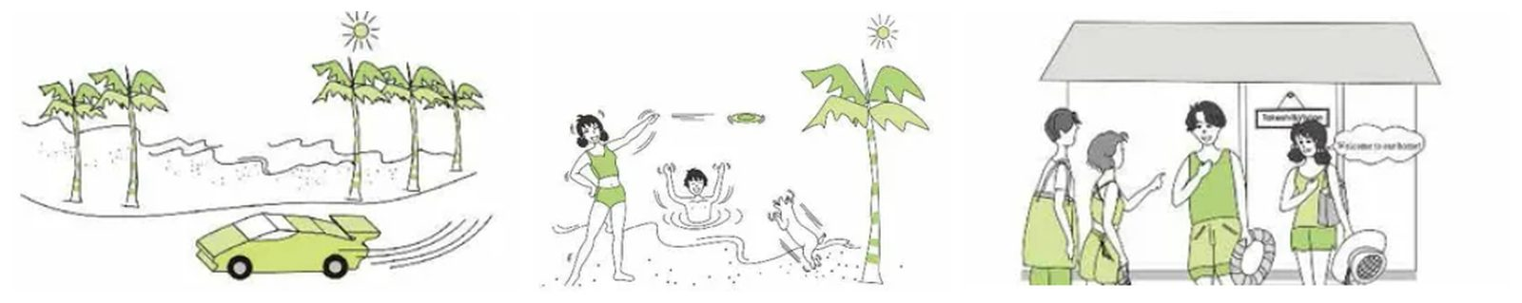
Useful Words & Phrases 實用單字片語
Word / Phrase | 中文 | Word / Phrase | 中文
young couple | 年輕夫妻 | caught | 接住
beach | 海邊 | laughed | 笑
sunshine | 陽光 | had fun | 玩得開心
this morning | 今天早上 | met | 認識
drove | 開車 | new friends | 新朋友
palm trees | 棕櫚樹 | talked | 聊天
blue sea | 藍色的海 | for a long time | 很久
sunny | 晴朗 | invited | 邀請
excited | 興奮 | beach house | 海邊小屋
arrived | 抵達 | welcome | 歡迎
frisbee | 飛盤 | had dinner | 吃晚餐
swimming | 游泳 | together | 一起
sea | 海 | happiest | 最快樂的
cute | 可愛的
Useful Sentence Patterns 實用句型
1. S love + Ving + at + 地點.
→ They love playing at the beach.
2. It was + adj. and adj., and S felt + adj.
→ It was sunny and hot, and they felt very excited.
3. At the same time, S was Ving.
→ At the same time, Takeshi was swimming in the sea.
4. On + 地點, S also + Ved + N.
→ On the beach, they also met two new friends, a man and a woman.
5. In the afternoon, S invited + 人 + to V.
→ In the afternoon, they invited their new friends to visit their beach house.
6. For S, it was the + 最高級 + N.
→ For them, it was the happiest day of the whole year.
Sentence Patterns 句型表
Column 1｜元素 & 關鍵字 | Column 2｜句型 | Column 3｜例句
人物介紹 Who  young couple 年輕夫妻 | S + are + a + adj. + N. | Takeshi and Vivian are a young couple.
喜好 Hobby  beach 海邊; sunshine 陽光 | S love + Ving + at + 地點. | They love playing at the beach.
圖一 時間地點  this morning 今天早上; drove 開車 | This morning, S + Ved + to + 地點. | This morning, they drove to the beach in their green sports car.
沿途 On the Way  palm trees 棕櫚樹; blue sea 藍色的海 | On the way, S saw + N and N. | On the way, they saw many palm trees and the blue sea.
心情 + 天氣 Feeling  sunny 晴朗; excited 興奮 | It was + adj. and adj., and S felt + adj. | It was sunny and hot, and they felt very excited.
圖二 時間 + 動作  arrived 抵達; frisbee 飛盤 | When S + Ved, S + Ved + N. | When they arrived, Vivian played frisbee on the beach.
動作 Action  swimming 游泳; sea 海 | At the same time, S was Ving. | At the same time, Takeshi was swimming in the sea.
發現 Discovery  cute 可愛的; caught 接住 | S + Ved over, Ved + adv., and Ved + N. | A cute dog ran over, jumped up high, and caught the frisbee.
心情 Feeling  laughed 笑; had fun 玩得開心 | S + Ved and had a lot of fun. | They laughed and had a lot of fun.
新朋友 New Friends  met 認識; new friends 新朋友 | On + 地點, S also + Ved + N. | On the beach, they also met two new friends, a man and a woman.
聊天 Chat  talked 聊天; for a long time 很久 | S + Ved with + 人 + for a long time. | They talked with them for a long time.
圖三 時間 + 動作  invited 邀請; beach house 海邊小屋 | In the afternoon, S invited + 人 + to V. | In the afternoon, they invited their new friends to visit their beach house.
說話 Speech  welcome 歡迎 | S said + adv., "..." | Vivian said happily, "Welcome to our home!"
結局 Ending  had dinner 吃晚餐; together 一起 | Then, S + Ved + N + together. | Then, they had dinner together.
萬用結尾 Lesson  happiest 最快樂的 | For S, it was the + 最高級 + N. | For them, it was the happiest day of the whole year.
範文 Model Essay (144 words)
Takeshi and Vivian are a young couple. They love playing at the beach. This morning, they drove to the beach in their green sports car. On the way, they saw many palm trees and the blue sea. It was sunny and hot, and they felt very excited. When they arrived, Vivian played frisbee on the beach. At the same time, Takeshi was swimming in the sea. A cute dog ran over, jumped up high, and caught the frisbee. They laughed and had a lot of fun. On the beach, they also met two new friends, a man and a woman. They talked with them for a long time. In the afternoon, they invited their new friends to visit their beach house. Vivian said happily, "Welcome to our home!" Then, they had dinner together. For them, it was the happiest day of the whole year.
主題 11｜出遊旅行 Trips & Outings
Topic 40｜台東度假篇 Summer Vacation in Taitung
題目：上週末 Greg 從台北出發，前往台東 (Taitung) 度假，下面是他每天所發生的事，請根據這些圖片寫一篇短文。
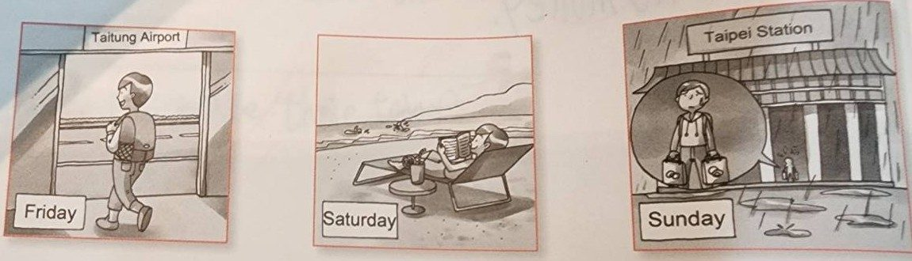
Useful Words & Phrases 實用單字片語
Word / Phrase | 中文 | Word / Phrase | 中文
senior high school student | 高中生 | hot | 炎熱
swimming | 游泳 | relaxed | 放鬆
the sea | 大海 | swam | 游泳
from Taipei | 從台北 | two hours | 兩小時
by airplane | 搭飛機 | last day | 最後一天
arrived in | 抵達(城市) | had breakfast | 吃早餐
hotel | 飯店 | checked out | 退房
tired | 累 | by train | 搭火車
went to bed | 上床睡覺 | raining hard | 下大雨
beach | 海灘 | Taipei Station | 台北車站
read a book | 看書 | lucky | 幸運
sunny | 晴朗 | great vacation | 很棒的假期
Useful Sentence Patterns 實用句型
1. S likes + Ving, and S loves + N.
→ He likes going swimming, and he loves the sea.
2. When S arrived in + 城市, it was + 時間, so + 句子
→ When he arrived in Taitung, it was nine thirty p.m., so he went to the hotel.
3. The next morning, S + Ved and Ved
→ The next morning, he went to the beach and read a book there.
4. That afternoon, S + Ved
→ That afternoon, he swam in the sea for two hours.
5. After Ving, S + Ved and Ved
→ After finishing breakfast, he checked out of the hotel and went back to Taipei by train.
6. S felt + adj. S thought it was a + adj. + N.
→ He felt lucky. He thought it was a great vacation.
Sentence Patterns 句型表
Column 1｜元素 & 關鍵字 | Column 2｜句型 | Column 3｜例句
人物介紹 Who  senior high school student 高中生 | S + is + a + 年齡-year-old + 職業. | Greg is a 16-year-old senior high school student.
喜好 Hobby  swimming 游泳; the sea 大海 | S likes + Ving, and S loves + N. | He likes going swimming, and he loves the sea.
圖一 時間地點交通  from Taipei 從台北; by airplane 搭飛機 | Last + 時間, S went to A from B by 交通 for + 原因. | Last Friday, he went to Taitung from Taipei by airplane for summer vacation.
抵達 Arrival  arrived in 抵達(城市); hotel 飯店 | When S arrived in + 城市, it was + 時間, so + 句子 | When he arrived in Taitung, it was nine thirty p.m., so he went to the hotel.
心情 + 動作  tired 累; went to bed 上床睡覺 | S was so + adj. + that + 句子 | He was so tired that he went to bed at ten o'clock.
圖二 隔天  beach 海灘; read a book 看書 | The next morning, S + Ved and Ved | The next morning, he went to the beach and read a book there.
天氣 Weather  sunny 晴朗; hot 炎熱 | The weather was + adj. It was + adj. and adj. | The weather was good. It was sunny and hot.
心情 + 原因  relaxed 放鬆 | S felt + adj. + because + 句子 | He felt relaxed because he didn't need to go to school.
活動 Activity  swam 游泳; two hours 兩小時 | That afternoon, S + Ved | That afternoon, he swam in the sea for two hours.
圖三 最後一天  last day 最後一天; had breakfast 吃早餐 | On the last day of the trip, S + Ved | On the last day of the trip, he had breakfast at the hotel.
連接動作 After Ving  checked out 退房; by train 搭火車 | After Ving, S + Ved and Ved | After finishing breakfast, he checked out of the hotel and went back to Taipei by train.
天氣變糟  raining hard 下大雨; Taipei Station 台北車站 | When S arrived at + 地點, it was Ving. | When he arrived at Taipei Station, it was raining hard.
萬用結尾  lucky 幸運; great vacation 很棒的假期 | S felt + adj. S thought it was a + adj. + N. | He felt lucky. He thought it was a great vacation.
範文 Model Essay (150 words)
Greg is a 16-year-old senior high school student. He likes going swimming, and he loves the sea. Last Friday, he went to Taitung from Taipei by airplane for summer vacation. When he arrived in Taitung, it was nine thirty p.m., so he went to the hotel. He was so tired that he went to bed at ten o'clock. The next morning, he went to the beach and read a book there. The weather was good. It was sunny and hot. He felt relaxed because he didn't need to go to school. That afternoon, he swam in the sea for two hours. On the last day of the trip, he had breakfast at the hotel. After finishing breakfast, he checked out of the hotel and went back to Taipei by train. When he arrived at Taipei Station, it was raining hard. He felt lucky. He thought it was a great vacation.
主題 11｜出遊旅行 Trips & Outings
Topic 41｜高雄親戚家遊記篇 My Trip to Kaohsiung
題目：上個星期，你到高雄（Kaohsiung）的親戚家玩，下面是你每天的活動，請根據這些圖片寫一篇約 50 字的簡短遊記。
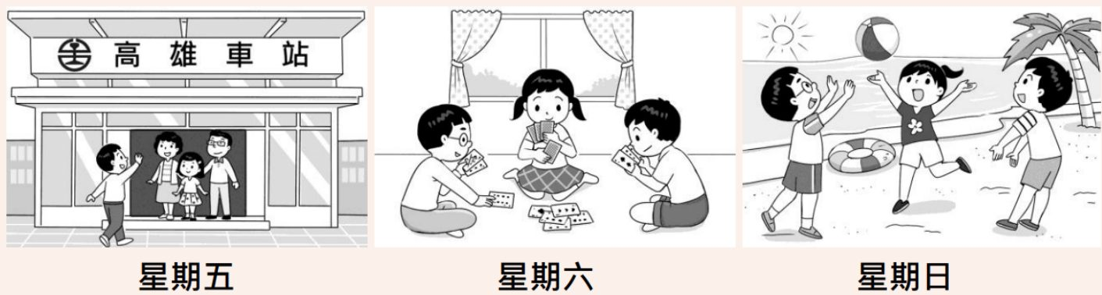
Useful Words & Phrases 實用單字片語
Word / Phrase | 中文 | Word / Phrase | 中文
elementary school student | 小學生 | won | 贏
travel | 旅行 | had a lot of fun | 玩得很開心
cousins | 表兄弟姊妹 | sunny | 晴朗的
took a train | 搭火車 | beach | 海灘
relatives | 親戚 | beach ball | 海灘球
were waiting for | 正在等 | sand | 沙灘
gate | 出口 | hot | 炎熱的
waved | 揮手 | cool | 涼爽的
excited | 興奮的 | said goodbye to | 和…道別
stayed at | 待在 | took the train home | 搭火車回家
brother | 哥哥/弟弟 | happiest | 最快樂的
sat on the floor | 坐在地上 | trip | 旅行
played cards | 玩撲克牌
Useful Sentence Patterns 實用句型
1. S like(s) to V and V + with + 人.
→ I like to travel and play with my cousins.
2. When S arrived at + 地點, S were waiting for + 人.
→ When I arrived at Kaohsiung Station, my uncle, my aunt and my cousin Lily were waiting for me.
3. On + 星期, S stayed at + 地點 + with + 人.
→ On Saturday, I stayed at my uncle's house with Lily and her brother, Ben.
4. On + 星期, the weather was + adj., so S went to + 地點.
→ On Sunday, the weather was sunny, so we went to the beach.
5. The N was + adj., but the N was + adj.
→ The sun was hot, but the wind was cool.
6. For S, it was the 最高級 + N + of + N.
→ For me, it was the happiest trip of the year.
Sentence Patterns 句型表
Column 1｜元素 & 關鍵字 | Column 2｜句型 | Column 3｜例句
人物介紹 Who  elementary school student 小學生 | S + am + a + 年齡-year-old + 職業. | I am a 12-year-old elementary school student.
喜好 Hobby  travel 旅行; cousins 表兄弟姊妹 | S like(s) to V and V + with + 人. | I like to travel and play with my cousins.
圖一 時間地點  took a train 搭火車; relatives 親戚 | Last Friday, S took a train to + 地點 + to V | Last Friday, I took a train to Kaohsiung to visit my relatives.
圖一 動作  were waiting for 正在等; gate 出口 | When S arrived at + 地點, S were waiting for + 人. | When I arrived at Kaohsiung Station, my uncle, my aunt and my cousin Lily were waiting for me.
心情 + 原因 Feeling  waved 揮手; excited 興奮的 | S + Ved + to + 人 + because + 句子 | I waved to them happily because I could stay with them for three days.
圖二 時間地點  stayed at 待在; brother 哥哥/弟弟 | On + 星期, S stayed at + 地點 + with + 人. | On Saturday, I stayed at my uncle's house with Lily and her brother, Ben.
圖二 動作  sat on the floor 坐在地上; played cards 玩撲克牌 | S sat on the floor and Ved + N + together. | We sat on the floor and played cards together.
心情 Feeling  won 贏; had a lot of fun 玩得很開心 | S + Ved + N, but S still had a lot of fun. | Lily won almost every game, but we still had a lot of fun.
圖三 時間地點  sunny 晴朗的; beach 海灘 | On + 星期, the weather was + adj., so S went to + 地點. | On Sunday, the weather was sunny, so we went to the beach.
圖三 動作  beach ball 海灘球; sand 沙灘 | S + Ved + with + N and Ved + 地點. | We played with a beach ball and ran on the sand.
細節 Details  hot 炎熱的; cool 涼爽的 | The N was + adj., but the N was + adj. | The sun was hot, but the wind was cool.
結局 Ending  said goodbye to 和…道別; took the train home 搭火車回家 | That evening, S said goodbye to + 人 and Ved. | That evening, I said goodbye to my relatives and took the train home.
萬用結尾 Lesson  happiest 最快樂的; trip 旅行 | For S, it was the 最高級 + N + of + N. | For me, it was the happiest trip of the year.
範文 Model Essay (151 words)
I am a 12-year-old elementary school student. I like to travel and play with my cousins. Last Friday, I took a train to Kaohsiung to visit my relatives. When I arrived at Kaohsiung Station, my uncle, my aunt and my cousin Lily were waiting for me. I waved to them happily because I could stay with them for three days. On Saturday, I stayed at my uncle's house with Lily and her brother, Ben. We sat on the floor and played cards together. Lily won almost every game, but we still had a lot of fun. On Sunday, the weather was sunny, so we went to the beach. We played with a beach ball and ran on the sand. The sun was hot, but the wind was cool. That evening, I said goodbye to my relatives and took the train home. For me, it was the happiest trip of the year.
主題 11｜出遊旅行 Trips & Outings
Topic 42｜帶外國朋友遊台南篇 My Weekend with Tom
題目：上周五你的外國朋友Tom來台灣拜訪你，請描述你上周末帶他出遊台灣知名景點的旅程。
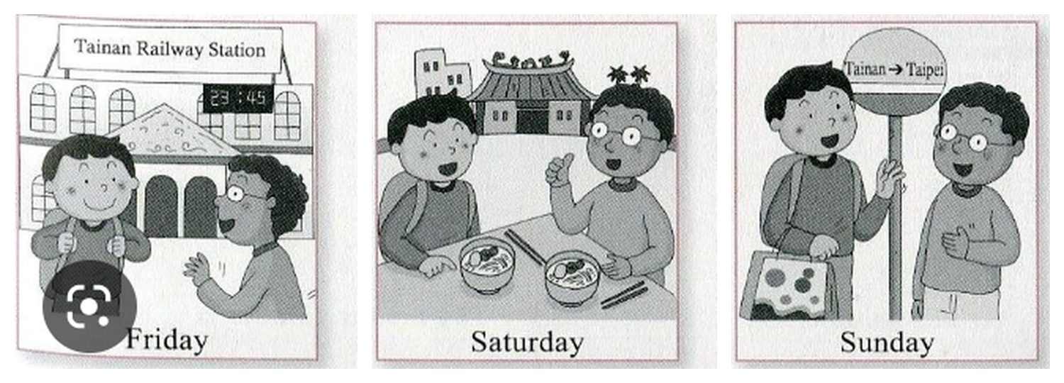
Useful Words & Phrases 實用單字片語
Word / Phrase | 中文 | Word / Phrase | 中文
junior high school student | 國中生 | noodles | 麵
Tainan | 台南 | shop | 小店
foreign friend | 外國朋友 | near | 在…附近
named | 名叫 | thumbs-up | 豎起大拇指
interested in | 對…有興趣 | delicious | 美味的
culture | 文化 | go back to | 回去
railway station | 火車站 | by bus | 搭公車
meet | 迎接 | got on | 上車
arrived | 抵達 | thanked | 感謝
late at night | 深夜 | wonderful | 很棒的
excited | 興奮的 | sad | 難過
show him around | 帶他四處看看 | said goodbye | 道別
famous | 有名的 | the best | 最棒的
temple | 廟宇 | weekend | 週末
Useful Sentence Patterns 實用句型
1. I have a + adj. + N + named + 名字, and S lives in + 地點.
→ I have a foreign friend named Tom, and he lives in America.
2. Last Friday, S went to + 地點 + to V
→ Last Friday, I went to Tainan Railway Station to meet him.
3. S felt + adj. + because + 句子
→ I felt very excited because I wanted to show him around my city.
4. S gave me a thumbs-up and said, "..."
→ Tom gave me a thumbs-up and said, "This is delicious!"
5. Before S + Ved, S + Ved + 人 + for + N.
→ Before he got on the bus, he thanked me for the wonderful trip.
6. For S, it was the 最高級 + N + of + N.
→ For me, it was the best weekend of the year.
Sentence Patterns 句型表
Column 1｜元素 & 關鍵字 | Column 2｜句型 | Column 3｜例句
人物介紹 Who  junior high school student 國中生; Tainan 台南 | S + am + a + 年齡-year-old + 職業 + in + 地點. | I am a 14-year-old junior high school student in Tainan.
朋友 Friend  foreign friend 外國朋友; named 名叫 | I have a + adj. + N + named + 名字, and S lives in + 地點. | I have a foreign friend named Tom, and he lives in America.
喜好 Hobby  interested in 對…有興趣; culture 文化 | S is interested in + N and N. | He is interested in Taiwanese culture and food.
圖一 時間地點  railway station 火車站; meet 迎接 | Last Friday, S went to + 地點 + to V | Last Friday, I went to Tainan Railway Station to meet him.
圖一 動作  arrived 抵達; late at night 深夜 | S + Ved at + 時間, so + 句子 | His train arrived at 11:45 p.m., so it was very late at night.
心情 + 原因 Feeling  excited 興奮的; show him around 帶他四處看看 | S felt + adj. + because + 句子 | I felt very excited because I wanted to show him around my city.
圖二 時間地點  famous 有名的; temple 廟宇 | On + 星期, S took + 人 + to + 地點. | On Saturday, I took him to a famous old temple.
圖二 動作  noodles 麵; shop 小店; near 在…附近 | After that, S + Ved + N at + 地點 + near + N. | After that, we ate noodles at a small shop near the temple.
心情 Feeling  thumbs-up 豎起大拇指; delicious 美味的 | S gave me a thumbs-up and said, "..." | Tom gave me a thumbs-up and said, "This is delicious!"
圖三 時間地點  go back to 回去; by bus 搭公車 | On + 星期, S had to V + by + 交通工具, so S + Ved | On Sunday, Tom had to go back to Taipei by bus, so I took him to the bus stop.
結局 Ending  got on 上車; thanked 感謝; wonderful 很棒的 | Before S + Ved, S + Ved + 人 + for + N. | Before he got on the bus, he thanked me for the wonderful trip.
心情 Feeling  sad 難過; said goodbye 道別 | S felt a little + adj. when S + Ved. | I felt a little sad when we said goodbye.
萬用結尾 Lesson  the best 最棒的; weekend 週末 | For S, it was the 最高級 + N + of + N. | For me, it was the best weekend of the year.
範文 Model Essay (152 words)
I am a 14-year-old junior high school student in Tainan. I have a foreign friend named Tom, and he lives in America. He is interested in Taiwanese culture and food. Last Friday, I went to Tainan Railway Station to meet him. His train arrived at 11:45 p.m., so it was very late at night. I felt very excited because I wanted to show him around my city. On Saturday, I took him to a famous old temple. After that, we ate noodles at a small shop near the temple. Tom gave me a thumbs-up and said, "This is delicious!" On Sunday, Tom had to go back to Taipei by bus, so I took him to the bus stop. Before he got on the bus, he thanked me for the wonderful trip. I felt a little sad when we said goodbye. For me, it was the best weekend of the year.
主題 11｜出遊旅行 Trips & Outings
Topic 43｜單車環島（第一人稱） Cycling Around Taiwan
題目：你在春假期間完成了一人單車環島之旅，回想旅途當中發生了不少驚險與好玩的事情，事後自己也覺得成長了不少。請依據下面的圖片，以第一人稱的敘述方式，寫一篇短文來描述你的單車環台之旅。
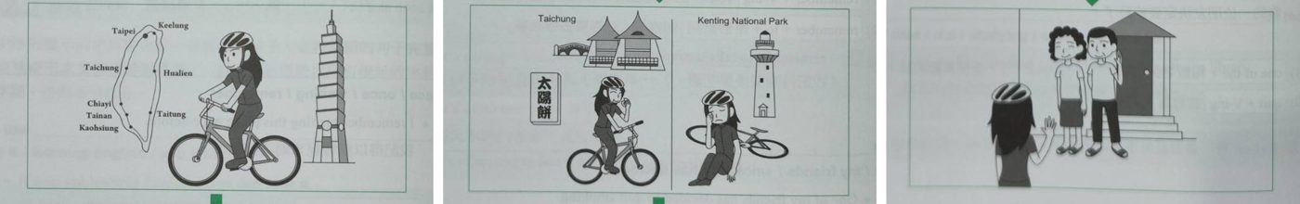
Useful Words & Phrases 實用單字片語
Word / Phrase | 中文 | Word / Phrase | 中文
senior high school student | 高中生 | fell off | 跌下
travel around | 環遊 | hurt my leg | 腿受傷
on my bike | 騎腳踏車 | bleeding | 流血
spring break | 春假 | hurt | 痛
came true | 成真 | give up | 放棄
toward the south | 往南 | finally | 終於
passed | 經過 | waiting for | 等待
sunny | 晴朗 | proud of | 以…為榮
windy | 颳風 | happy to see | 很高興見到
Sun Cakes | 太陽餅 | grown up | 長大
famous | 有名的 | brave enough | 夠勇敢
on my way to | 在去…路上 | on my own | 獨自
Useful Sentence Patterns 實用句型
1. To V + has always been my dream.
→ To travel around Taiwan on my bike has always been my dream.
2. I + Ved toward ..., and I + Ved
→ I rode my bike toward the south, and I passed many cities.
3. In + 地方, I + Ved and Ved
→ In Taichung, I visited a beautiful park and ate Sun Cakes, the famous food there.
4. I hurt my + N, and it was Ving.
→ I hurt my leg, and it was bleeding.
5. 時間 + later, when I + Ved, S were Ving
→ Two weeks later, when I finally got back home, my parents were waiting for me at the door.
6. After + N, I felt that + 句子. Now I am + adj. + enough to V
→ After the trip, I felt that I had grown up. Now I am brave enough to do things on my own.
Sentence Patterns 句型表
Column 1｜元素 & 關鍵字 | Column 2｜句型 | Column 3｜例句
人物介紹 Who (第一人稱)  senior high school student 高中生 | I am a + 年齡-year-old + 職業. | I am a 17-year-old senior high school student.
夢想 Dream  travel around 環遊; on my bike 騎腳踏車 | To V + has always been my dream. | To travel around Taiwan on my bike has always been my dream.
圖一 時間地點  spring break 春假; came true 成真 | This + 時間, my dream came true. I started + N + from + 地方. | This spring break, my dream came true. I started my trip from Taipei 101.
路線 Route  toward the south 往南; passed 經過 | I + Ved toward ..., and I + Ved | I rode my bike toward the south, and I passed many cities.
天氣 Weather  sunny 晴朗; windy 颳風 | Some days were + adj., and some days were + adj. | Some days were sunny, and some days were windy.
圖二 台中  Sun Cakes 太陽餅; famous 有名的 | In + 地方, I + Ved and Ved | In Taichung, I visited a beautiful park and ate Sun Cakes, the famous food there.
意外 Accident  on my way to 在去…路上; fell off 跌下 | However, on my way to + 地方, I accidentally + Ved | However, on my way to Kenting National Park, I accidentally fell off my bike.
受傷 Hurt  hurt my leg 腿受傷; bleeding 流血 | I hurt my + N, and it was Ving. | I hurt my leg, and it was bleeding.
不放棄 Never give up  hurt 痛; give up 放棄 | It + Ved so much, but I didn't V | It hurt so much, but I didn't give up.
圖三 回家  finally 終於; waiting for 等待 | 時間 + later, when I + Ved, S were Ving | Two weeks later, when I finally got back home, my parents were waiting for me at the door.
心情 Feeling  proud of 以…為榮; happy to see 很高興見到 | S were + adj. + of me, and I was + adj. + to V | They were very proud of me, and I was very happy to see them.
萬用結尾  grown up 長大; brave enough 夠勇敢; on my own 獨自 | After + N, I felt that + 句子. Now I am + adj. + enough to V | After the trip, I felt that I had grown up. Now I am brave enough to do things on my own.
範文 Model Essay (154 words)
I am a 17-year-old senior high school student. To travel around Taiwan on my bike has always been my dream. This spring break, my dream came true. I started my trip from Taipei 101. I rode my bike toward the south, and I passed many cities. Some days were sunny, and some days were windy. In Taichung, I visited a beautiful park and ate Sun Cakes, the famous food there. However, on my way to Kenting National Park, I accidentally fell off my bike. I hurt my leg, and it was bleeding. It hurt so much, but I didn't give up. Two weeks later, when I finally got back home, my parents were waiting for me at the door. They were very proud of me, and I was very happy to see them. After the trip, I felt that I had grown up. Now I am brave enough to do things on my own.
主題 12｜工作與日常作息 Work & Daily Routines
Topic 44｜週六加班忙碌篇 A Busy Saturday
題目：Joyce 上週六非常的忙碌，因為她必須去公司加班。下面是她所發生的事，請根據這些圖片寫一篇短文。
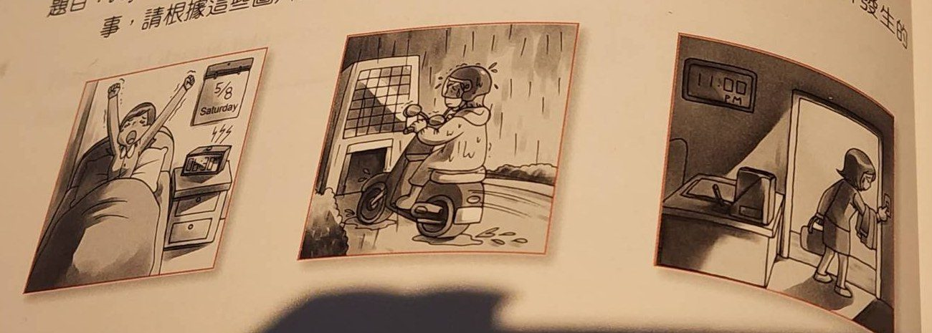
Useful Words & Phrases 實用單字片語
Word / Phrase | 中文 | Word / Phrase | 中文
business woman | 女商人 | a lot of traffic | 車很多
hard-working | 勤奮 | Christmas sale | 聖誕特賣
works overtime | 加班 | almost one hour | 將近一小時
woke up | 起床 | late | 遲到
holiday | 假日 | angry at | 對…生氣
had to | 必須 | arrived home | 到家
had breakfast | 吃早餐 | no time | 沒時間
rode a motorcycle | 騎機車 | without taking a shower | 沒洗澡
terrible | 糟糕 | the busiest | 最忙的
raining cats and dogs | 傾盆大雨 | the most tiring | 最累的
Useful Sentence Patterns 實用句型
1. S is + adj., and S often + Vs
→ She is very hard-working, and she often works overtime.
2. It was ..., but S had to V + because + 句子
→ It was a holiday, but she had to go to her company because she had a lot of work to do.
3. It was Ving ... while S was Ving
→ The weather was terrible. It was raining cats and dogs while she was riding.
4. As a result, S was + 時間 + late, and + 句子
→ As a result, she was forty minutes late, and her boss was angry at her.
5. S had no time to V
→ She had no time to eat dinner.
6. For + 人, it was the + 最高級 + N + of + one's life!
→ For her, it was the busiest and most tiring day of her life!
Sentence Patterns 句型表
Column 1｜元素 & 關鍵字 | Column 2｜句型 | Column 3｜例句
人物介紹 Who  business woman 女商人; 30-year-old | S + is + a + 年齡-year-old + 職業. | Joyce is a 30-year-old business woman.
個性 + 習慣 (現在式)  hard-working 勤奮; works overtime 加班 | S is + adj., and S often + Vs | She is very hard-working, and she often works overtime.
圖一 時間 (進入過去式)  woke up 起床; six thirty a.m. | Last + 時間, S woke up at + 時間. | Last Saturday, she woke up at six thirty a.m.
原因 Reason  holiday 假日; had to 必須 | It was ..., but S had to V + because + 句子 | It was a holiday, but she had to go to her company because she had a lot of work to do.
圖二 時間地點  had breakfast 吃早餐; rode a motorcycle 騎機車 | After S + Ved, S + Ved | After she had breakfast, she rode her motorcycle to work.
天氣 Weather  terrible 糟糕; raining cats and dogs 傾盆大雨 | It was Ving ... while S was Ving | The weather was terrible. It was raining cats and dogs while she was riding.
狀況細節 Besides  a lot of traffic 車很多; Christmas sale 聖誕特賣 | Besides, there was a lot of + N + because + 句子 | Besides, there was a lot of traffic because there was a Christmas sale.
花時間 Time spent  almost one hour 將近一小時 | It took + 人 + 時間 + to V | It took her almost one hour to get to her office.
影響 Result  late 遲到; angry at 對…生氣 | As a result, S was + 時間 + late, and + 句子 | As a result, she was forty minutes late, and her boss was angry at her.
圖三 時間地點  arrived home 到家; eleven o'clock at night | When S arrived home, it was already + 時間. | When she arrived home, it was already eleven o'clock at night.
晚餐 Dinner  no time 沒時間 | S had no time to V | She had no time to eat dinner.
so...that  without taking a shower 沒洗澡 | S was so + adj. + that + 句子 | She was so tired that she went to bed without taking a shower.
結尾感受  the busiest 最忙的; the most tiring 最累的 | For + 人, it was the + 最高級 + N + of + one's life! | For her, it was the busiest and most tiring day of her life!
範文 Model Essay (152 words)
Joyce is a 30-year-old business woman. She is very hard-working, and she often works overtime. Last Saturday, she woke up at six thirty a.m. It was a holiday, but she had to go to her company because she had a lot of work to do. After she had breakfast, she rode her motorcycle to work. The weather was terrible. It was raining cats and dogs while she was riding. Besides, there was a lot of traffic because there was a Christmas sale. It took her almost one hour to get to her office. As a result, she was forty minutes late, and her boss was angry at her. When she arrived home, it was already eleven o'clock at night. She had no time to eat dinner. She was so tired that she went to bed without taking a shower. For her, it was the busiest and most tiring day of her life!
主題 12｜工作與日常作息 Work & Daily Routines
Topic 45｜夜班Jeff的作息篇 Jeff's Night Shift
題目：夜班Jeff每天的作息。請依據下面的圖片，寫一篇約 50 字的短文，描述 Jeff 每天的作息。
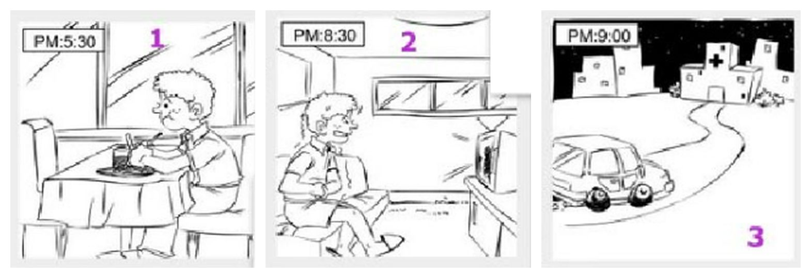
Useful Words & Phrases 實用單字片語
Word / Phrase | 中文 | Word / Phrase | 中文
nurse | 護理師 | living room | 客廳
hospital | 醫院 | funny shows | 搞笑節目
night shift | 夜班 | laughs out loud | 大聲笑
during the day | 白天 | relaxed | 放鬆的
at night | 晚上 | before work | 上班前
gets up | 起床 | drives to | 開車去
afternoon | 下午 | start his work | 開始工作
dinner | 晚餐 | dark | 黑暗的
restaurant | 餐廳 | quiet | 安靜的
near | 在…附近 | takes care of | 照顧
sleepy | 想睡的 | all night | 整晚
has just woken up | 剛睡醒 | not easy | 不容易
sofa | 沙發 | loves his job | 熱愛工作
Useful Sentence Patterns 實用句型
1. S works at + 地點, and S always + Vs
→ He works at a hospital, and he always works the night shift.
2. Every day, S gets up at + 時間.
→ Every day, he gets up at about five o'clock in the afternoon.
3. S often looks + adj. because + 句子
→ He often looks sleepy because he has just woken up.
4. V-ing + makes + 人 + feel + adj.
→ Watching TV makes him feel relaxed before work.
5. The N is + adj., and the N are + adj.
→ The sky is dark, and the streets are quiet.
6. For S, it is not easy to V, but S + Vs
→ For Jeff, it is not easy to work at night, but he loves his job.
Sentence Patterns 句型表
Column 1｜元素 & 關鍵字 | Column 2｜句型 | Column 3｜例句
人物介紹 Who  nurse 護理師 | S + is + a + 年齡-year-old + 職業. | Jeff is a 30-year-old nurse.
工作 Job  hospital 醫院; night shift 夜班 | S works at + 地點, and S always + Vs | He works at a hospital, and he always works the night shift.
作息 Routine  during the day 白天; at night 晚上 | S usually + Vs + during + N because + 句子 | He usually sleeps during the day because he works at night.
起床 Get Up  gets up 起床; afternoon 下午 | Every day, S gets up at + 時間. | Every day, he gets up at about five o'clock in the afternoon.
圖一 時間地點  dinner 晚餐; restaurant 餐廳; near 在…附近 | At + 時間, S + Vs + N at + 地點. | At 5:30 p.m., he eats dinner at a restaurant near his home.
心情 + 原因 Feeling  sleepy 想睡的; has just woken up 剛睡醒 | S often looks + adj. because + 句子 | He often looks sleepy because he has just woken up.
圖二 時間地點  sofa 沙發; living room 客廳 | At + 時間, S sits on + N and + Vs + N. | At 8:30 p.m., he sits on the sofa and watches TV in the living room.
圖二 動作  funny shows 搞笑節目; laughs out loud 大聲笑 | S likes + N, so S often + Vs | He likes funny shows, so he often laughs out loud.
心情 Feeling  relaxed 放鬆的; before work 上班前 | V-ing + makes + 人 + feel + adj. | Watching TV makes him feel relaxed before work.
圖三 時間地點  drives to 開車去; start his work 開始工作 | At + 時間, S drives to + 地點 + to V | At 9:00 p.m., he drives to the hospital to start his work.
細節 Details  dark 黑暗的; quiet 安靜的 | The N is + adj., and the N are + adj. | The sky is dark, and the streets are quiet.
工作 Work  takes care of 照顧; all night 整晚 | At + 地點, S takes care of + 人 + all night. | At the hospital, he takes care of sick people all night.
萬用結尾 Lesson  not easy 不容易; loves his job 熱愛工作 | For S, it is not easy to V, but S + Vs | For Jeff, it is not easy to work at night, but he loves his job.
範文 Model Essay (148 words)
Jeff is a 30-year-old nurse. He works at a hospital, and he always works the night shift. He usually sleeps during the day because he works at night. Every day, he gets up at about five o'clock in the afternoon. At 5:30 p.m., he eats dinner at a restaurant near his home. He often looks sleepy because he has just woken up. At 8:30 p.m., he sits on the sofa and watches TV in the living room. He likes funny shows, so he often laughs out loud. Watching TV makes him feel relaxed before work. At 9:00 p.m., he drives to the hospital to start his work. The sky is dark, and the streets are quiet. At the hospital, he takes care of sick people all night. For Jeff, it is not easy to work at night, but he loves his job.
主題 12｜工作與日常作息 Work & Daily Routines
Topic 46｜放學後不得閒篇 Alice's Busy Afternoon
題目：放學了，但 Alice 可不得閒。請根據圖片寫一篇約 50 字的短文。
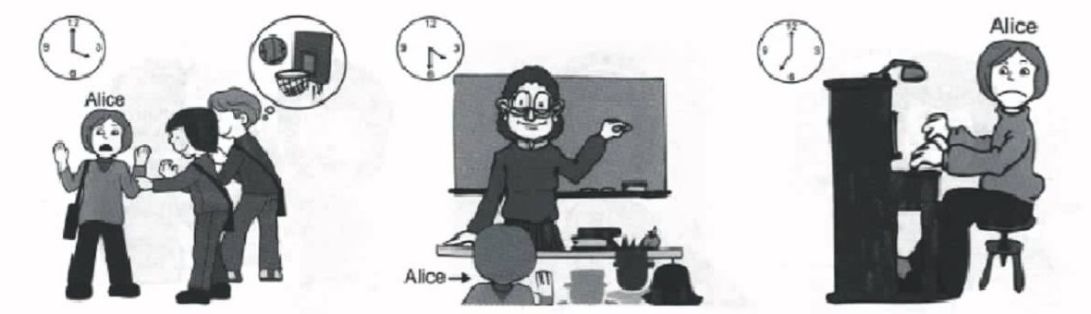
Useful Words & Phrases 實用單字片語
Word / Phrase | 中文 | Word / Phrase | 中文
elementary school student | 小學生 | carefully | 仔細地
play basketball | 打籃球 | tired | 累的
school was over | 放學了 | go home | 回家
classmates | 同學 | practiced the piano | 練鋼琴
asked | 邀請 | in the evening | 傍晚
sad | 難過的 | didn't want to | 不想
say no | 拒絕 | finish | 完成
cram school | 補習班 | unhappy | 不開心的
study | 讀書 | at the end of the day | 一天結束時
blackboard | 黑板 | more time | 更多時間
Useful Sentence Patterns 實用句型
1. S likes to V with + 人, but S is always + adj.
→ She likes to play basketball with her friends, but she is always busy after school.
2. S asked + 人 + to V + with + 人.
→ Two of her classmates asked her to play basketball with them.
3. At + 時間, S went to + 地點 + to V
→ At 4:30, she went to a cram school to study English and math.
4. S was so + adj. + that + 句子
→ She was so tired that she wanted to go home.
5. S didn't want to V, but S had to V
→ She didn't want to play, but she had to finish her practice.
6. S thought to herself, "..."
→ She thought to herself, "I want more time to play with my friends!"
Sentence Patterns 句型表
Column 1｜元素 & 關鍵字 | Column 2｜句型 | Column 3｜例句
人物介紹 Who  elementary school student 小學生 | S + is + a + 年齡-year-old + 職業. | Alice is a 12-year-old elementary school student.
喜好 Hobby  play basketball 打籃球 | S likes to V with + 人, but S is always + adj. | She likes to play basketball with her friends, but she is always busy after school.
圖一 時間地點  school was over 放學了 | Yesterday, school was over at + 時間. | Yesterday, school was over at four o'clock in the afternoon.
圖一 動作  classmates 同學; asked 邀請 | S asked + 人 + to V + with + 人. | Two of her classmates asked her to play basketball with them.
心情 + 原因 Feeling  sad 難過的; say no 拒絕 | S felt + adj. + because + S had to V | She felt sad because she had to say no to them.
圖二 時間地點  cram school 補習班; study 讀書 | At + 時間, S went to + 地點 + to V | At 4:30, she went to a cram school to study English and math.
圖二 動作  blackboard 黑板; carefully 仔細地 | S + Ved + N, and S + Ved + adv. | The teacher wrote many things on the blackboard, and Alice listened carefully.
心情 Feeling  tired 累的; go home 回家 | S was so + adj. + that + 句子 | She was so tired that she wanted to go home.
圖三 時間地點  practiced the piano 練鋼琴; in the evening 傍晚 | At + 時間 + in the evening, S + Ved + N. | At seven o'clock in the evening, she practiced the piano at home for two hours.
動作 Action  didn't want to 不想; finish 完成 | S didn't want to V, but S had to V | She didn't want to play, but she had to finish her practice.
結局 Ending  unhappy 不開心的; at the end of the day 一天結束時 | As a result, S felt + adj. and adj. + 時間. | As a result, she felt unhappy and very tired at the end of the day.
萬用結尾 Lesson  more time 更多時間 | S thought to herself, "..." | She thought to herself, "I want more time to play with my friends!"
範文 Model Essay (145 words)
Alice is a 12-year-old elementary school student. She likes to play basketball with her friends, but she is always busy after school. Yesterday, school was over at four o'clock in the afternoon. Two of her classmates asked her to play basketball with them. She felt sad because she had to say no to them. At 4:30, she went to a cram school to study English and math. The teacher wrote many things on the blackboard, and Alice listened carefully. She was so tired that she wanted to go home. At seven o'clock in the evening, she practiced the piano at home for two hours. She didn't want to play, but she had to finish her practice. As a result, she felt unhappy and very tired at the end of the day. She thought to herself, "I want more time to play with my friends!"
主題 12｜工作與日常作息 Work & Daily Routines
Topic 47｜暑假打工篇 Ben's Summer Job
題目：Ben 去年暑假去打工。請根據以下的圖片寫一篇約 50 字的短文。注意：未依提示作答者，將予扣分。
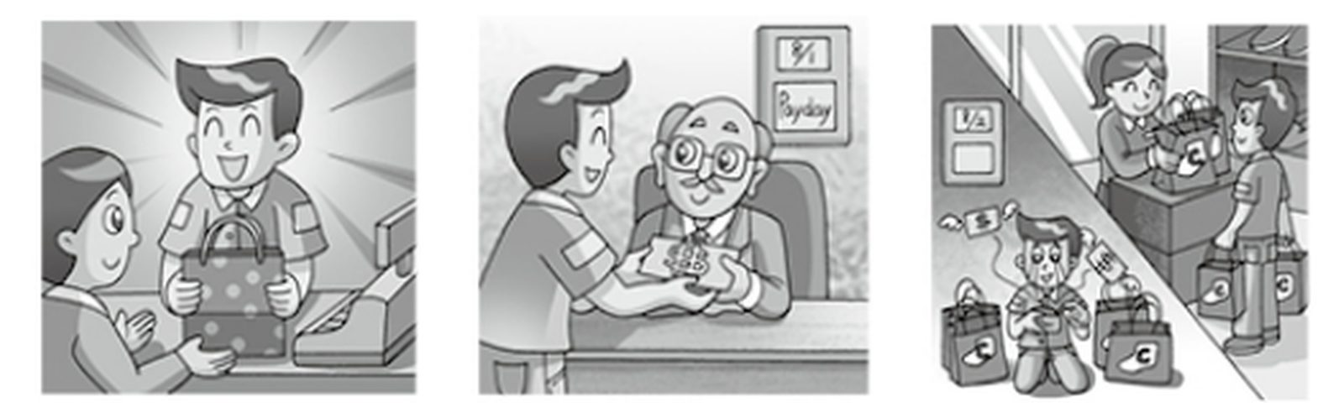
Useful Words & Phrases 實用單字片語
Word / Phrase | 中文 | Word / Phrase | 中文
senior high school student | 高中生 | pay | 薪水
shopping | 購物 | excited | 興奮
money | 錢 | smiling | 微笑
last summer | 去年夏天 | the next day | 隔天
worked part-time | 打工 | went shopping | 去購物
store | 商店 | bought | 買
clerk | 店員 | a lot of | 很多
sold | 賣 | price | 價格
customers | 顧客 | at all | 一點也不
worked hard | 努力工作 | spent | 花
smiled | 微笑 | all | 全部
happy | 開心 | sad | 難過
friendly | 友善 | empty wallet | 空錢包
payday | 發薪日 | important lesson | 重要的教訓
boss | 老闆 | save money | 存錢
Useful Sentence Patterns 實用句型
1. S likes + Ving, but S doesn't have much + N.
→ He likes shopping, but he doesn't have much money.
2. S was a + N, and S + Ved + N + to + 人.
→ He was a clerk, and he sold things to customers.
3. On + 日期, it was + N, and S gave + 人 + N.
→ On August 1, it was payday, and his boss gave him his first pay.
4. The next day, S + Ved + at + 地點.
→ The next day, he went shopping at a big store.
5. Soon, S found that + 句子.
→ Soon, he found that he had spent all his money.
6. S has learned an important lesson: it is + adj. + to V.
→ He has learned an important lesson: it is important to save money and spend it carefully.
Sentence Patterns 句型表
Column 1｜元素 & 關鍵字 | Column 2｜句型 | Column 3｜例句
人物介紹 Who  senior high school student 高中生 | S + is + a + 年齡-year-old + 職業. | Ben is a 17-year-old senior high school student.
喜好 Hobby  shopping 購物; money 錢 | S likes + Ving, but S doesn't have much + N. | He likes shopping, but he doesn't have much money.
圖一 時間地點  last summer 去年夏天; worked part-time 打工; store 商店 | Last summer, S + Ved + at + 地點. | Last summer, he worked part-time at a store.
圖一 動作  clerk 店員; sold 賣; customers 顧客 | S was a + N, and S + Ved + N + to + 人. | He was a clerk, and he sold things to customers.
努力 Hard Work  worked hard 努力工作; smiled 微笑 | S always + Ved and Ved + at + 人. | He always worked hard and smiled at every customer.
心情 + 原因 Feeling  happy 開心; friendly 友善 | S felt + adj. + because + 句子. | He felt happy because the customers were friendly to him.
圖二 時間地點  payday 發薪日; boss 老闆; pay 薪水 | On + 日期, it was + N, and S gave + 人 + N. | On August 1, it was payday, and his boss gave him his first pay.
心情 Feeling  excited 興奮; smiling 微笑 | S was so + adj. + that + 句子. | Ben was so excited that he couldn't stop smiling.
圖三 時間地點  the next day 隔天; went shopping 去購物 | The next day, S + Ved + at + 地點. | The next day, he went shopping at a big store.
動作 Action  bought 買; a lot of 很多 | S + Ved + a lot of + N. | He bought a lot of clothes, shoes, and bags.
花費 Spending  price 價格; at all 一點也不 | S didn't think about + N + at all. | He didn't think about the price at all.
發現 Discovery  spent 花; all 全部 | Soon, S found that + 句子. | Soon, he found that he had spent all his money.
心情 Feeling  sad 難過; empty wallet 空錢包 | S felt + adj., and S + Ved. | He felt very sad, and he cried with his empty wallet in his hands.
萬用結尾 Lesson  important lesson 重要的教訓; save money 存錢 | S has learned an important lesson: it is + adj. + to V. | He has learned an important lesson: it is important to save money and spend it carefully.
範文 Model Essay (144 words)
Ben is a 17-year-old senior high school student. He likes shopping, but he doesn't have much money. Last summer, he worked part-time at a store. He was a clerk, and he sold things to customers. He always worked hard and smiled at every customer. He felt happy because the customers were friendly to him. On August 1, it was payday, and his boss gave him his first pay. Ben was so excited that he couldn't stop smiling. The next day, he went shopping at a big store. He bought a lot of clothes, shoes, and bags. He didn't think about the price at all. Soon, he found that he had spent all his money. He felt very sad, and he cried with his empty wallet in his hands. He has learned an important lesson: it is important to save money and spend it carefully.
主題 12｜工作與日常作息 Work & Daily Routines
Topic 48｜馬克夏日消暑篇 Mark's Cool Summer
題目：夏天到了，馬克（Mark）常常在夏天的時候用許多方式來消暑，請依據下面的圖片，寫一篇約 50 字的短文，描寫圖片的情節。
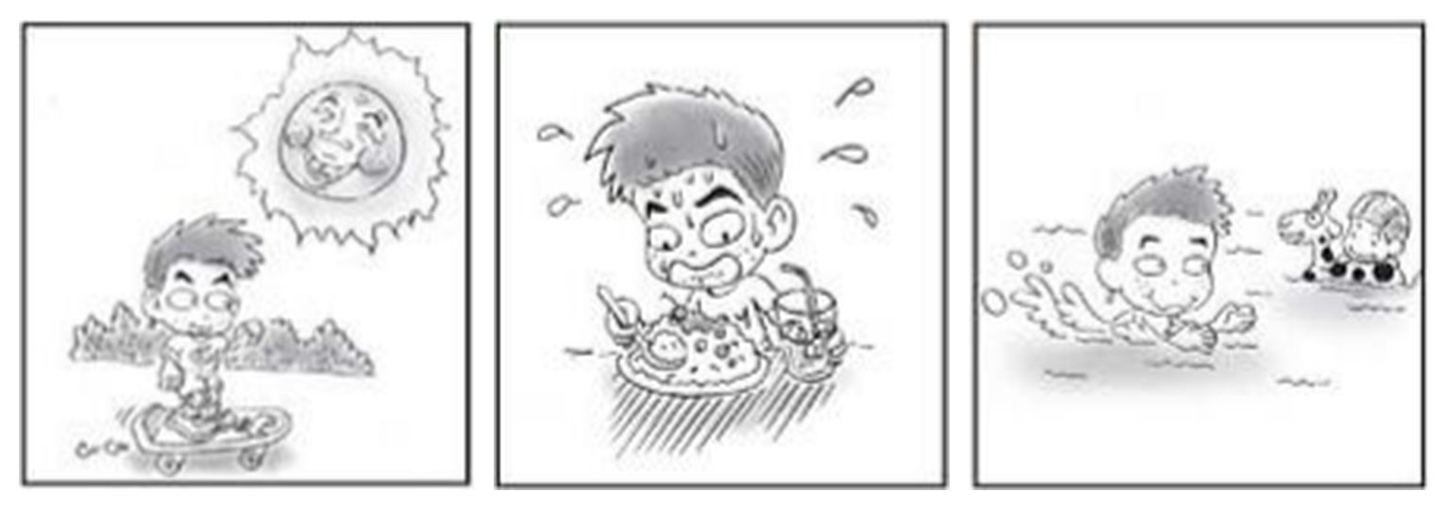
Useful Words & Phrases 實用單字片語
Word / Phrase | 中文 | Word / Phrase | 中文
junior high school student | 國中生 | cool | 涼快的
summer | 夏天 | happy | 開心的
hot weather | 炎熱的天氣 | on weekends | 週末
very hot | 非常熱 | swimming pool | 游泳池
Taiwan | 台灣 | animal float | 動物造型游泳圈
skateboard | 滑板 | in the water | 在水裡
under the hot sun | 在大太陽下 | favorite | 最喜歡的
sweats | 流汗 | stay cool | 保持涼爽
uncomfortable | 不舒服的 | many ways | 很多方法
cool down | 降溫 | enjoy | 享受
shaved ice | 剉冰 | the most fun | 最好玩的
cold juice | 冰果汁 | season | 季節
straw | 吸管
Useful Sentence Patterns 實用句型
1. S likes + N, but S doesn't like + N.
→ He likes summer vacation, but he doesn't like the hot weather.
2. Sometimes S + Vs + N + under + N.
→ Sometimes he rides his skateboard in the park under the hot sun.
3. To V, S often + Vs + N.
→ To cool down, he often eats a big plate of shaved ice with fruit on top.
4. On + 時間, S goes + V-ing + in + 地點.
→ On weekends, he goes swimming in the swimming pool.
5. V-ing + is + S's favorite way to V
→ Swimming is his favorite way to stay cool.
6. For S, N is the 最高級 + N + of + N.
→ For Mark, summer is the most fun season of the year.
Sentence Patterns 句型表
Column 1｜元素 & 關鍵字 | Column 2｜句型 | Column 3｜例句
人物介紹 Who  junior high school student 國中生 | S + is + a + 年齡-year-old + 職業. | Mark is a 13-year-old junior high school student.
喜好 Hobby  summer 夏天; hot weather 炎熱的天氣 | S likes + N, but S doesn't like + N. | He likes summer vacation, but he doesn't like the hot weather.
天氣 Weather  very hot 非常熱; Taiwan 台灣 | In + 季節, it is + adj. + in + 地點, and + 句子 | In summer, it is very hot in Taiwan, and the sun is very strong.
圖一 動作  skateboard 滑板; under the hot sun 在大太陽下 | Sometimes S + Vs + N + under + N. | Sometimes he rides his skateboard in the park under the hot sun.
心情 + 原因 Feeling  sweats 流汗; uncomfortable 不舒服的 | S + Vs a lot, so S feels + adj. | He sweats a lot, so he feels very uncomfortable.
圖二 動作  cool down 降溫; shaved ice 剉冰 | To V, S often + Vs + N. | To cool down, he often eats a big plate of shaved ice with fruit on top.
細節 Details  cold juice 冰果汁; straw 吸管 | S also + Vs + N + with + N. | He also drinks a glass of cold juice with a straw.
心情 Feeling  cool 涼快的; happy 開心的 | N + makes + 人 + feel + adj. and adj. | The ice makes him feel cool and happy.
圖三 時間地點  on weekends 週末; swimming pool 游泳池 | On + 時間, S goes + V-ing + in + 地點. | On weekends, he goes swimming in the swimming pool.
圖三 動作  animal float 動物造型游泳圈; in the water 在水裡 | S plays with + N + in the water and has a great time. | He plays with a cute animal float in the water and has a great time.
喜好 Favorite  favorite 最喜歡的; stay cool 保持涼爽 | V-ing + is + S's favorite way to V | Swimming is his favorite way to stay cool.
萬用結尾 Lesson  many ways 很多方法; enjoy 享受 | S thinks that + 句子 | He thinks that there are many ways to enjoy the hot summer, and he loves all of them.
結尾 Ending  the most fun 最好玩的; season 季節 | For S, N is the 最高級 + N + of + N. | For Mark, summer is the most fun season of the year.
範文 Model Essay (150 words)
Mark is a 13-year-old junior high school student. He likes summer vacation, but he doesn't like the hot weather. In summer, it is very hot in Taiwan, and the sun is very strong. Sometimes he rides his skateboard in the park under the hot sun. He sweats a lot, so he feels very uncomfortable. To cool down, he often eats a big plate of shaved ice with fruit on top. He also drinks a glass of cold juice with a straw. The ice makes him feel cool and happy. On weekends, he goes swimming in the swimming pool. He plays with a cute animal float in the water and has a great time. Swimming is his favorite way to stay cool. He thinks that there are many ways to enjoy the hot summer, and he loves all of them. For Mark, summer is the most fun season of the year.
主題 12｜工作與日常作息 Work & Daily Routines
Topic 49｜未來的計畫（未來式） David's Future Plans
題目：David 現在是國中生，他對自己的未來擬定了計畫。請依據下面的圖片，寫一篇短文來描述 David 對未來的計畫。
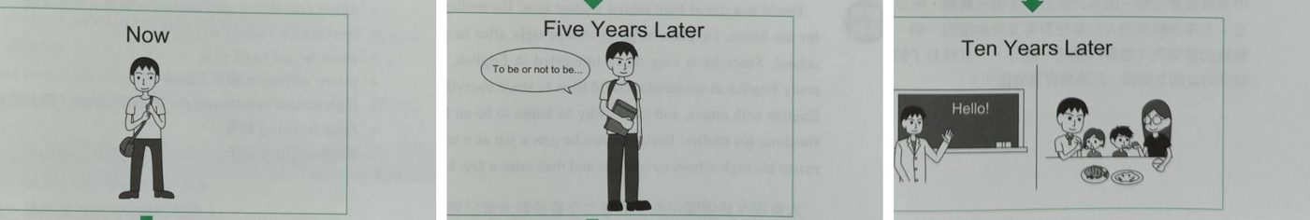
Useful Words & Phrases 實用單字片語
Word / Phrase | 中文 | Word / Phrase | 中文
junior high school student | 國中生 | English teacher | 英文老師
studies hard | 用功 | become | 成為
plans | 計畫 | high school | 高中
interested in | 對…有興趣 | marry | 娶
practices | 練習 | sweetheart | 女友
plans to | 計畫 | raise | 養育
senior high school | 高中 | take kids to | 帶孩子去
foreigners | 外國人 | park | 公園
college student | 大學生 | busy but happy | 忙碌但快樂
continue to | 繼續 | dreams come true | 夢想成真
study abroad | 出國讀書 | works hard | 努力
share | 分享
Useful Sentence Patterns 實用句型
1. S + Vs, and S has + N.
→ He studies hard, and he has big plans for his future.
2. S plans to V
→ He plans to go to a good senior high school first.
3. S will continue to V
→ He will continue to study English at university.
4. S likes to V, so S wants to V
→ He likes to share what he knows with others, so he wants to be an English teacher.
5. S will V + 人 + to + 地方 + on weekends.
→ He will take his kids to the park on weekends.
6. S thinks that + 句子 + if + 句子.
→ David thinks that dreams can come true if he works hard.
Sentence Patterns 句型表
Column 1｜元素 & 關鍵字 | Column 2｜句型 | Column 3｜例句
人物介紹 Who  junior high school student 國中生 | S + is + a + 年齡-year-old + 職業. | David is a 15-year-old junior high school student.
個性 Personality  studies hard 用功; plans 計畫 | S + Vs, and S has + N. | He studies hard, and he has big plans for his future.
圖一 Now (現在式)  interested in 對…有興趣; practices 練習 | Now, S is interested in + N, and S + Vs | Now, he is very interested in English, and he practices it every day.
計畫 Plan  plans to 計畫; senior high school 高中 | S plans to V | He plans to go to a good senior high school first.
目的 Purpose  foreigners 外國人 | S wants to V + so that + S can V | He wants to learn more English so that he can talk with foreigners.
圖二 Five Years Later (未來式)  college student 大學生 | 時間 + later, S will + V | Five years later, he will be a college student.
大學 University  continue to 繼續 | S will continue to V | He will continue to study English at university.
留學 Study abroad  study abroad 出國讀書 | S may also V + for + 時間. | He may also study abroad in America for one year.
原因 Reason  share 分享; English teacher 英文老師 | S likes to V, so S wants to V | He likes to share what he knows with others, so he wants to be an English teacher.
圖三 Ten Years Later  become 成為; high school 高中 | 時間 + later, S will become + N. | Ten years later, he will become an English teacher at a high school.
家庭 Family  marry 娶; sweetheart 女友; raise 養育 | Besides, S will V and V | Besides, he will marry his high school sweetheart and raise two kids.
生活 Life  take kids to 帶孩子去; park 公園 | S will V + 人 + to + 地方 + on weekends. | He will take his kids to the park on weekends.
感受 Feeling  busy but happy 忙碌但快樂 | S believes that + 句子 | He believes that his life will be busy but happy.
萬用結尾  dreams come true 夢想成真; works hard 努力 | S thinks that + 句子 + if + 句子. | David thinks that dreams can come true if he works hard.
範文 Model Essay (156 words)
David is a 15-year-old junior high school student. He studies hard, and he has big plans for his future. Now, he is very interested in English, and he practices it every day. He plans to go to a good senior high school first. He wants to learn more English so that he can talk with foreigners. Five years later, he will be a college student. He will continue to study English at university. He may also study abroad in America for one year. He likes to share what he knows with others, so he wants to be an English teacher. Ten years later, he will become an English teacher at a high school. Besides, he will marry his high school sweetheart and raise two kids. He will take his kids to the park on weekends. He believes that his life will be busy but happy. David thinks that dreams can come true if he works hard.

