Project 1: Static Foundations
Feedback for Dead Frame
Student: Jennifer Guinanzaca Course: CSC 436, Fall 2026 Reviewed at: b20d482
Repo: github.com/JenniferGuinanzaca/Dead-Frame Live: deadframe-csc436.netlify.app

Grade: 84 / 100
Category | Points | Earned | One line
Semantic HTML | 20 | 18 | Valid, clean outline, every element the brief lists; nav links are not a list, cards are divs
CSS layout | 25 | 22 | Flexbox nav, hero and filters, Grid gallery, a real dark palette; a fixed-width image and a fixed 4-column grid
Responsive design | 15 | 11 | Perfect at 375 and 768; horizontal scroll from 769px to about 1100px because of one width: 700px
JavaScript interaction | 15 | 12 | Cards built from data, filter works and is clean; the active button never moves
Repository and deployment | 15 | 14 | 32 commits over three days with the best messages in the class; README complete and honest
Content and polish | 10 | 7 | 13 real films with real posters and a coherent theme; 9.5 MB of images
Total | 100 | 84 | The best process in the class, and a site that shows it. Two real bugs are holding it back.

How this review was made
Your instructor reviewed this project with Claude (Anthropic's AI) as a second set of eyes. Claude cloned the repo, read every line, loaded the live site at 375, 768, 900, 1024, 1200 and 1280 pixels wide, ran the W3C validator, clicked every filter button and counted the cards, weighed the images, and read the console. Every note and every point in this document was read and approved by your instructor. Same standard, same rubric, just more time spent looking at your code than one human has in a grading week.

The short version
Your commit history is the model answer. Thirty-two commits across three days, each one a single change with a message that says what it did: "add hover effect for hero button," "style movie card," "fix array," "add mobile responsiveness." Anyone can read that log and watch the site get built. Nobody else in the class did that this well.
The site itself is solid. Valid HTML with every semantic element the brief lists and one clean h1. Flexbox for the nav, the hero and the filter bar, Grid for the gallery. Cards generated from a data array with a working genre filter. A dark, serif-led design that fits a horror archive. And a README that explains, honestly, why you chose a local array over an API. That is a good engineering decision, well documented.
Two bugs cost the most. The hero image is a fixed 700 pixels wide, so from just above your 768px breakpoint to about 1100px, which is iPad landscape and most small laptops, the page scrolls sideways. And when you click a filter, the cards change but the red highlight stays on "All," because the script never moves the active class. Both are a few lines. Then the images: 9.5 MB for fifteen files shown at 300 pixels wide, with one poster at 3.6 MB.

What Claude measured
Check | Result
Horizontal scroll at 375 / 768 px | None
Horizontal scroll at 900 px | 204 px of overflow (page is 1104 px wide)
Horizontal scroll at 1024 px | 80 px of overflow
Horizontal scroll at 1200 / 1280 px | None
Overflowing element | .hero-image img at a fixed 700 px
W3C HTML validator | 0 errors, 0 warnings
Heading order | h1 > h2 > h3, no skipped levels
Semantic elements | header, nav, main, 3 section, footer
Cards rendered from data | 13
Filter: Slasher / Zombie / All | 3 / 3 / 13 cards, correct titles
Active button after clicking Slasher | Still "All"
Console errors | 0
Grid columns at 375 / 768 / 1280 | 1 / 2 / 4
Images | 15 files, 9.45 MB; Midsommar 3.6 MB (1382 by 2048), Insidious 1.5 MB, hero GIF 962 KB
Commits | 32, from Sep 13 6:36 PM to Sep 15 11:02 PM
README | Title, description, run locally, live URL: all four

The site at three widths
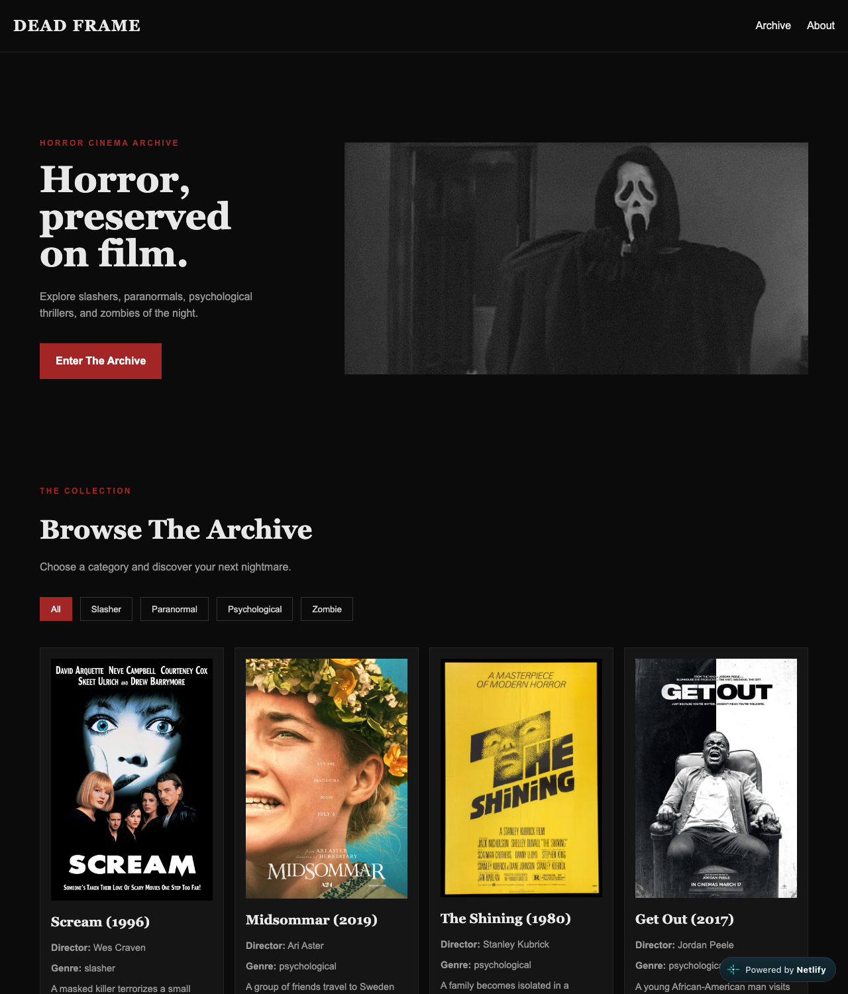
Desktop, 1280px. Two-column hero, four-column archive. At this width it fits.
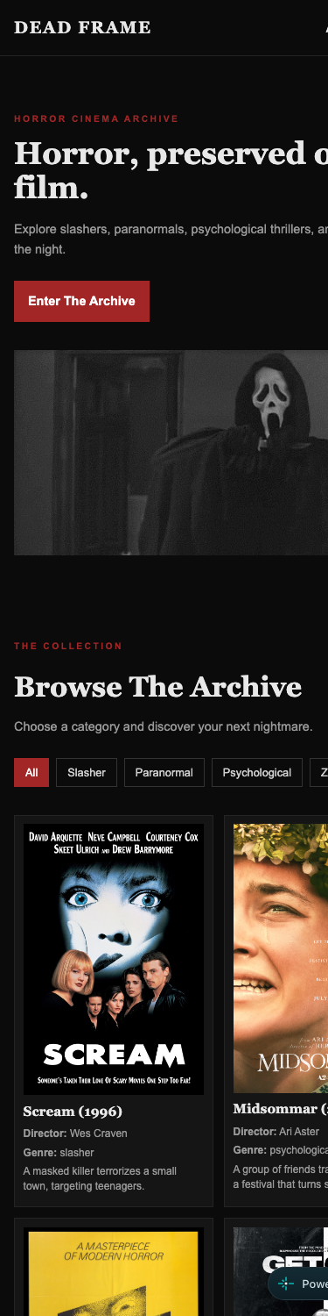  Phone, 375px. Stacked hero, no horizontal scroll. | 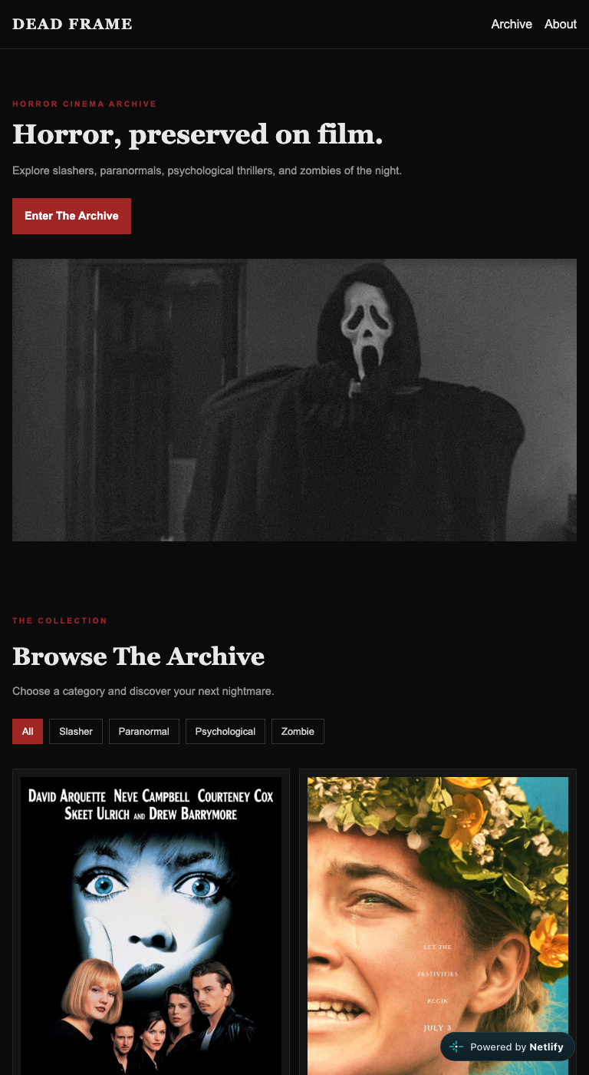  Tablet, 768px. Two columns of cards. One pixel wider and the hero image overflows.

Semantic HTML: 18 / 20

What is working
- header > nav, main with three sections, footer. One h1 (index.html line 25), h2 per section, h3 per card. The validator has nothing to say. lang, viewport, a real title. Every poster gets the film's title as alt text, straight from the data (script.js line 11).
- The eyebrow-then-heading pattern ("THE COLLECTION" above "Browse The Archive") is done with a p and an h2, which is the right way; the eyebrow is not a heading.

What to change
- Nav links are in a div (lines 14 to 17). Two links is still a list. ul > li > a, and your Flexbox rules keep working.
- Movie cards are divs (script.js line 7). Each card is a self-contained item with its own heading: that is article. One word in createElement.
- The logo links to # (line 12). Point it at #hero or index.html so it means "top of page" instead of "nowhere."
- Small: the hero image alt is "Scream gif" (line 32). Alt text describes the picture, not the file: "Ghostface in a dark hallway."

CSS layout: 22 / 25

What is working
- Flexbox, yours, three ways: the nav with space-between (style.css lines 21 to 26), the hero as a two-column row with flex: 1 on the text (lines 51 to 62), and the wrapping filter bar (lines 124 to 129).
- Grid for the gallery (lines 150 to 154), stepping 4 to 2 to 1 across the breakpoints.
- The design is coherent: near-black, one red accent, Georgia for headings and Arial for body, letter-spacing on the eyebrows, a hover state on every interactive element. It reads like a horror archive.

What to change
- width: 700px on the hero image (lines 64 to 67) is the one rule causing the horizontal scroll. Inside a flex row, the text column shrinks but the image never does, so at 1024px the row is 289 + 96 + 700 = 1085px plus padding. width: 100%; max-width: 700px on the image and flex: 1 1 50%; min-width: 0 on its wrapper fixes it at every width.
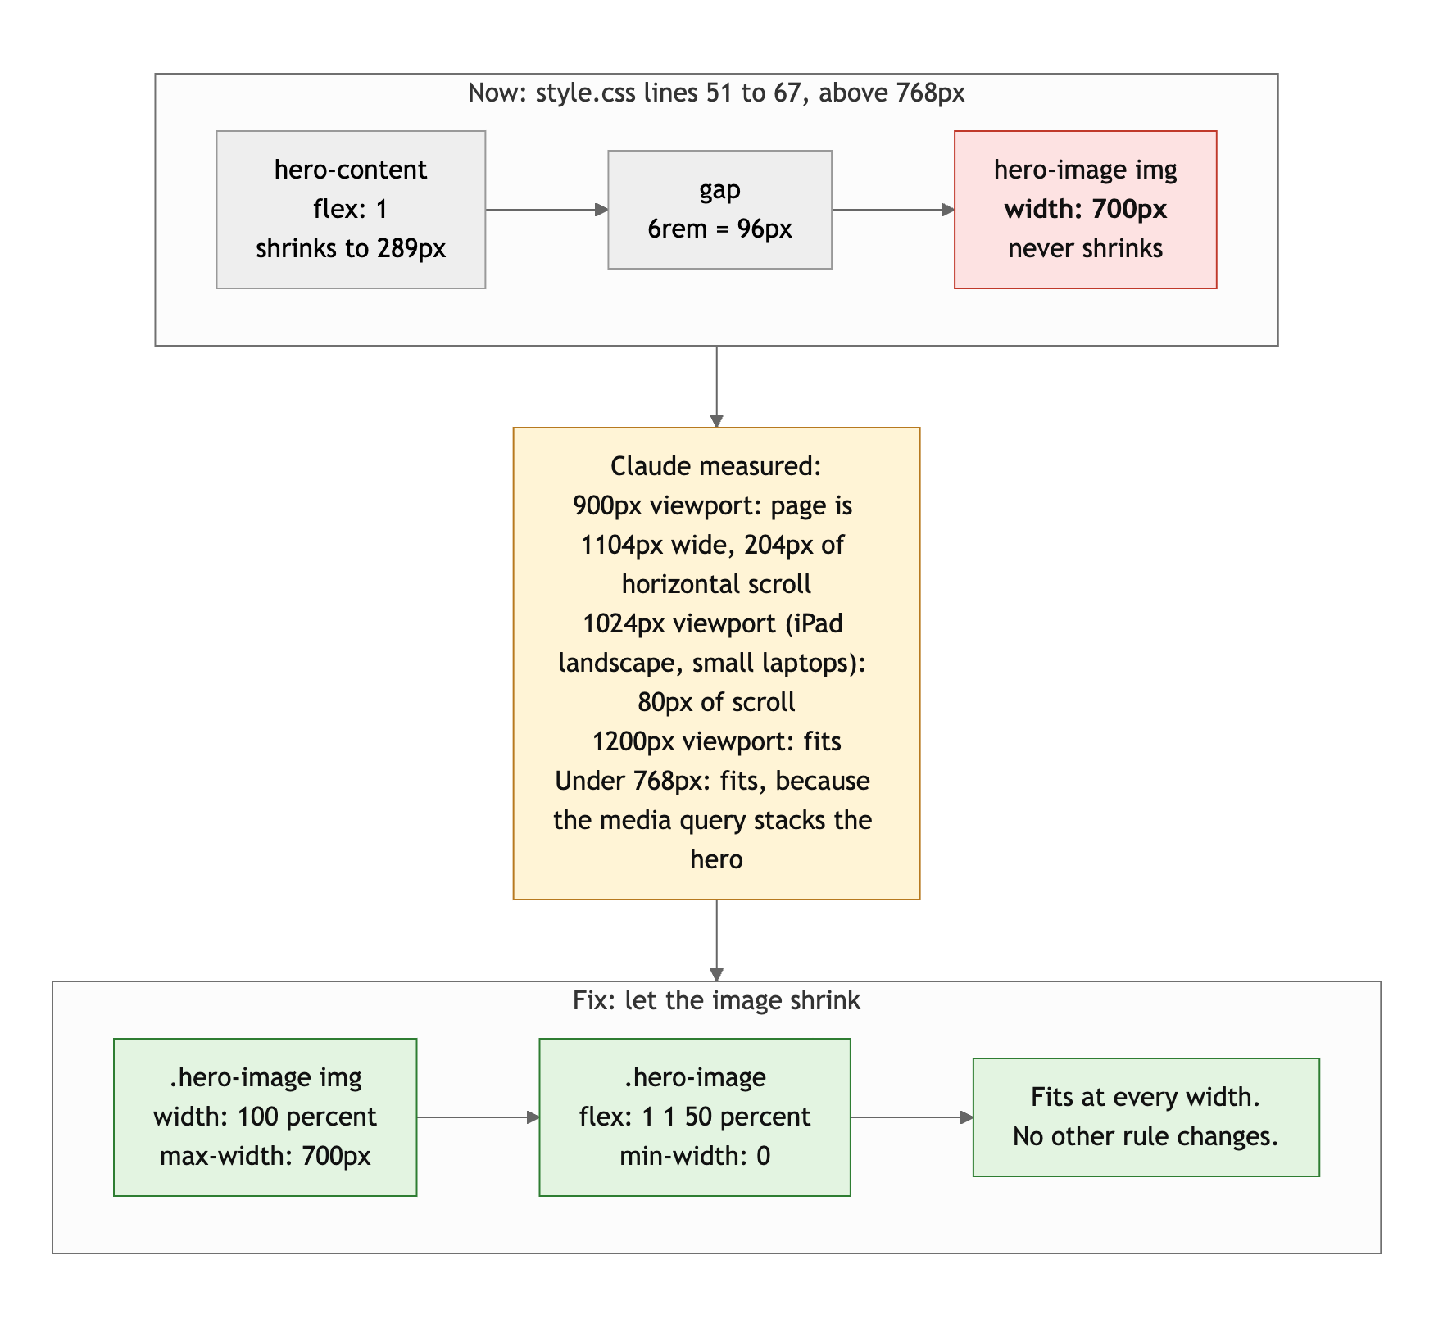
Diagram 1. Why the hero overflows between 769px and about 1100px, and the two rules that fix it.
- repeat(4, 1fr) (line 152) is a fixed four columns until 768px, so at 800px each card is under 200px wide. repeat(auto-fit, minmax(220px, 1fr)) gives you 1, 2, 3, 4 columns as space allows and deletes two of your media-query rules.
- The 480px query re-declares display: flex on the nav (lines 348 to 353); it already is flex. Only the direction changes.

Responsive design: 11 / 15

What is working
- At 375px: no scroll, nav stacks, hero stacks, one column of cards, filter buttons wrap. At 768px: no scroll, two columns. Two breakpoints with real changes at each. The phone view looks designed for a phone.

What to change
- Horizontal scroll from 769px to about 1100px. The brief's requirement is no horizontal scrolling. Your 768px query stacks the hero, so phones and portrait tablets are fine. Above it, the 700px image kicks in and the page overflows until the viewport is wide enough to hold it. Claude measured 204px of overflow at 900px and 80px at 1024px. That is the entire iPad-landscape and small-laptop range. One CSS rule (see above).
- Desktop-first. Both queries are max-width. The brief asked for mobile-first. Your phone styles are the simpler ones anyway; make them the default and add the row layout with min-width.

JavaScript interaction: 12 / 15

What is working
- The archive is built from data. Thirteen film objects in movies.js, a displayMovies function that clears the grid and builds a card per film with createElement and a template literal (script.js lines 3 to 21), and a filter that uses Array.filter on genre (lines 23 to 39). Claude clicked every button: Slasher shows 3, Zombie shows 3, All shows 13, all the right titles. Zero console errors. Separating data from behavior into two files is a good instinct.

What to change
- The active button never moves. The active class starts on "All" in the HTML (index.html line 45) and the click handler never touches it. Click Slasher: three cards, and "All" is still red. The fix is three lines at the top of the handler.
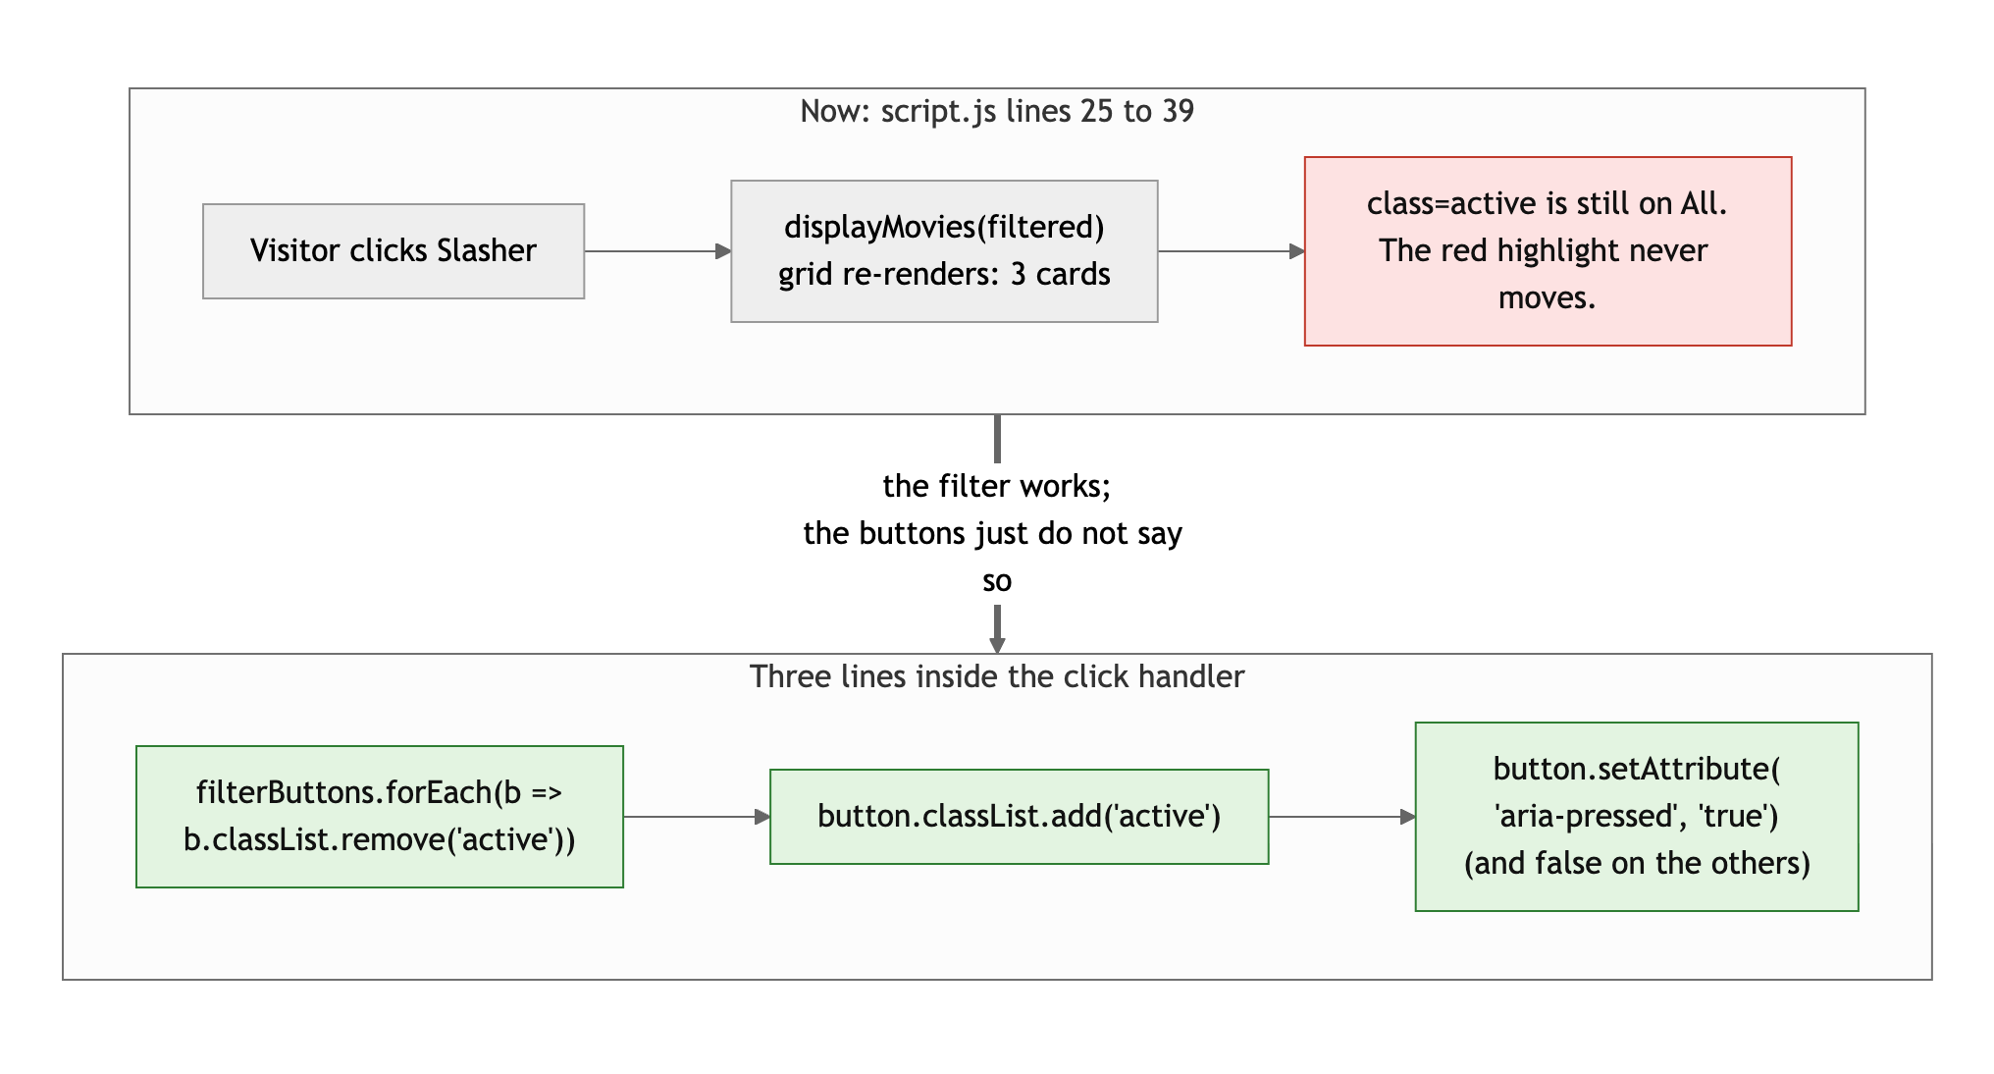
Diagram 2. The filter works, but the button state never changes. Three lines fix it.
- category == "all" (line 30). Use ===. Loose equality is a habit that bites later.
- Small: displayMovies rebuilds every card with innerHTML on each click. For 13 films it is instant. For 300 it would not be. Toggling hidden on existing cards is the scalable version, and it is the same amount of code.

Repository and deployment: 14 / 15

What is working
- This is the commit history the brief describes. 32 commits from September 13 to 15. "created project structures," "add nav & hero," "reset margin and padding," "link css to html," "add hover effect for hero button," "add movie data to array," "add movie filter," "fix array," "add mobile responsiveness." Present tense, one change each, in the order you would teach it. When something broke, the fix is its own commit. This is the log every other student should look at.
- README has all four items, plus something rare: a paragraph explaining a design decision. You wanted to use a movie API, worried it might be down during grading, and chose a local array instead. That is exactly the kind of judgment call the brief wants, and writing it down is better still. .gitignore covers .DS_Store. Live URL works in a private window and matches the repo.

What to change
- The live URL in the README ends in #. Trim it.
- All three days are the last three before the deadline. The messages are perfect; starting a week earlier would have left time for the two bugs above.

Content and polish: 7 / 10

What is working
- Thirteen real films, real posters, a director and a one-line description for each, four real genres, a hero GIF that fits. The copy has a voice ("discover your next nightmare"). Real content in every section, no lorem ipsum.

What to change
- 9.45 MB of images. Midsommar's poster is 1382 by 2048 and 3.6 MB, shown at 300px wide. Insidious is 1.5 MB. The hero GIF is nearly 1 MB. On a phone connection that is 10 to 20 seconds before the archive is browsable. Resize every poster to about 600px wide and export as JPEG at 80 percent or WebP; the whole folder drops under 1 MB. Add loading="lazy" to the card images in displayMovies so posters below the fold do not block the hero.
- The filter looks broken even though it works, because "All" stays highlighted. Visitors trust the button state, not the card count.
- The sideways scroll on a laptop is the first thing a laptop user will notice.

Your next three moves
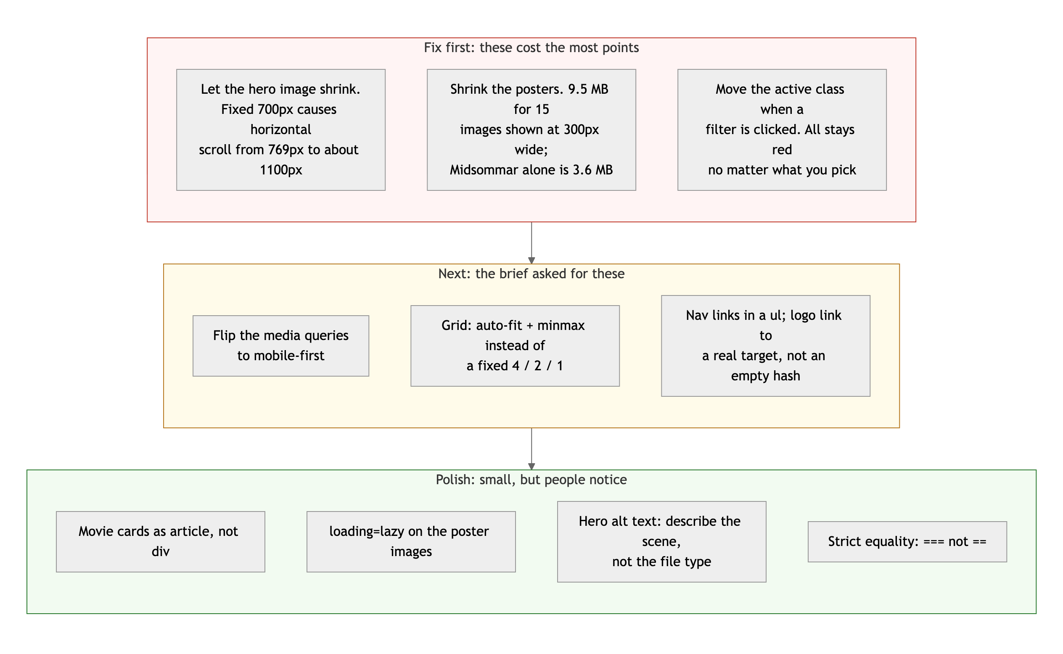
Diagram 3. Priority order. Top row first: it is where the points are.
- Fix the two bugs. One CSS rule for the hero image, three lines for the active button. Twenty minutes, and the site works at every width and the filter looks like it works.
- Shrink the images. Resize, re-export, add loading="lazy". Half an hour, and the archive loads before a visitor gives up.
- Keep committing like this. Your history is the model answer. Next time, start it a week earlier so there is time to open the site on a laptop and click every button before you submit.

You built the archive the right way, in the right order, and wrote it all down. The last pass is the only thing missing.
This review lives in a pull request on your repo. It only adds feedback files and does not touch your code. Merge it, close it, or just read it. Questions go to office hours or the Brightspace board.

