**Alexia Mourtou, Anastasios Kyranas**

**Dr. Panagiotis Yannakopoulos**

John Abbott College  [Company address]

Internet of Things

Table of Contents

List of Tables and Figures 1

Abstract 2

1. Introduction 3

2. Overview 4

2.1. Applications 4

2.1.1. Environmental monitoring 4

2.1.2. Infrastructure management 5

2.1.3. Manufacturing 5

2.1.4. Energy management 5

2.1.5. Medical and healthcare systems 5

2.1.6. Building and home automation 6

2.1.7. Transportation 6

3. How big is the Internet of Things? 6

4. Conclusion 8

References 10

Heading 1 10

Heading 2 10

Heading 3 10

# List of Tables and Figures

Figure 1: The difference between the Industrial Internet of Things and Consumer Internet of Things (Internet of Things Architecture, 2015) 3

Figure 2: The Internet of Things redefined - from connecting devices to creating value (Internet of Things Architecture, 2015) 7

**Internet of Things**

**Alexia Mourtou[1], Anastasios Kyranas[2]**

**Dr. Panagiotis Yannakopoulos[3]**

# Abstract

We’re entering a new era of computing technology that many are calling the Internet of Things (IoT). Machine to machine, machine to infrastructure, machine to environment, the Internet of Everything, the Internet of Intelligent Things, intelligent systems—call it what you want, but it’s happening, and its potential is huge.

We see the IoT as billions of smart, connected “things” (a sort of “universal global neural network” in the cloud) that will encompass every aspect of our lives, and its foundation is the intelligence that embedded processing provides. The IoT is comprised of smart machines interacting and communicating with other machines, objects, environments and infrastructures. As a result, huge volumes of data are being generated, and that data is being processed into useful actions that can “command and control” things to make our lives much easier and safer—and to reduce our impact on the environment. The creativity of this new era is boundless, with amazing potential to improve our lives. The following thesis is an extensive reference to the possibilities, utility, applications and the evolution of the Internet of Things.

# Introduction

The Internet of Things (IoT) is the network of physical objects—devices, vehicles, buildings and other items—embedded with electronics, software, sensors, and network connectivity that enables these objects to collect and exchange data. The IoT allows objects to be sensed and controlled remotely across existing network infrastructure, creating opportunities for more direct integration of the physical world into computer-based systems, and resulting in improved efficiency, accuracy and economic benefit; when IoT is augmented with sensors and actuators, the technology becomes an instance of the more general class of cyber-physical systems, which also encompasses technologies such as smart grids, smart homes, intelligent transportation and smart cities. Each thing is uniquely identifiable through its embedded computing system but is able to interoperate within the existing Internet infrastructure. Experts estimate that the IoT will consist of almost 50 billion objects by 2020 (Bassi, 2013).

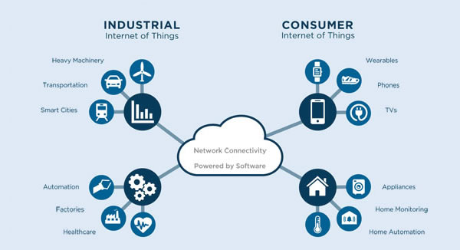

Figure 1: The difference between the Industrial Internet of Things and Consumer Internet of Things (Internet of Things Architecture, 2015)

# Overview

### *2.1. Applications*

According to Gartner, Inc. (a technology research and advisory corporation), there will be nearly 26 billion devices on the Internet of Things by 2020. ABI Research estimates that more than 30 billion devices will be wirelessly connected to the Internet of Things by 2020. As per a recent survey and study done by Pew Research Internet Project, a large majority of the technology experts and engaged Internet users who responded—83 percent—agreed with the notion that the Internet/Cloud of Things, embedded and wearable computing (and the corresponding dynamic systems (Internet of Things - From Research and Innovation to Market Deployment, 2015)) will have widespread and beneficial effects by 2025. As such, it is clear that the IoT will consist of a very large number of devices being connected to the Internet. In an active move to accommodate new and emerging technological innovation, the UK Government, in their 2015 budget, allocated £40,000,000 towards research into the Internet of Things. The British Chancellor of the Exchequer George Osborne, posited that the Internet of Things is the next stage of the information revolution and referenced the interconnectivity of everything from urban transport to medical devices to household appliances (From the internet of Computers to the Internet of Things, 2015).

### 2.1.1. Environmental monitoring

Environmental monitoring applications of the IoT typically use sensors to assist in environmental protection by monitoring air or water quality, atmospheric or soil conditions, and can even include areas like monitoring the movements of wildlife and their habitats (loT, 2015) (From the internet of Computers to the Internet of Things, 2015).

### 2.1.2. Infrastructure management

Monitoring and controlling operations of urban and rural infrastructures like bridges, railway tracks, on- and offshore- wind-farms is a key application of the IoT (The Internet of Things: How the Next Evolution of the Internet Is Changing Everything, 2015). The IoT infrastructure can be used for monitoring any events or changes in structural conditions that can compromise safety and increase risk (Internet of Things - From Research and Innovation to Market Deployment, 2015).

### 2.1.3. Manufacturing

Network control and management of manufacturing equipment, asset and situation management, or manufacturing process control bring the IoT within the realm on industrial applications and smart manufacturing as well (Bassi, 2013).

### 2.1.4. Energy management

Integration of sensing and actuation systems, connected to the Internet, is likely to optimize energy consumption as a whole. (Internet of Things - From Research and Innovation to Market Deployment, 2015) It is expected that IoT devices will be integrated into all forms of energy consuming devices (switches, power outlets, bulbs, televisions, etc.) and be able to communicate with the utility supply company in order to effectively balance power generation and energy usage (Internet of Things Architecture, 2015).

### 2.1.5. Medical and healthcare systems

IoT devices can be used to enable remote health monitoring and emergency notification systems. These health monitoring devices can range from blood pressure and heart rate monitors to advanced devices capable of monitoring specialized implants, such as pacemakers or advanced hearing aids (Internet of Things Architecture, 2015).

### 2.1.6. Building and home automation

IoT devices can be used to monitor and control the mechanical, electrical and electronic systems used in various types of buildings (e.g., public and private, industrial, institutions, or residential) (Internet of Things - From Research and Innovation to Market Deployment, 2015) in home automation and building automation systems (The Internet of Things: How the Next Evolution of the Internet Is Changing Everything, 2015).

### 2.1.7. Transportation

The IoT can assist in integration of communications, control, and information processing across various transportation systems.

# 3. How big is the Internet of Things?

Big and getting bigger -- there are already more connected things than people in the world. Analyst Gartner calculates that around 8.4 billion IoT devices were in use in 2017, up 31 percent from 2016, and this will likely reach 20.4 billion by 2020. Total spending on IoT endpoints and services will reach almost $2tn in 2017, with two-thirds of those devices found in China, North America and Western Europe, said Gartner.

Out of that 8.4 billion devices, more than half will be consumer products like smart TVs and smart speakers. The most-used enterprise IoT devices will be smart electric meters and commercial security cameras, according to Gartner.

Table 1: loT Units Installed Base by Category (Millions of Units)

|  |  |  |  |  |
| --- | --- | --- | --- | --- |
| **Category** | **2016** | **2017** | **2018** | **2020** |
| Consumer | 3,963.0 | 5,244.3 | 7,036.3 | 12,863.0 |
| Business: Cross-Industry | 1,102.1 | 1,501.0 | 2,132.6 | 4,381.4 |
| Business: Vertical-Specific | 1,316.6 | 1,635.4 | 2,027.7 | 3,171.0 |
| **Grand Total** | **6,381.8** | **8,380.6** | **11,196.6** | **20,415.4** |

Another analyst, IDC, puts worldwide spending on IoT at $772.5bn in 2018 -- up nearly 15 percent on the $674bn that will be spent in 2017. IDC predicts that total spending will hit $1tn in 2020 and $1.1tn in 2021.

According to IDC, hardware will be the largest technology category in 2018 with $239bn going on modules and sensors, with some spending on infrastructure and security. Services will be the second largest technology category, followed by software and connectivity. (htt)

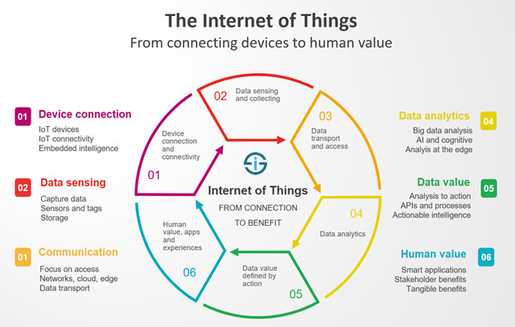

Figure 2: The Internet of Things redefined - from connecting devices to creating value (Internet of Things Architecture, 2015)

# Conclusion

The pervasiveness of embedded processing is already happening everywhere around us. At home, appliances as mundane as your basic toaster now come with an embedded MCU that not only sets the darkness of the piece of toast to your preference, but also adds functional safety to the device. Your refrigerator has started talking to you and keeping track of what you put in it. There are energy-aware

HVAC systems that can now generate a report on the activity in your house and recommend ways to reduce your energy consumption. The electrification of vehicles has already started happening, and in just a few years from now, each car will contain >50 percent more electronics than it did just five years ago. The cars of the future will indeed be able to drive themselves. Similar changes are also happening in other aspects of our lives … in factories, transportation, school systems, stadiums and other public venues. Embedded processing is everywhere.

Connecting those smart devices (nodes) to the web has also started happening, although at a slower rate. The pieces of the technology puzzle are coming together to accommodate the Internet of Things sooner than most people expect. Just as the Internet phenomenon happened not so long ago and caught like a wildfire, the Internet of Things will touch every aspect of our lives in less than a decade.

# References

(s.d.). Récupéré sur https://www.zdnet.com/article/what-is-the-internet-of-things-everything-you-need-to-knowabout-the-iot-right-now/

Bassi, A. (2013). *Enabling Things to Talk: Designing loT solutions with the loT Architectural Reference Model.* Springer Open.

*From the internet of Computers to the Internet of Things*. (2015, 12 27). Récupéré sur http://vs.inf.ethz.ch/publ/papers/Internet-of-things.pdf

*Internet of Things - From Research and Innovation to Market Deployment.* (2015).

*Internet of Things Architecture*. (2015, 11 18). Récupéré sur http://www.iot-a.eu

*loT*. (2015, 11 15). Récupéré sur Wikipedia: https://en.wikipedia.org/wiki/Internet_of_Things

*The Internet of Things: How the Next Evolution of the Internet Is Changing Everything*. (2015, 11 15). Récupéré sur http://www.cisco.com/c/dam/en_us/about/ac79/docs/innov/IoT_IBSG_0411FINAL. pdf

1. Alexia Mourtou, Student, email: cse08_256@ecs.teipir.gr
2. Anastasios Kyranas, Student, email: cse08_243@ecs.teipir.gr
3. Dr. Panagiotis Yannakopoulos, Professor TEI Piraeus

   Department of Electronic Computer Systems Engineering

   Piraeus University of Applied Sciences