AOU : 2000-3000 Num_Cluster: 5 Year: 2016

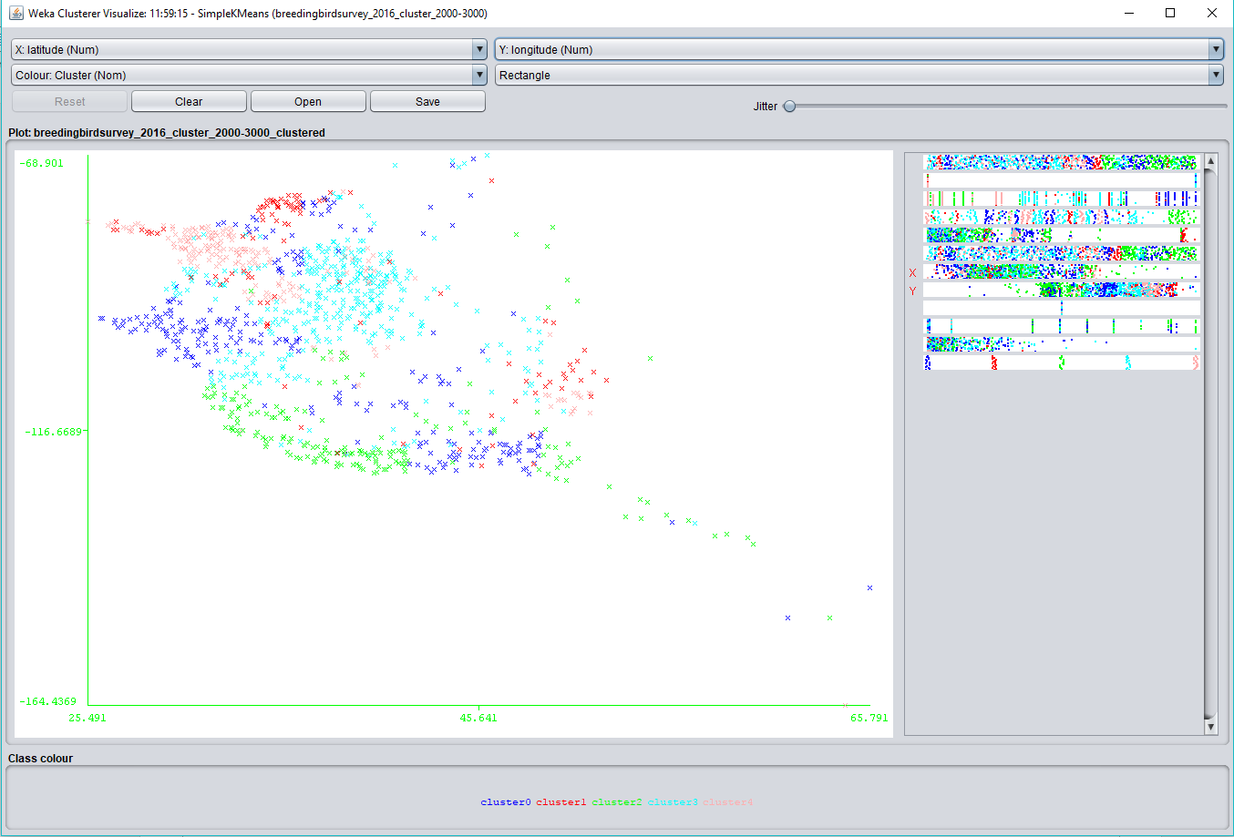

AOU Species: 3000-4000 Num_Cluster: 5 Year: 2016

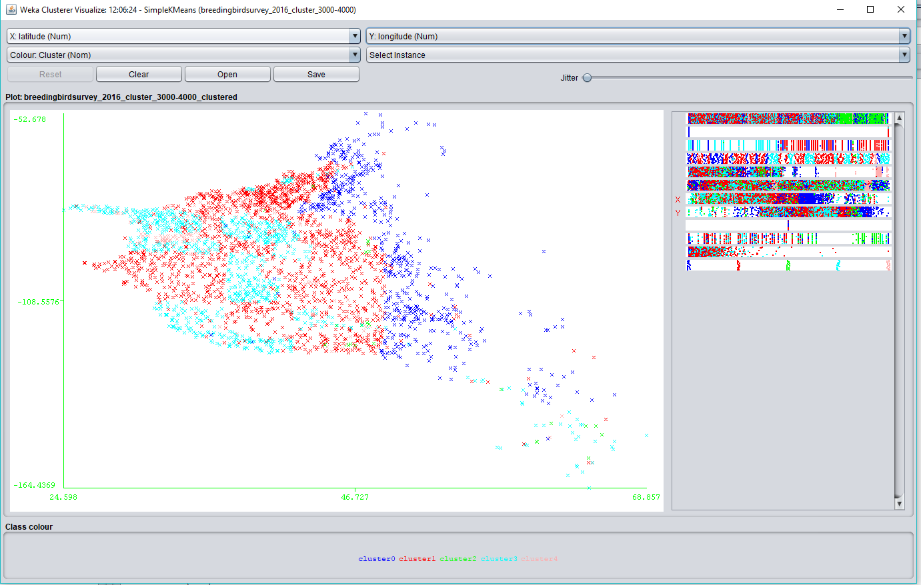

AOU Species: 3000-4000 Num_Cluster: 6 Year: 2016

