# **7.2C: Interacting with Kubernetes**

**Verify that the application is running by running kubectl get pods and kubectl get services**

By running Kubectl get pods

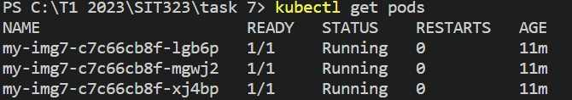

And by running kubectl get services

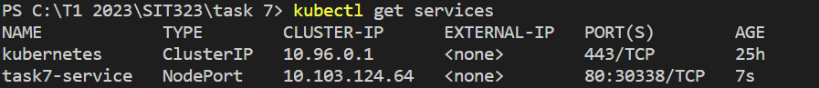

**Use the kubectl port-forward command to forward traffic from a local port to the Kubernetes service**

I used the kubeclt port forward command along with the image name.

**Access the application in a web browser by navigating to localhost**

**Github link**

**References**

<https://kubernetes.io/docs/tasks/access-application-cluster/port-forward-access-application-cluster/>