Hill-Valley data output:

1. The learning curves (plots of Negative log-likelihood vs # of iterations) were smoothed given the original plots were too noise to see the pattern.

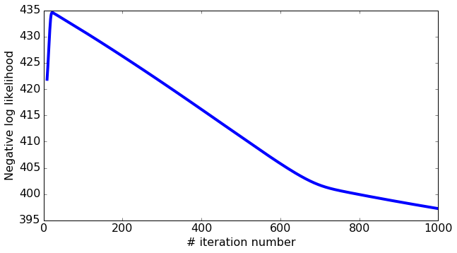

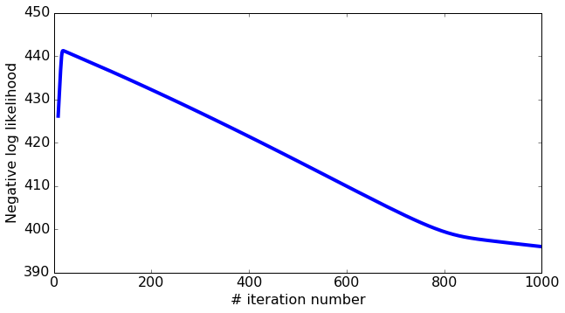



The best learning rate ( i.e. step size $η$ ~ $4.5E-13$). The curves don’t change much as the learning rate ranges from 4.4E-13 to 4.8E-13.

The L2 penalty coefficient $λ$ values would not change the learning rate very much.

1. Error table

|  |  |  |  |  |
| --- | --- | --- | --- | --- |
|  | L2 penalty $λ$ | Learning rate $η$ | Training Error | Testing Error |
| Model_1 | 0.1 | $$4.2E-13$$ | 0.8688298672012027 | 0.87103047073306239 |
| Model_2 | 0.01 | $$4.5E-13$$ | 0.8684758097022649 | 0.87071454250324087 |
| Model_3 | 0.001 | $$4.8E-13$$ | 0.86564879674920747 | 0.86863922085562084 |

Code in Python:

# -*- coding: utf-8 -*-

"""

Implement logistic regression to analyze Hill_Valley data

"""

import os

import pandas as pd

import numpy as np

import matplotlib.pyplot as plt

os.chdir("C:\\Users\\lancerts\\Dropbox\\statistics courses\\Applied Machine Learning\\HW\\HW3\\hill-valley")

#import data

X_train = pd.read_csv("X.dat",sep=" ",header=None).as_matrix()

Y_train= pd.read_csv("Y.dat",sep=" ",header=None).as_matrix().flatten()

X_test= pd.read_csv("Xtest.dat",sep=" ",header=None).as_matrix()

Y_test= pd.read_csv("Ytest.dat",sep=" ",header=None).as_matrix().flatten()

X_train.shape

Y_train.shape

#X_train.plot.bar() #EDA of data

'''

produces probablistic estimate for P(y_i = 1 | x_i, w) estimate ranges between 0 and 1.. Feature_matrix~ X, coefficients~ w

'''

def predict_probability(feature_matrix, coefficients):

# Take dot product of feature_matrix and coefficients

score = np.dot(feature_matrix,coefficients)

# Compute P(y_i = +1 | x_i, w) using the link function

predictions = 1/(1+np.exp(-score))

# return predictions

return predictions

"""

Here is the derivative of log likelihood:

errors ~ Yi-Yi_hat

feature ~ Xi

coefficient ~ wi

l2_penalty ~ lambda

"""

def feature_derivative_with_L2(errors, feature, coefficient, l2_penalty, feature_is_constant):

# Compute the dot product of errors and feature

derivative = np.dot(errors,feature)

# add L2 penalty term for any feature that isn't the intercept.

if not feature_is_constant:

## YOUR CODE HERE

derivative = derivative - 2*l2_penalty*coefficient

return derivative

def compute_log_likelihood_with_L2(feature_matrix,Y, coefficients, l2_penalty):

indicator = (Y==+1)

scores = np.dot(feature_matrix, coefficients)

lp = np.sum((indicator-1)*scores - np.log(1. + np.exp(-scores))) - l2_penalty*np.sum(coefficients[1:]**2)

return lp

"""

step_size ~ learning rate 'eta'

l2_penalty ~ coefficient 'lambda'

"""

def logistic_regression_with_L2(feature_matrix,Y, initial_coefficients, step_size, l2_penalty, max_iter):

coefficients = np.array(initial_coefficients) # make sure it's a numpy array

neg_log_likelihood_all = []

for itr in xrange(max_iter):

# Predict P(y_i = +1|x_i,w) using your predict_probability() function

## YOUR CODE HERE

predictions = predict_probability(feature_matrix, coefficients)

# Compute indicator value for (y_i = +1)

indicator = (Y ==+1)

# Compute the errors as indicator - predictions

errors = indicator - predictions

for j in xrange(len(coefficients)): # loop over each coefficient

is_intercept = (j == 0)

# Recall that feature_matrix[:,j] is the feature column associated with coefficients[j].

# Compute the derivative for coefficients[j]. Save it in a variable called derivative

## YOUR CODE HERE

derivative = feature_derivative_with_L2(errors, feature_matrix[:,j], coefficients[j], l2_penalty, is_intercept)

# add the step size times the derivative to the current coefficient

## YOUR CODE HERE

coefficients[j] = coefficients[j] + step_size*derivative

# compute negative log-likelihood

lp = compute_log_likelihood_with_L2(feature_matrix, Y, coefficients, l2_penalty)

neg_log_likelihood_all.append(-lp)

return coefficients, neg_log_likelihood_all

#plot negative log-likelihood

def make_plot(neg_log_likelihood_all, smoothing_window=10, label=''):

plt.rcParams.update({'figure.figsize': (9,5)})

neg_log_likelihood_all_ma = np.convolve(np.array(neg_log_likelihood_all), \

np.ones((smoothing_window,))/smoothing_window, mode='valid')

plt.plot(np.array(range(smoothing_window-1, len(neg_log_likelihood_all))),

neg_log_likelihood_all_ma, linewidth=4.0, label=label)

plt.rcParams.update({'font.size': 16})

plt.tight_layout()

plt.xlabel('# iteration number')

plt.ylabel('Negative log likelihood')

plt.legend(loc='lower right', prop={'size':14})

m = list(X_train.shape)[1]

model_1 = logistic_regression_with_L2(X_train, Y_train, initial_coefficients = np.zeros(m), step_size = 4.2e-13, l2_penalty = 0.1, max_iter =1000)

make_plot(list(model_1)[1],)

model_2 = logistic_regression_with_L2(X_train, Y_train, initial_coefficients = np.zeros(m), step_size = 4.5e-13, l2_penalty = 0.01, max_iter =1000)

make_plot(list(model_2)[1],)

model_3 = logistic_regression_with_L2(X_train, Y_train, initial_coefficients = np.zeros(m), step_size = 4.8e-13, l2_penalty = 0.001, max_iter =1000)

make_plot(list(model_3)[1],)

"""

(b) Calculate the misclassification errors

"""

from sklearn.metrics import roc_auc_score

# model_1

pred1_train=predict_probability(X_train, list(model_1)[0])

pred1_test=predict_probability(X_test, list(model_1)[0])

error_train1=roc_auc_score(Y_train, pred1_train)

error_test1=roc_auc_score(Y_test, pred1_test)

#model_2

pred2_train=predict_probability(X_train, list(model_2)[0])

pred2_test=predict_probability(X_test, list(model_2)[0])

error_train2=roc_auc_score(Y_train, pred2_train)

error_test2=roc_auc_score(Y_test, pred2_test)

#model_3

pred3_train=predict_probability(X_train, list(model_3)[0])

pred3_test=predict_probability(X_test, list(model_3)[0])

error_train3=roc_auc_score(Y_train, pred3_train)

error_test3=roc_auc_score(Y_test, pred3_test)