Web Technologies:

Coursework One Report

# Jenifer S / 40417718 / July 2019

## Included features:

The webpage allows the user to give a note a title and content, which then prints onto the page in a specific area for printed notes.

The webpage has a sidebar which allows navigation between a user-specific settings page and the main page once server-side processing has been implemented for the webpage. The settings page is not included in the part one prototype, because it would not have any functionality without a server backend.

There is no maximum for the number of notes that can be displayed on the page at once. However, the notes are not persistent and will be removed when the page is refreshed.

There is a word count feature that prints the number of words in the content section of the note.

## Initial plan:

To plan what the site should look like, a wireframe was created to act as a rough guide, considering the features outlined above. This is shown in Figure One.

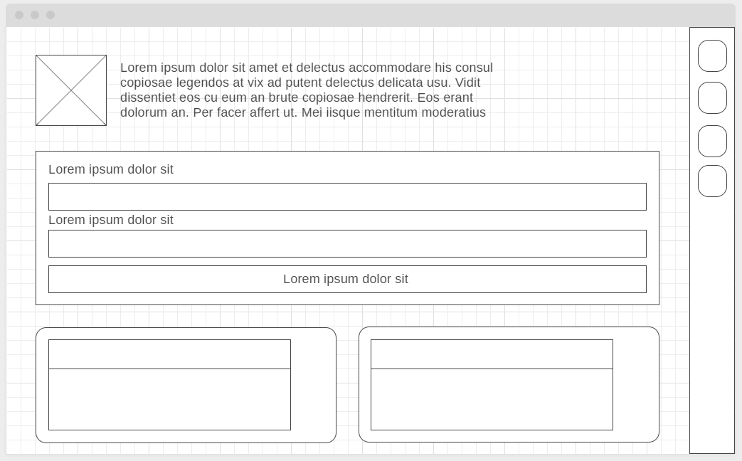

Figure One: The wireframe created to act as a design guide for the site.

The wireframe includes the areas for the title of the page, the form for the user to save their note and the printed notes below the form. The sidebar also includes navigation icons to allow the user to switch between the main page and the settings page. Printed notes will appear below the form and will show the content that the user added to the form.

## Prototype design:

The prototype for the front page of the website is shown below. The webpage has a blue colour theme to complement the bright pink of the logo. It has a sidebar on the right-hand side of the page, which contains icons that navigate to different areas of the site. The title also acts as a link back to the main page.

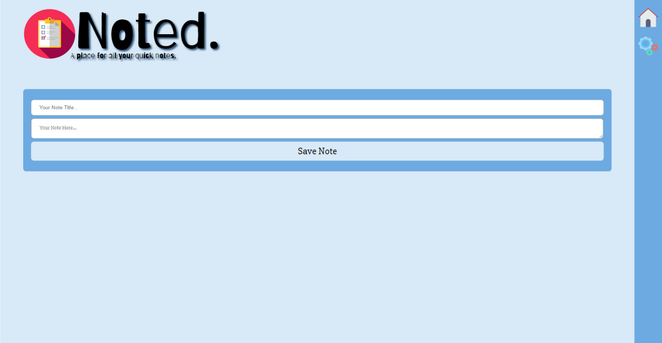

Figure Two: The front page of the site.

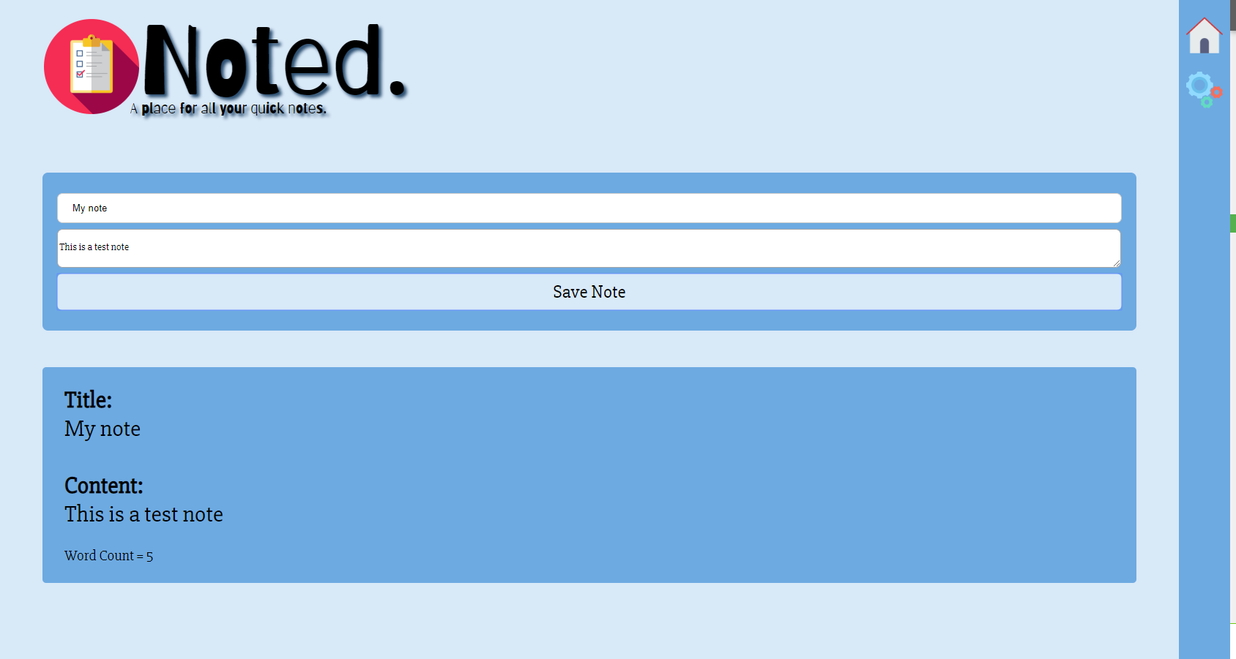The text area in the centre of the page takes a note title and content from the user, which then prints to the page after it is submitted. A printed note is shown below.

Figure Three: A printed note on the front page of the site.

The notes are list one after another on the page. There is not limit to space and therefore as many notes that the user wants to print can be added. This is shown in Figure Four. Notes are not listed side by side as shown in the wireframe, but one after the other. I felt that the same sizes of the printed note sizes make the website more consistent and cleaner overall.

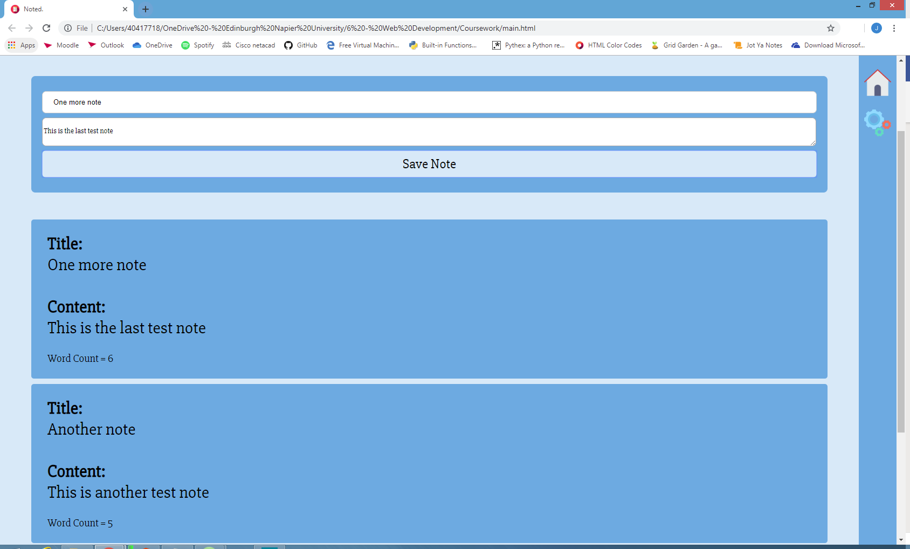

Figure Four: Notes are listed one after the other on the page.

## Note listing:

The website takes into account when there is a text overflow and wraps the text around the div. This is shown in Figure Five.

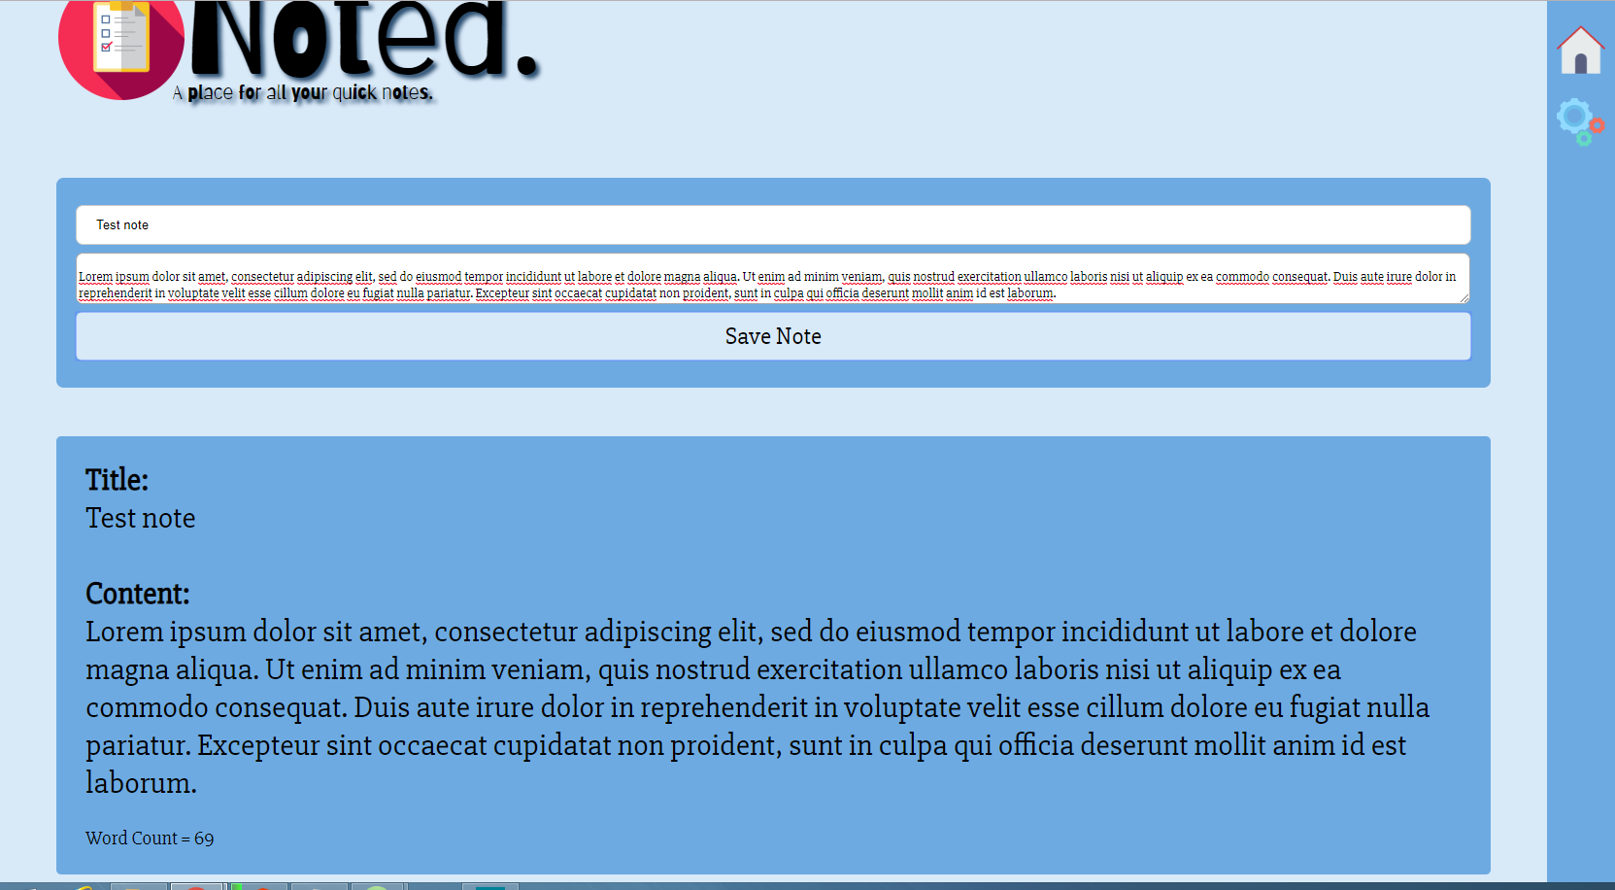

Figure Five: A note where the text wraps around in the printed note.

## Challenges:

The most challenging parts of developing the site were the text wrap around and the printing out of the notes themselves.   
The text wrap around in the event of an overflow was challenging because the overarching div that contained the text did not affect the separate divs for the note title and content, as a result of the rules of inheritance of the word-wrap property.

Overall, the design of the site meets the requirements and initial plan set out. The design of the page also fits with the initial wireframe.