Interest Rate Changes and Household Debt Management in Australia:
Evidence from 2015–2025 and Implications for 2026

- Introduction
Over the past decade, Australia has experienced significant changes in its monetary policy environment. The country went through a long period of low interest rates, followed by very supportive policy settings during the COVID-19 pandemic. From 2022 onwards, interest rates increased rapidly as monetary policy shifted toward tightening. These changes in interest rates have affected household borrowing behaviour, particularly decisions between fixed-rate and variable-rate loans.
Interest rate changes influence not only households that already have loans, but also the borrowing decisions households make in the future. When interest rates change quickly, households may reconsider whether fixed-rate or variable-rate loans are more suitable, especially when thinking about the risks involved in repaying their loans. As a result, changes in monetary policy can lead to changes in the structure of household lending over time. These changes in loan structure can be understood as households responding to how easy or difficult it is for them to manage their debt repayments.
This report analyses the relationship between changes in the cash rate environment and household loan structure in Australia. The analysis does not aim to predict exact outcomes for 2026; rather, it draws implications based on observed household responses to past interest rate changes. The focus is therefore on identifying likely directions and behavioural patterns inferred from historical responses under comparable monetary conditions.
- Monetary Policy Background
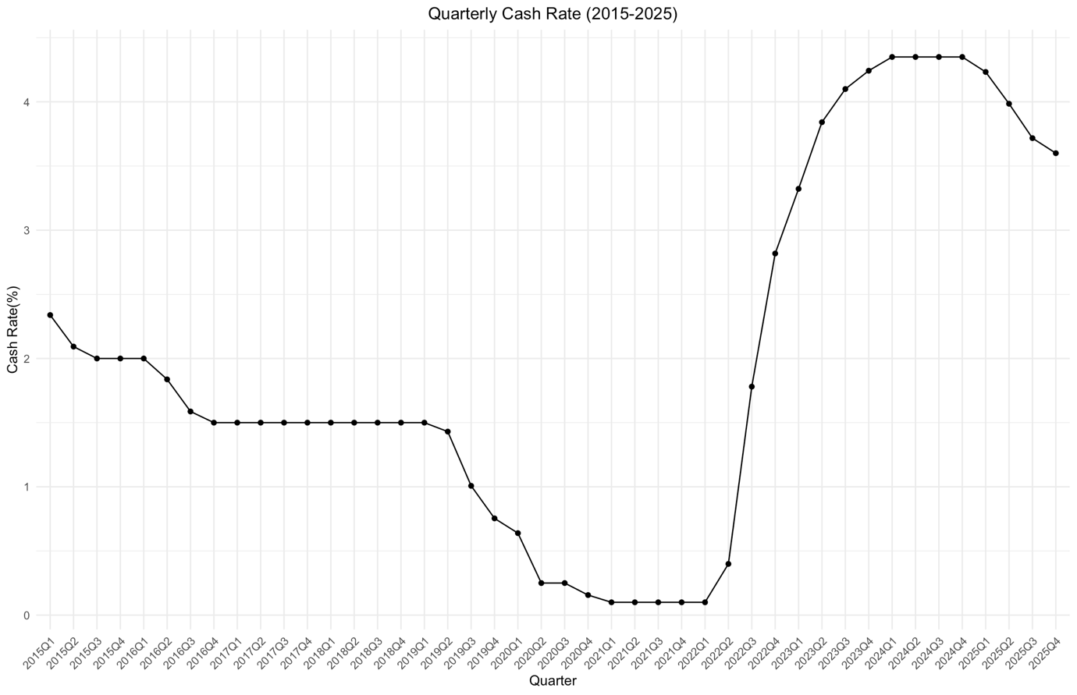
Figure 1. Quarterly Cash Rate (2015-2025)

The cash rate is the main interest rate set by the Reserve Bank of Australia(RBA). It plays an important role in the economy because it influences borrowing costs for households and businesses. Changes in the cash rate affect mortgage repayments, expectations about future interest rates, and the relative attractiveness of fixed-rate and variable-rate loans.
Figure 1 shows quarterly average cash rate in Australia from 2015 to 2025. Over this period, several clear phases can be observed. Interest rates gradually declined before 2020 and remained low for an extended period. During the COVID-19 pandemic, the cash rate reached historically low levels. This was followed by a sharp increase in interest rates between 2022 and 2023, and then a period of high interest rates with early signs of easing toward the end of the sample.
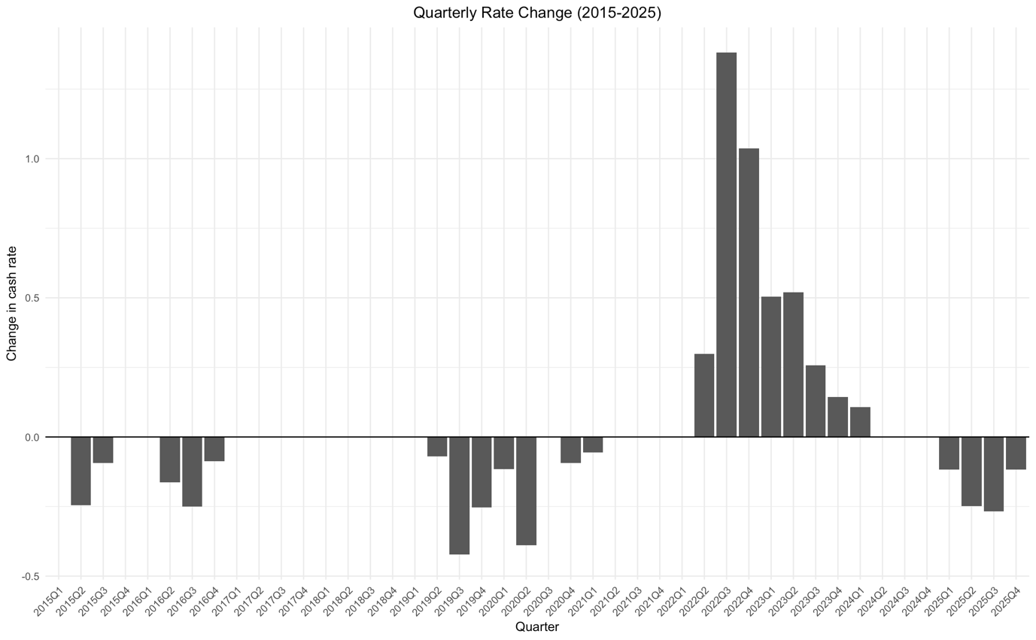
Figure 2. Quarterly change in cash rate

While the level of the cash rate provides useful background information, changes in the cash rate are especially important for understanding borrower behaviour. Figure 2 presents the quarterly change in the cash rate over the same period. The increase during 2022 and 2023 indicates a rapid tightening phase. This is likely to have placed significant pressure on households, particularly those with variable-rate loans or fixed-rate loans reaching the end of their fixed period.

- Interest Rate Regimes
To analyse how changes in interest rates affect household loan structure, it is useful to divide the sample period into different interest rate regimes. Borrowers may respond differently depending on whether interest rates are falling, stable, or rising.
Based on quarterly changes in the cash rate shown in Figure 2, this report classifies the period into three regimes : easing periods, stable periods, and tightening periods. Easing periods are defined as quarters in which cash rate decreased, stable periods as quarters with little or no change, and tightening periods as quarters in which the cash rate increased.
This classification allows for a clearer comparison of household loan structure across different monetary policy environments. In the following sections, loan statistics from APRA are analysed separately for each interest rate regime.

- Data and Methodology
The Reserve Bank of Australia's (RBA) quarterly household financial statistics are used in this analysis. The Household and Business Balance Sheets and Household Finances: Selected Ratios statistical tables, which offer details on household debt levels, balance sheet positions, and debt servicing indicators over time, are used as the primary data sources for this analysis.
A classification of interest rate regimes based on quarterly changes in the cash rate is matched with RBA household data in order to investigate the influence of monetary policy on household borrowing behavior. It is possible to analyze household financial outcomes across various monetary policy environments by classifying periods as easing, stable, or tightening. Changes in household debt levels, net worth, and debt servicing ratios are used as indirect indicators of how households modify their borrowing behavior in response to changes in interest rates, even though direct data on the shares of fixed-rate and variable-rate loans are not available for the entire sample period.
This method enables the analysis to determine whether households have been able to handle increasing pressure to service debt in various cash rate environments. Instead of pinpointing specific loan-type shares, the approach concentrates on behavioral reactions and balance sheet results, which shed light on households' ability to adjust to shifting interest rate conditions and guide predictions about possible developments in 2026.

- Analysis : Household Debt Responses to Interest Rate Changes
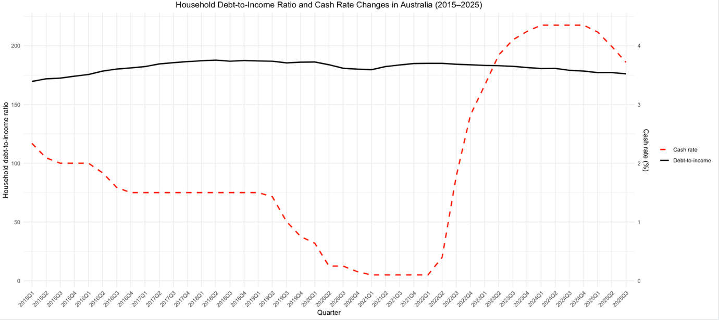
Figure 3. Household Debt-to-Income Ratio and Cash Rate Changes

Figure 3 illustrates the relationship between the household debt-to-income ratio and changes in the cash rate from 2015 to 2025. The debt-to-income ratio increased gradually during the prolonged low interest rate period prior to 2020. During the COVID-19 period, despite historically low interest rates, the ratio stabilised and began to decline slightly. Following the rapid tightening cycle from 2022 onwards, a more noticeable decline in the debt-to-income ratio is observed. This pattern suggests that households adjusted their borrowing behaviour in response to rising interest rates. Instead of continuing to take on more debt, households seems to have reduced new borrowing or paid down exsiting loans as debt repayment became more difficult.

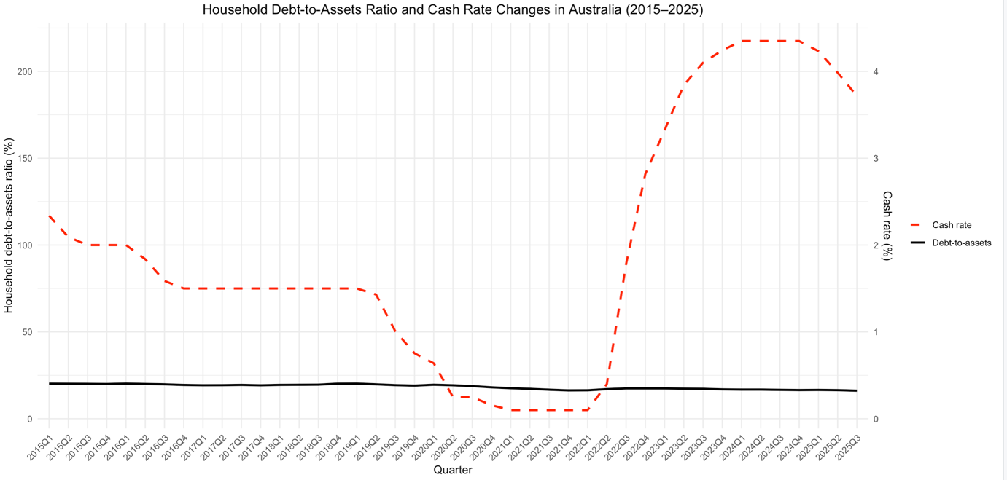
Figure 4. Household Debt-to-Assets Ratio and Cash Rate Changes
Figure 4 illustrates the relationship between the household debt-to-asset ratio and the cash rate over the same period. In contrast to the debt-to-income ratio, debt-to-assets ratio remained relatively stable throughout most of the period. Even during the sharp increase in interest rates from 2022 to 2023, the ratio did not change significantly. This stability indicates that household balance sheets benefited from asset accumulation, particularly during periods of rising housing and financial asset values. As a result, households were able to absorb higher interest rates without a substantial weakening of their overall financial position.

In conclusion, Figure 3 and 4 suggest that Australian households responded to changes in the interest rate through a combination of short-term behavioural adjustments and longer-term balance sheet resilience. While interest rates rising led to a reduction in debt relative to income, the overall debt-to-assets remained stable. This suggests that households were not only reducing their debt repayments, but were also supported by their assets, which helped them deal with higher interest rates.

- Implications for 2026
Based on the observed patterns, it is likely that households will continue to adopt cautious borrowing behaviour if relatively high interest rates remains in 2026. Rather than significantly increasing debt, households may prioritise managing existing loans and relying on assets to handle repayment pressure.
The observed adjustment in household debt also has implications for loan structure choices. The relatively gradual response of household debt measures to rapid interest rate increase suggests that many households were not immediately exposed to rising interest costs. This may reflect a preference for fixed-rate loans as well as cautious loan management, especially during periods of rapidly rising interest rates.

- Conclusion
This report examined how changes in the cash rate affected household debt behaviour in Australia between 2015 and 2025. By analysing household debt-to-income and debt-to-assets ratios, the observations suggest that households adjusted their borrowing behaviour in response to rising interest rates.
While higher interest rates led to a reduction in debt relative to income, the overall debt-to-assets remained relatively stable, indicating that households were supported by assets. These results suggest that Australian households were not passive in the face of interest rate changes, but instead actively managed their debt through behavioural adjustments and balance sheet resilience.

