**Experiment No.: 3**

**Aim:** Familiarisation of linux commands.

**CO2:** Perform system administration task.

**Procedure:**

1. pwd : print the working directory

$pwd



a. ls -R : prints subdirectory contents

$ls -R

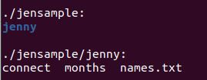

b. ls -l : long listing

$ls -l



c. ls -a : to list all hidden files

$ls -a



d. ls -al : list the files and directory with detailed information

$ls -al

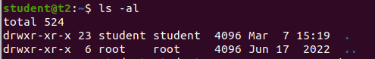

e. ls -t : list the file sorted in the order of the last modified file.

$ls -t

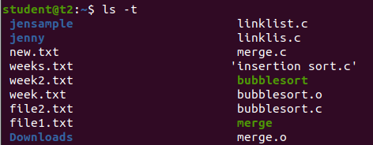

f. ls -r : to reverse the natural sorting order

$ls -r

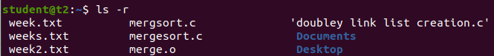

3. history : to review the commands that have been previously executed for certain period of time.

$history

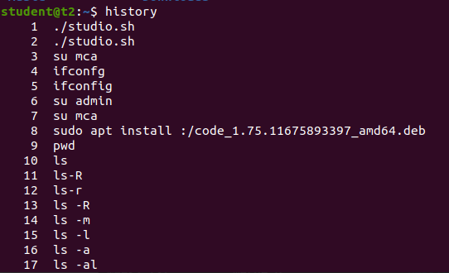

4. man : we can learn and understand different commands right from the shell.

$man ls

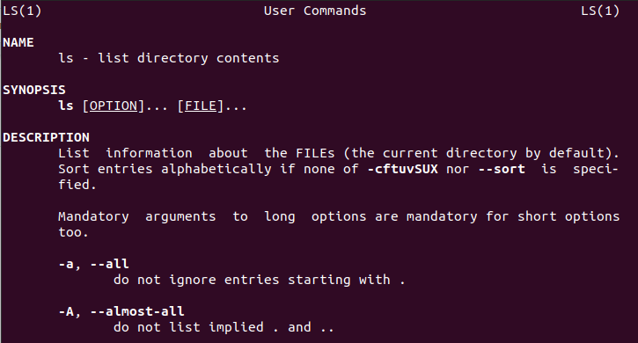

5. mkdir : creates new directory

$mkdir jenny

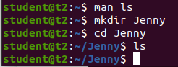

6. rmdir : to remove directory

$rmdir Jenny



7. touch : to create new file

$touch file.txt



8. cat > [filename] : create a new file and open it to add content.

$cat > colors

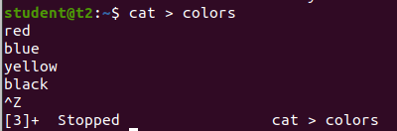

a. cat >> [filename] : to append new contents to existing file contents

$cat >> colors

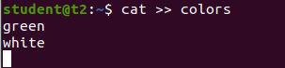

b. cat [filename] : to display file contents.

$cat colors

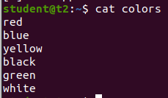

c. cat -n [filename] : to display content with line numbers

$cat -n colors

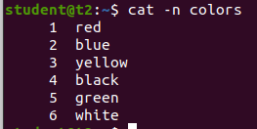

d. cat -b [filename] : No line numbering for blank spacing.

$cat -b colors

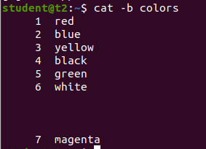

e. cat -e [filename] : to display $ character at the end of each line.

$cat -e colors

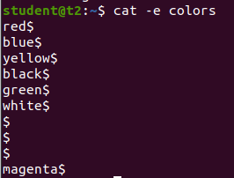

f. cat [filename] << EOF : used as page end marker.

$cat colors << EOF

g. cat [filename] | tr a-z A-Z > [filename] : to convert lower

**Result**

The program was executed and the result was successfully obtained. Thus CO1 was obtained.