Week 2 Assignment
Jeneffer Ligogo

- What are the top 10 longest yellow taxi trips and green taxi trips in Q1 2025?

2. How many yellow trips were taken in January 2025?
Query: SELECT COUNT(*) AS jan_yellow_trips
FROM yellow_quarter1_2025
WHERE tpep_pickup_datetime BETWEEN '2025-01-01 00:00:00' AND '2025-01-31 23:59:59';
Answer: 3.48 million
3. How many green trips were taken in January 2025?
SELECT COUNT (*) AS jan_green_trips
FROM green_quarter1_2025
WHERE lpep_pickup_datetime BETWEEN '2025-01-01 00:00:00' AND '2025-01-31 23:59:59';
Answer: 48,288 trips
4. How many yellow trips had passenger_count as NULL or 0?
Query:
SELECT COUNT(*) AS yellow_null_zero
FROM yellow_quarter1_2025
WHERE passenger_count IS NULL OR passenger_count = 0;
Answer: 2.33 million
How many green trips had passenger_count as NULL or 0?
Query:
SELECT COUNT(*) AS green_null_zero
FROM green_quarter1_2025
WHERE passenger_count IS NULL OR passenger_count = 0;
Answer: 9,750 trips.
5. What are the top 10 busiest days for yellow taxis and green taxis in Q1 2025?

6. What is the total revenue by month for yellow taxis in Q1 2025?
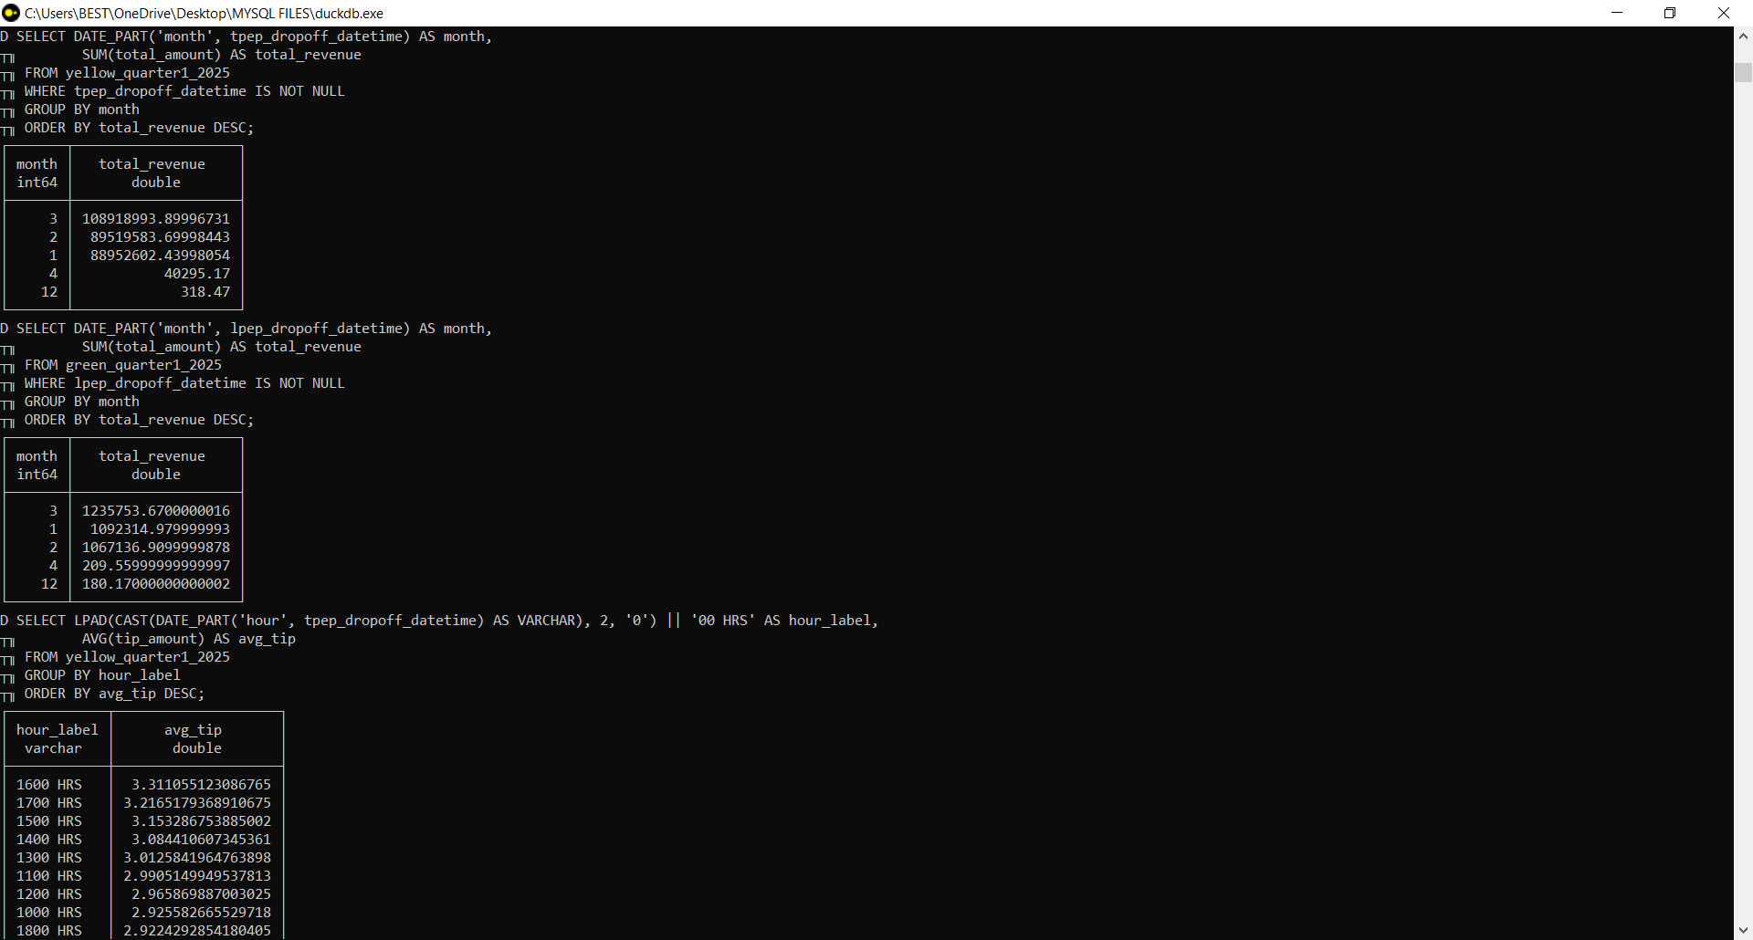
7. What is the average tip by drop-off hour for yellow taxis and green taxis in Q1 2025?

