Week 3 Assignment
Question 1a
Yellow taxi
CREATE OR REPLACE TABLE yellow_quarterly_summary_2023 AS
SELECT
CASE
WHEN strftime('%m', tpep_pickup_datetime) IN ('01','02','03') THEN 'Q1'
WHEN strftime('%m', tpep_pickup_datetime) IN ('04','05','06') THEN 'Q2'
WHEN strftime('%m', tpep_pickup_datetime) IN ('07','08','09') THEN 'Q3'
WHEN strftime('%m', tpep_pickup_datetime) IN ('10','11','12') THEN 'Q4'
END AS quarter,
COUNT(*) AS total_trips,
SUM(total_amount) AS total_revenue,
AVG(trip_distance) AS avg_mileage,
AVG(passenger_count) AS avg_passenger_count
FROM yellow_2023
GROUP BY quarter
ORDER BY quarter;

SELECT *
FROM yellow_quarterly_summary_2023
ORDER BY total_revenue DESC
LIMIT 1;

Answer: Quarter 4 total revenue 294959694.3898009

Green taxi
CREATE OR REPLACE TABLE green_quarterly_summary_2023 AS
SELECT
CASE
WHEN strftime('%m', lpep_pickup_datetime) IN ('01','02','03') THEN 'Q1'
WHEN strftime('%m', lpep_pickup_datetime) IN ('04','05','06') THEN 'Q2'
WHEN strftime('%m', lpep_pickup_datetime) IN ('07','08','09') THEN 'Q3'
WHEN strftime('%m', lpep_pickup_datetime) IN ('10','11','12') THEN 'Q4'
END AS quarter,
COUNT(*) AS total_trips,
SUM(total_amount) AS total_revenue,
AVG(trip_distance) AS avg_mileage,
AVG(passenger_count) AS avg_passenger_count
FROM green_2023
GROUP BY quarter
ORDER BY quarter;
SELECT *
FROM green_quarterly_summary_2023
ORDER BY total_revenue DESC
LIMIT 1;

Answer: Quarter 2 4765207.959999947

Question 1b
Yellow
CREATE OR REPLACE TABLE yellow_zone_summary_2023 AS
SELECT
l.Borough,
l.Zone,
COUNT(*) AS total_trips,
SUM(y.total_amount) AS total_revenue
FROM yellow_2023 y
JOIN taxi_lookup l
ON y.PULocationID = l.LocationID
GROUP BY l.Borough, l.Zone
ORDER BY total_revenue DESC;
SELECT *
FROM yellow_zone_summary_2023
ORDER BY total_revenue DESC
LIMIT 1;

Answer: │ Queens │ JFK Airport │ 1992304 │ 155548162.91015014 │

Green
CREATE OR REPLACE TABLE green_zone_summary_2023 AS
SELECT
l.Borough,
l.Zone,
COUNT(*) AS total_trips,
SUM(g.total_amount) AS total_revenue
FROM green_2023 g
JOIN taxi_lookup l
ON g.PULocationID = l.LocationID
GROUP BY l.Borough, l.Zone
ORDER BY total_revenue DESC;

SELECT *
FROM green_zone_summary_2023
ORDER BY total_revenue DESC
LIMIT 1;

Answer: │ Manhattan │ East Harlem North │ 159159 │ 3218017.239999982 │

Part B
Question 1
CREATE OR REPLACE TABLE yellow_revenue_buckets_2023 AS
SELECT
bucket,
COUNT(*) AS trip_count,
ROUND(100.0 * COUNT(*) / (SELECT COUNT(*) FROM yellow_2023), 2) AS percentage_of_trips
FROM (
SELECT
CASE
WHEN total_amount BETWEEN 0 AND 9.99 THEN '0-9.99'
WHEN total_amount BETWEEN 10 AND 19.99 THEN '10-19.99'
WHEN total_amount BETWEEN 20 AND 49.99 THEN '20-49.99'
WHEN total_amount >= 50 THEN '50+'
ELSE 'Other'
END AS bucket
FROM yellow_2023
) t
GROUP BY bucket
ORDER BY trip_count DESC;
Answer

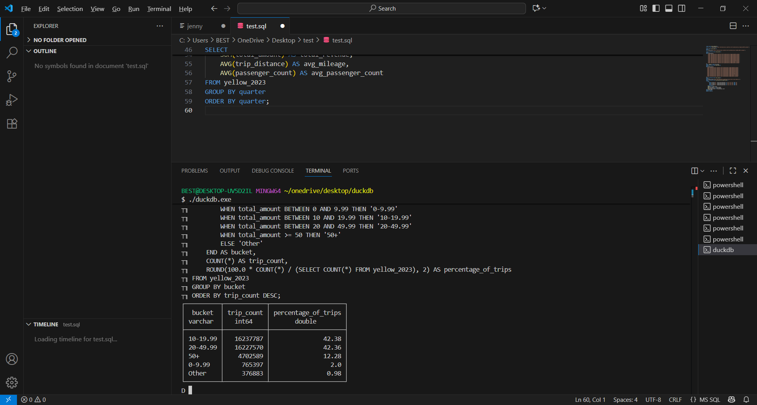

Green

SELECT
bucket,
COUNT(*) AS trip_count,
ROUND(100.0 * COUNT(*) / (SELECT COUNT(*) FROM green_2023), 2) AS percentage_of_trips
FROM (
SELECT
CASE
WHEN total_amount BETWEEN 0 AND 9.99 THEN '0-9.99'
WHEN total_amount BETWEEN 10 AND 19.99 THEN '10-19.99'
WHEN total_amount BETWEEN 20 AND 49.99 THEN '20-49.99'
WHEN total_amount >= 50 THEN '50+'
ELSE 'Other'
END AS bucket
FROM green_2023
) t
GROUP BY bucket
ORDER BY trip_count DESC;
Answer
