Week 3 ASSIGNMENT 3B
Q1. For 2023, which borough had the highest TOTAL revenue? (compare green + yellow)
│ Manhattan │ 801950504.73 │ Yellow │
Q2. Top 5 dropoff zones for yellow and green (by trip count) in 2023
SELECT
l.Borough,
l.Zone,
COUNT(*) AS trip_count
FROM yellow_2023 y
JOIN taxi_lookup l ON y.DOLocationID = l.LocationID
WHERE EXTRACT(year FROM y.tpep_dropoff_datetime) = 2023
GROUP BY l.Borough, l.Zone
ORDER BY trip_count DESC
LIMIT 5;
Answer
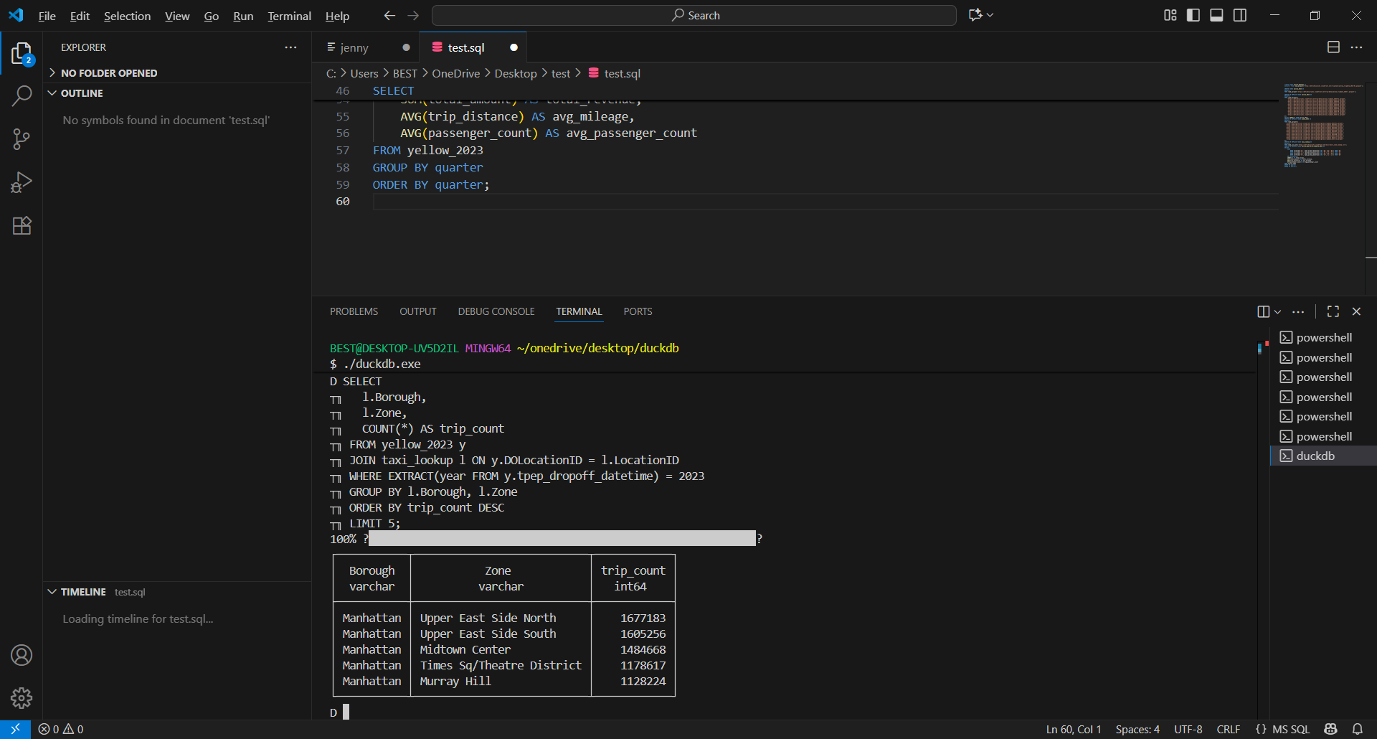

Green
SELECT
l.Borough,
l.Zone,
COUNT(*) AS trip_count
FROM green_2023 g
JOIN taxi_lookup l ON g.DOLocationID = l.LocationID
WHERE EXTRACT(year FROM g.lpep_dropoff_datetime) = 2023
GROUP BY l.Borough, l.Zone
ORDER BY trip_count DESC
LIMIT 5;
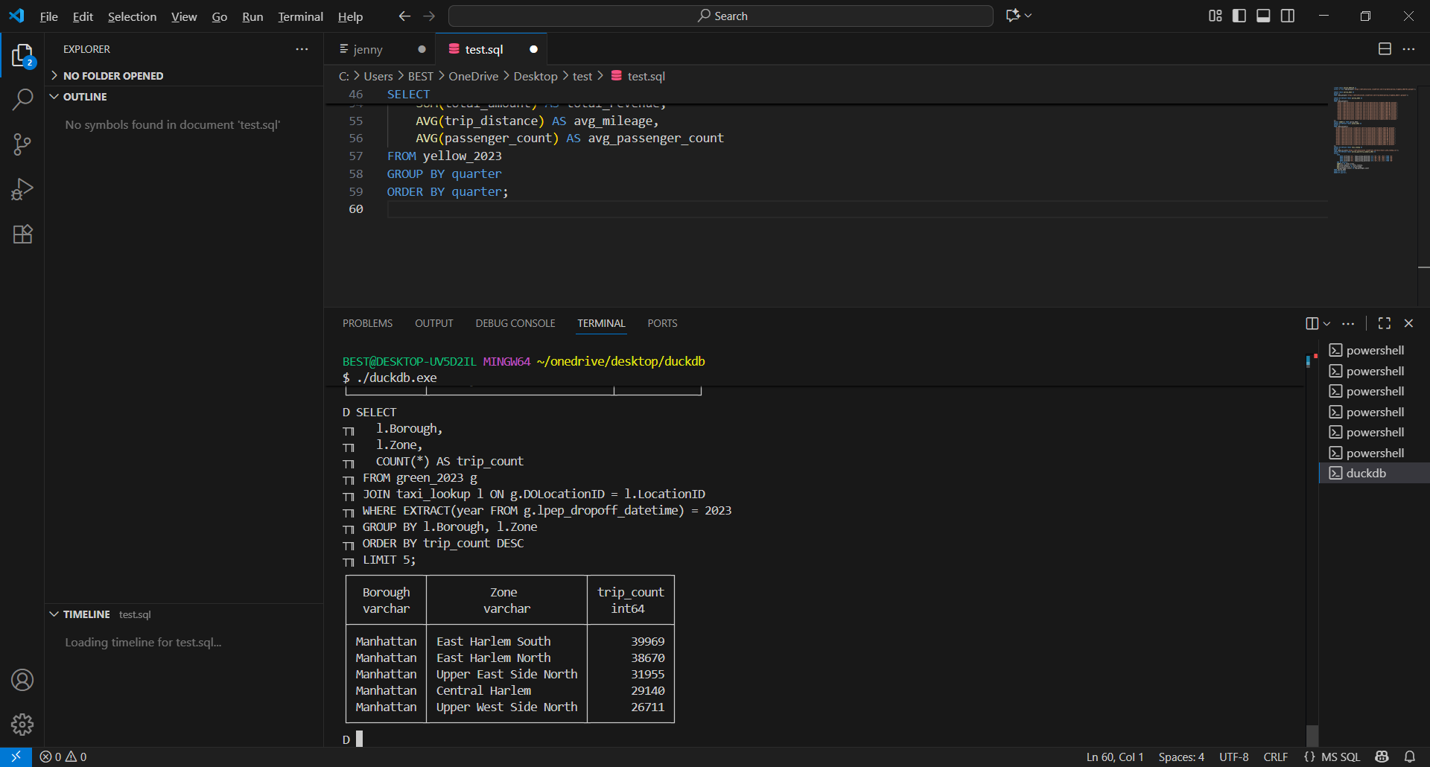

Q3. Preferred payment matrix (Cash, Credit, Other) — counts per payment label
SELECT
CASE
WHEN payment_type IN (2) THEN 'Cash' -- common mapping: 2 => Cash
WHEN payment_type IN (1) THEN 'Credit' -- common mapping: 1 => Credit (card)
ELSE 'Other'
END AS payment_label,
COUNT(*) AS trip_count,
ROUND(100.0 * COUNT(*) / (SELECT COUNT(*) FROM yellow_2023
WHERE EXTRACT(year FROM tpep_pickup_datetime) = 2023), 2) AS pct_of_yellow_trips
FROM yellow_2023
WHERE EXTRACT(year FROM tpep_pickup_datetime) = 2023
GROUP BY payment_label
ORDER BY trip_count DESC;
Yellow taxi answer
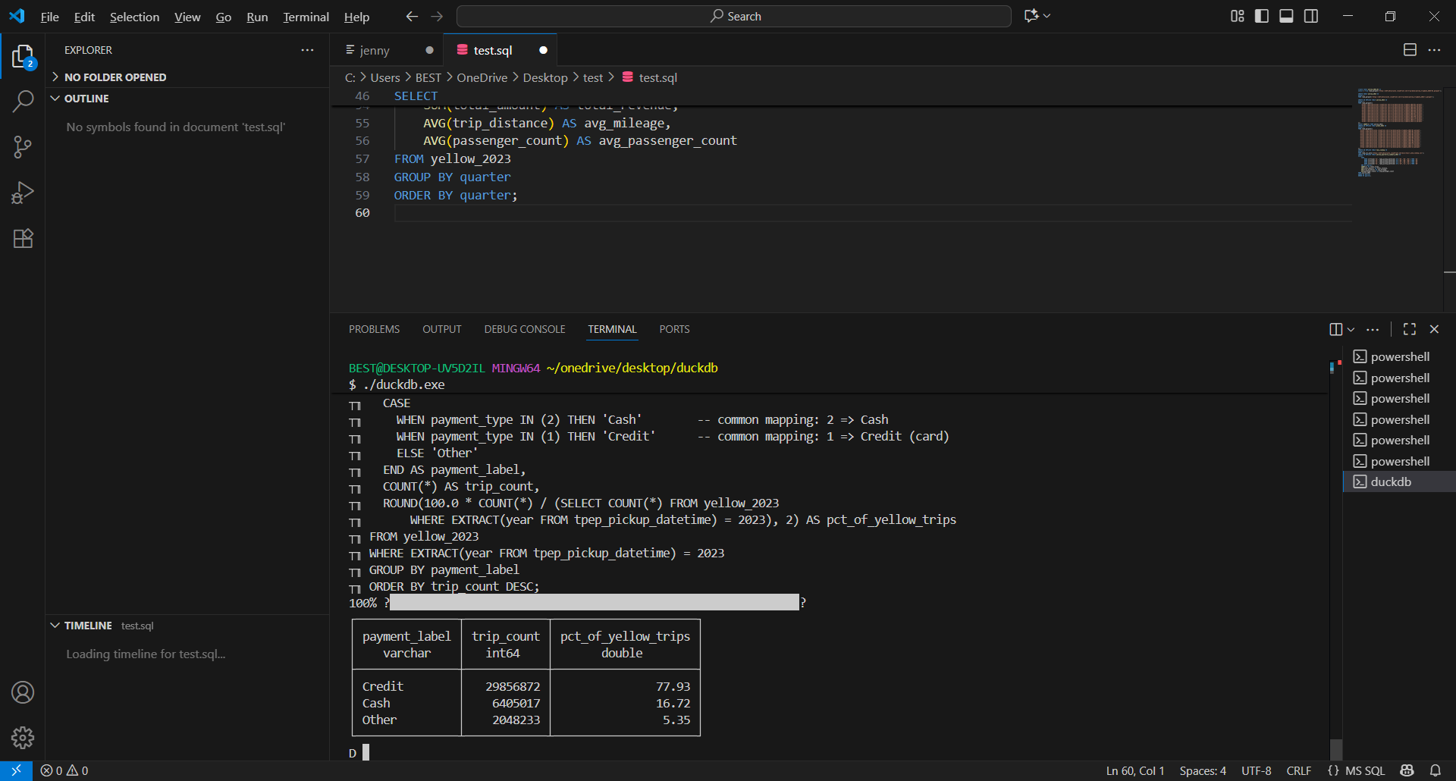
Green
SELECT
CASE
WHEN payment_type IN (2) THEN 'Cash'
WHEN payment_type IN (1) THEN 'Credit'
ELSE 'Other'
END AS payment_label,
COUNT(*) AS trip_count,
ROUND(100.0 * COUNT(*) / (SELECT COUNT(*) FROM green_2023
WHERE EXTRACT(year FROM lpep_pickup_datetime) = 2023), 2) AS pct_of_green_trips
FROM green_2023
WHERE EXTRACT(year FROM lpep_pickup_datetime) = 2023
GROUP BY payment_label
ORDER BY trip_count DESC;

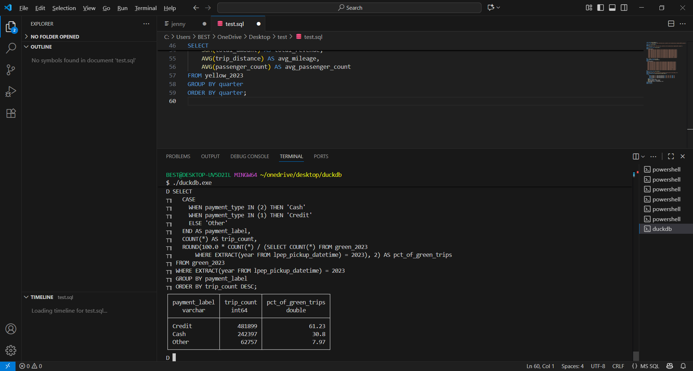

Q4. Dropoff zones used by both yellow and green in 2023
SELECT DISTINCT l.Zone, l.Borough
FROM taxi_lookup l
WHERE l.LocationID IN (
SELECT DISTINCT DOLocationID FROM yellow_2023
WHERE EXTRACT(year FROM tpep_dropoff_datetime) = 2023
)
AND l.LocationID IN (
SELECT DISTINCT DOLocationID FROM green_2023
WHERE EXTRACT(year FROM lpep_dropoff_datetime) = 2023
)
ORDER BY l.Borough, l.Zone;
Answer

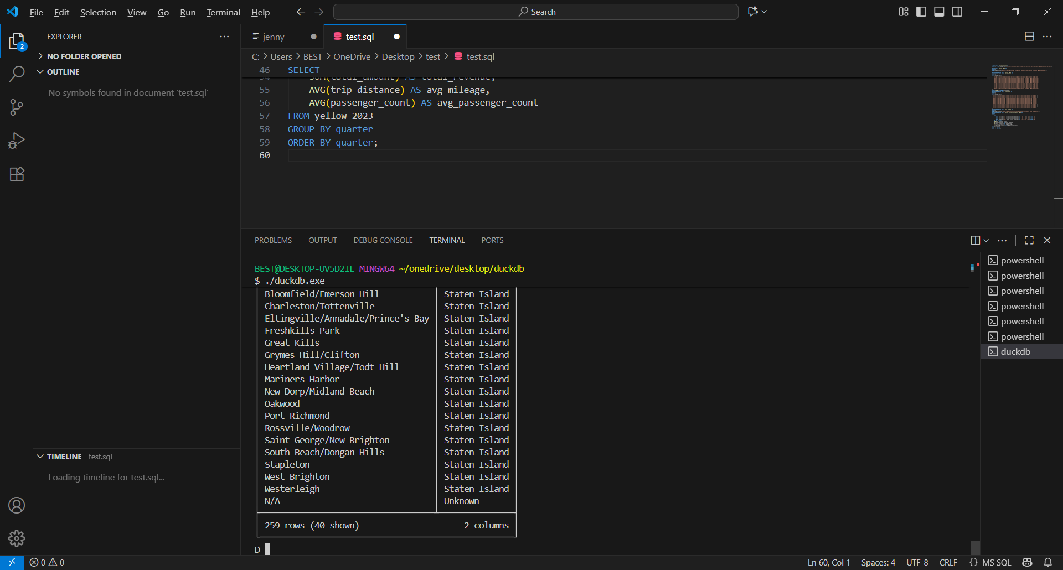

Q4B. Pickup zones used by yellow but NOT green in 2023
SELECT l.Zone, l.Borough
FROM taxi_lookup l
WHERE l.LocationID IN (
SELECT DISTINCT PULocationID FROM yellow_2023 WHERE EXTRACT(year FROM tpep_pickup_datetime)=2023
)
AND l.LocationID NOT IN (
SELECT DISTINCT PULocationID FROM green_2023 WHERE EXTRACT(year FROM lpep_pickup_datetime)=2023
)
ORDER BY l.Borough, l.Zone;
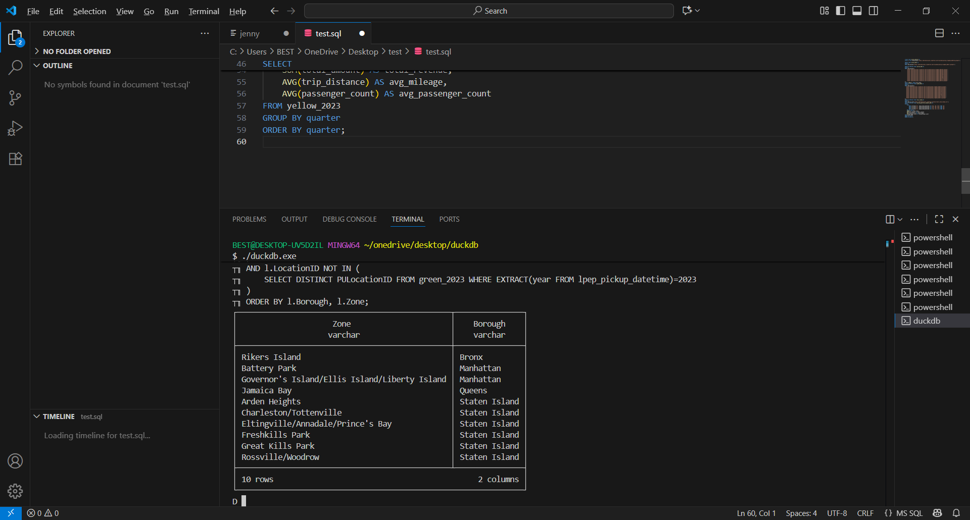
Q5. Yellow: top 50 days where daily revenue > average fare across all trips in 2023
WITH overall_avg AS (
SELECT AVG(total_amount) AS avg_fare
FROM yellow_2023
WHERE EXTRACT(year FROM tpep_pickup_datetime) = 2023
),
daily_revenue AS (
SELECT
DATE(tpep_pickup_datetime) AS day,
SUM(total_amount) AS daily_revenue,
COUNT(*) AS trips
FROM yellow_2023
WHERE EXTRACT(year FROM tpep_pickup_datetime) = 2023
GROUP BY day
)
SELECT
day,
ROUND(daily_revenue, 2) AS daily_revenue,
trips
FROM daily_revenue
WHERE daily_revenue > (SELECT avg_fare FROM overall_avg)
ORDER BY daily_revenue DESC
LIMIT 50;
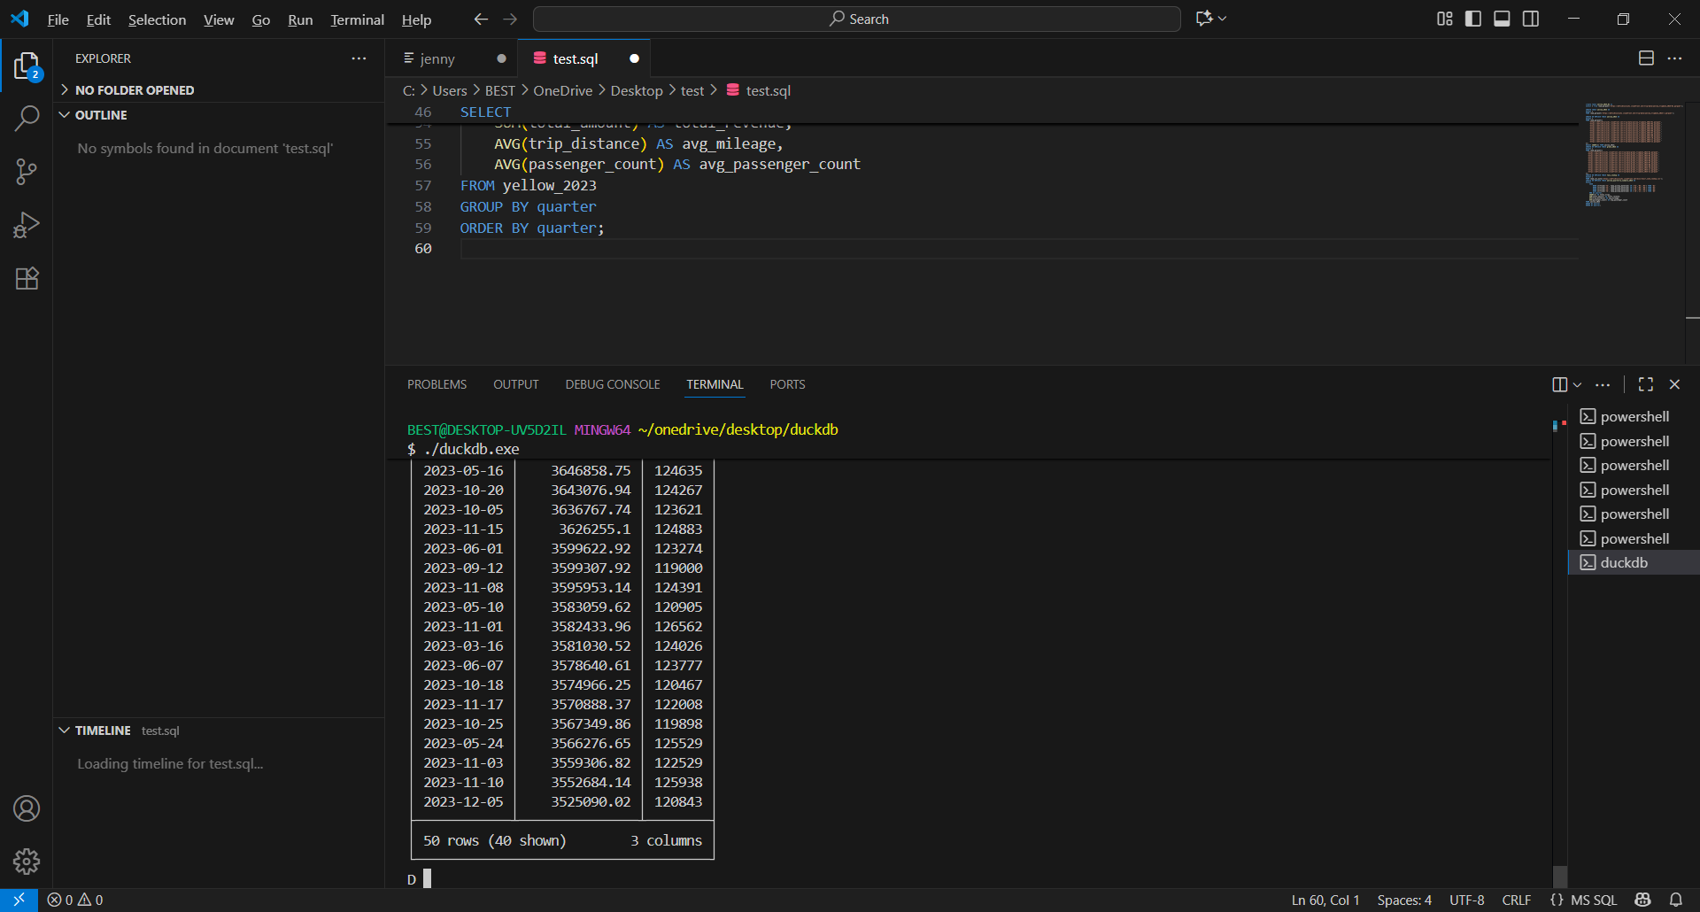
Q5B. Yellow 2023: top 5 days in each calendar month ranked by daily average
WITH daily_avg AS (
SELECT
EXTRACT(month FROM tpep_pickup_datetime)::INT AS month,
DATE(tpep_pickup_datetime) AS day,
AVG(total_amount) AS daily_avg_total_amount
FROM yellow_2023
WHERE EXTRACT(year FROM tpep_pickup_datetime) = 2023
GROUP BY month, day
),
ranked AS (
SELECT
month,
day,
ROUND(daily_avg_total_amount, 2) AS daily_avg_total_amount,
ROW_NUMBER() OVER (PARTITION BY month ORDER BY daily_avg_total_amount DESC) AS day_rank
FROM daily_avg
)
SELECT month, day, daily_avg_total_amount, day_rank
FROM ranked
WHERE day_rank <= 5
ORDER BY month, day_rank;
