Week 4 assignment 2
Question 1
WITH cte_duration AS (
SELECT
VendorID,
tpep_pickup_datetime,
tpep_dropoff_datetime,
passenger_count,
trip_distance,
total_amount,
ROUND(EXTRACT(EPOCH FROM (tpep_dropoff_datetime - tpep_pickup_datetime)) / 60.0, 2) AS trip_duration_minutes,
'0' || strftime('%m', tpep_pickup_datetime) AS month_number,
strftime('%B', tpep_pickup_datetime) AS month_name
FROM yellow_2023
WHERE strftime('%Y', tpep_pickup_datetime) = '2023'
),
cte_valid AS (
SELECT *
FROM cte_duration
WHERE trip_duration_minutes >= 1
AND trip_distance > 0
AND total_amount > 0
)
SELECT
month_number,
month_name,
VendorID,
ROUND(AVG(trip_duration_minutes), 2) AS avg_trip_duration_minutes
FROM cte_valid
GROUP BY month_number, month_name, VendorID
ORDER BY month_number, VendorID;
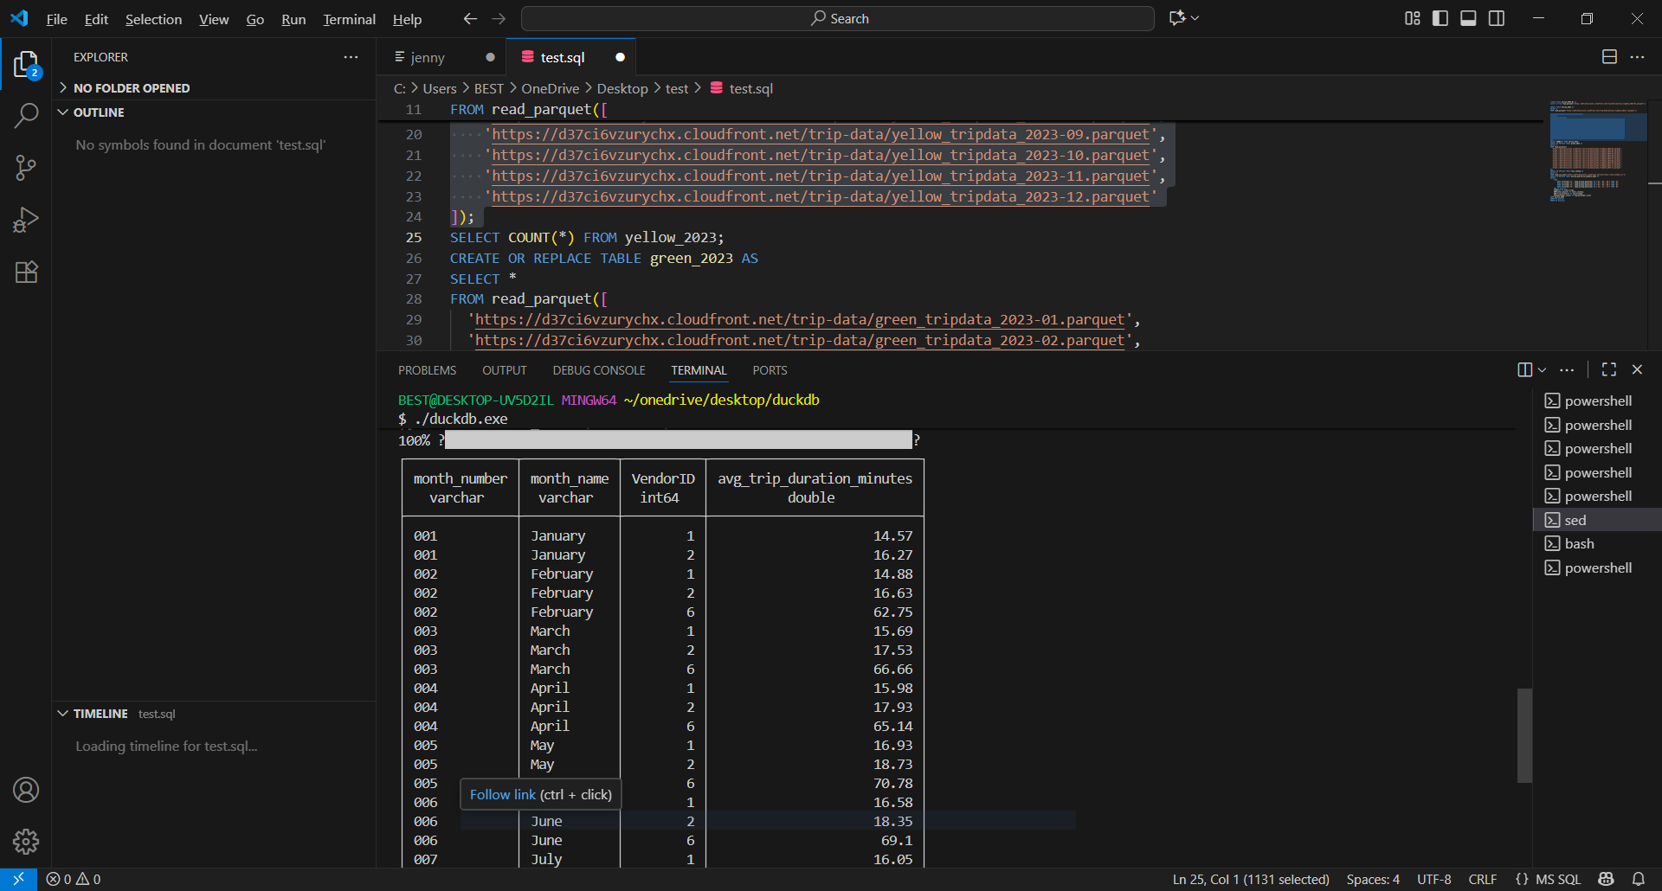

Top 5 longest trips per vendor each month (DENSE_RANK):
WITH cte_duration AS (
SELECT
VendorID,
tpep_pickup_datetime,
tpep_dropoff_datetime,
ROUND(EXTRACT(EPOCH FROM (tpep_dropoff_datetime - tpep_pickup_datetime)) / 60.0, 2) AS trip_duration_minutes,
'0' || strftime('%m', tpep_pickup_datetime) AS month_number,
strftime('%B', tpep_pickup_datetime) AS month_name
FROM yellow_2023
WHERE strftime('%Y', tpep_pickup_datetime) = '2023'
),
cte_valid AS (
SELECT *
FROM cte_duration
WHERE trip_duration_minutes >= 1
),
ranked AS (
SELECT
VendorID,
month_number,
month_name,
tpep_pickup_datetime,
tpep_dropoff_datetime,
trip_duration_minutes,
DENSE_RANK() OVER (
PARTITION BY month_number, VendorID
ORDER BY trip_duration_minutes DESC
) AS trip_rank
FROM cte_valid
)
SELECT *
FROM ranked
WHERE trip_rank <= 5
ORDER BY month_number, VendorID, trip_rank;
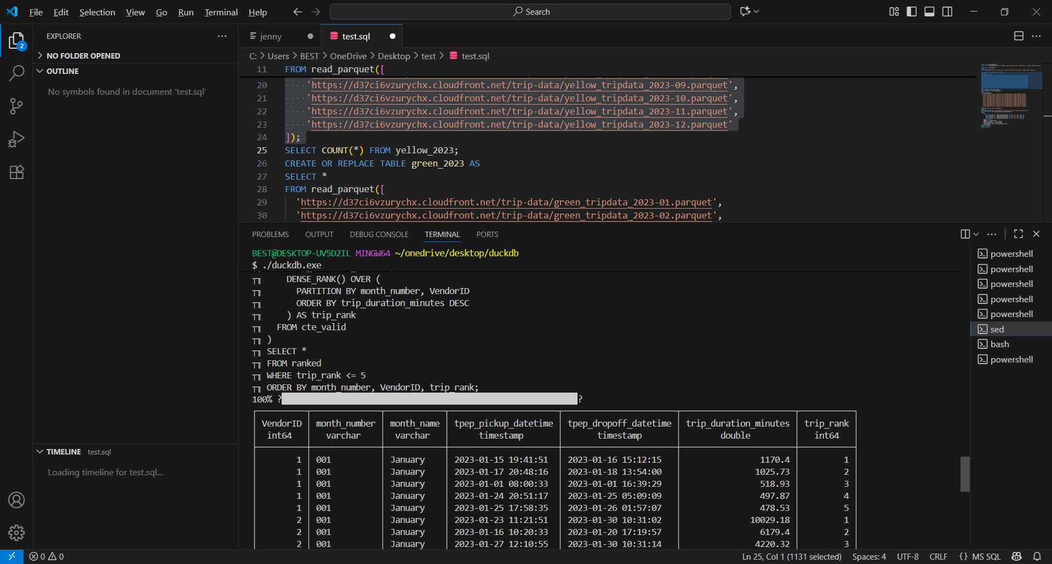
Q2. top 10% tips per month using PERCENT_RANK()
WITH cte_tips AS (
SELECT
'0' || strftime('%m', tpep_pickup_datetime) AS month_number,
strftime('%B', tpep_pickup_datetime) AS month_name,
tip_amount,
PERCENT_RANK() OVER (
PARTITION BY strftime('%m', tpep_pickup_datetime)
ORDER BY tip_amount ASC
) AS tip_percentile
FROM yellow_2023
WHERE strftime('%Y', tpep_pickup_datetime) = '2023'
AND tip_amount IS NOT NULL
)
SELECT
month_number,
month_name,
tip_amount,
ROUND(tip_percentile, 3) AS tip_percentile
FROM cte_tips
WHERE tip_percentile >= 0.9
ORDER BY month_number, tip_percentile DESC;
