A （a）
Question 1: The distinct roles of NumPy and Pandas in processing high-frequency energy grid telemetry
NumPy and Pandas have different but complementary roles in processing high-frequency energy telemetry.
NumPy is suitable for storing numerical readings in arrays and performing calculations across many values, such as selecting hours when a hub’s grid load exceeds a threshold or identifying battery temperatures above 45°C.
Pandas provides labelled data structures, especially DataFrames, which make it easier to handle records by column, replace missing measurements with a median, and summarize revenue by charger type using groupby()
Combining NumPy vectorization with Pandas DataFrame operations can make large datasets easier and faster to process. Vectorized operations apply calculations to whole arrays without requiring an explicit Python loop for every reading. Pandas builds on array-based processing and provides convenient tools for cleaning and grouping tabular data. This reduces repetitive code and can improve execution efficiency, although actual performance depends on the operation, dataset size, and available memory.
The following example demonstrates two NumPy operations and two Pandas operations.
import numpy as np
import pandas as pd
# Rows represent hours; columns represent three charging hubs.
grid_load_kw = np.array([
[120, 135, 160],
[110, 145, 180],
[125, 150, 175]
])
# NumPy operation 1: select hours where at least one hub exceeds 170 kW.
peak_hours = grid_load_kw[grid_load_kw.max(axis=1) > 170]
# NumPy operation 2: boolean masking to find temperatures above 45°C.
battery_temp_c = np.array([39.2, 46.1, 43.7, 48.3])
overheated_temps = battery_temp_c[battery_temp_c > 45]
# Example session data for Pandas operations.
sessions = pd.DataFrame({
"charger_type": ["AC", "DC", "AC", "DC"],
"power_kw": [7.2, np.nan, 6.8, 28.0],
"revenue_myr": [12.5, 30.0, 15.0, 42.0]
})
# Pandas operation 1: replace missing power values with the column median.
sessions["power_kw"] = sessions["power_kw"].fillna(
sessions["power_kw"].median()
)
# Pandas operation 2: calculate total revenue for each charger type.
revenue_by_charger = sessions.groupby("charger_type")["revenue_myr"].sum()
print("Peak-hour load rows:\n", peak_hours)
print("Temperatures above 45°C:", overheated_temps)
print("Sessions after median imputation:\n", sessions)
print("Revenue by charger type:\n", revenue_by_charger)
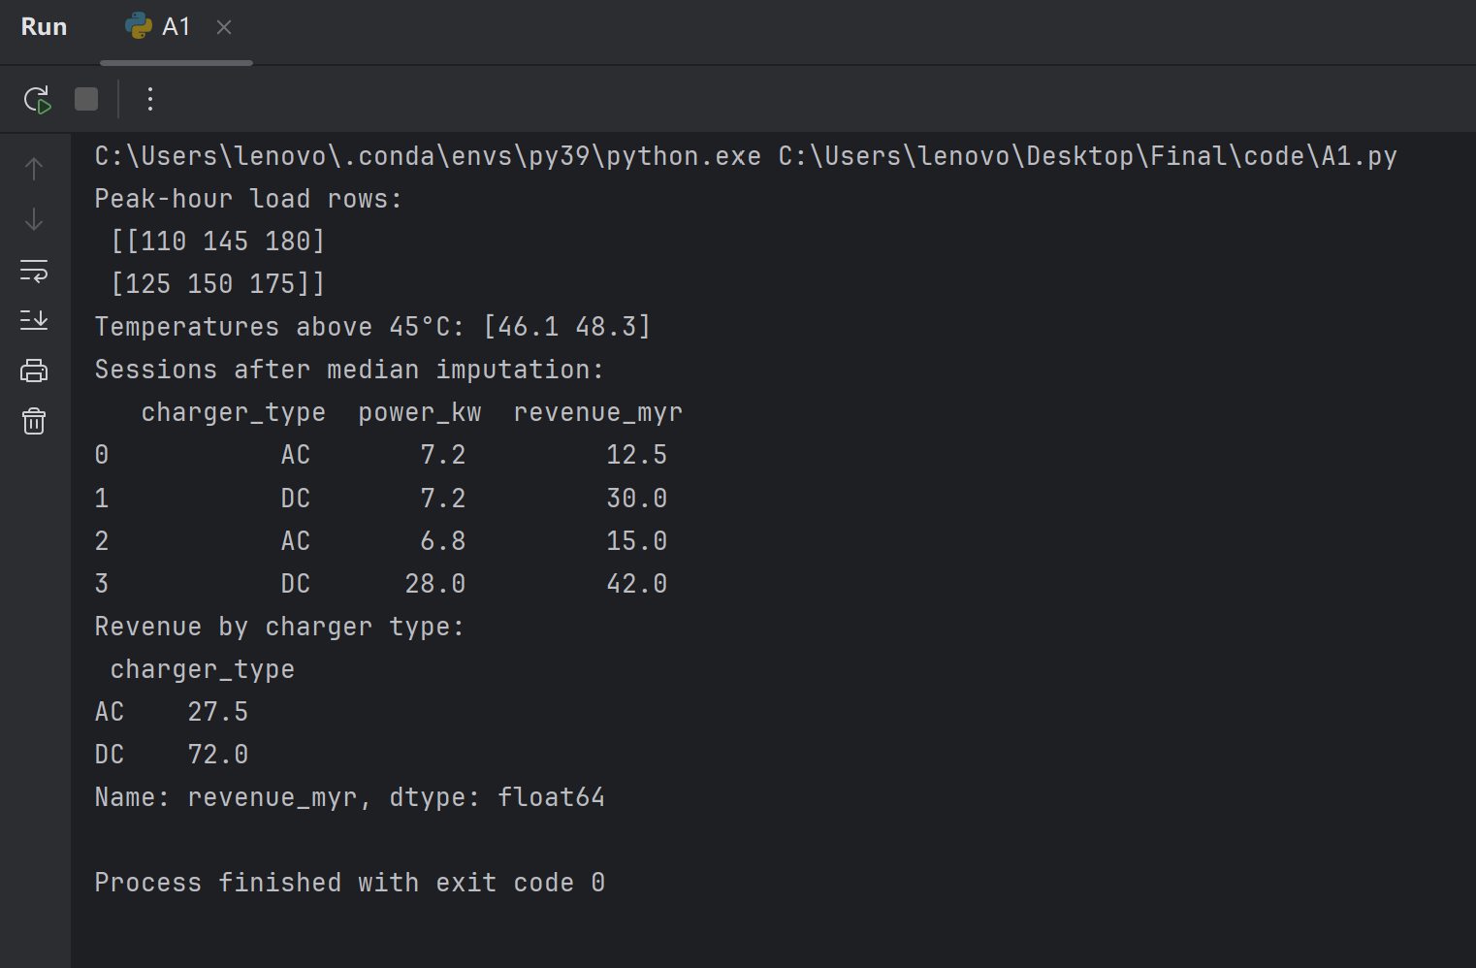

Question 2: functional programming paradigms
A charging session is classified as high-risk when its overstay duration is greater than 20 minutes and its battery temperature is above 40°C. The following code uses filter() to identify these sessions, map() to calculate a 15% surcharge, and reduce() to total the surcharge revenue.
from functools import reduce
# Real-world simulation of campus charging session records:
# (Session_ID, Charger_Type, Duration_Mins, Overstay_Mins, Battery_Temp_C, Base_Fee_MYR)
charging_sessions = [
("SESS-101", "AC", 120, 25, 42.5, 15.0), # Overstay 25>20, Temp 42.5>40 -> High risk
("SESS-102", "DC", 45, 5, 38.0, 30.0), # Normal
("SESS-103", "DC", 90, 35, 46.1, 50.0), # Overstay 35>20, Temp 46.1>40 -> High risk
("SESS-104", "AC", 60, 0, 31.0, 10.0), # Normal
("SESS-105", "DC", 110, 40, 41.8, 40.0) # Overstay 40>20, Temp 41.8>40 -> High risk
]
# 1. Filter: Extract high-risk sessions where overstay time exceeds 20 minutes AND battery temperature exceeds 40°C
high_risk_sessions = list(filter(
lambda s: s[3] > 20 and s[4] > 40.0,
charging_sessions
))
# 2. Map: Calculate a 15% surcharge penalty for the identified high-risk sessions
surcharged_sessions = list(map(
lambda s: {
"Session_ID": s[0],
"Base_Fee": s[5],
"Surcharge": s[5] * 0.15 # 15% surcharge applied to the base fee
},
high_risk_sessions
))
# 3. Reduce: Calculate the total surcharge revenue generated across all alert sessions
total_surcharge_revenue = reduce(
lambda acc, curr: acc + curr["Surcharge"],
surcharged_sessions,
0.0 # Initial accumulator value set to 0.0
)
# Print execution results
print(f"Total High-Risk Alert Sessions: {len(high_risk_sessions)}")
for item in surcharged_sessions:
print(f" - Session {item['Session_ID']}: Base Fee MYR {item['Base_Fee']:.2f} -> Surcharge MYR {item['Surcharge']:.2f}")
print(f"Total Surcharge Revenue Generated: MYR {total_surcharge_revenue:.2f}")
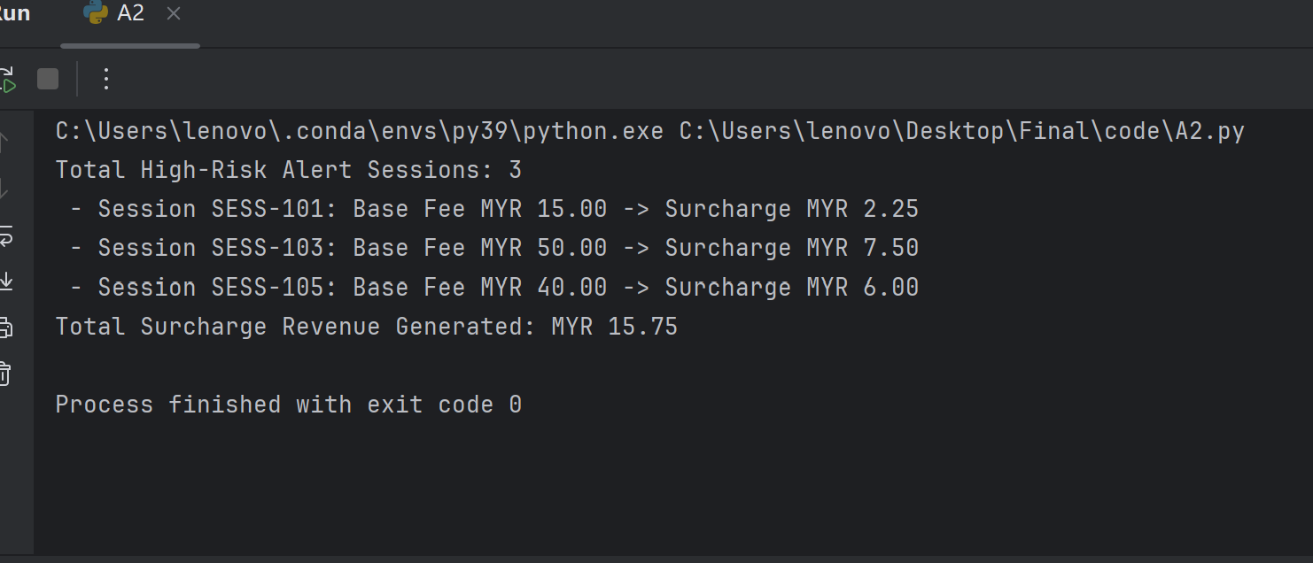
Three sessions meet both conditions: SESS-101, SESS-103, and SESS-105. Their surcharges are MYR 2.25, MYR 7.50, and MYR 6.00, respectively, giving a total surcharge revenue of MYR 15.75.
The filter lambda returns a Boolean value, while the map lambda creates a surcharge record for each qualifying session. This version converts the iterator results to lists so that it can print the high-risk session count and each session’s surcharge. The lists use additional memory, but they preserve the detail needed for this output. If only the total were required, the iterators could be passed directly to reduce() without storing the intermediate lists. Python’s functional programming tools support this kind of iterator-based processing (Python Software Foundation, n.d.).

Question 3: Data Visualization for Executive Reporting
Effective executive visualizations present the main comparison clearly and use titles, axis labels, units, and legends that can be understood without technical interpretation. A restrained colour palette, readable annotations, and consistent scales help reduce the effort needed to compare values.
Matplotlib provides detailed control over figures, axes, labels, and export. Seaborn is built on Matplotlib and provides concise functions for common statistical charts, including heatmaps and box plots. Seaborn can create statistical visualizations with fewer commands, while Matplotlib allows further customization of the layout (Matplotlib Development Team, n.d.; Waskom, n.d.).
Chart 1: Hourly charging revenue by charger type
The following code groups net billable amounts by session start hour and charger type, then plots the AC and DC totals as grouped bars.
from pathlib import Path
import pandas as pd
import matplotlib.pyplot as plt
# A_C1.py 位于 Final\code，CSV 位于 Final
project_dir = Path(__file__).resolve().parent.parent
csv_path = project_dir / "cleaned_energy_sales_data.csv"
print("正在读取：", csv_path)
df = pd.read_csv(csv_path)
# 按开始小时和充电器类型汇总净收入
hourly_revenue = df.pivot_table(
index="Start_Hour",
columns="Charger_Type",
values="Net_Billable_MYR",
aggfunc="sum",
fill_value=0,
)
# 确保横轴显示 0 到 23 时
hourly_revenue = hourly_revenue.reindex(range(24), fill_value=0)
# 绘制分组柱状图
ax = hourly_revenue.plot(
kind="bar",
figsize=(12, 6),
width=0.8,
color=["#2A788E", "#F0A202"],
)
ax.set_title("Hourly Charging Revenue by Charger Type")
ax.set_xlabel("Start Hour")
ax.set_ylabel("Revenue (MYR)")
ax.legend(title="Charger Type", frameon=False)
ax.grid(axis="y", linestyle="--", alpha=0.35)
plt.tight_layout()
plt.show()
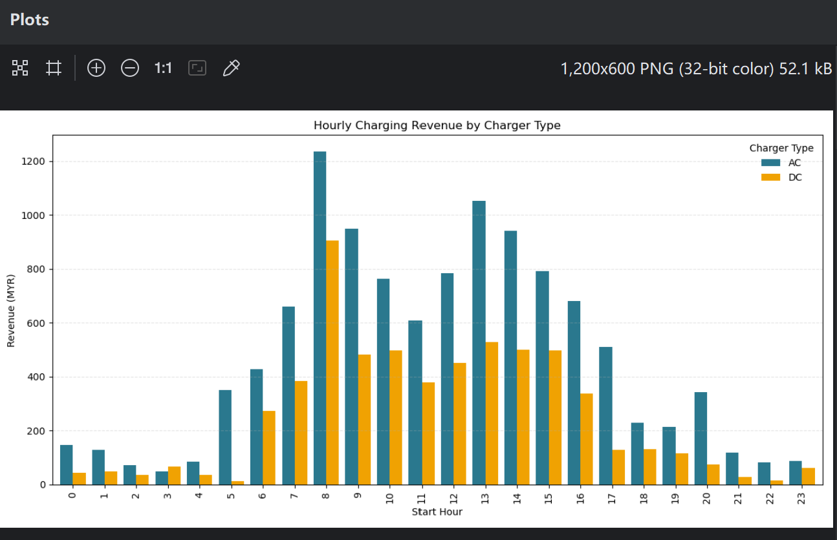Figure 1: Hourly Charging Revenue by Charger Type
The grouped bars allow facility managers to compare AC and DC revenue across the day. In the generated chart, the largest revenue peak occurs at approximately 08:00. The labels and shared revenue scale make the two charger categories straightforward to compare.

Chart 2: Correlation heatmap
The requested heatmap refers to ambient campus temperature, charging duration, and grid load. However, the supplied EV session data does not contain ambient temperature or measured grid-load fields. The following heatmap therefore uses available session measures—battery temperature, charging duration, and delivered energy—and should be presented as an available-data substitute.
from pathlib import Path
import pandas as pd
import matplotlib.pyplot as plt
import seaborn as sns
# A_C2.py 在 Final\code，CSV 在 Final 文件夹
project_dir = Path(__file__).resolve().parent.parent
csv_path = project_dir / "cleaned_energy_sales_data.csv"
# 读取数据，创建 df
df = pd.read_csv(csv_path)
# 这些列确实存在于提供的清理后数据中
available_columns = [
"Battery_Temp_C",
"Duration_Mins",
"Energy_kWh",
]
corr = df[available_columns].corr()
plt.figure(figsize=(7, 5))
sns.heatmap(
corr,
annot=True,
fmt=".2f",
cmap="vlag",
center=0,
vmin=-1,
vmax=1,
square=True,
)
plt.title("Correlation Between Available EV Session Measures")
plt.tight_layout()
plt.show()

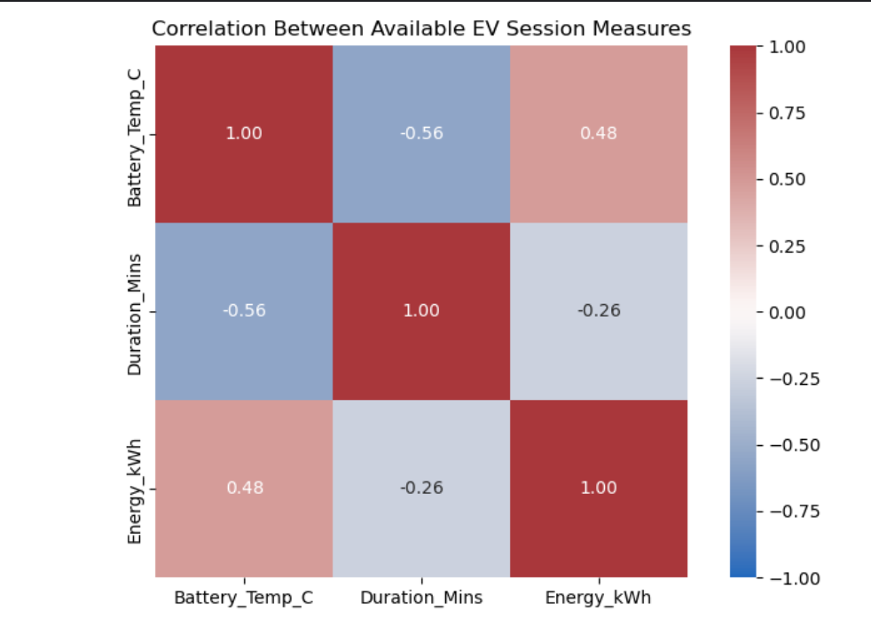
Figure 2: Correlation Matrix of Available EV Session Measures
The heatmap shows a moderate negative correlation between battery temperature and charging duration (r = −0.56), and a moderate positive correlation between battery temperature and delivered energy (r = 0.48). Charging duration has a weak negative correlation with delivered energy (r = −0.26). These correlations describe associations in the supplied session data and do not establish causation. Battery temperature and energy are available measures; they are not substitutes for the ambient temperature and measured grid load specified in the question.

Section B: Python Programming
Question 1: Data Pipeline and Feature Engineering
The EV charging dataset contains 1,200 session records. The raw file has 25 missing values in Duration_Mins and 35 missing values in Energy_kWh. The pipeline converts numeric fields to numeric types and imputes missing numeric values with the median of the corresponding column. For the supplied data, the median duration is 97 minutes and the median energy delivered is 13.28 kWh.
Categorical fields are validated against the values used in the dataset: Charger_Type is AC or DC; User_Type is Student, Staff, or Other Visitor; and Grid_Status_Label is Normal, Grid_Surge, or Overheated. Invalid labels are replaced with the most frequent valid category in the respective column. This helps prevent unexpected category values from affecting grouping and dashboard filters.
The pipeline engineers the following metrics:
- Duration_Hours = Duration_Mins / 60
- Power_Rate_kW = Energy_kWh / Duration_Hours
- Carbon_Savings_kgCO2 = Energy_kWh × 0.475
If duration is zero, the pipeline assigns a power rate of zero to avoid division by zero. The cleaned dataset is exported as cleaned_energy_sales_data.csv, and descriptive statistics are printed to the console.
The raw EV file does not specify the campus tariff formula. Therefore, the implementation uses documented example assumptions: AC charging is MYR 6 per hour, DC charging is MYR 15 per hour, a 25% surcharge applies during the selected peak hours or when the grid status is Grid_Surge, and overstay minutes beyond 20 minutes are charged at MYR 0.20 per minute. Under these assumptions:
Net_Billable_MYR = Base_Fee_MYR + Peak_Surge_MYR + Overstay_Fee_MYR
These amounts should be updated if the campus provides an official tariff schedule. Using the generated cleaned data, the dashboard reports approximately 18,630.1 kWh of energy delivered, 8,849.3 kg CO₂ of carbon savings, and MYR 15,783.90 in session revenue.
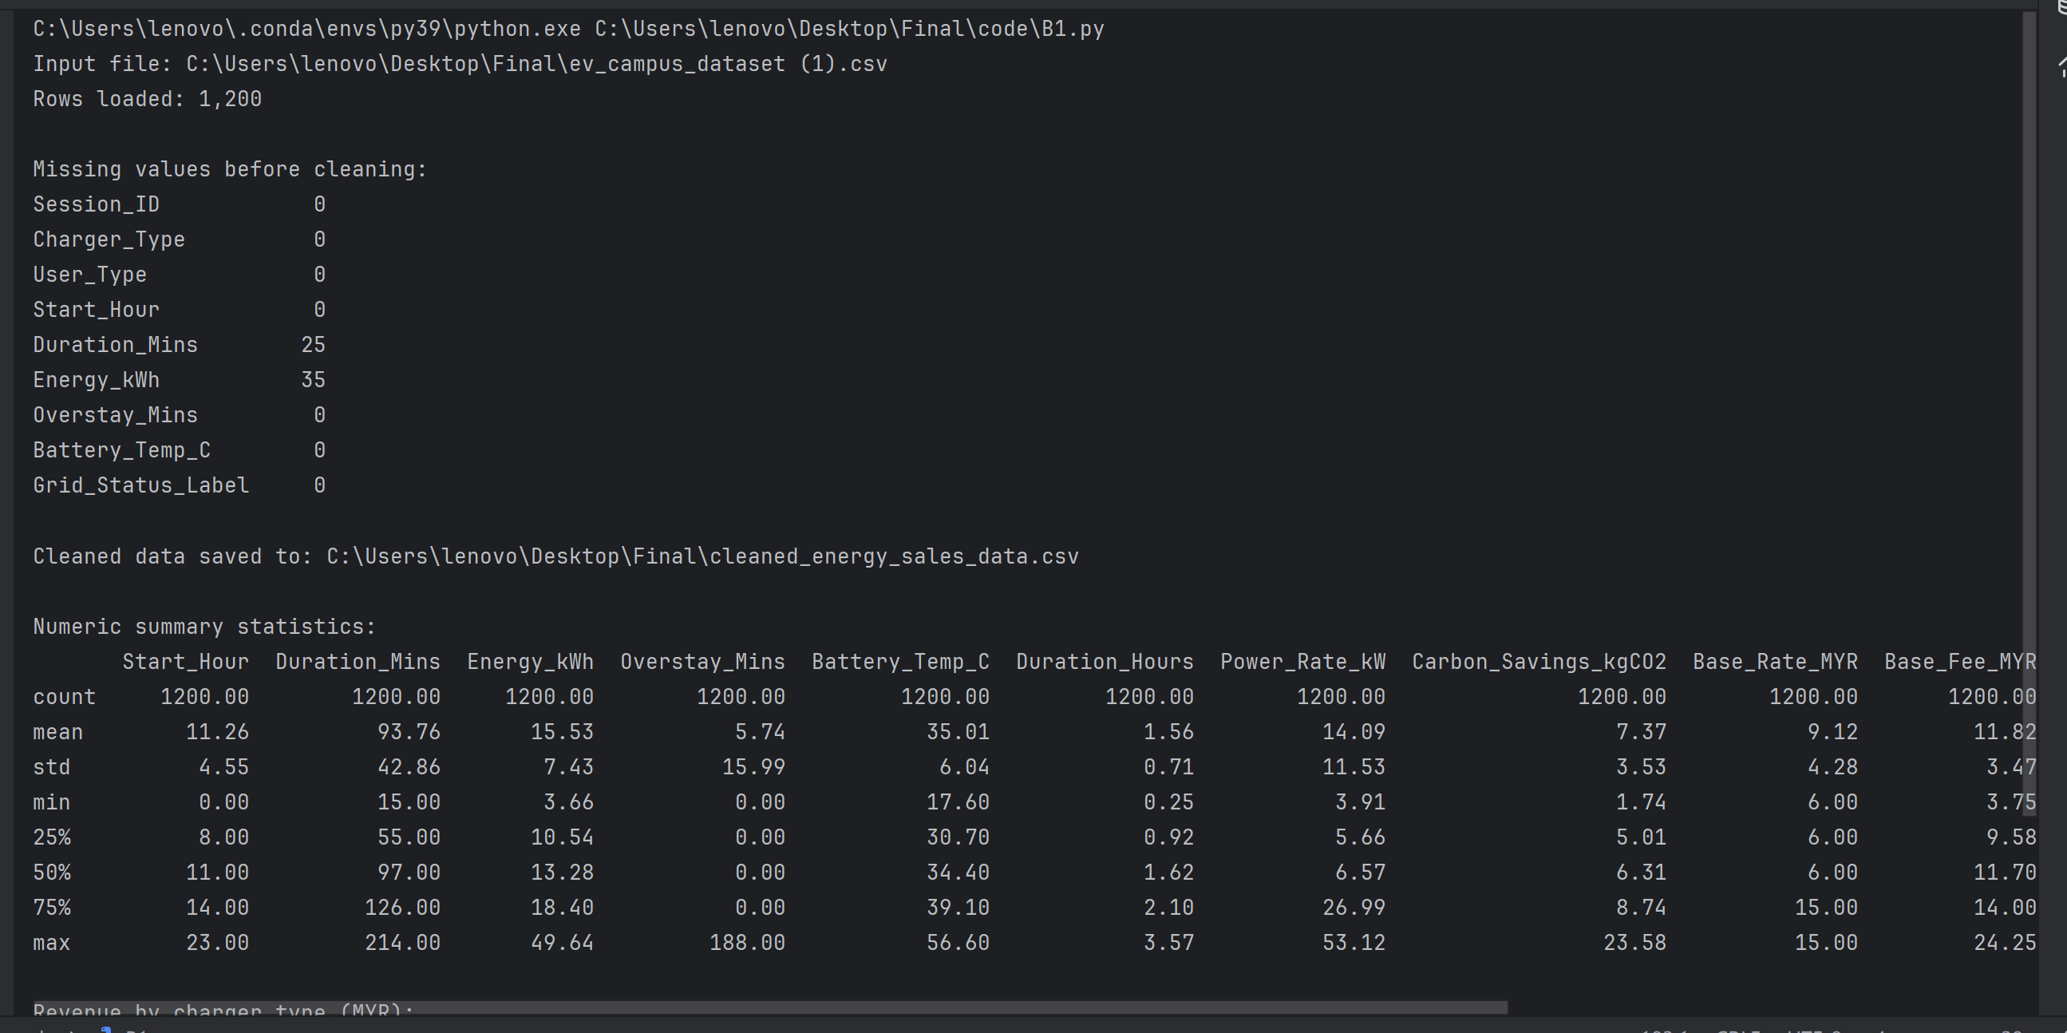
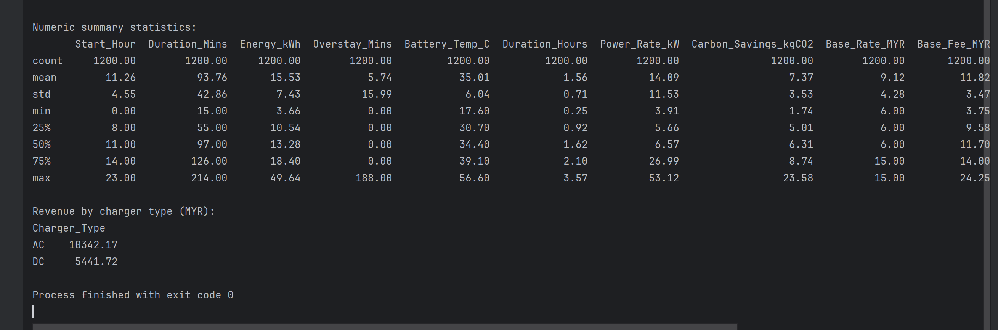
Question 2: Visualization Module
The visualization module produces three panels using Matplotlib and Seaborn. The first panel groups session energy by Start_Hour and displays it as an hourly charging-demand proxy. The provided data does not include measured grid-load or solar-generation records. Therefore, the solar curve is illustrative and must not be interpreted as observed campus generation.
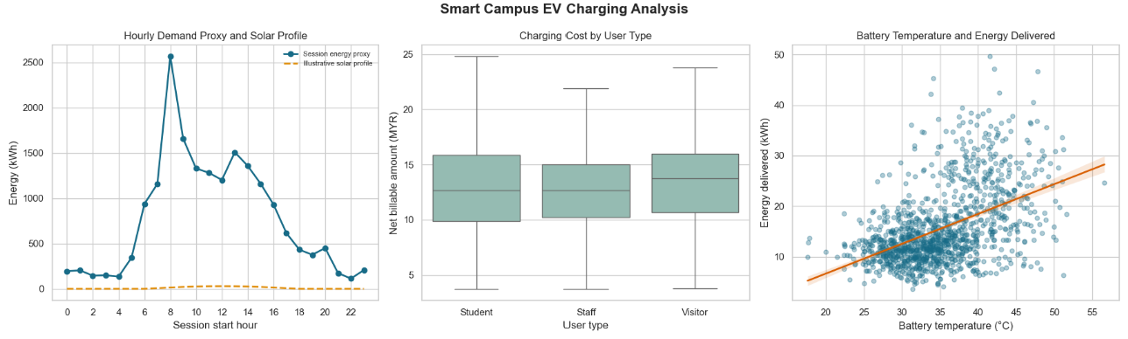
Figure 3. Three-panel visualization of hourly charging-energy proxy and illustrative solar profile, charging cost by user type, and battery temperature versus energy delivered.
The second panel is a box plot comparing Net_Billable_MYR across Student, Staff, and Visitor sessions. The box plot allows comparison of the median, spread, and range of session costs among user groups. The third panel plots Battery_Temp_C against Energy_kWh and overlays a regression trendline to summarize the direction of their association. A trendline indicates association in the sample and does not establish that temperature causes a change in energy delivered.
In the current combined figure, the illustrative solar curve appears nearly flat because its values are much smaller than the summed hourly session energy. For a clearer comparison of profile shapes, both series should be normalized to an index with a maximum of 100 and labelled as normalized profiles. This displays relative hourly patterns without implying that the solar values are actual measurements.
Question 3: Streamlit Dashboard
The Streamlit application provides three pages: Executive Overview, Session Explorer, and Sales Transactions. The Executive Overview presents four KPI cards: total energy delivered, carbon offset, session revenue, and active high-risk alert count. In the displayed run, the high-risk alert count is 24.
Sidebar controls include a minimum-energy slider, a charger-type multiselect, a session date-range widget, and a configurable temperature threshold. The high-risk rule flags records where overstay duration is greater than 20 minutes and battery temperature is greater than the selected threshold. The application displays a Streamlit alert banner when matching records are found and shows the flagged sessions in a table.
The Session Explorer presents session visualizations, including cost by user type and battery temperature versus energy. The Sales Transactions page displays the separate sales dataset, which contains transaction dates and revenue. Filtered EV session data is displayed in a table and can be exported through the CSV download button.
The supplied EV session dataset does not contain a session-date field. Consequently, the date-range control is displayed but cannot filter EV sessions unless a date field is added to the source data. The application states this limitation in the sidebar. Sales transactions are handled separately because the sales dataset is not keyed to individual charging sessions.
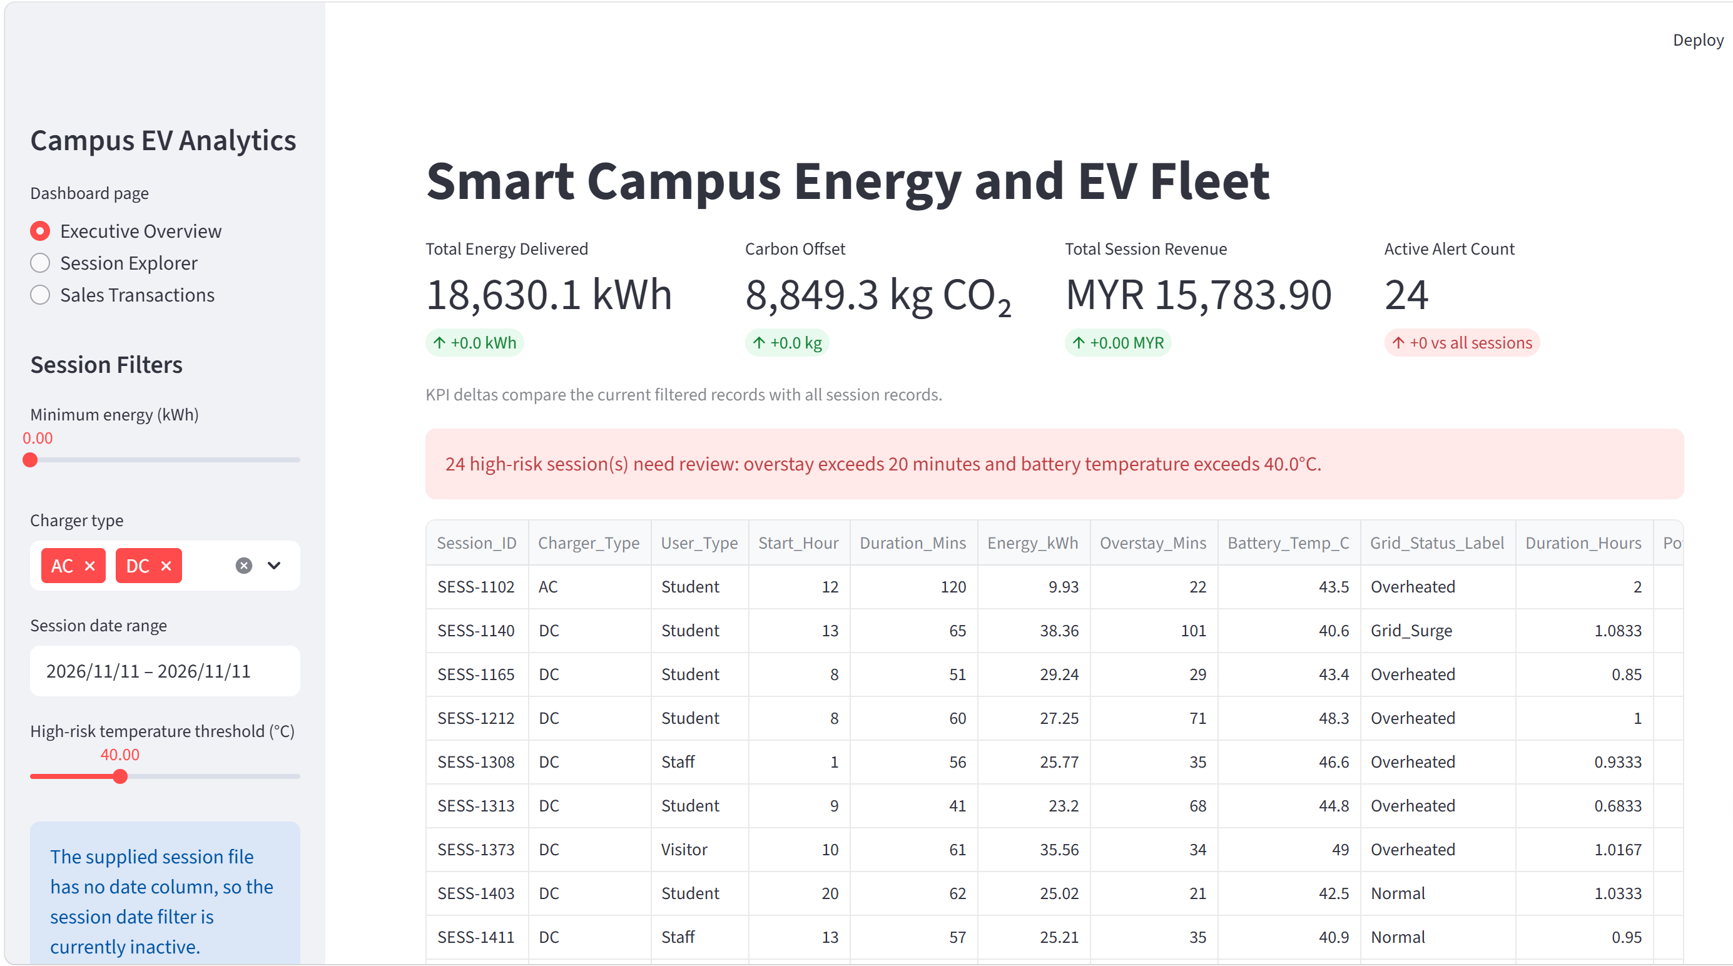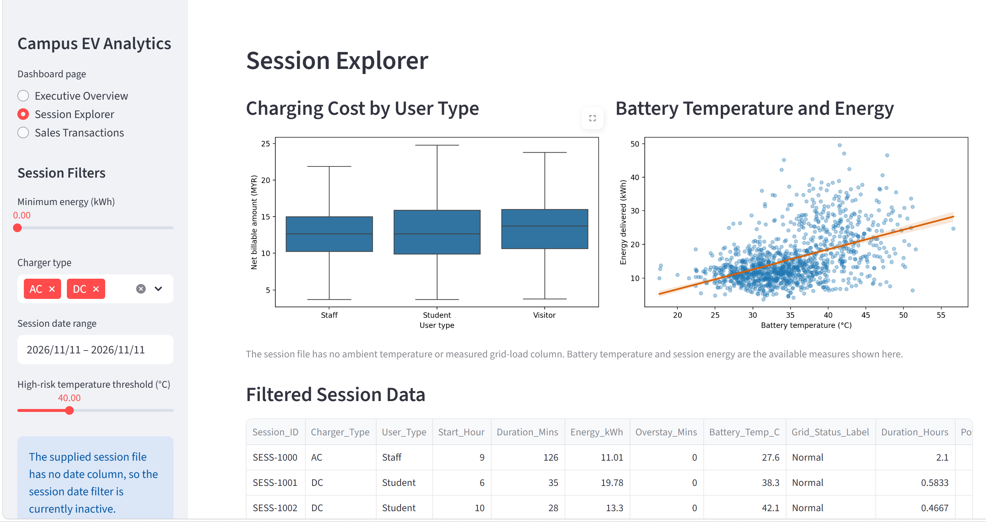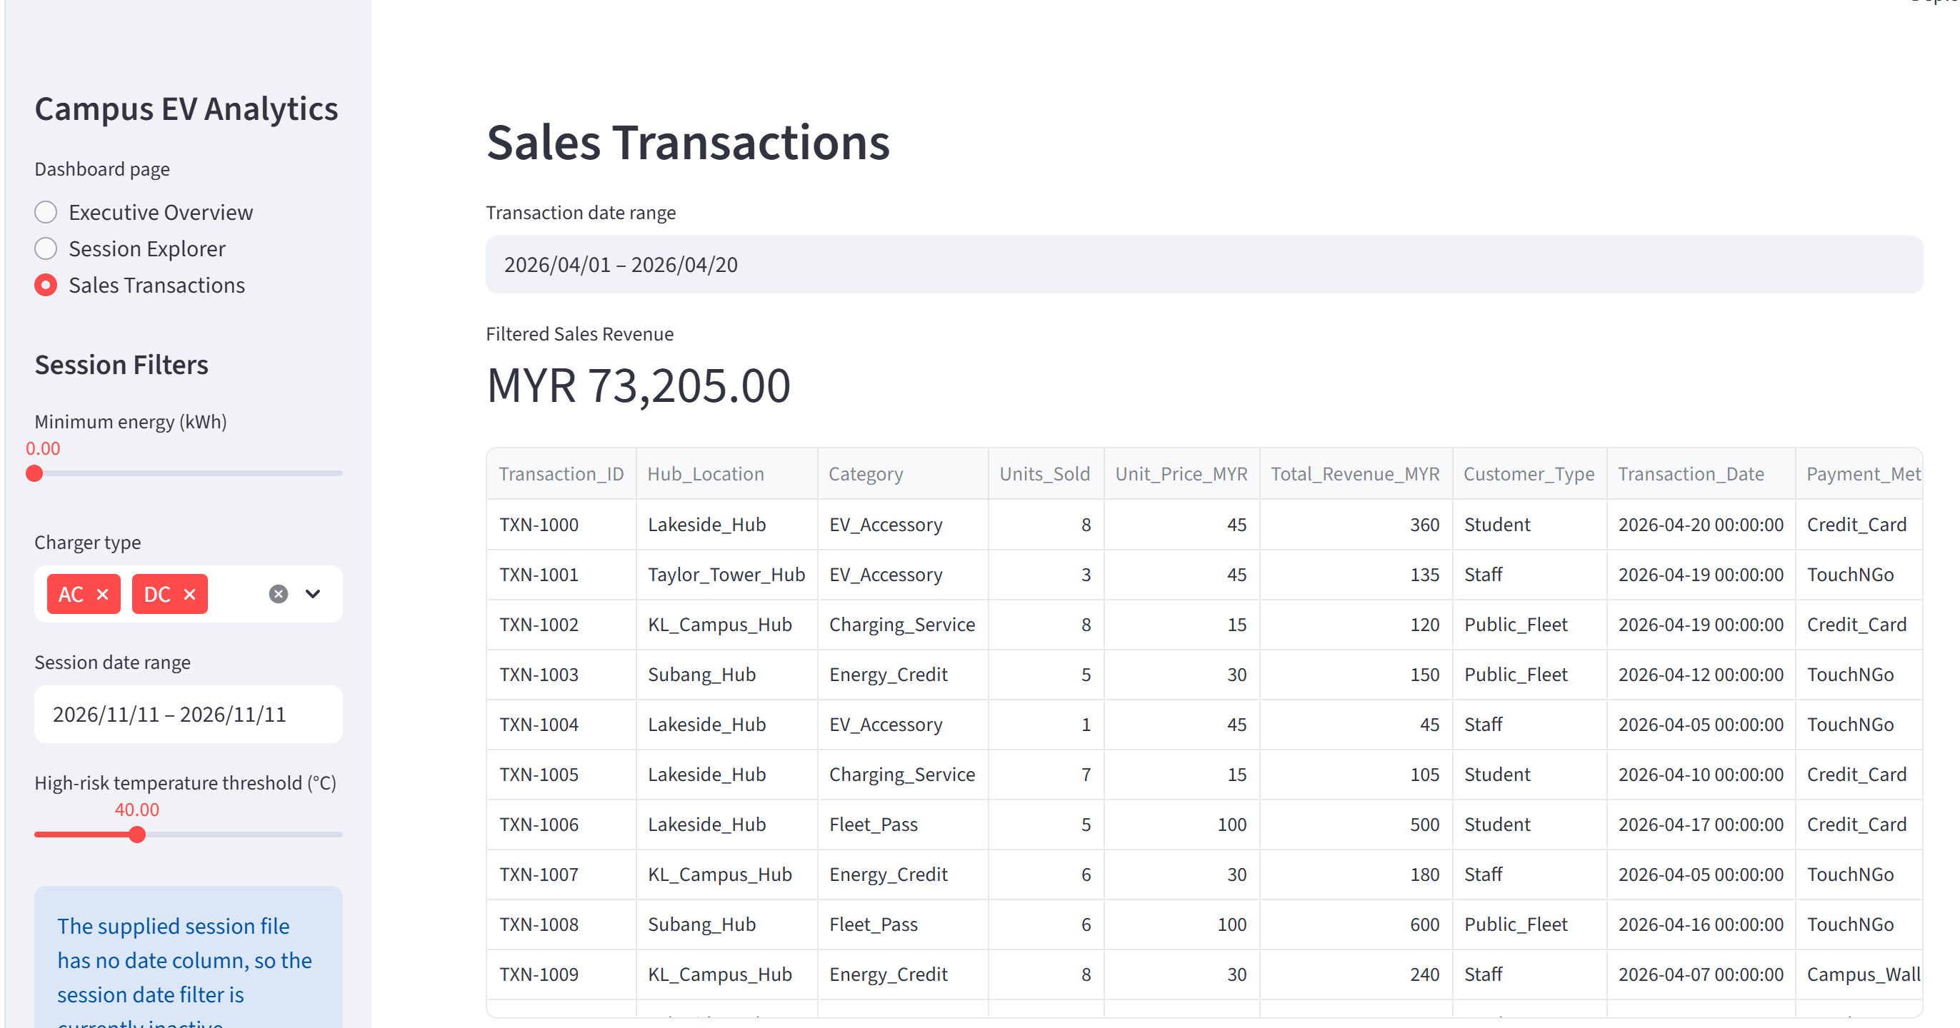
The application separates data loading, filtering, chart rendering, and page display into functions. It checks for missing files and required columns, caches loaded data, and provides error messages when data cannot be read. The complete source code for the dashboard and supporting modules should be included in the report appendix and supplied as .py files. The project dependencies are listed in requirements.txt.

References
- Matplotlib Development Team. (n.d.). Quick start guide. https://matplotlib.org/stable/users/explain/quick_start.html
- NumPy Developers. (n.d.). NumPy: The absolute basics for beginners. https://numpy.org/doc/stable/user/absolute_beginners.html
- pandas Development Team. (n.d.). Group by: split-apply-combine. https://pandas.pydata.org/docs/user_guide/groupby.html
- Python Software Foundation. (n.d.). Functional programming HOWTO. https://docs.python.org/3/howto/functional.html
- Streamlit, Inc. (n.d.). Streamlit documentation. https://docs.streamlit.io/
- Waskom, M. (n.d.). seaborn: Statistical data visualization. https://seaborn.pydata.org/

