Adse1310 – Assignment 3

In this assignment I will focus on glucose monitoring systems as an example of an Internet of Things (IoT) device in the healthcare sector. IoT, Internet of Things, consists of devices that communicate information over an internet connection. The devices use different layers of communication and analytics to provide users with a beneficial experience without human interaction. These devices are often nowadays found in our everyday lives such as smartphones, smartwatches, smart-home applications, etc. However, they can also be found useful in other parts of our lives such as healthcare for example. As technology has evolved, we can see that the attention for implementing IoT devices in the healthcare sector has risen. The example of Glucose Monitoring Systems, or Continuous Glucose Monitoring Systems (CGMs), have been “recently” implemented in the 20th century.

Diabetes is a major health concern and according to CDC Global Health 415 million people suffer from the disease, and more to come. Glucose refers to the level of concentration of blood sugar in the blood. The glucose levels fluctuate throughout the day and either too high or low levels are symptoms of diabetes. CGMs are small monitors attached to the skin with a tiny sensor that manages to measure these glucose levels. The device can also provide an alarm to tell when the levels are either too high or low. This is therefore ‘perfect’ for diabetic patients as their levels will be recorded throughout the whole day.

CGMs are small devices created to be easily handled by all patients. They are typically attached to upper arms, abdomen, or other lumbar regions and removed after 7-14 days as to not jeopardize the sensor nor the patient’s health. This is typically a non-invasive device but is determined by the placement of the sensor as well as its communication process. However, in most cases it is considered a non-invasive device. Before CGMs were introduced most diabetic patients would endure finger pricking to measure their glucose levels manually. This would also be done several times a day. With the new CGMs, glucose levels can be measured continually throughout the day and night without the patients nor a doctors’ intervention.

(Picture of a CGMs)

CGMs utilize the typical IoT based approach meaning it consists of a sensor, a transmitter, and a monitor. You could also say that CGMs consists of a sensory layer, a gateway, and a cloud. There are also other components included in the build such as microcontrollers, communication blocks and different management mechanisms. There is also something called nRF protocols that is heavily used by CGMs. These protocols transmit data from the sensory layer to the gateway through wireless IP-based transceivers such as for example Wi-Fi. The gateway then collects the data from this wireless sensor and transmits it again to the cloud. The nRF transceiver is also compatible with most if not all types of smart devices nowadays, which refers to the gateway. The gateway is a hub between the sensory layer and the cloud and is often a smartphone or laptop, in possession of the patient themselves. Here, data can be 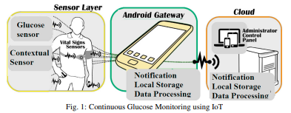processed in the local host and then push notifications locally. The cloud is where the data is “published” for all participants to see, such as doctors and other personnel. The cloud is where the real-time monitoring happens and can push notifications to all parts.

These layers and protocols can be customized and is not always the same as a lot of different companies produce CGMs. Some are said to be more energy efficient for example. Rasyid, et al. looked at CGMs using a glucometer sensor, an Arduino uno and a Zigbee module. This construction and combination use more high power than say other components. There are many different types of CGMs on the market and some does not provide real-time monitoring, some are less energy efficient and some lack instant alerts.   
However, some CGMs benefit from their advanced data collections of body- and or environmental- temperatures. These readings can not only be collected for the patients or doctors to see, but to manage energy consumption of the CGMs device itself. Body temperatures can be used for energy harvesting and can be used to create a more energy sufficient IoT device.

These devices can measure a lot more data than just glucose levels. CGMs can measure body temperature and environmental temperature as well. All the data is also presented in a readable form for all people and typically presented in graphs or other displays of data. This makes the device inclusive of both patients and doctors. This is very helpful of everyone in use of the device and its data as even the patients can get first-hand understanding of their own health. The patients can make corrective actions quickly due to the mobility of its data. It is very important to note that the CGMs second most important attribute is its ability to alert during, after and even beforehand it receives glucose levels. This ability is mainly due to its sensor and wireless connection to other receiving devices. The system analyzes data and constant feedback to construct a generalized simulation of glucose fluctuations. Due to this CGMs can give patients an alert beforehand and help them avoid deviations or even more extreme events that could be life-threatening.

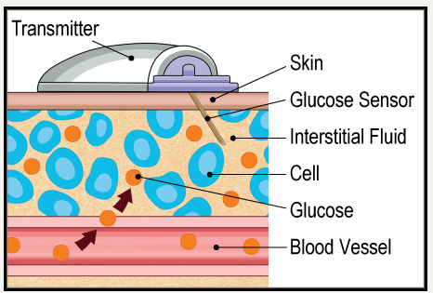Glucose is a concentrated source of energy and is extremely important for our body to perform several tasks. Glucose can be found in our blood stream and can fluctuate depending on food intake, exercise, or bodily regulations. A high level of glucose can release a hormone called insulin and low levels of glucose releases another hormone called glucagon. The sensor inserted into the skin uses a glucometer sensor that works in the interstitial fluid of our body. This glucometer sensor takes practice in electrochemical based methods to identify these hormones, electrodes, or enzymes necessary to read and understand the glucose levels present.

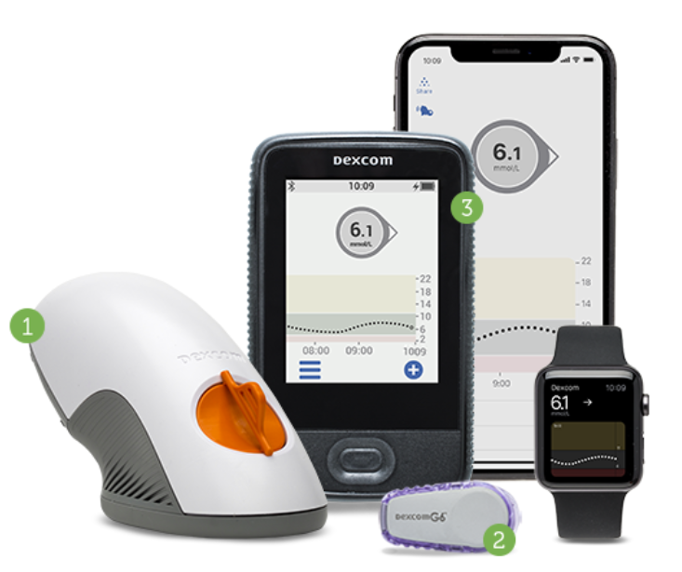The data is as mentioned received by a gateway, or in other terms, received by a smartphone or other smart device available. Most people have smartphones or even wearables that can download the required software of the CGMs. Here the patient can read their own data, which is presented in a certified app, usually by the same manufacturer of the CGMs device. The patient can look at their own statistics and determine whether they need to inject additional insulin or if they need to consume food, exercise, etc. They can take measures of their own compared to going to a doctor’s office to get statistics and advice manually.   
The doctors are also, of course, able to see the data received. This is available to them over the cloud and are in most cases inserted into a medical system already in use at the doctor’s office or hospital. This way it is easy to implement for both doctors and patients as devices and some software systems are already in use.   
Some CGMs provide their patients with a separate monitor. This monitor displays the same information as the mobile app does but is convenient for those without access to a smartphone or other such devices. The information displayed is usually a prominent and front-figure number of the patient’s real-time glucose levels. There is usually an indication at all times of the patient’s glucose range and whether it is in a downward turn or an upwards one. With the help of app development, it is easily readable and present trending graphs from past data.

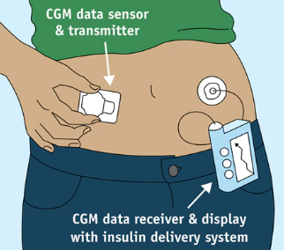A great benefit of IoT devices is their ability to communicate with each other. This is also applicable to CGMs as they can communicate with insulin pumps and pens, and other diabetes technologies. There is a great deal of insulin pumps on the market that works in the same sense as CGMs. These devices are also dependent on glucose levels, which is data that can be transmitted from CGMs. The data can provide the pumps with sufficient information and alarms of when to pump insulin when needed. This is a great benefit to diabetes patients as it can also help prevent high fluctuations of glucose levels and keep their health steady. These pumps and pens also come in various variations to help accommodate all kinds of needs and situations.

There are many other benefits to the use of CGMs. Some are already mentioned as; continuous use for over a week, availability of records, alarms, tracking, integration of other technologies, etc. However, there are some negative sides as well. CGMs can be considered a relatively new IoT device and with this comes a great deal of trial and error. First, it is found that people tend to divert from using IoT devices. This could primarily be because IoT is not a common term for all people and therefore lack information of use and benefits. Second, some studies show issues regarding the accuracy of glucometer sensors. There is also some concern whether glucose levels can be adequately measured in the interstitial fluid. Third, these systems are not necessarily cheap. Health insurance is different from country to country, but in some patients would have to pay a great deal of money to purchase the systems. The sensors also have to be changed after a week of use.

With more attention to healthcare and technology CGMs and other diabetic technologies continue to advance. If users are trained and informed about these devices and their benefits it can be properly adopted for many more to use. CGMs is a small and light device with an easy interface to make for a better user experience. The data collected is also of great use for patients and doctors, but I can imagine it can be used for a lot more than those diagnosed with diabetes. Athletes, other patients, and researchers could also benefit from such an IoT device. Over time it will most likely become even more popular amongst patients. Manufacturers and developers will help adopt new technologies and perhaps make the devices more energy efficient, accurate and long-lasting, all to help medical development as well as people’s health.

Sources:

Hossain, I., Yusof, A. F., Hussin, A. R. C., A.Lahad, N. & Sadiq, A. S. (2021). Factors influencing adoption model of continuous glucose monitoring devices for internet of things healthcare. *Internet of Things, 15, 1000353.*  
[https://doi.org/10.1016/j.iot.2020.100353](https://doi-org.ezproxy.oslomet.no/10.1016/j.iot.2020.100353)

Gia, T. N., Ali, M., Dhaou, I. B., M.Rahmani, A., Westerlund, T., Liljeberg, P. & Tenhunen, H. (2017). IoT-based continuous glucose monitoring system: A feasibility study. *Procedia Computer Science, 109, 327-332.*  
<https://doi.org/10.1016/j.procs.2017.05.359>

Kim, Y., Saviers, K. R., Fisher, T. S. & Irazoqui, P. P. (2018). Continuous glucose monitoring with a flexible biosensor and wireless data acquisition system. *Sensors and Actuators B: Chemical, 275, 237-243.*  
<https://doi.org/10.1016/j.snb.2018.08.028>

Karim, A. N. M., Nordin, A. N. & Begum, S. (2014). Technical and Economic Feasibility of Sensor Technology for Health/Environmental Condition Monitoring. Comprehensive Materials Processing, 13, 499-514.  
<https://doi.org/10.1016/B978-0-08-096532-1.01322-4>

Zhang, J. X. J. & Hoshino, K. (2014). Electrical Transducers: Electrochemical Sensors and Semiconductor Molecular Sensors. Molecular Sensors and Nanodevices, 196-232.  
<https://doi.org/10.1016/B978-1-4557-7631-3.00004-1>

Vaddiraju, S., Burgess, D. J., Tomazos, I., Jain, F. C., & Papadimitrakopoulos, F. (2010). Technologies for continuous glucose monitoring: current problems and future promises. *Journal of diabetes science and technology*, *4*(6), 1540–1562.   
<https://doi.org/10.1177/193229681000400632>

Farnsworth, C. (2022, 7. february). What to know about continuous glucose monitors. *Medical News Today.*   
<https://www.medicalnewstoday.com/articles/continuous-glucose-monitoring>

Walsh, J., Roberts, R., Morris, R., & Heinemann, L. (2015). Device connectivity: the next big wave in diabetes. *Journal of diabetes science and technology*, *9*(3), 701–705.   
<https://doi.org/10.1177/1932296814568806>

Hu, J., Wu, K. & Liang, W. (2019). An IPv6-based framework for fog-assisted healthcare monitoring. *Advances in Mechanical Engineering, 11(1), 1-13.*  
[https://doi.org/10.1177/1687814018819515](https://doi.org/10.1177%2F1687814018819515)

National Institute of Diabetes and Digestive and Kidney Diseases. (2017). Continuous Glucose Monitoring.   
<https://www.niddk.nih.gov/health-information/diabetes/overview/managing-diabetes/continuous-glucose-monitoring>

Dexcom Continuous Glucose Monitoring. <https://www.dexcom.com/nb-NO>

Hoskins, M. (2021). All About the Dexcom G6 Continuous Glucose Monitor. *Healthline*. <https://www.healthline.com/diabetesmine/dexcom-g6-cgm-product-review>

The Naomi Berrie Diabetes Center. <https://www.nbdiabetes.org/news/continuous-glucose-monitoring-system-cgms>