Table of Contents

HomeView and HomeController 2

Create Shared _Layout 4

Simplify Table.cshtml 8

Reset default launchURL 9

Run Project 10

# HomeView and HomeController

Create a subfolder Home under the folder Views

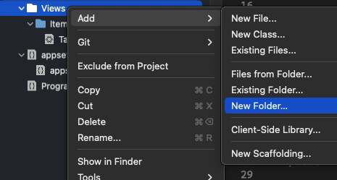

Create a file Index.csthtml under the Home folder

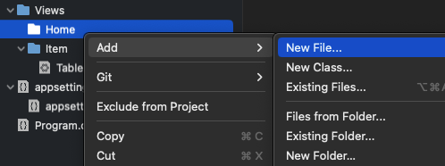

Select Razor View and Create with the name Index

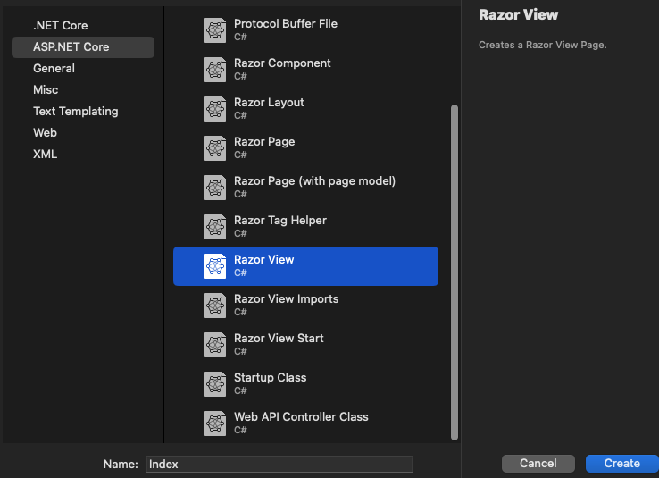

Change the Index.cshtml to this:

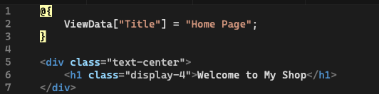

Create a new file (Controller Class) under the folder Controller

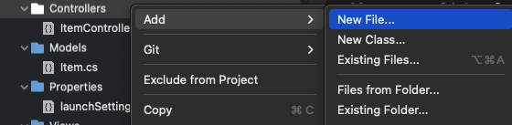

Select Controller Class with the name “HomeController”

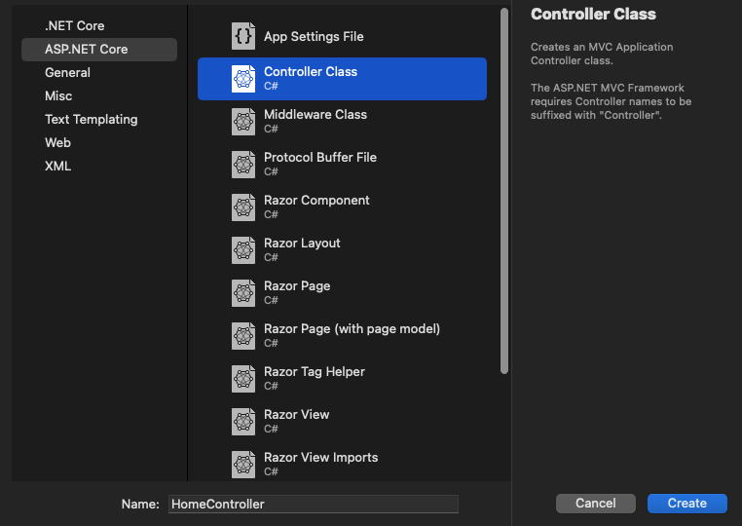

We don’t need to change this file

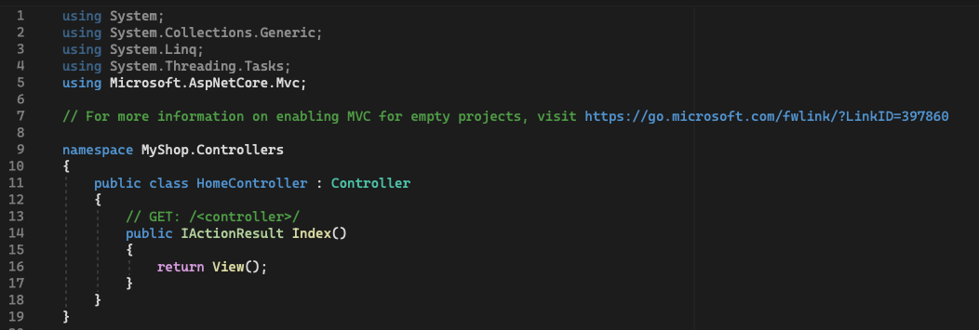

# Create Shared _Layout

Create a subfolder Shared under the folder Views

Create a file Razor Layout with the name “_Layout” under the Shared folder

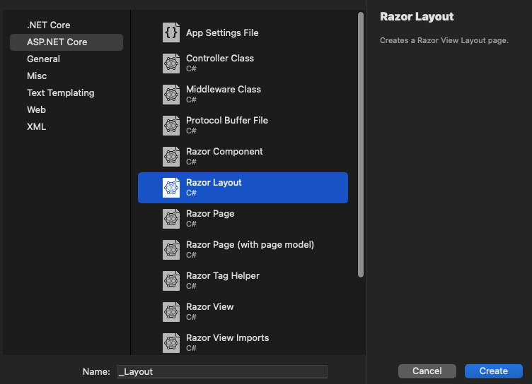

Copy the code in _Layout.cshtml from the FirstMVC project into the _Layout.cshtml file and

Modify the code: change the stylesheet reference, change the nav-item, change the view title, delete the footer part

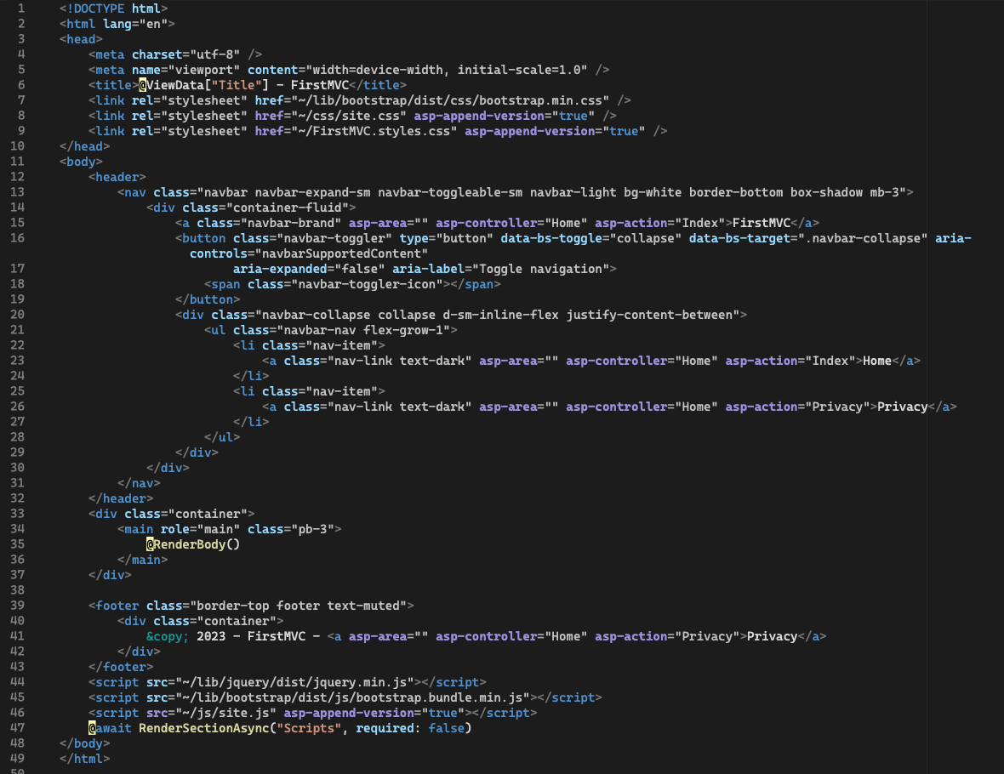

delete

change

change

Change to this:

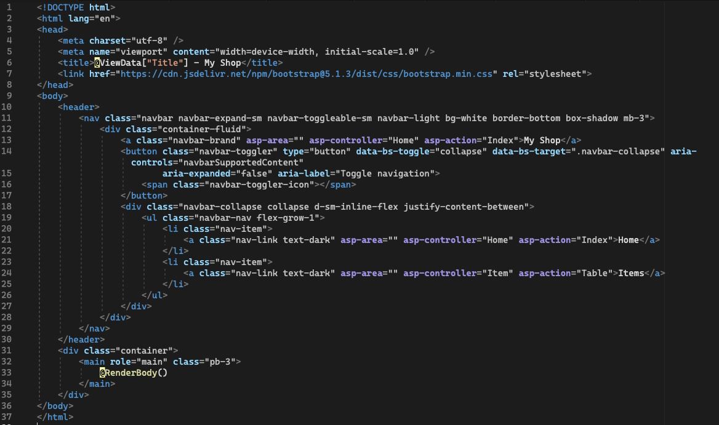

Note: the routing and navigation follows the default pattern “Controller/Action” as specified in the Program.cs.

Create an empty css file with the name “_Layout.cshtml.css” in the Shared folder

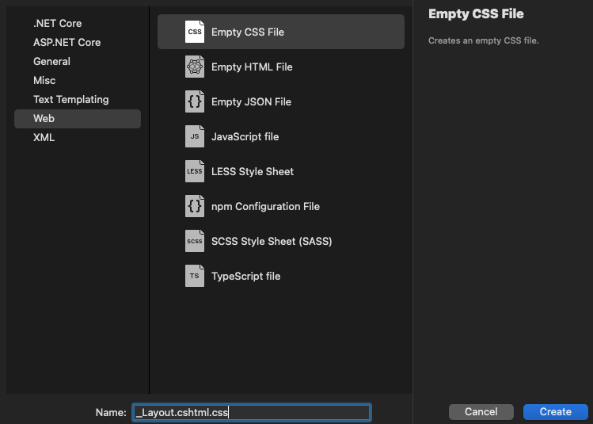

Copy the code of the file _Layout.cshtml.css from the FirstMVC project into the _Layout.cshtml.css folder

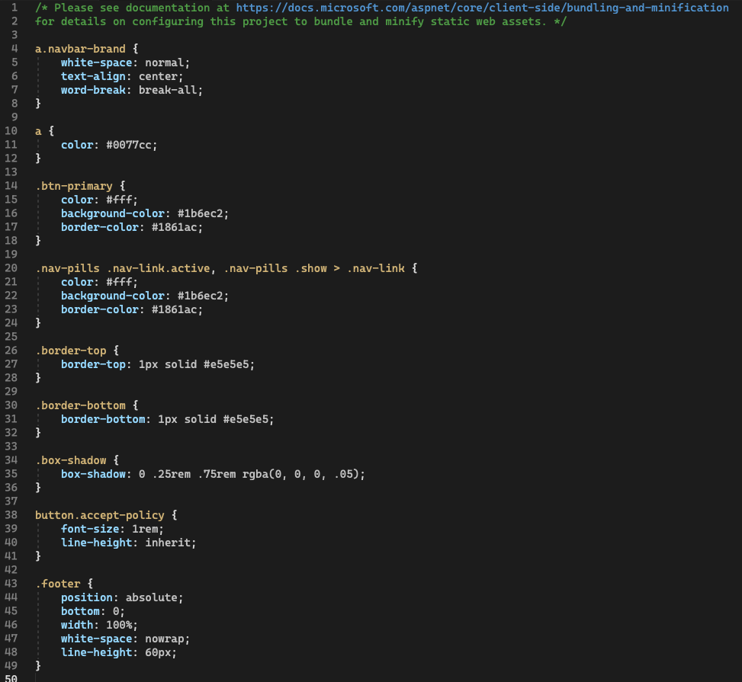

Create file _ViewImports under the View folder

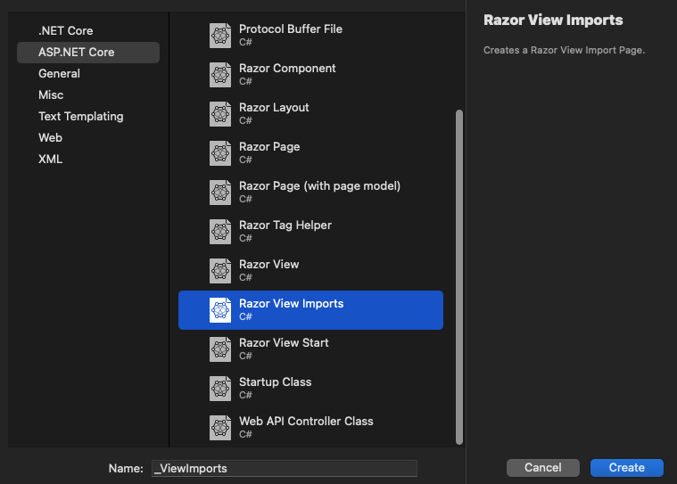

Add the following code into _ViewImports.cshtml

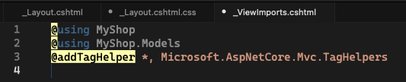

Note: It is special Razor view file allows you to define common statements applied to all other views in the application. It acts as a global import file for your views.

(Line3) is used to add tag helpers, which enables to create custom HTML elements (tags). Here it enables routing and navigation, e.g., the pattern of “Controller/Action”.

Create file Razor View Start under the View folder

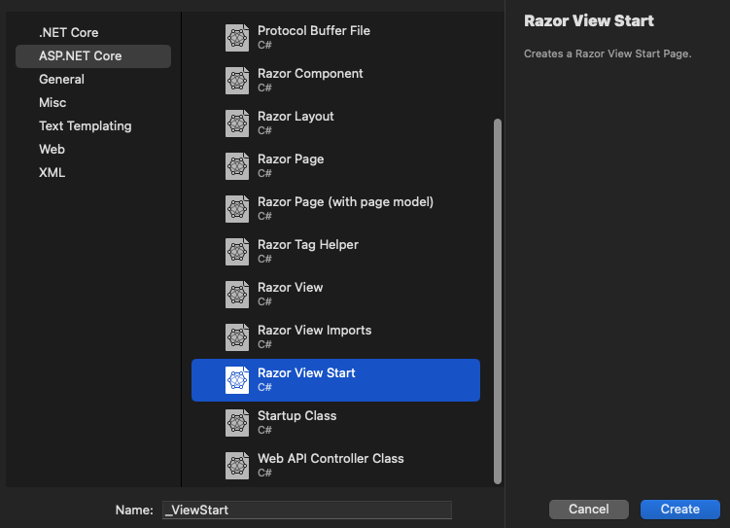

With the following code in the _ViewStart.cshtml (specifying the default layout):

It is a special Razor view file applied to all other views in the application. It acts as a global layout page for your views



# Simplify Table.cshtml

Change the Table.cshtml file to this (remove the head and other information):

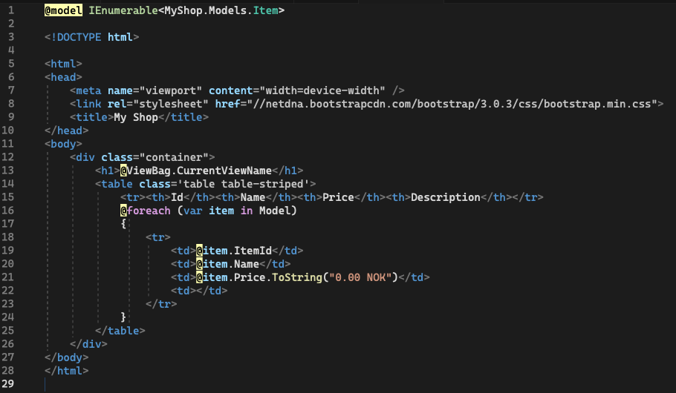

delete

delete

After change:

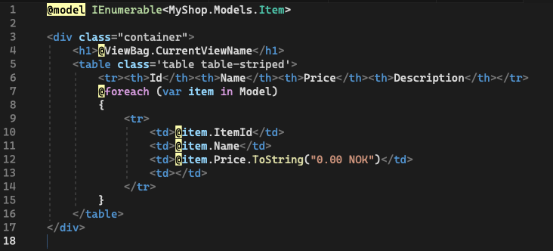

# Reset default launchURL

Go to launchSettings.json and delete the launchUrl line

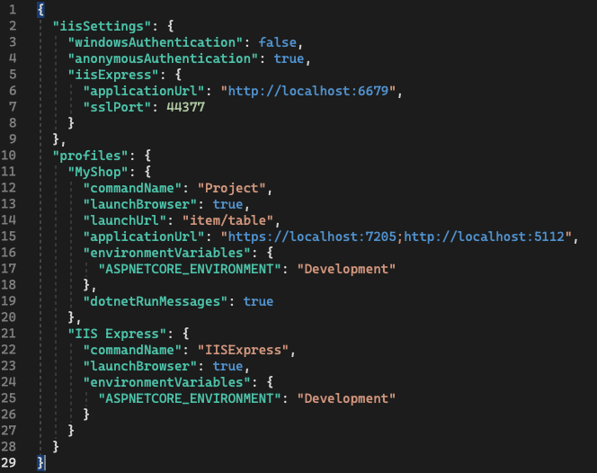

delete

After deleting

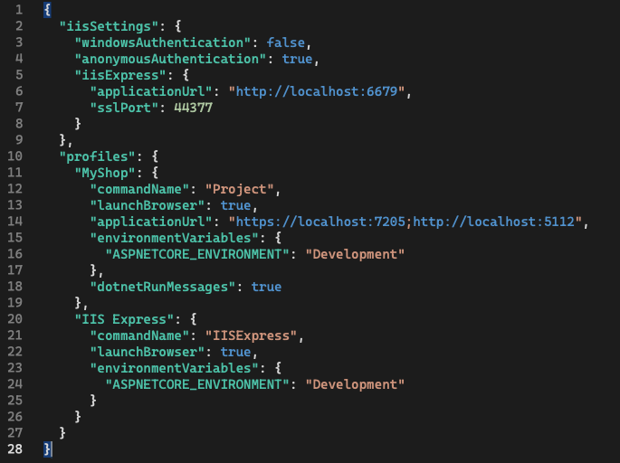

# Run Project

Now run the project, the default page becomes /Home/Index

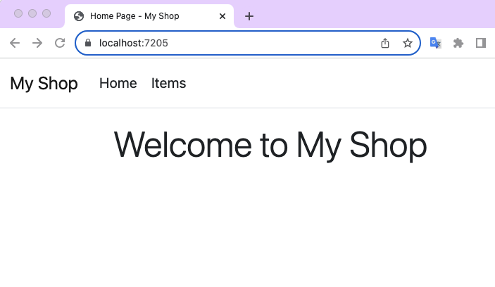

Click Items, we go to /Item/Table

