Inf2B – CW2: Report 1

Jenny Lin

---- report1.pdf for Task 1 -----

Task 1.1

- Ten figures: Figure 1,...,Figure 10 (shown in the same page)

Figure k (k=1,...,10) shows the images of the first ten samples in

the training data (Xtrn) for Class k.

|  |  |  |
| --- | --- | --- |
|  |  |  |
|  |  |  |
|  |  |  |
|  |  |  |

Task 1.2

- A single figure of 11 images, where image k (k=1,...,10) is the image of

the mean vector for Class k, and image 11 is the image of the mean

vector for all the classes.

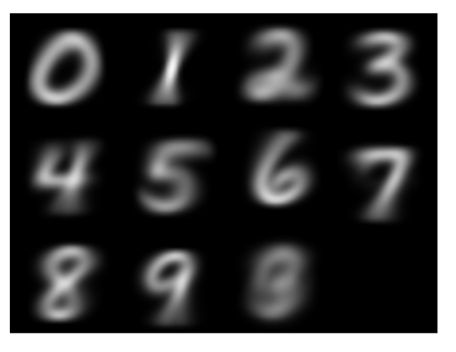

Task 1.3

- A figure which shows a graph of cumulative variance

(NB. do not normalise the value by the total variance, but simply plot

the cumulative sum of variance for D=1,...,784.)

- A table that shows the minimum numbers of PCA dimensions to cover

70%, 80%, 90%, and 95% of the total variance.

show the ﬁgure of commutative covariance, and show the values of MinDims.

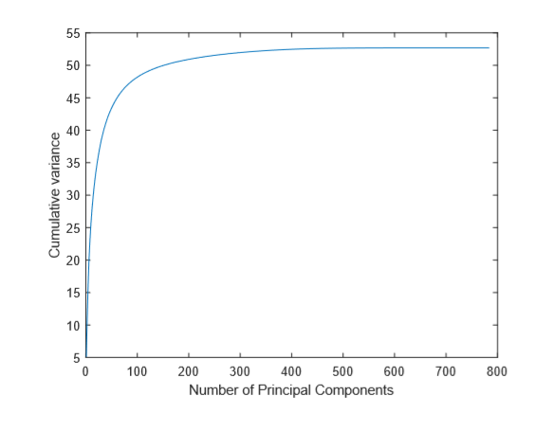

Task 1.4

- A single figure that displays the images of first ten principal components,

where image i (i=1,...,10) is the image of i-th principal component.

Task 1.5

- Figures or a figure that display(s) a graph of SSE where k on x-axis, SSE on

y-axis. Either a separate figure for each k or a single figure

showing all is fine.

- A table or a figure that displays the time taken for each k.

Task 1.6

- Nine figures: Figure i displays the images of cluster centres

obtained with k-Mean clustering when k = Ks(i), i=1,...,9.

Task 1.7

- Five figures: Figure i (i=1,...,5) displays a cross section of the

cluster regions for k, where k is the i-th element in [1,2,3,5,10].

- Descriptions of the methods/algorithms you employed for the

visualisation of cluster regions.

Task 1.8

- A report of your mini research project, in which you describe your

investigation including approaches/methods, results, findings, and

discussions.

The expected length of the report for this is one page. A bit

longer than that is fine, but no more than 2 pages.