LEARNING JOURNAL
DAY 1 WEEK 1
DATE 11-17-25
Students shall input learnings (i.e. what has been learned, activities performed, problems encountered, and other comments) in this reference file every day.
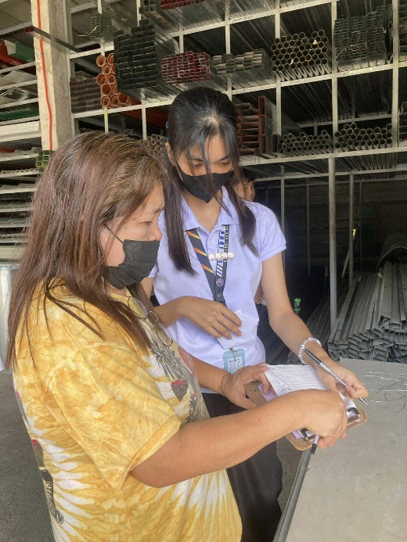


REFLECTION

Day 1, of our Immersion started with us introducing ourselves to our mentor, Cher Rosie. After that we walked around the area where we assigned so we could familiarize ourselves with the surrounding. Then we are given our designated tasks. There are four roles: office, store, checker and auditing. I was first assigned as a checker, so every truck, delivery that arrived, I inspected all items or supplies that were delivered or sent out. We based everything on the receipt to make sure the quantities matched what was written on the truck.
NOTED BY MENTOR________________

LEARNING JOURNAL
DAY 2 WEEK 1
DATE 11-18-25
Students shall input learnings (i.e. what has been learned, activities performed, problems encountered, and other comments) in this reference file every day.

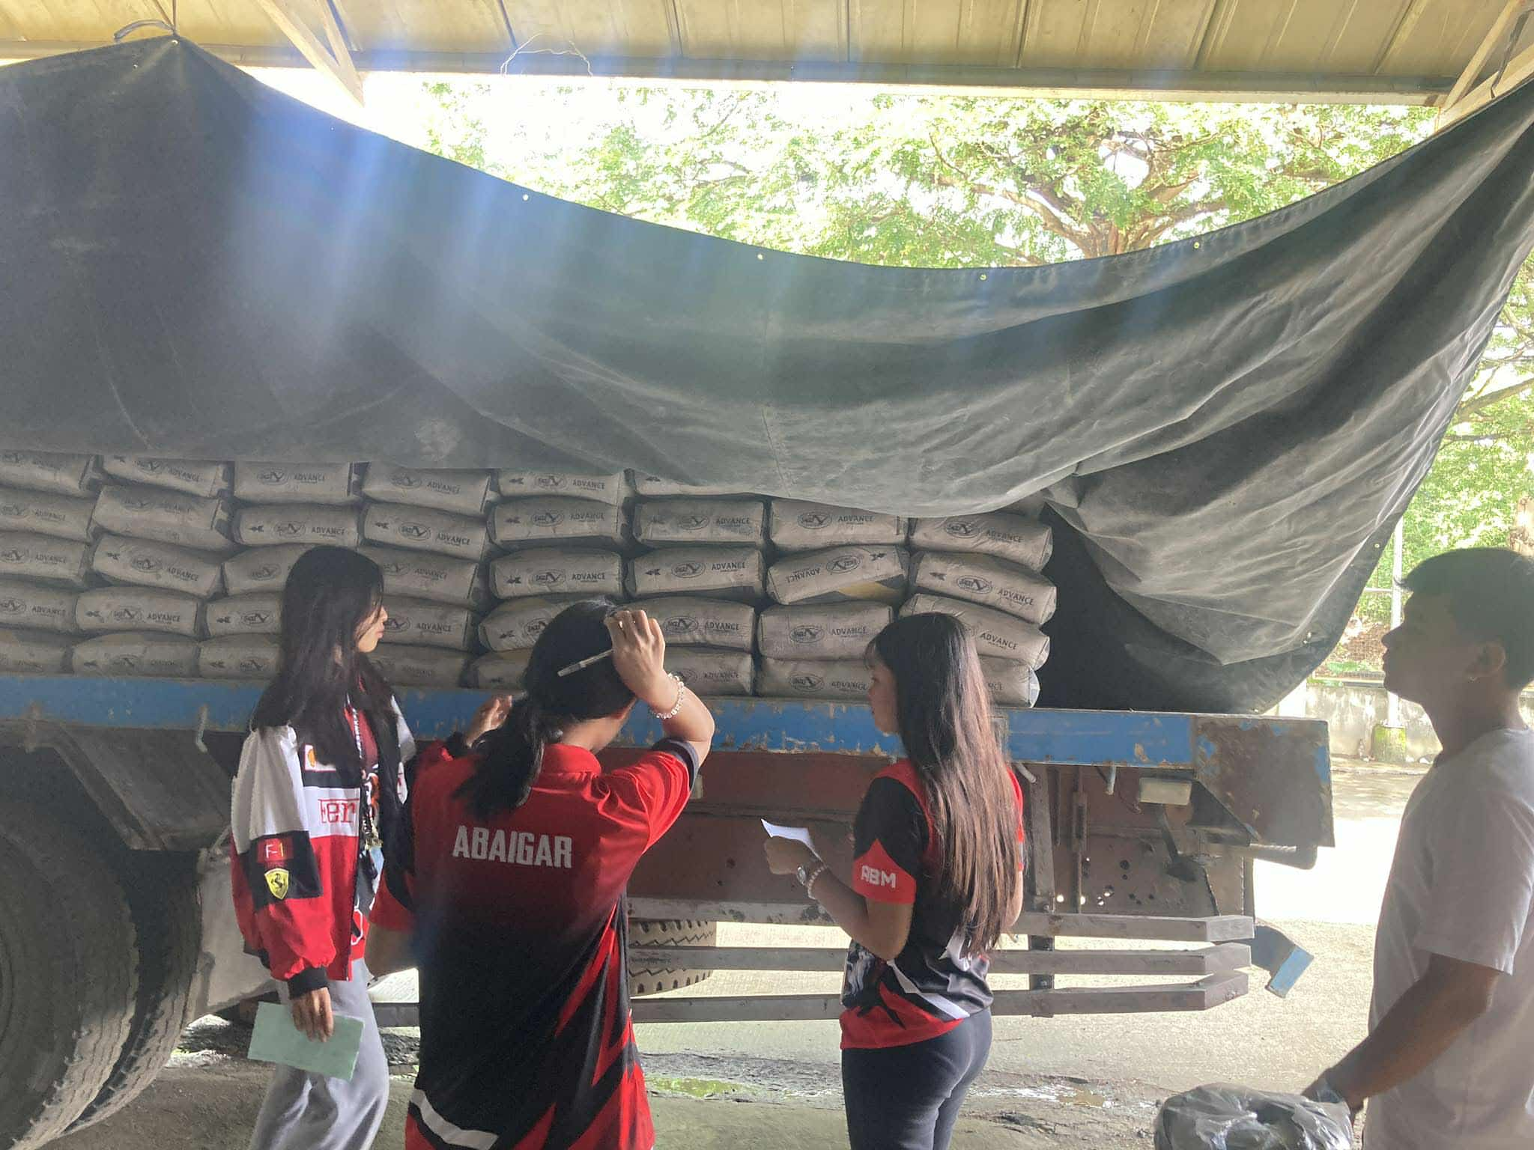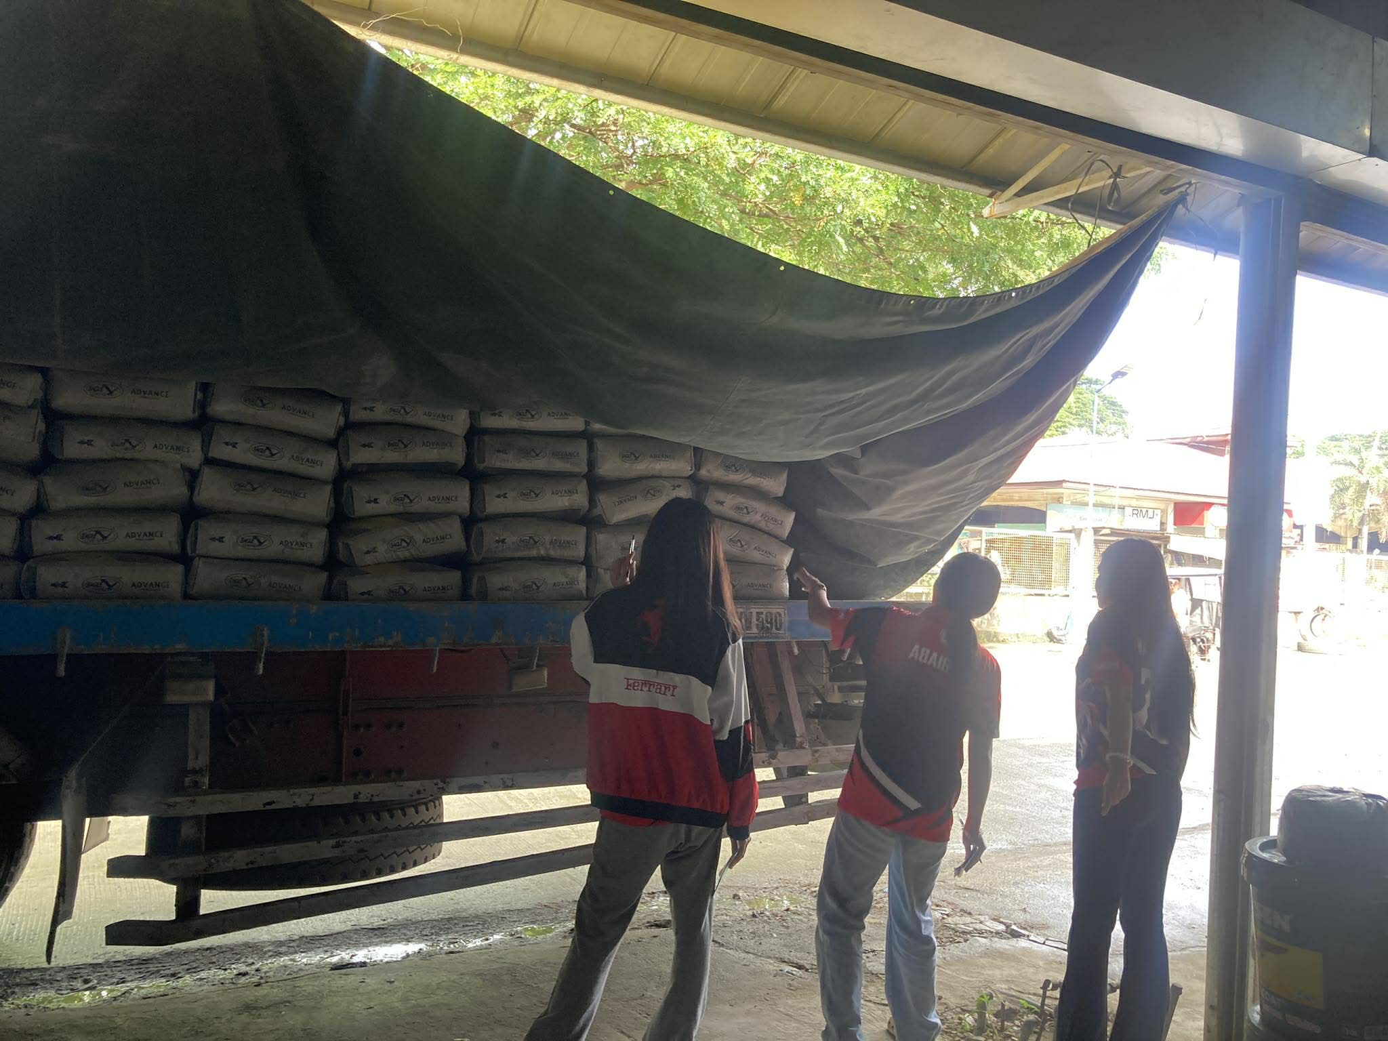
REFLECTION
Day 2, I started to learn all the tasks we were doing and even tho’ I was still assigned as a checker. Throughout the day, I slowly become more familiar with how the hardware operates, especially in handling materials like steal, cement, and other construction supplies. Being inside the hardware also though me of being discipline and alertness.
NOTED BY MENTOR_______________

LEARNING JOURNAL
DAY 3 WEEK 1
DATE 11-19-25
Students shall input learnings (i.e. what has been learned, activities performed, problems encountered, and other comments) in this reference file every day.

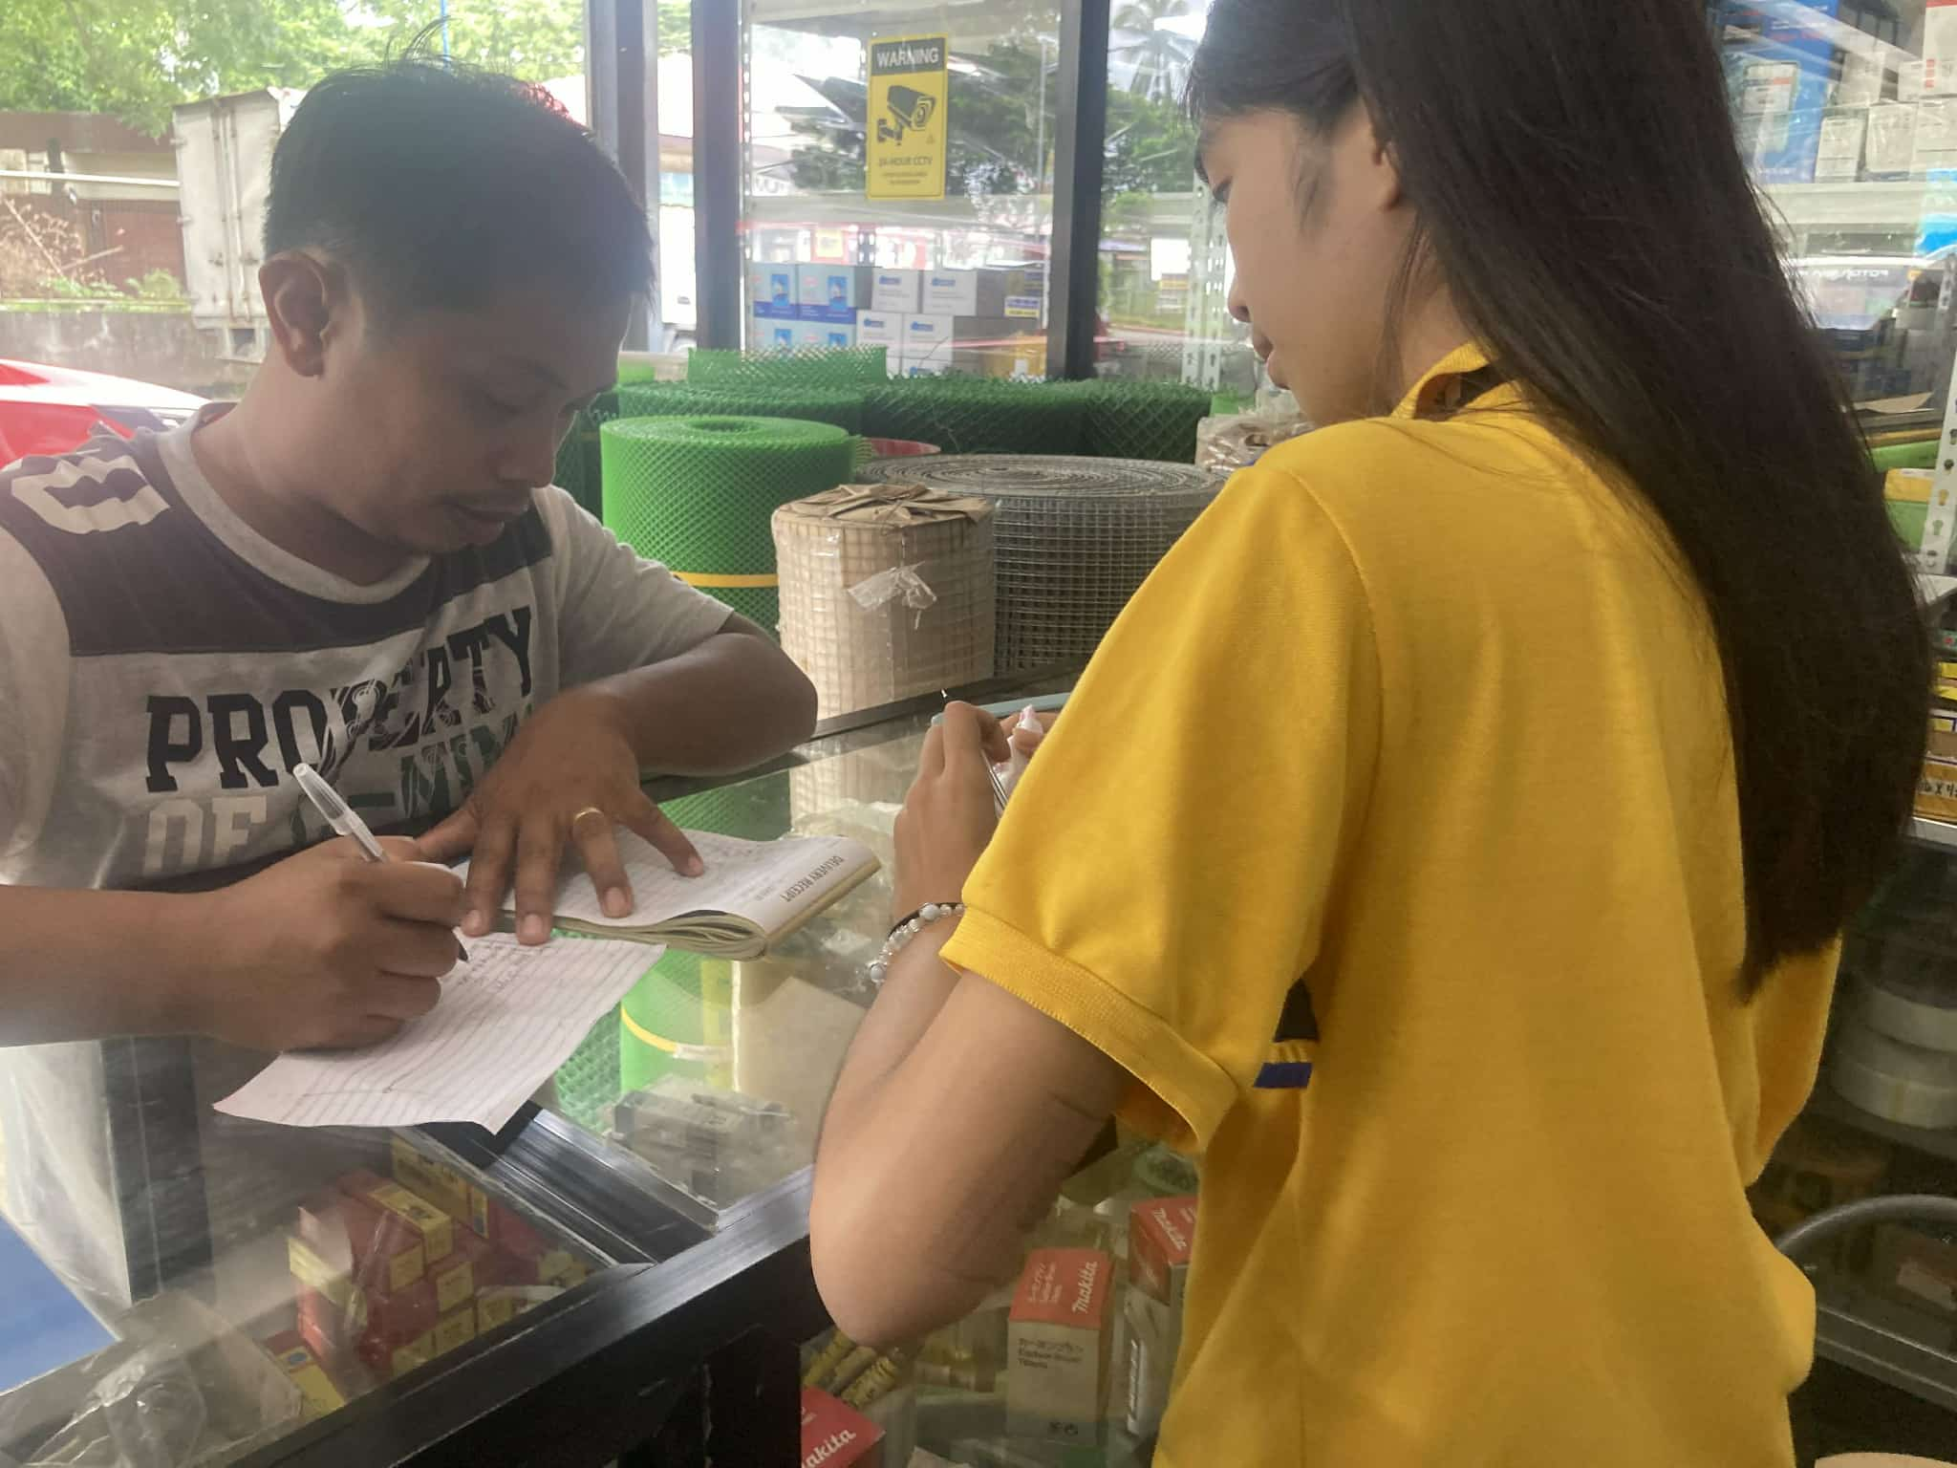
REFLECTION
Day 3, of our immersion, we changed work stations and I was assigned to the hardware. My task was to write receipts and record the orders or deliveries of the customers. It was actually fun writing down their orders, even if I had to make sure everything was correct. Little by little, I’m starting to learn more about the things inside the hardware and what they’re used for. The only struggle for me today was the dust, especially from the cement. That’s really my weakness because I easily get colds. But I know I can handle it as long as I’m careful with myself. But still, I’m learning, that matters.
NOTED BY MENTOR__________________

LEARNING JOURNAL
DAY 4 WEEK 1
DATE 11-20-25
Students shall input learnings (i.e. what has been learned, activities performed, problems encountered, and other comments) in this reference file every day.

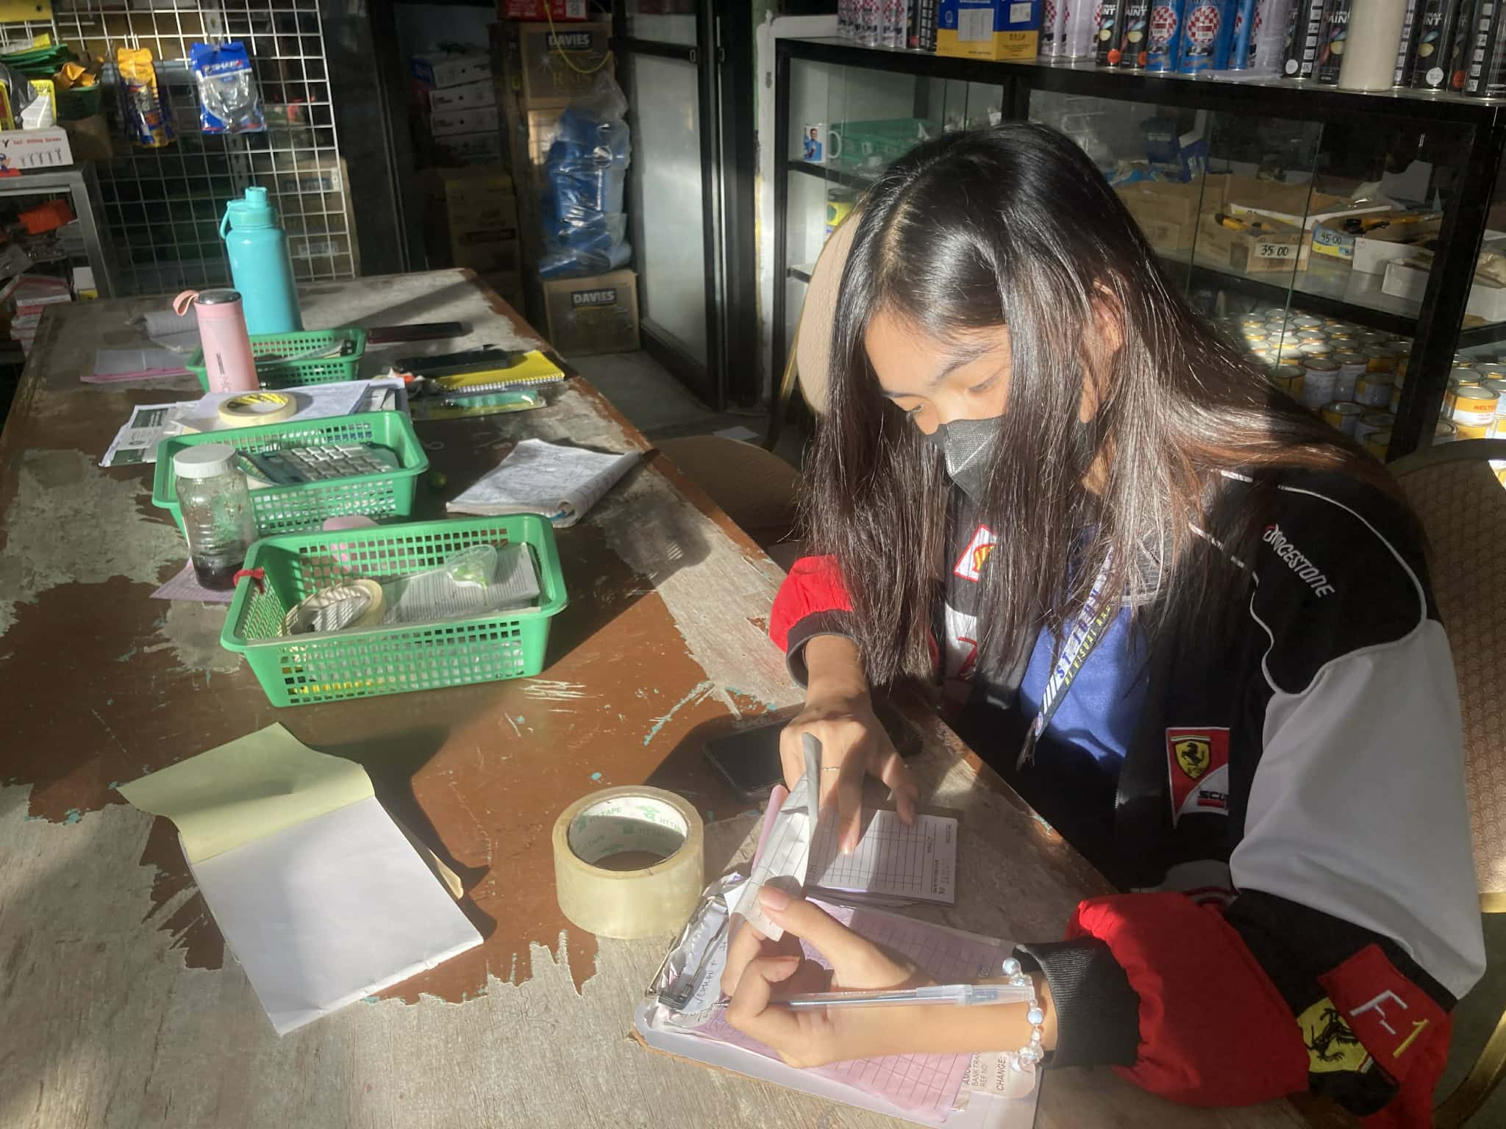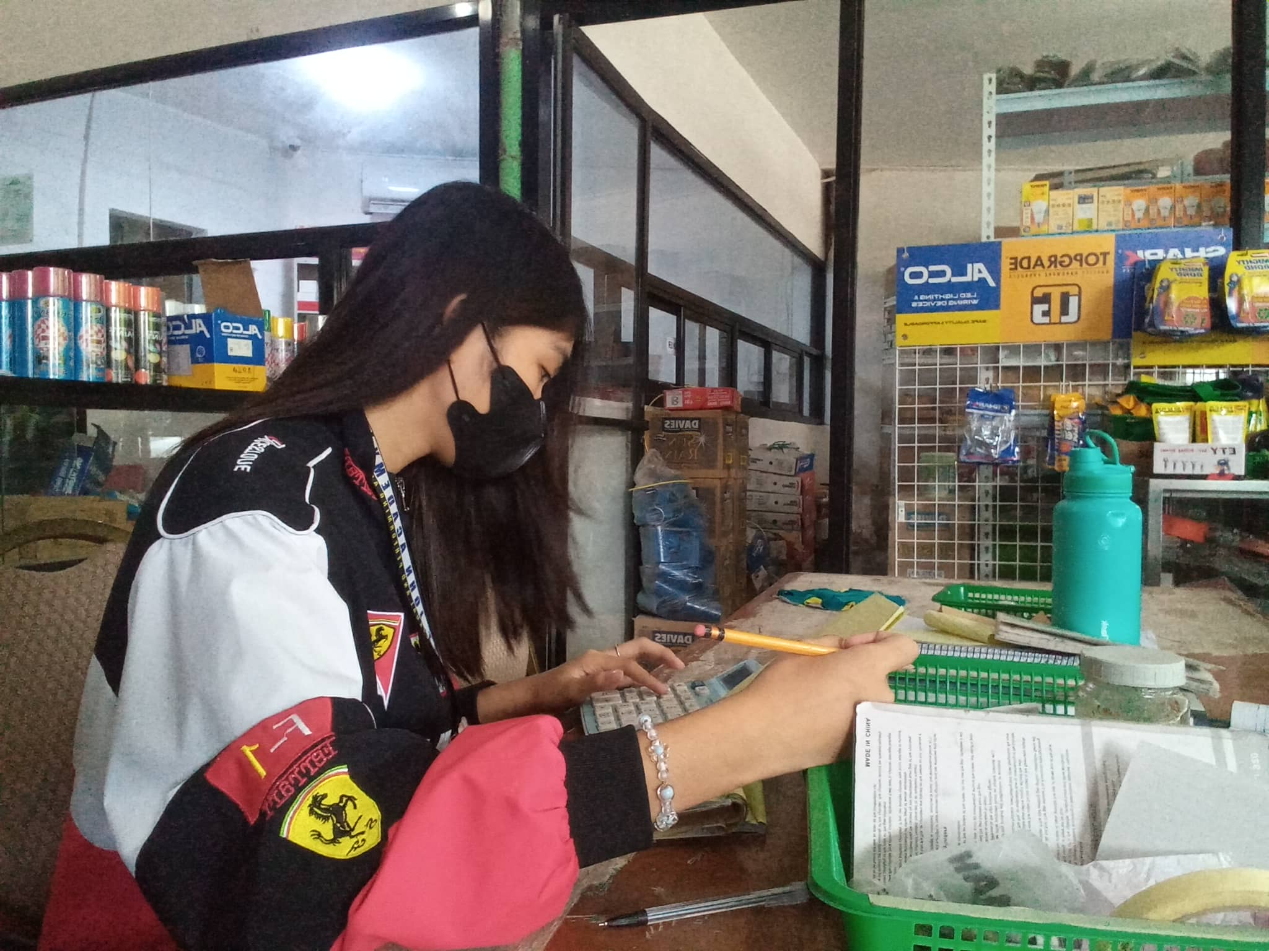
REFLECTION
Day 4, my situation was almost the same. I was still assigned to the hardware doing receipts and recording deliveries. But today felt a bit easier because I’m getting used to the tasks already. I understand the items faster now and I’m more confident when writing the receipts. It’s still dusty, but I tried to prepare myself better. I’m learning how to manage it while still doing my tasks properly. Even if the work seems simple, I realized it still requires focus and being organized.
NOTED BY MENTOR__________________

LEARNING JOURNAL
DAY 5 WEEK 1
DATE 11-21-25
Students shall input learnings (i.e. what has been learned, activities performed, problems encountered, and other comments) in this reference file every day.
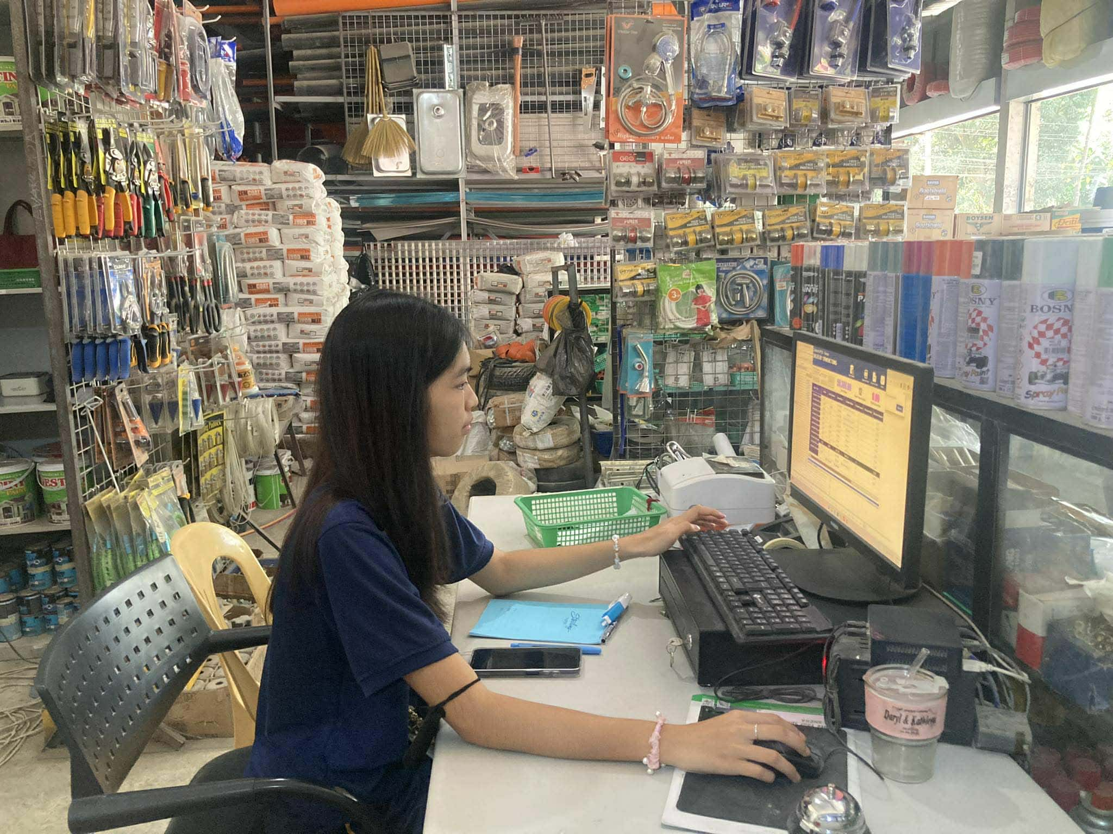
REFLECTION
Day 5, we switched stations again and this time I was assigned to record the transactions and orders of the customers using the computer. I actually enjoyed it because I really like typing and I’m kind of used to working with computers, so it felt natural and comfortable for me. It was fun, but I realized I also needed to be extra careful. I had to make sure the prices were correct and that each transaction was placed under the right category whether it was cash, credit, or any other type of payment.
NOTED BY MENTOR_________________

LEARNING JOURNAL
DAY 6 WEEK 2
DATE 11-25-25
Students shall input learnings (i.e. what has been learned, activities performed, problems encountered, and other comments) in this reference file every day.
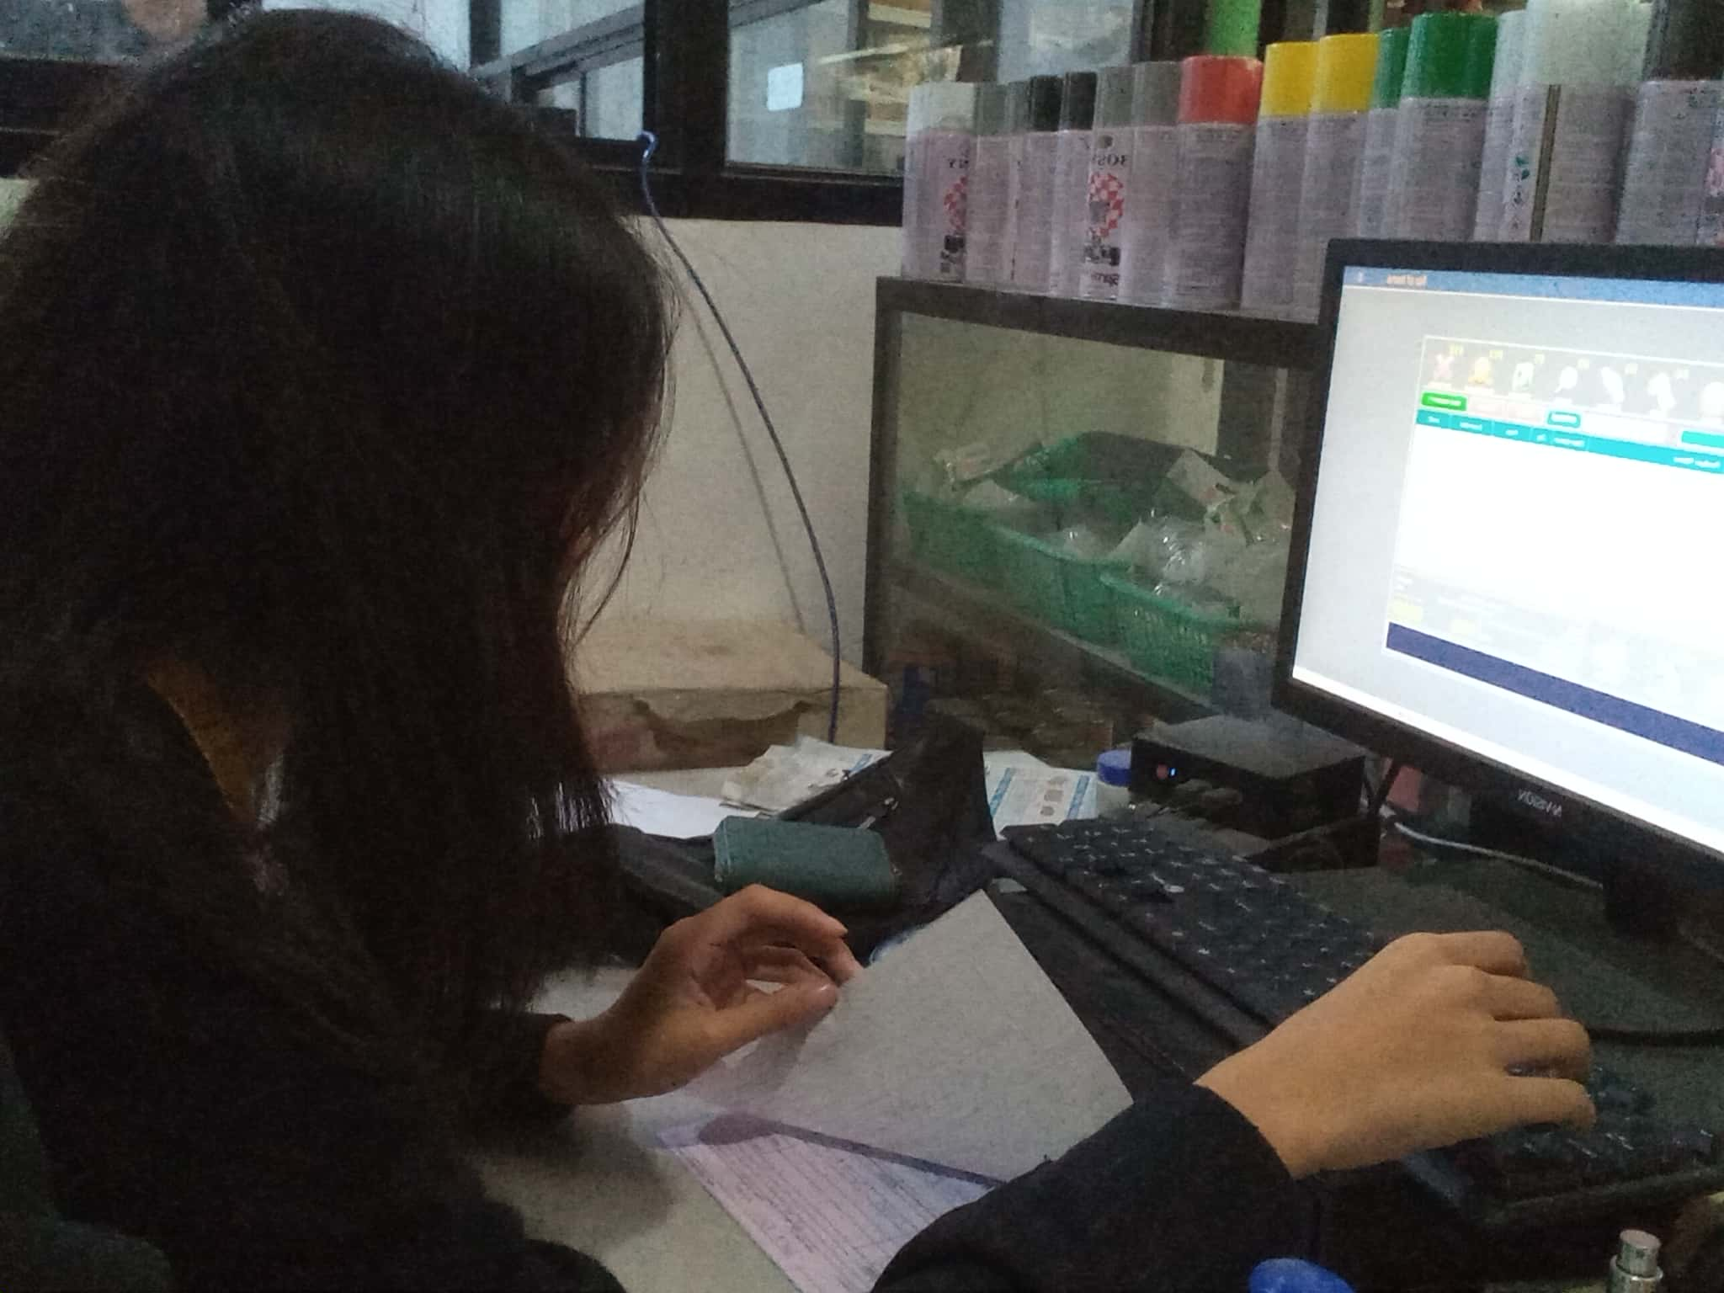
REFLECTION
Day 6, I continued working on the same tasks, recording customer transactions and typing their orders into the system or application. Since I’m already getting used to it, the work felt smoother compared to yesterday. I noticed that I’m becoming more confident when checking the details of each transaction. Even though I’m comfortable with computers, I still reminded myself to stay careful. Some customers order multiple items at once, so I really had to focus on the quantities, prices, and the payment method they used. I learned that even small mistakes can cause confusion later, so double-checking has become a habit for me.
NOTED BY MENTOR__________________

LEARNING JOURNAL
DAY 7 WEEK 2
DATE 11-26-25
Students shall input learnings (i.e. what has been learned, activities performed, problems encountered, and other comments) in this reference file every day.
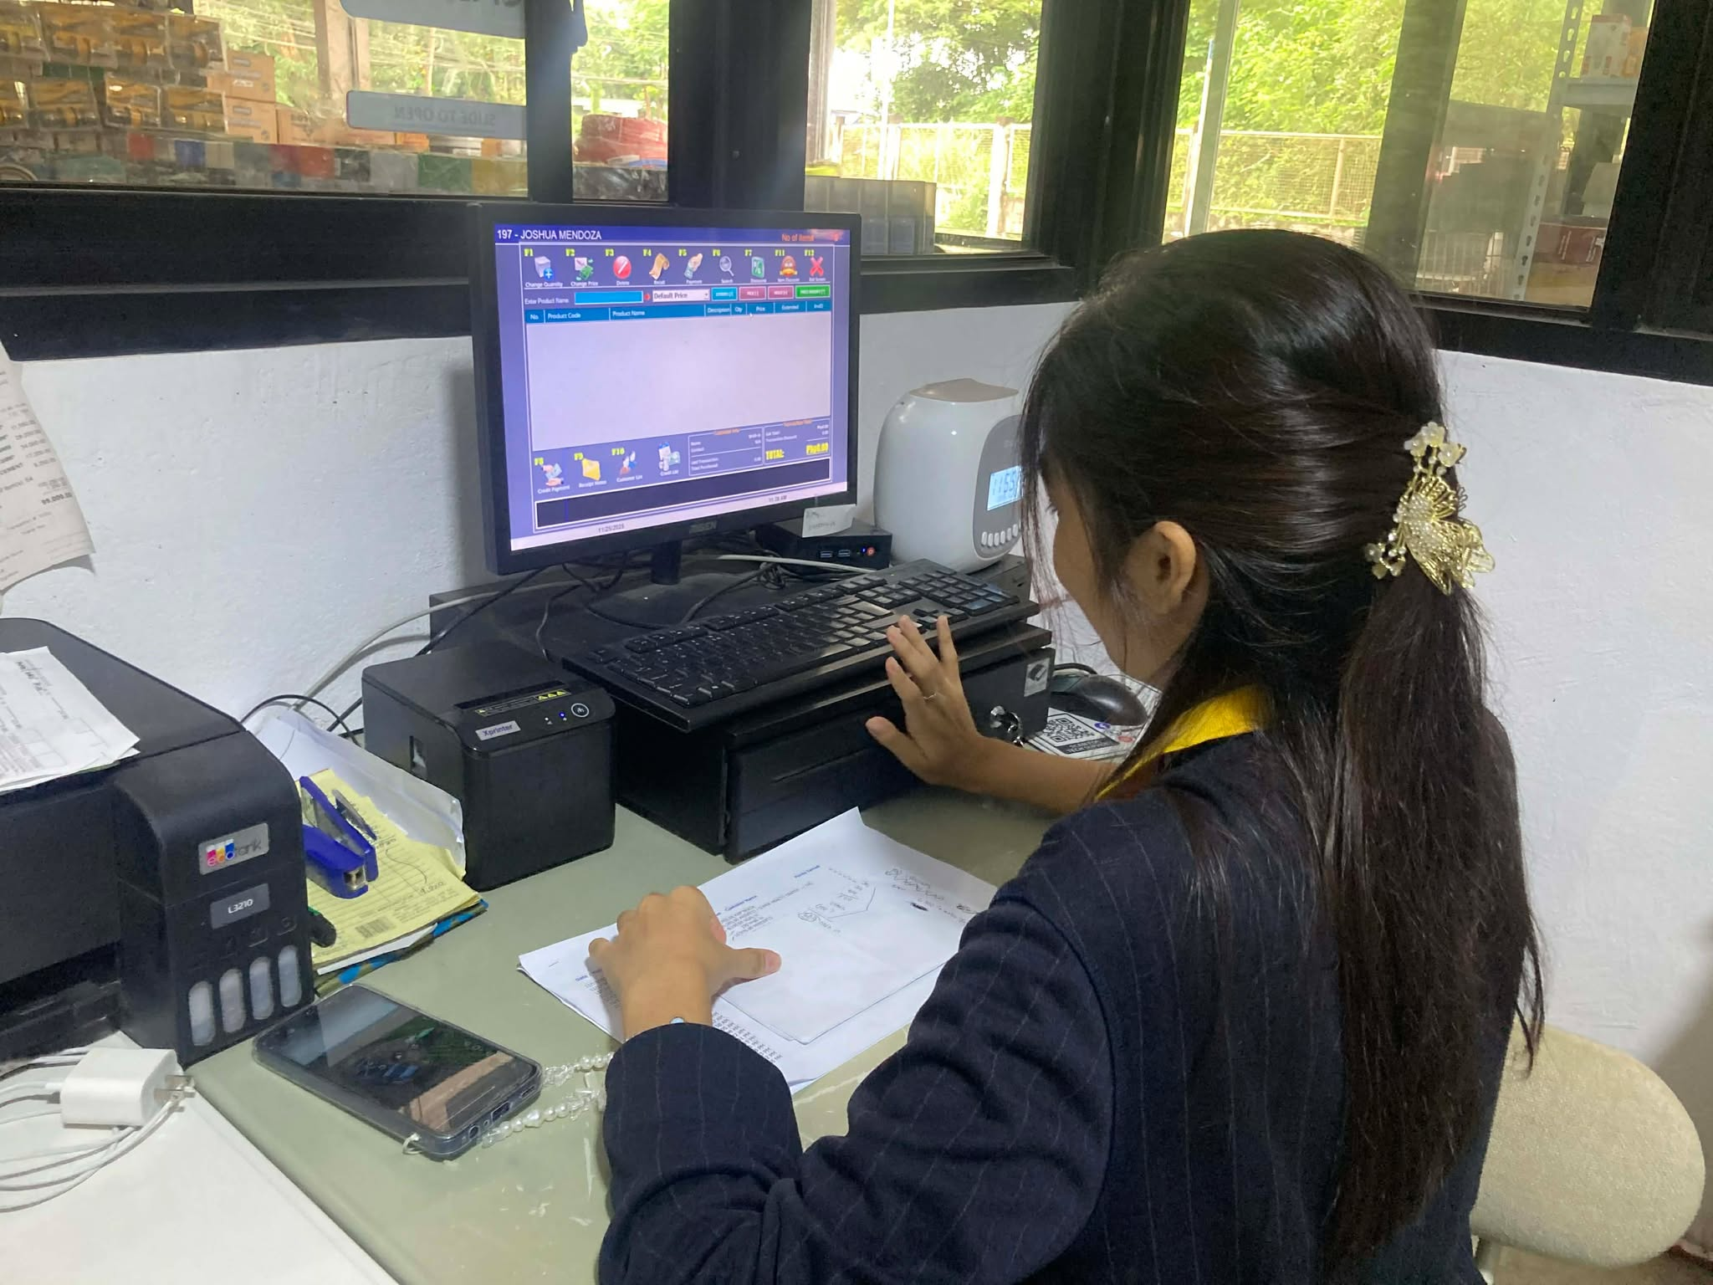
REFLECTION
Day 7, still the same tasks. typing and recording all the customer transactions. At this point, I’m already getting the rhythm of the work. I’m more comfortable with the system, and I don’t hesitate much anymore when entering prices or checking the payment method. Today felt a bit busier than usual, but somethings Kuya Josh, always volunteer to record the tasks, cuz im not that fast to record when there were moments where customers came in at the same time, so kuya josh na nag intindi hehehe.
NOTED BY MENTOR_________________

LEARNING JOURNAL
DAY 8 WEEK 2
DATE 11-27-25
Students shall input learnings (i.e. what has been learned, activities performed, problems encountered, and other comments) in this reference file every day.

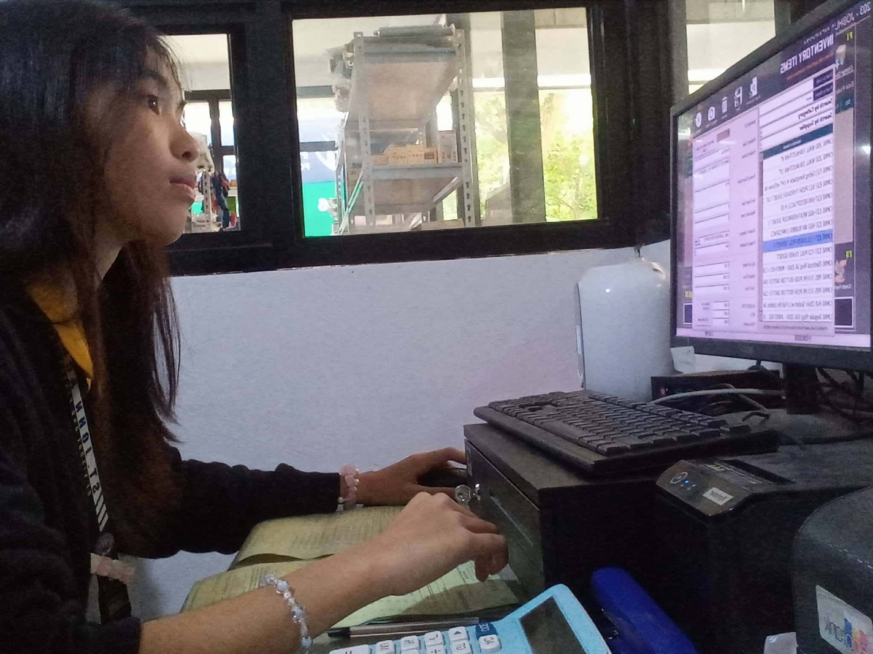
REFLECTION
Day 8, we switched positions again and I was assigned inside the office. My main tasks were updating and recording the transactions, and this time the payments from the customers were handed directly to me. It felt a bit heavier than my previous tasks because I had to be extra careful. Holding the actual money means it’s my responsibility to keep it safe and give the correct change. I realized how important accuracy is one wrong amount can affect the whole balance at the end of the day.
NOTED BY MENTOR___________________

LEARNING JOURNAL
DAY 9 WEEK 2
DATE 11-28-25
Students shall input learnings (i.e. what has been learned, activities performed, problems encountered, and other comments) in this reference file every day.
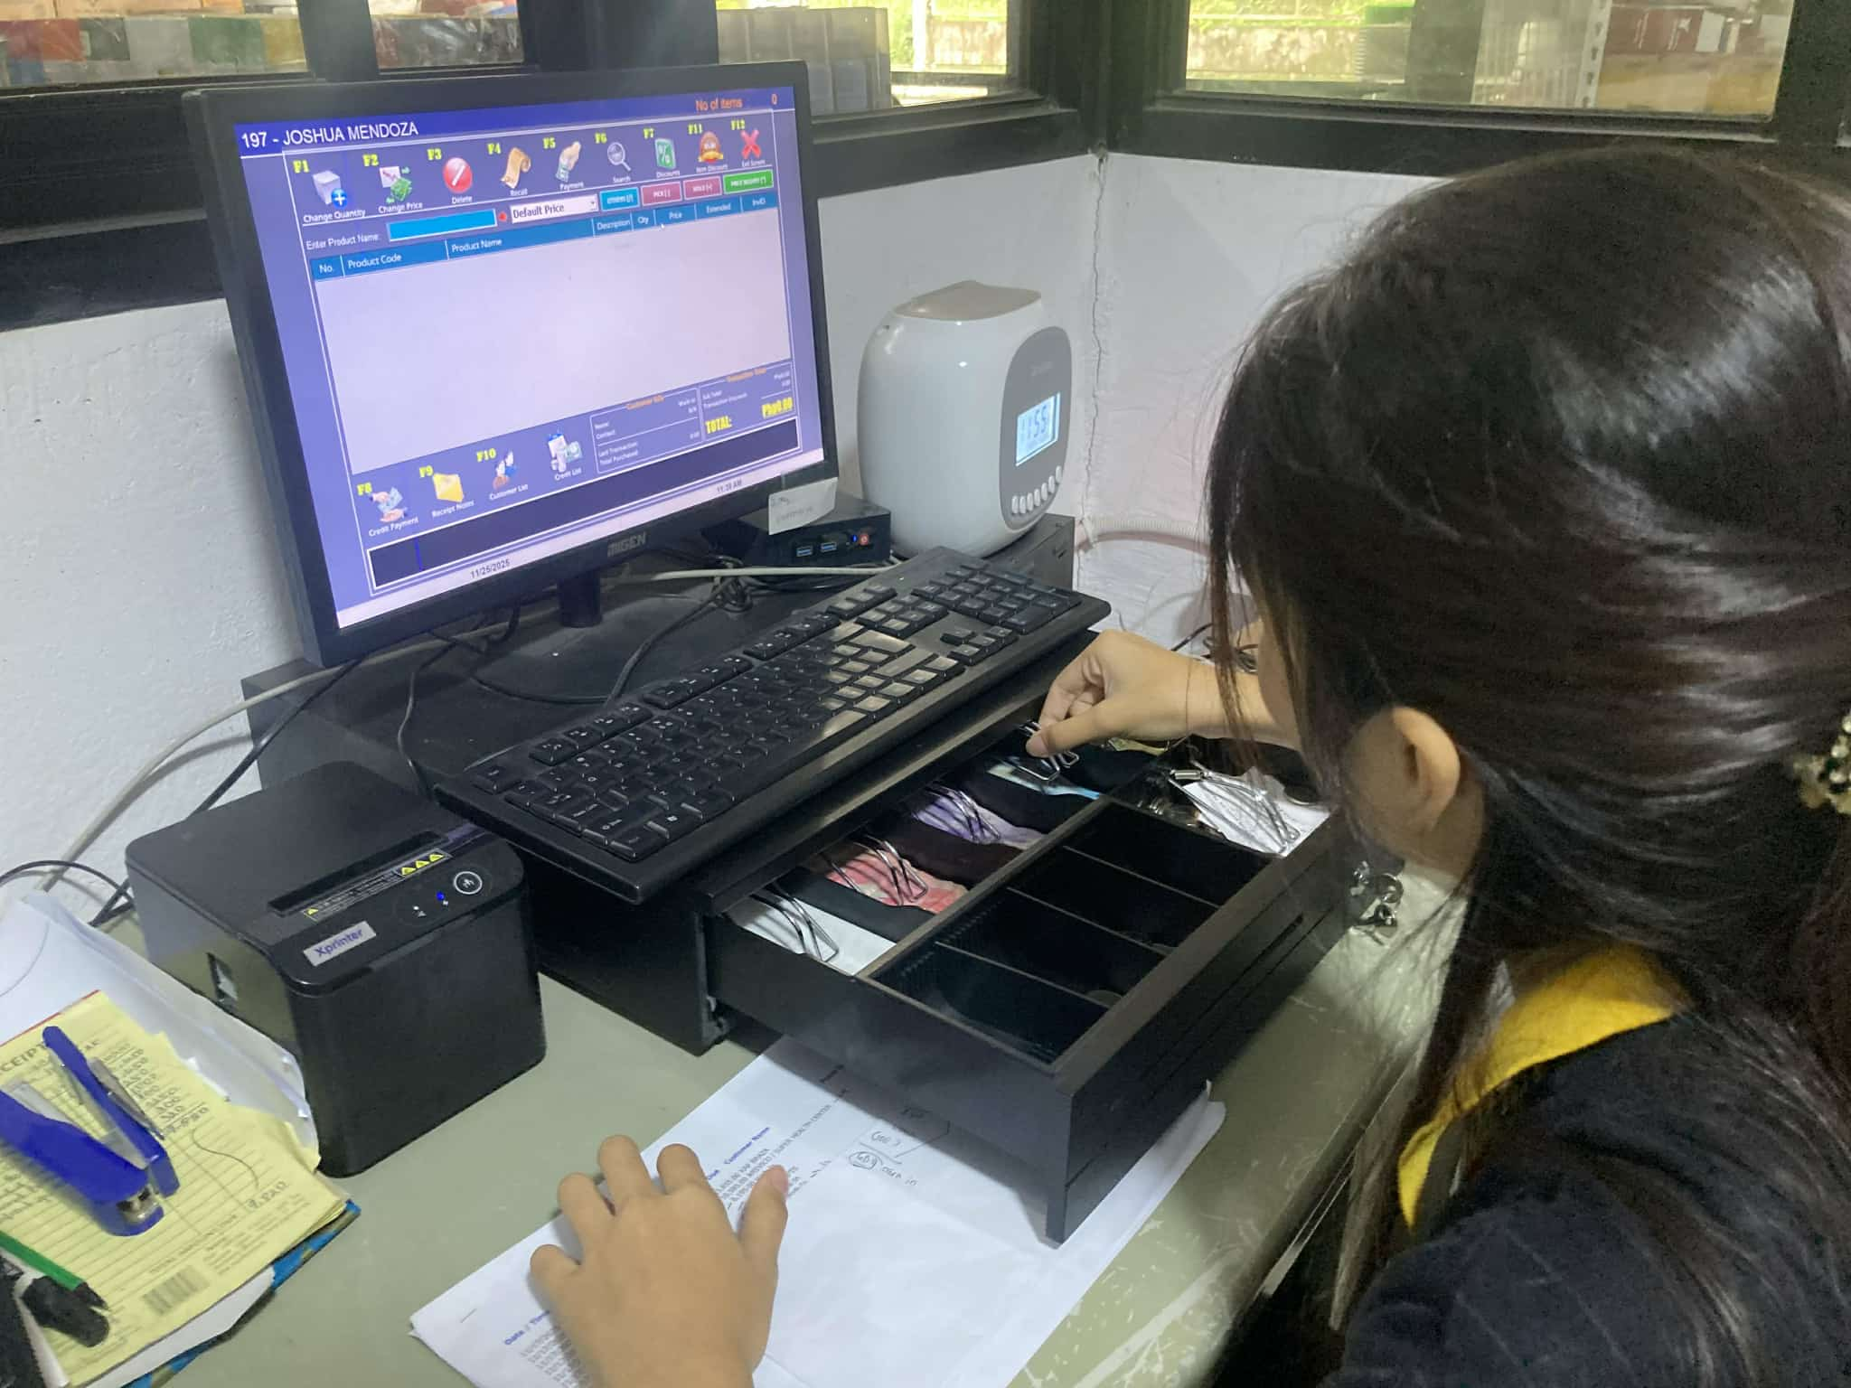
REFLECTION
Day 9, I continued my tasks in the office, still handling updates and recording the daily transactions. But today felt a little different because I was more confident in managing the payments. I already knew the flow, so I wasn’t as nervous as yesterday. There were more customers than usual, so I had to keep up with counting money, checking receipts, and updating the records. When we start balancing the money, there are times when the amount comes up short, so we have to figure out where the shortage came from. If we can’t find the error, it becomes our responsibility to cover it. But if the money is over just a small excess it’s fine, and we can record it under expenses.
NOTED BY MENTOR________________________________________

LEARNING JOURNAL
DAY 10 WEEK 2
DATE 11-29-25
Students shall input learnings (i.e. what has been learned, activities performed, problems encountered, and other comments) in this reference file every day.

REFLECTION

Officially Day 10, it’s our last day today, last day of our Immersion… ___________________________________________________________________________________________________________________________________________________________________________________________________________________________________________________________________________________________________________________________________________________________________________________________________________________________________________________________________________________________________________________________________________________________________________________________________________________________
NOTED BY MENTOR________________________________________

