**Fast Food Sales Analysis**

**Description**:  
This dataset captures sales transactions from a local restaurant in India. It includes details such as the order ID, date of the transaction, item names (representing various food and beverage items), item types (categorized as Fast-food or Beverages), item prices, quantities ordered, transaction amounts, transaction types (cash, online, or others), the gender of the staff member who received the order, and the time of the sale (Morning, Evening, Afternoon, Night, Midnight). The dataset offers a valuable snapshot of the restaurant’s daily operations and customer behavior.

**Columns**:

1. **order_id**: a unique identifier for each order.
2. **date**: date of the transaction.
3. **item_name**: name of the food.
4. **item_type**: category of item (Fastfood or Beverages).
5. **item_price**: price of the item for 1 quantity.
6. **Quantity**: how much quantity the customer orders.
7. **transaction_amount**: the total amount paid by customers.
8. **transaction_type**: payment method (cash, online, others).
9. **received_by**: gender of the person handling the transaction.
10. **time_of_sale**: different times of the day (Morning, Evening, Afternoon, Night, Midnight).

**Potential Uses**:

* Analyzing sales trends over time.
* Understanding customer preferences for different items.
* Evaluating the impact of payment methods on revenue.
* Investigating the performance of staff members based on gender.
* Exploring the popularity of items at different times of the day.

The raw data as gotten from Kaggle used for this analysis can be found in the link below. <https://github.com/JennyOtomi/Data-Analysis-Portfolio/blob/main/Excel/RestaurantAnalysis/Balaji%20Fast%20Food%20Sales.csv>

**Steps 1 — Clean and format file**

The date column for some records had an invalid format (“MM/dd/yyyy”), I formatted the records with the wrong date format to the right date format. I also multiplied the item price and quantity to get the sales amount in the transaction amount column.

**Step 2 — Creating My Pivots and Charts**

I created different pivots for this analysis starting with the sales by month and years as shown below. This implies there was a huge decline in sales in the year 2023. There are always high sales in the month of may too.

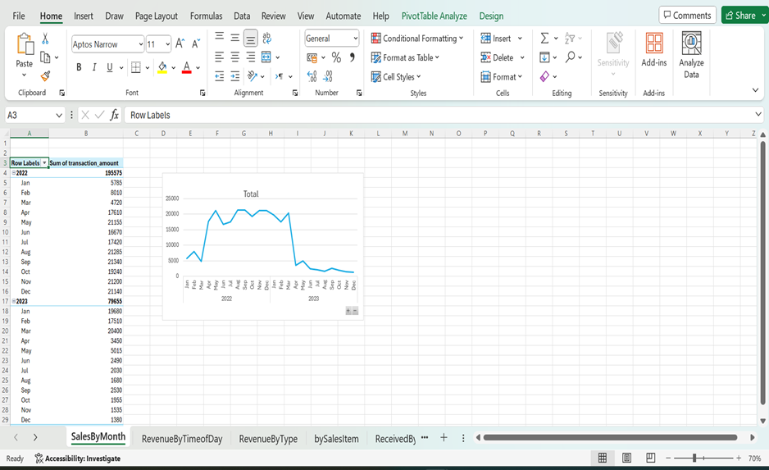Sales made for different months and years

I created a Pivot for sales by the time of the day that orders were made by customer. We have the following time of day where orders can be placed Morning, Afternoon, Evening, Midnight and Night. Below is the pivot and chart. This chart shows that more sales were made at night, followed by afternoon.

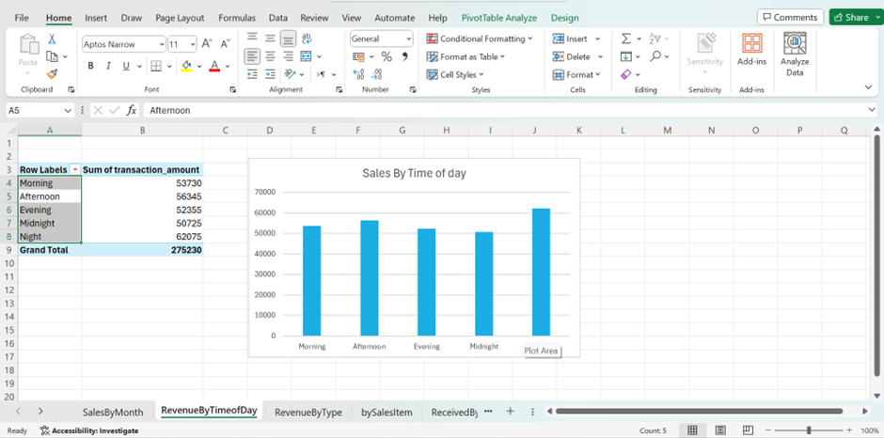Sales By Time of day orders were made

There are two major categories of food sold at Balaji restaurant, they are Beverages and Fast food. To see the percentage sales made for each category for the two years under review, I created a chart for this as shown below. We can see that sales for beverage reduced in the year 2023 while there was an increase in the sales of fast food. This tells us that a few people made a change to their taste from beverage to fast food.

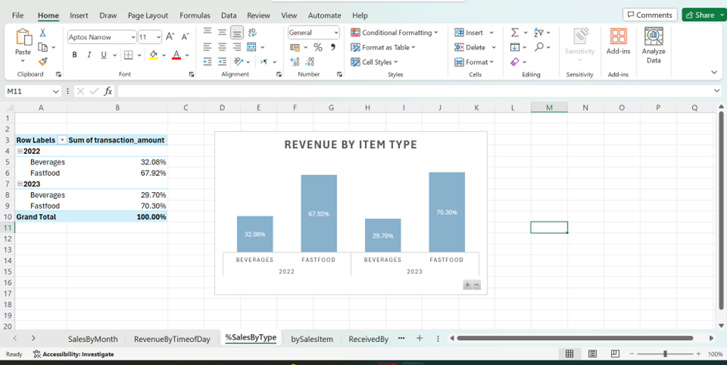chart showing sales made by food categories

There are different types of items under the two major categories of food sold at the restaurant which are Vadapav, Aalopuri, Panipuri, Sugarcane juice, Cold coffee, Frankie, Sandwich. To find out the sales made for each item, please see below pie chart. The sandwich is the most sold food item followed by the frankie while vadapav was the least sold item.

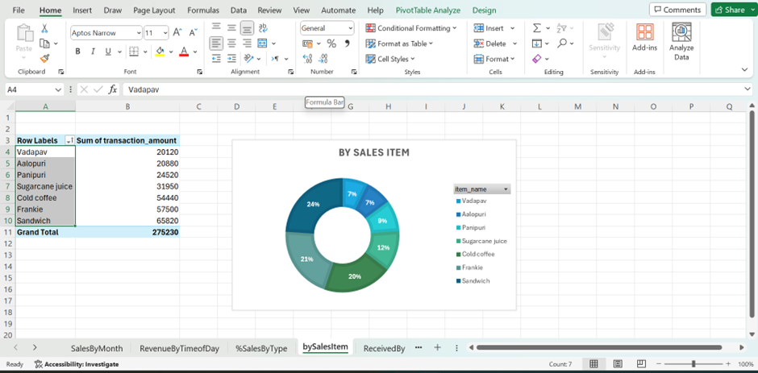pie chart showing the various food items sold at Balaji restaurant

To get the gender that received orders. the chart below was created. From the chart below, the male staff received more orders than their female counterpart in both years. In 2022, the male staff received 196 orders more than the female while there was 178 more orders received by male than the female in 2023.

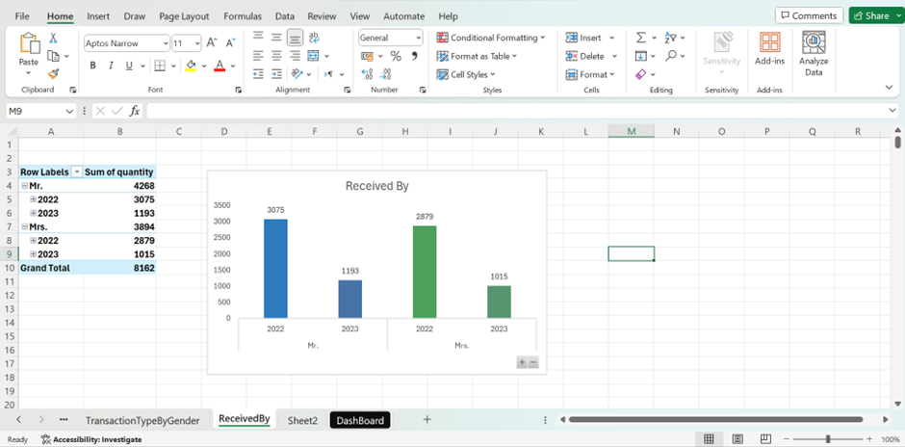

This chart was created for the payment channels and the summation of the sales. From the chart below, people made more cash payments, followed by online.

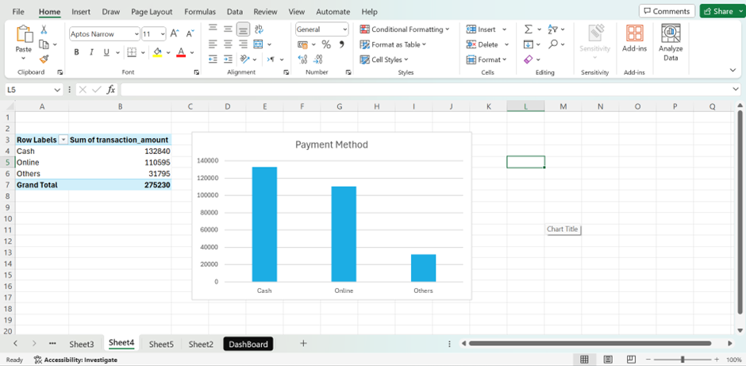pivot chart showing the payment methods

The last chart is to show the popularity of item by time of day. Cold coffee is the most ordered item at night, morning and afternoon. Sugarcane juice is the most popular item ordered in the evenings while panipuri is the most popular item ordered at midnight.

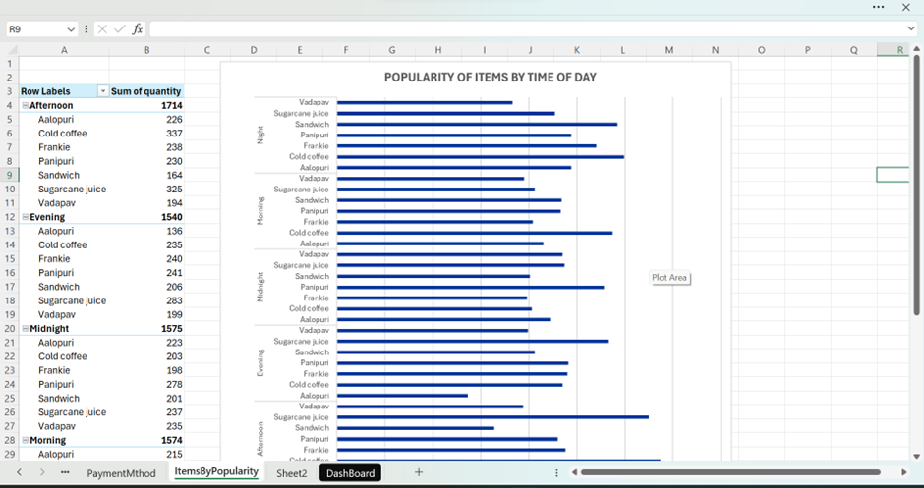

**CONCLUSION**

The restaurant had a total of 8,162 order quantity with total sales amount of 275,230. There was a huge decline in sales in the year 2023, the restaurant had more sales in 2022 than in 2023. Customers preferred sandwich to any other food. Customers made more cash payment than any other method (online and others). The male staff had more orders than the female staff.

Below is the whole dashboard put together.