The killer is 67318.The murderer was Jeremy Bower.

1. Ran a query from crime scene table to get the witnesses.

select * from crime_scene_report

where type = 'murder'

and date = '20180115'

and city = 'SQL City'

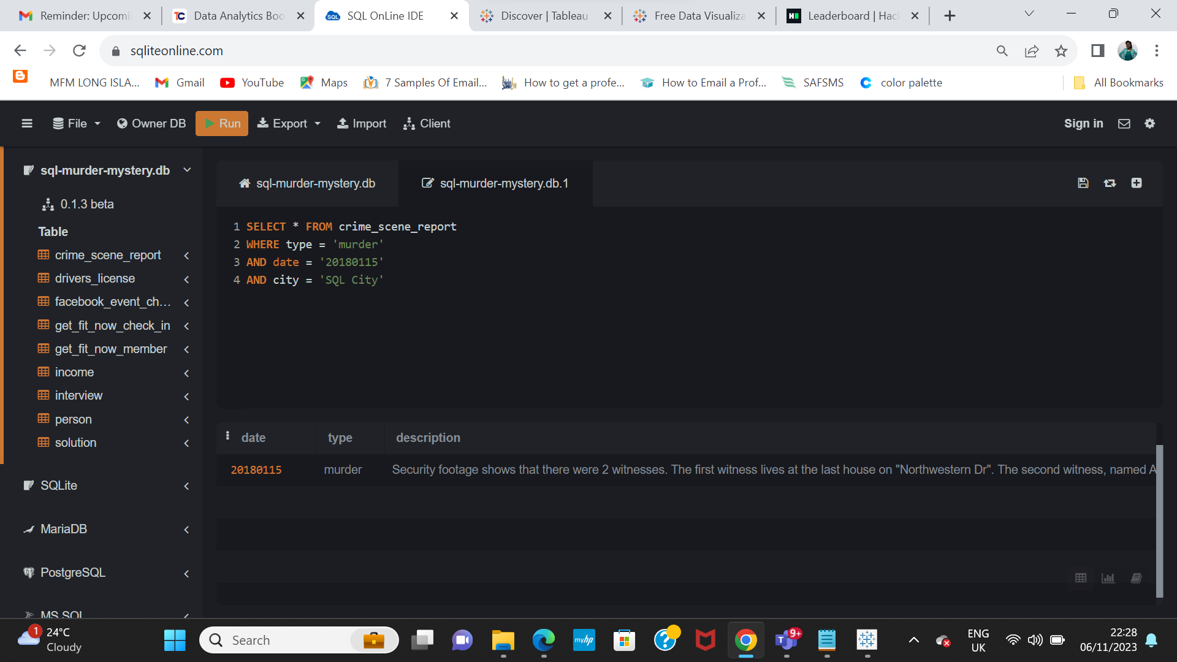

2. Ran the query below to retrieve the details of the witnesses described in the result of the query in no. 1 above

select * from person where

address_number = (select max(address_number)

from person where address_street_name like '%NorthWestern%') or

(name like '%Annabel%' and address_street_name like '%Franklin%')

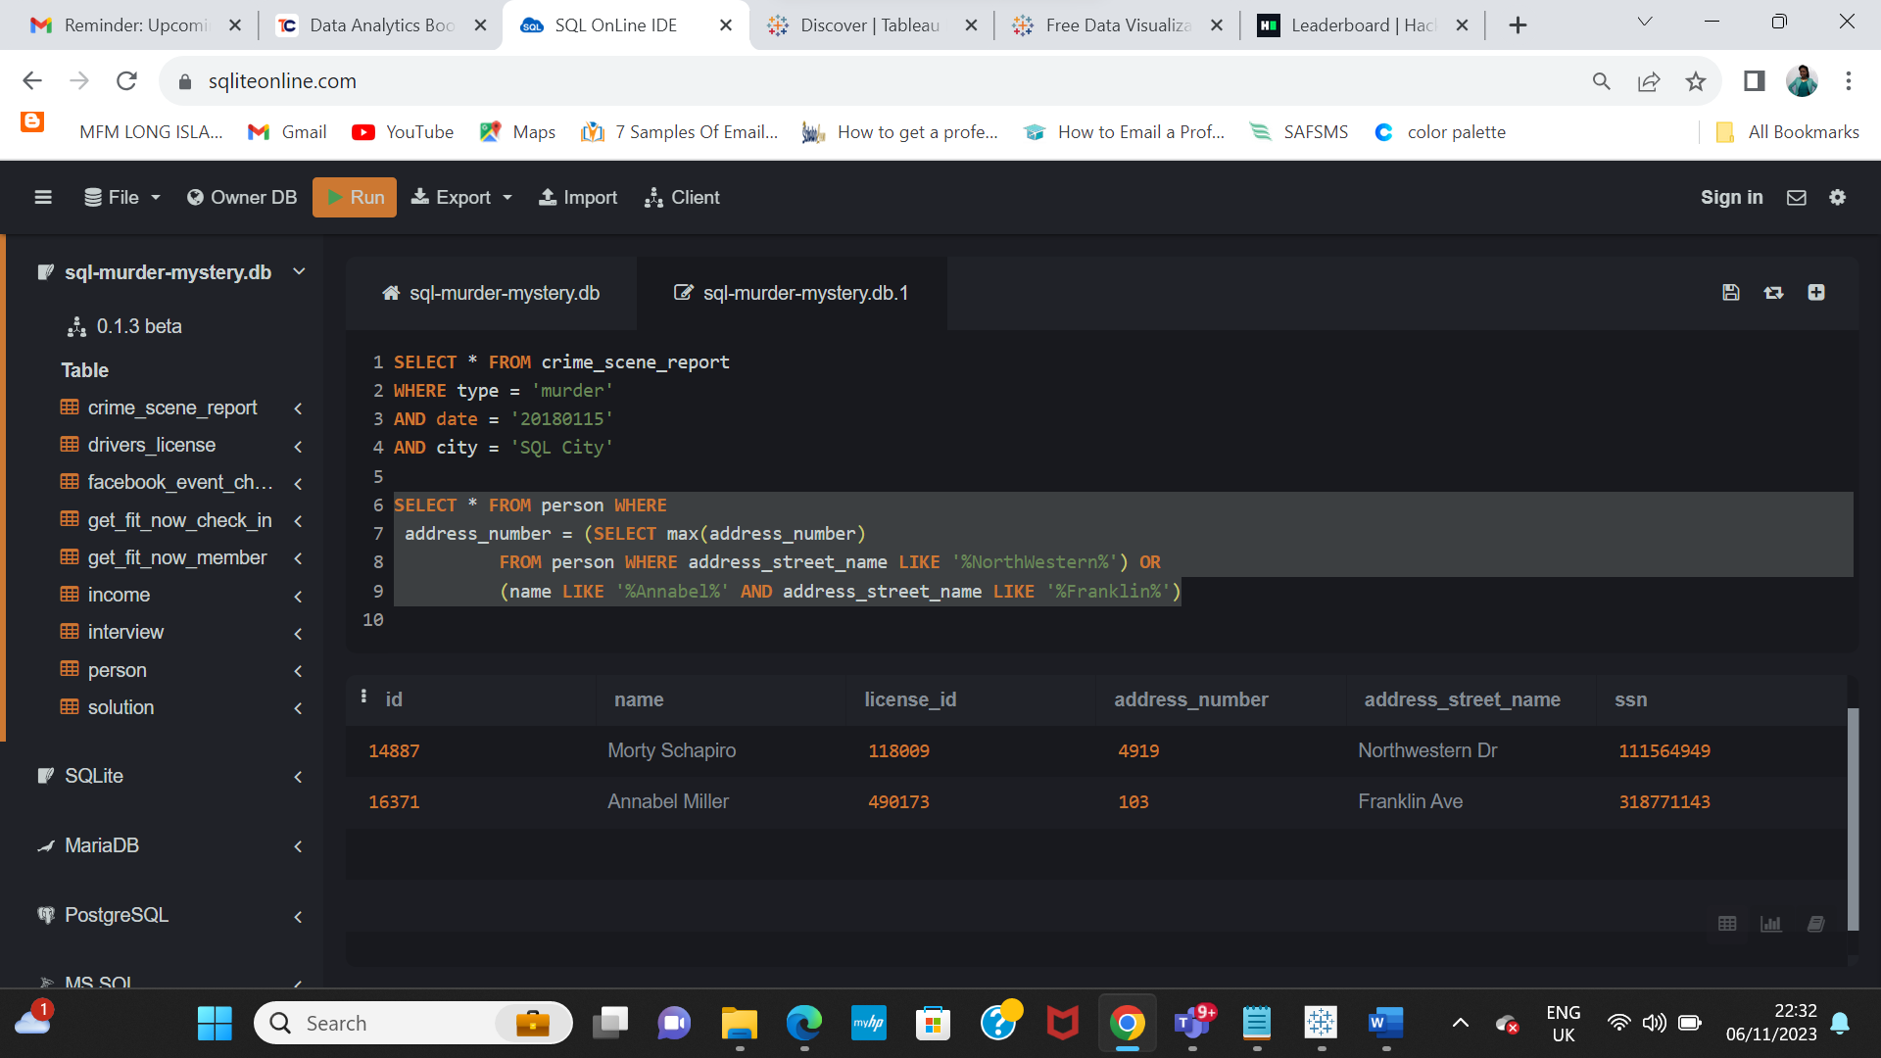

3. I ran the query below to get the interview details of the witnesses using the id retrieved from the query in no. 2 above

**select * from interview**

**where person_id in (14887, 16371)**

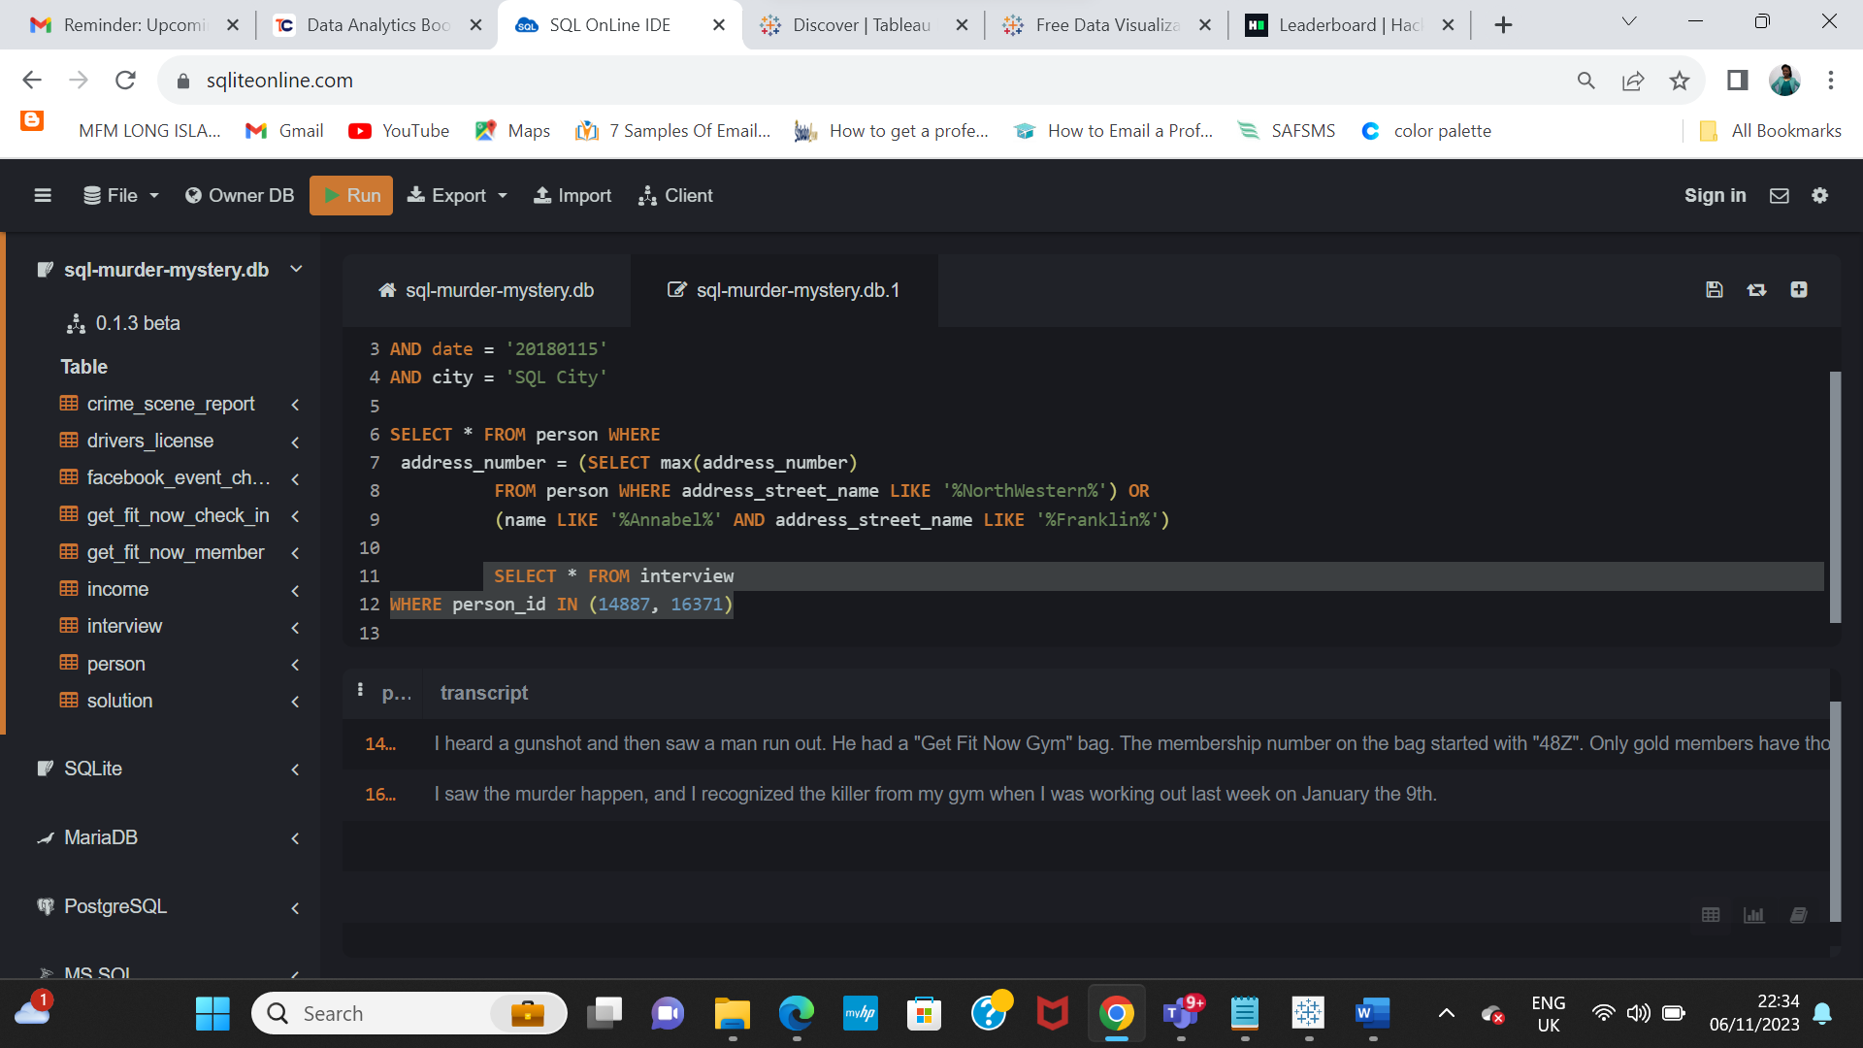

4. Using the details from the interview granted by the witnesses, I ran the query below to get the persons that match the decription given by the witnesses.

**select * from get_fit_now_check_in where**

**membership_id in (select id from get_fit_now_member where membership_status = 'gold' and id like '%48Z%')**

I got two people that matched the description that was given as shown in the screenshot below, so I went further to check the driver's license table for the car that has the description given by the first witness and I got 2 males and 1 female.

**select * from drivers_license**

**where plate_number like '%H42W%'**

The witnesses said a man committed the murder so that ruled out the female from the result above, leaving us with 2 males.

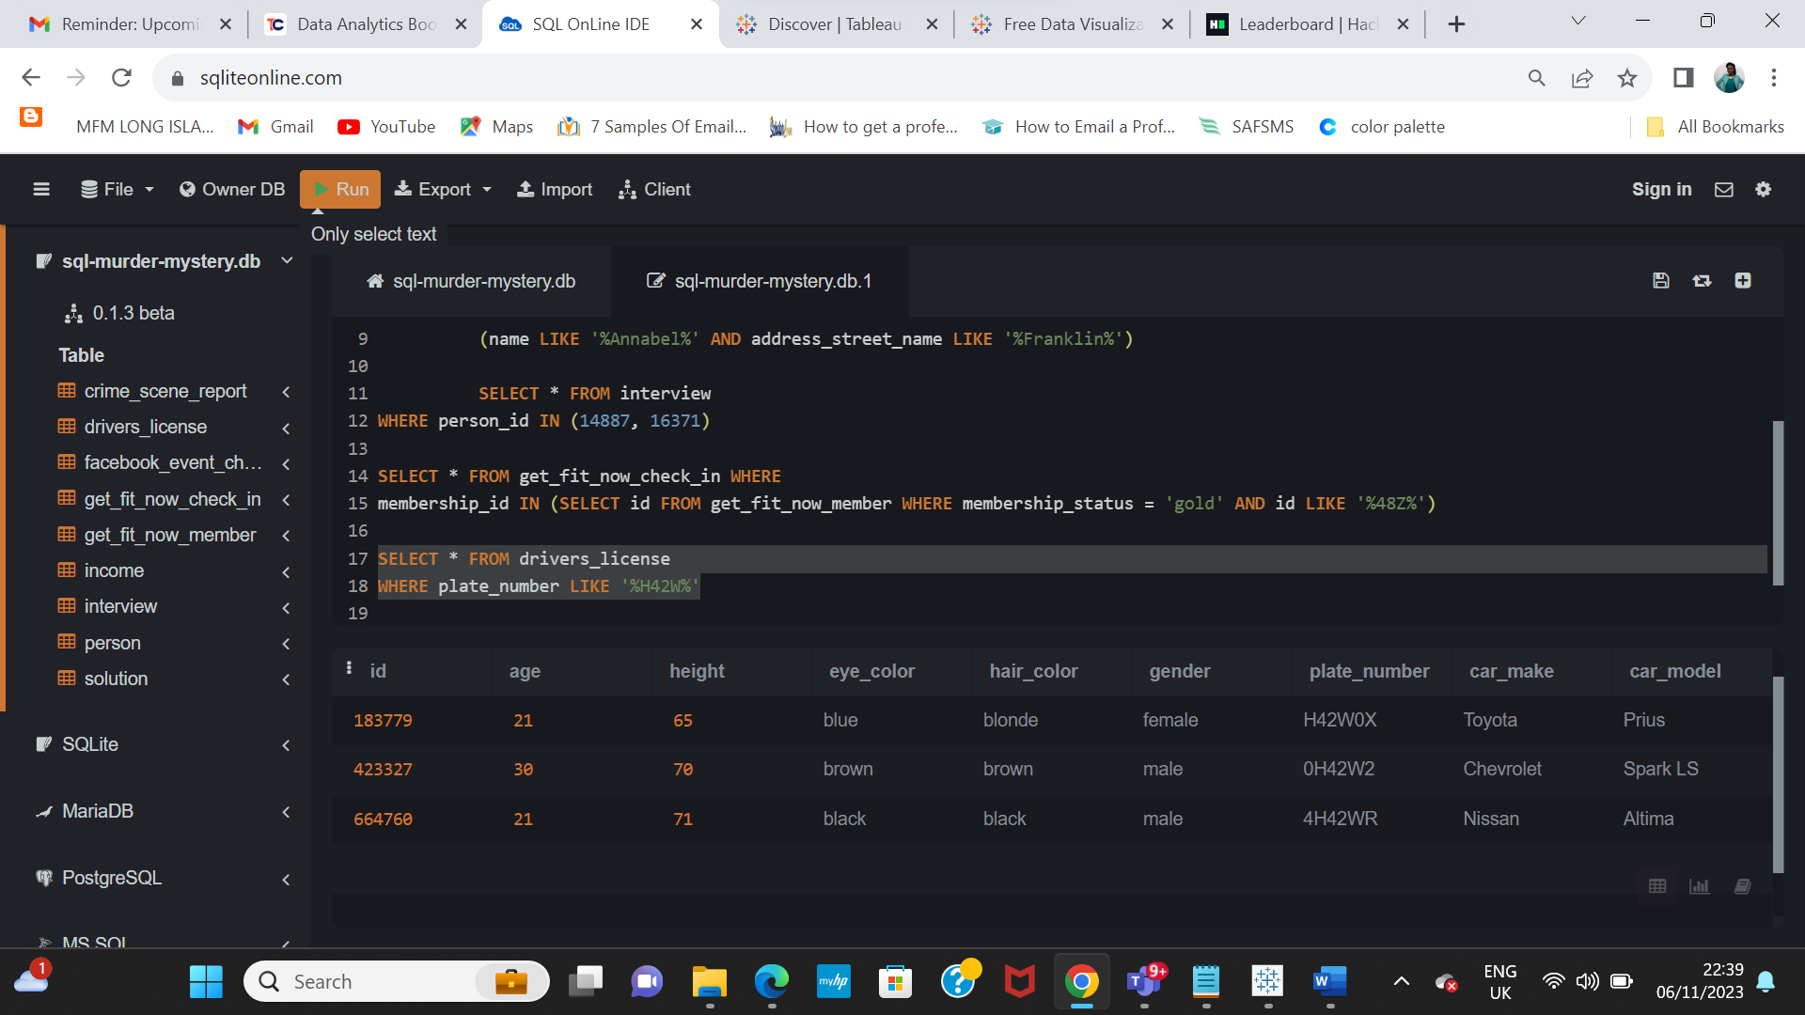

**5.** I still went further to run this query to confirm the real murderer based on the witnesses' statement

**select person.name, person.license_id,**

**drivers_license.id, drivers_license.plate_number,**

**person.id, t.id as membership_id, t.membership_status, t.name**

**from person**

**inner join drivers_license on person.license_id = drivers_license.id**

**inner join get_fit_now_member t on person.id = t.person_id**

**where (drivers_license.plate_number like '%H42W%')**

**and person.id in (select person_id from get_fit_now_member**

**where membership_status = 'gold' and id like '%48Z%')**

**and (t.membership_status = 'gold' and t.id like '%48Z%')**

and I got only one person which was "Jeremy Bowers, with driver's license - 423327, person id - 67318

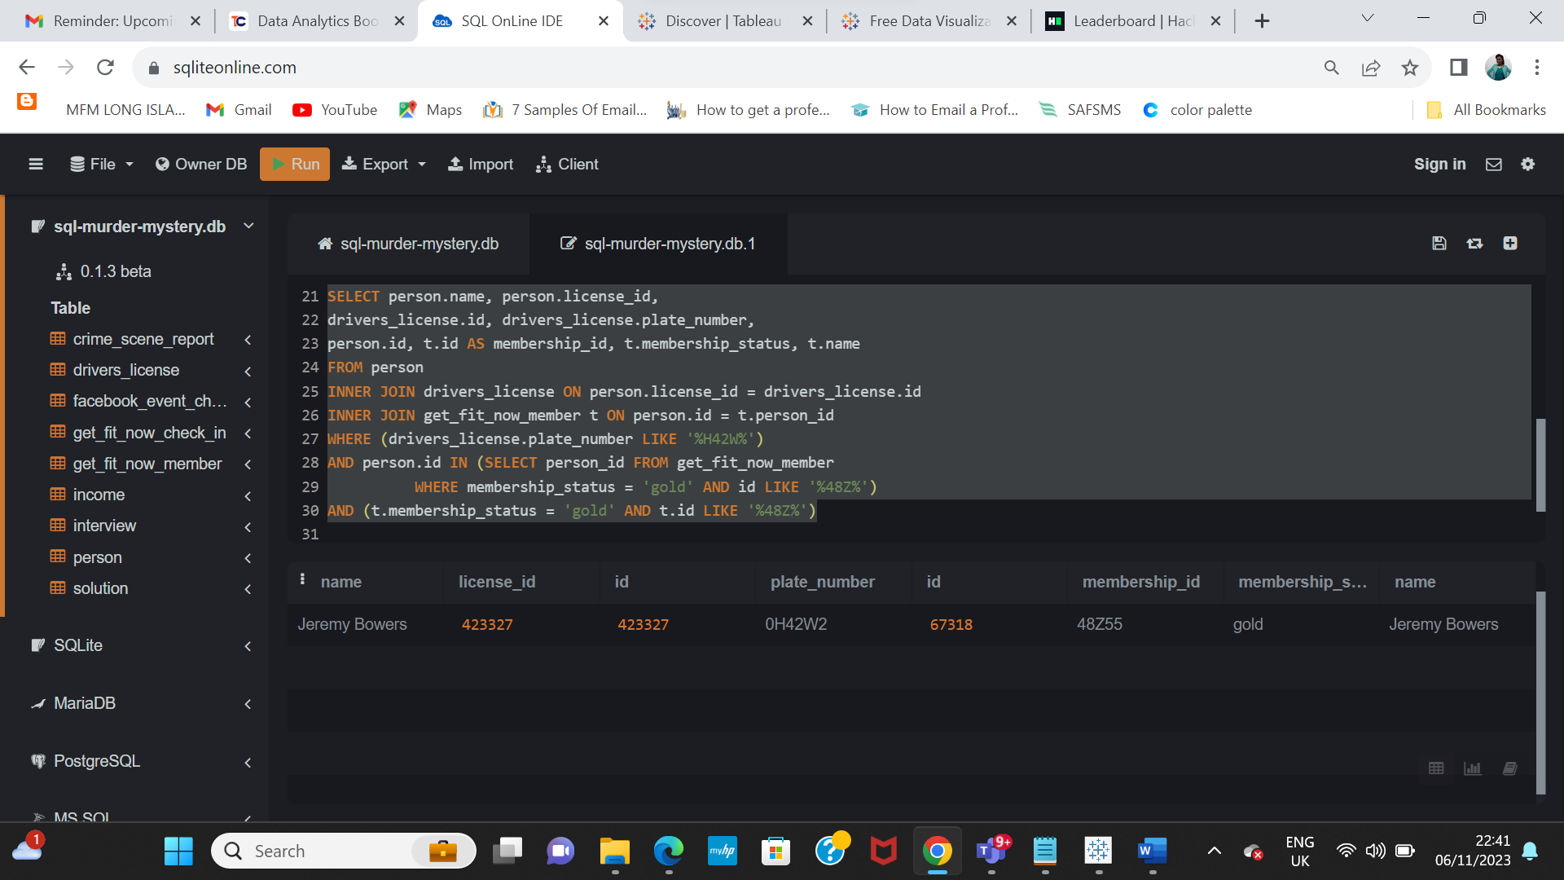

However, on the day of the murder there was a facebook event which he attended. I found that out by running the query below

**select * from facebook_event_checkin where person_id = 67318**

