5/20/2025
Julio Velasco and Rishabh Choudhary
India Subnational PFR Data Visualization Tool: User’s Manual
Contents
Table of figures 2
Introduction 3
Using the tool 3
Getting and opening the tool 3
Navigating the tool 4
Updating the tool 6
Unprotect sheets 7
Chart format 8
Fiscal Benchmarking 8
Selection of peers 9
Macro-fiscal section 10
Revenues section 13
Expenditure section 13
Fiscal Dashboards 15
Fiscal Health Index 15
Fiscal Sustainability Index 16
Analyzing variables 18
Manually setting the variable to be analyzed 18
Using context menus to set the variable sot be analyzed 19
Alternative visualizations to analyze variables 19

Table of figures
Figure 1. How to enable macros 3
Figure 2. Messages that could pop up when the file is open 4
Figure 3. “Subnational PFR” sheet 4
Figure 4. Structure of visualization modules 5
Figure 5. Data density indicators and alternative to navigate between sheets 6
Figure 6. Option to update the backend information 8
Figure 7. Selection of the state of interest and the comparison groups 10
Figure 8. Selection of the state of interest and the comparison groups 10
Figure 9. Cyclically adjusted primary balance 11
Figure 10. Revenue elasticity 12
Figure 11. Efficiency analysis 13
Figure 12. Fiscal Health Index 15
Figure 13. Desegregated Fiscal Heath Index 16
Figure 12. Fiscal Health Index 17
Figure 14. Fiscal Sustainability Index 17
Figure 15. Setting the parameters in the “Analysis” sheet 18
Figure 16. Use the “Analyze this variable” option in Excel context menu 19

Introduction
The Subnational Data Visualization Tool is designed to support a comprehensive analysis of public finance statistics at the subnational level. The "Subnational Data Visualization Tool" is an Excel-based tool crafted to evaluate the fiscal performance of a state of interest compared to up to three comparison groups and calculate the fiscal health and sustainability indexes across all states. It leverages data from subnational databases and estimations carried out by the World Bank team. The tool aims to complement specialists’ judgment, knowledge, and expertise by offering insights into fiscal trends and performance across various states.
This manual aims to guide users through the functionalities of the Subnational Data Visualization Tool, ensuring they can effectively utilize its features for fiscal analysis. The first section provides step-by-step instructions on navigating the tool. The second section describes how to carry out the benchmarking analysis for a state of interest. The third section describes how to analyze the fiscal health and sustainability indexes. Finally, the fourth section will explain how to use the analysis sheet to evaluate any variables in the tool using alternative visualizations.

Using the tool

Getting and opening the tool
Download the tool, open it in Excel’s desktop application, and enable macros. To use the tool, users need to download it to their preferred location on their computers from the India country office web page using the following link. An internet connection is only required for the initial download of the Excel file and updating the backend database; no internet connection is needed to run the analysis within the tool. After saving the tool on their computers, users need to open the file and accept macros that allow Excel to manage a relatively large number of calculations, enable some tools to facilitate navigation, and allow a faster update of the backend data, among other things. If a security warning with the message "Some active content has been disabled" appears, press the "Enable Content" button (Figure 1).
Figure 1. How to enable macros
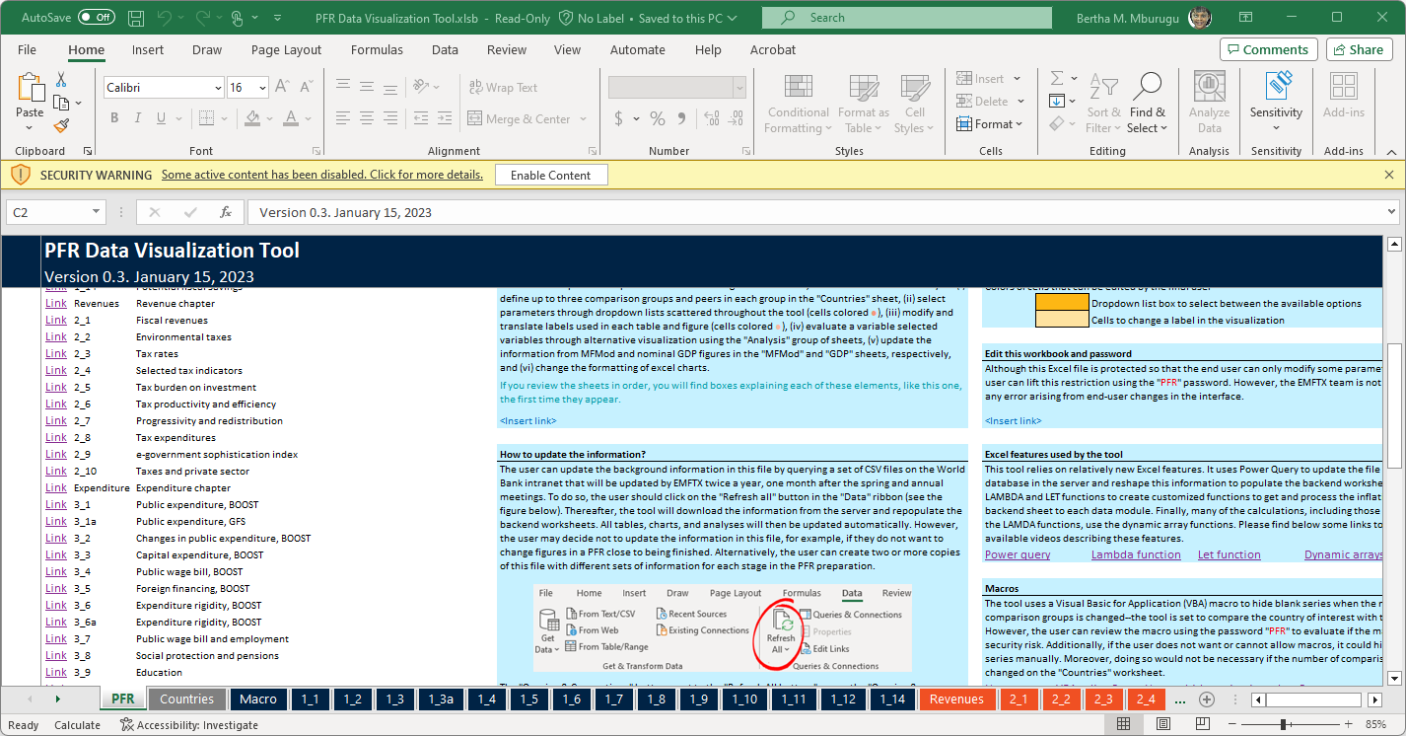
If a message asking, “Do you want to make this file a Trusted Document?” pops up (Figure 2), click the “Yes” [1] button to make the file a trusted document so Excel can enable macros. If a privacy level window pops up, mark the check box [2] to ignore the privacy level and click on the “Save” [3] button to allow the tool to connect to the server to update the backend information.
Figure 2. Messages that could pop up when the file is open
Make the file a trusted document | Ignore private level so the tool can connect to server
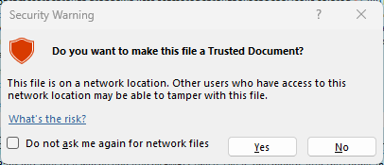  1 | 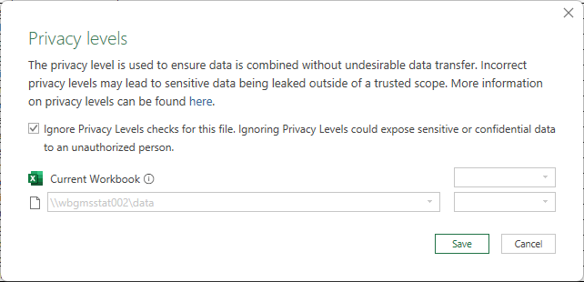  2
After this simple step, users can open the file and start using the tool. If users cannot enable macros after these steps, they could try to reopen it after saving it with another name using Excel or reviewing the “Trust Center” setting in their Excel files.
3

Navigating the tool
Figure 3. “Subnational PFR” sheet
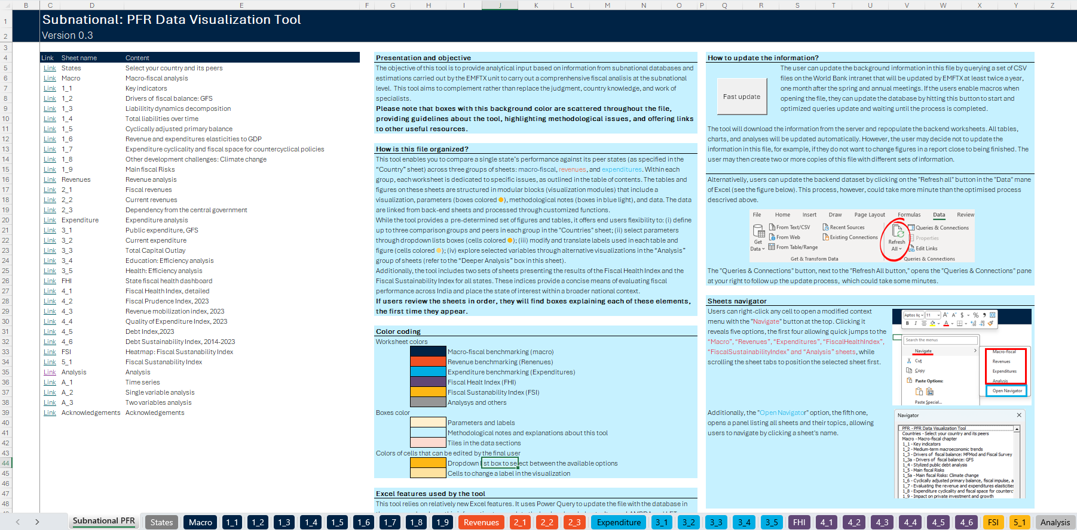
6
6
5
4
3
2
1

The tool is organized into seven worksheet groups. After accessing macros, the tool will open the “Subnational PFR” sheet (Figure 3) that contains the table of contents with links to all other sheets [1] and various light blue boxes describing how to use the tool [2]. The table of contents includes information on the structure and content of each section, helping users understand the layout of the tool. It distinguishes the other six groups in addition to the Acknowledgement sheet. The first four groups, “States”, “Macro-fiscal”, “Revenues”, and “Expenditures”, are designed to compare the situation of a state of interest with up to three comparison groups to carry out a benchmark analysis [3]. The “State” sheet allows users to set the state of interest and define the comparison groups. The “Macro-fiscal”, “Revenues”, and “Expenditures” groups are made of several sheets, where each evaluates a particular issue through one or more visualizations. After this section, the tool has two additional sections to assess the Fiscal Health Index (FHI) and Fiscal Sustainability Index (FSI) across all states, the fiscal dashboards [4]. Finally, the “Analysis” group has some options to evaluate any variable users select throughout different visualization from time series to alternative cross-states comparisons [5]. The sheets of each group can be distinguished because the color code shown in the cover sheet [6].
Figure 4. Structure of visualization modules
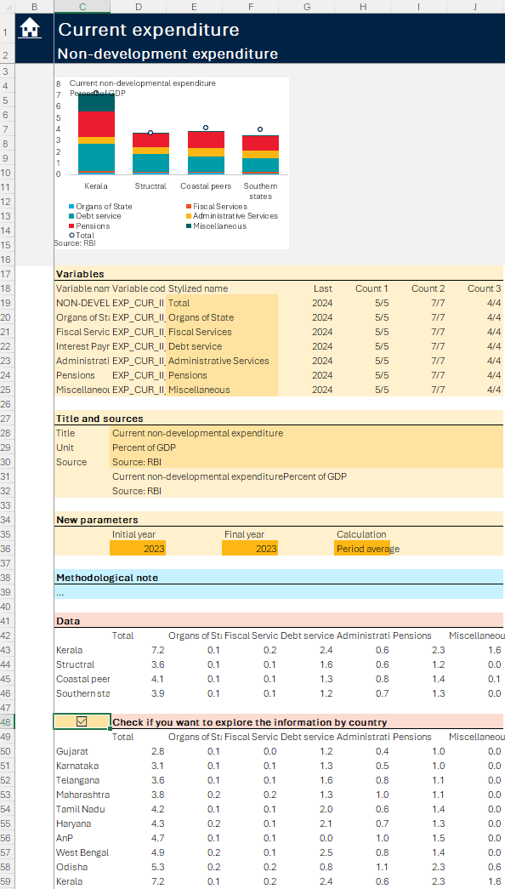
10
9
7
8
6
5
4
3
2
1
The tool also has some hidden sheets with the backend data. The “_Data” sheet has a table with all the information for official sources used by the tool. The “_Estimations” sheet has some figures estimated by the World Bank, including the data used and estimated in the efficiency analysis. The “_States” sheet includes some backend tables, including the list of states and the suggested comparison states for each state. Although these sheets can be unhidden using Excel, the end users generally do not need to do so, as the tool offers an instrument to analyze this information. To unhide a sheet, right-click on any sheet’s tab, select “Unhide…”, and select the sheet of interest.
Except for the cover sheet of each group, each sheet has one or more visualization modules with the same components. Each visualization module has one or more suggested table or chart (Figure 4) [1]. Below the visualization, it has one or more orange boxes [2] where users can edit variable names [3], edit the visualization title and sources [4], evaluate the state coverage of data [5], and set parameters to produce the visualization [6], such as initial and final year. Users only need to type the label they want to show in the visualization in the medium orange cells to edit the variable names, titles, and sources. To change the parameters, users should change the value in the drop-down list boxes in the dark orange cells. Below the orange boxes, the visualizations have a light blue box containing methodological notes to help users understand the data, which could include the definition of some variables, or the methodology used to calculate other variables [7]. Below the methodological note, the visualization module has data used to produce the visualization so users can review the data or copy it to create their own visualizations [8]. When the visualization compares the state of interest with the average of comparison groups, the visualization module has another data section [9] where users can view the data disaggregated by state by hitting the check box in the header of this section [10].
Figure 5. Data density indicators and alternative to navigate between sheets
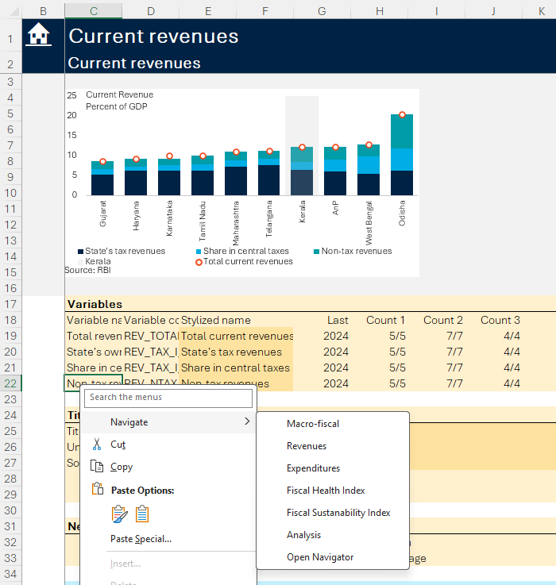
2
6
5
4
4
1
The visualization modules contain some indicators about data availability in the orange boxes. These indicators are usually arranged in four columns in the same row as the variable name and codes (Figure 5) [1]. The first column, “Last”, displays the last year with available information for the state of interest, disregarding the period selected to help users set the period to be use in the visualization. The other three columns show the ratio between the countries with available figures and the number of countries in each comparison group to help users define the time parameters or evaluate if the group averages have enough information to be representative.
7
The tool offers a couple of instruments to navigate between sheets. Users can navigate between sheets using the traditional options in Excel, such as checking the sheet tab [2] at the bottom of the application or using the activate menu by right-clicking the navigation buttons in the bottom- left corner of the application [3]. Alternatively, users can go to any sheet using the link in the table of contents in the “Subnational PFR” sheet and hit the house icon in the top-left corner of each sheet to return to the “Supernational PFR” sheet [4]. Users can also navigate between sheets using the context menu. When users right-click any cell [5], a modified context menu pops up with the "Navigate" button at the top [6]. Hovering the mouse over it reveals seven options. The first six allow jumps to the “Macro”, “Revenues”, “Expenditures”, “FiscalHealthIndex”, “FiscalSustainabilityIndex”, and “Analysis” sheets, the first sheet in each group [7]. Additionally, the "Open Navigator" option [8], the seventh option, opens a panel listing all sheets, allowing users to navigate to any sheet by clicking on its name.
3

Updating the tool
The tool relies on a back-end database periodically updated by the World Bank’s country team. The Excel tool is only the front-end to facilitate the analysis of an extensive database built by the World Bank’s country team, placed on the country team’s SharePoint (Box 1). The team pulls this information from official sources, mainly the Reserve Bank of India (RBI) State Finances Study for fiscal figures and the Ministry of Statistics and Programme Implementation (MOSPI) for macro-economic database. Note: A year denotes the fiscal year. For instance, 2022 is FY 2022-23 starting April 2022. For fiscal variables, 2023 is revised, and 2024 is budget estimates. Based on this information, the team classifies and prioritizes variables that are used to keep the tool as simple as possible and estimate some parameters that could inform the analysis. The country team updates This back-end database at least once a year to ensure the end users have the latest available figures.
The tool allows users to automatically update the backend database with the data on the server. The information in SharePoint is retrieved to the Excel tool using Power Query so the users can update the data from the server whenever they want, preserving their customization, including the selection of peers, without downloading the latest version of the tool. However, as the backend data are in an internal SharePoint, the feature can only be implemented when the computer is connected to the World Bank system.
There are two options to update the backend data (Figure 6). To update the backend data, users only need to go to the “Data” [1] menu in Excel, click on the “Refresh All” [2] button in the "Queries & Connections" section [3], and wait until all queries are updated. If they want to follow up the update process users should click in the "Queries & Connections" [4] button in the "Queries & Connections" [3] section of the “Data” [1] menu before updating the data, so Excel opens a panel at the right [5] showing all queries used by the tool to get the data from the server. This panel will show progress rings next to the queries during the update, which could take several minutes. Alternatively, users can also hit the “Fast update” [6] button in the “Subnational PFR” sheet [7], which optimizes the order of queries to accelerate the update and shows a message when all queries are updated.
Figure 6. Option to update the backend information
Plain excel
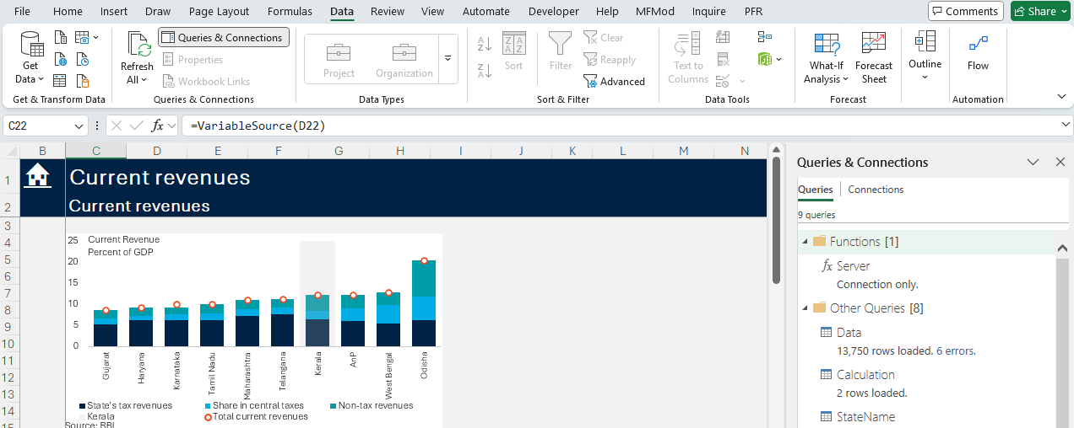
5
4
3
2
1
Fast update
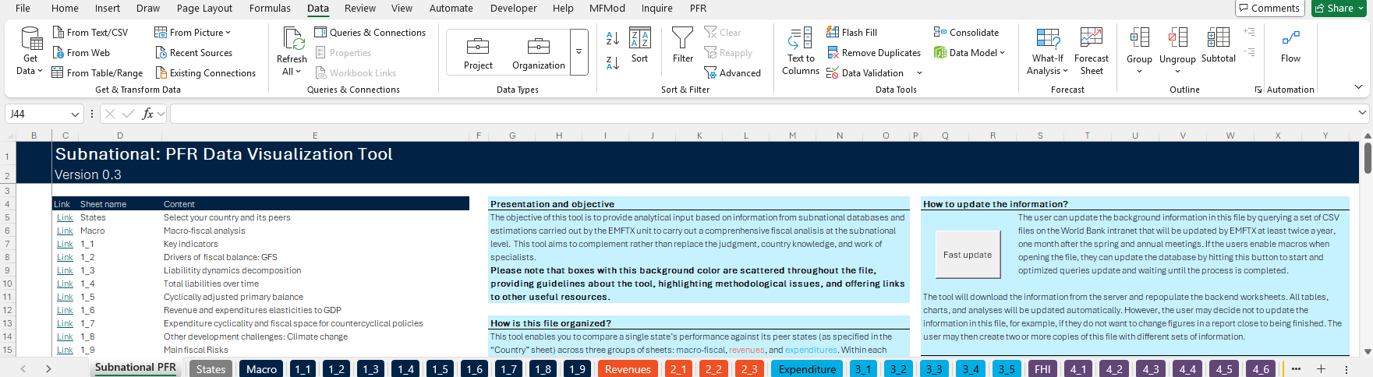
7
6
Box 1. The back-end database
The backend data processing for the tool is a structured workflow executed in R, aimed at transforming diverse datasets into a unified format for analysis and visualization. The process begins with setting up the environment by loading the necessary libraries and configuring the working directory. Key datasets are imported from multiple Excel files, including fiscal data, variable codes, state codes, and additional public financial metrics.
The master public finance database is from the Reserve Bank of India (RBI) State Finance Study, which provides comprehensive coverage of state public finances starting in the 1990s. Important datasets include wages and salaries, operations and maintenance expenditures, social sector expenditure, climate indicators, and cyclical estimates. Each dataset is formatted to include fiscal year information and integrated into a master dataset.
Social sector expenditure data provides insights into state-level social spending, while climate data from the Department of Science and Technology (DST) measures climate vulnerability. Energy indicators from NITI offer insights into state-level energy initiatives. Cyclical and potential components of fiscal metrics are calculated, identifying cyclical components of spending and real GDP. New fiscal variables are created using algebraic operations, and data on nominal GDP, sectoral gross value added, and inflation is imported and merged. Real GDP and per capita income data undergo similar processing.
Peer selection involves clustering states into peer groups based on GDP per capita and population using k-means clustering, helping to understand the relative economic positions of different states. This comprehensive data processing workflow ensures the tool is equipped with accurate and detailed fiscal data, enabling insightful analysis across economic, social, and environmental dimensions.

Unprotect sheets
All sheets in the data tool are protected so that users may only modify certain elements. Cells in medium orange allow users to insert text to set titles, sources, notes, and labels in the visualizations. The drop-down list boxes in darker orange cells enable users to modify parameters such as year and time aggregation protocols. No other cells can be modified without unprotecting a sheet. The check boxes allow users to select items (e.g. states and comparison groups) and enable some options, like viewing the information by state when the visualization only shows the group averages. Additionally, users can modify the chart by changing the format and modifying the series to be shown, using the conventional Excel features.
Users may also unprotect sheets using the password “PFR” to explore and modify any tool element. Being able to unprotect the sheet or macros allows the final users to analyze the data or change the chart with some degree of freedom. However, it is worth noting that any modifications made to the interface by end-users after unprotecting the worksheets are done at the user’s own risk.

Chart format
All charts in the tool have a similar structure and format. To keep the charts as simple as possible, most have a white background, use black Calibri Light font of six-point size, have the series label at the bottom, and do not include grid lines or the y-axis line. Charts already include titles, subtitles, notes, and sources, which can be modified using the orange boxes in the corresponding data module. Most charts use the three primary colors and their variants to prevent visuals from becoming overwhelming. Blue and green (cool colors) are commonly used to plot most series, while orange (a warm color) highlights the most critical issue in the chart, generally the state of interest. The size of most charts is also standardized to 1.9' in height and 3.08' in width. Although this size seems small in the Excel file, it was set to allow the final users to include two charts side-by-side in a single line in Word.

Fiscal Benchmarking
This section will describe how to use benchmarking analysis to understand the fiscal challenges of a state of interest. While the first section describes how to select the state of interest and define the comparison groups, the other sections outline the content of the macro, revenues, and expenditure groups of sheets. As most visualizations are self-explanatory and/or can be understood with the description of visualization modules above, these sections will focus on the most complex visualizations that could require more information.

Selection of peers
The second sheet, “States”, focuses on selecting the state of interest and defining the comparison groups for benchmarking analyses. The benchmarking exercise involves four steps (Figure 7):
- Select the State: Begin by selecting the state to be analyzed from the drop-down list box in cell G8 in the first section on this sheet [1]. This is the state that will be analyzed in the “Macro”, “Revenue”, and “Expenditure” group of sheets in the tool.
- Define up to three comparison groups: Check the checkboxes in column E under the second section to select the comparison groups to be used in the benchmark analysis [2]. The tool allows users to define up to three comparison groups: suggested peers and two groups of customized peers. The "suggested peers" group is set in the back end based on income per capita and population. The other two peer groups are fully flexible, depending on the user's objective.
In column G, this section allows users to rename the state of interest and each group to describe the criteria used to define the groups or translate their names [3]; these names will be used in all visualizations. For example, the suggested peers can be defined as structural peers. Similarly, when analyzing a coastal state, it could be benchmarked against "coastal peers" as one peer grouping, while another group could be based on regional location.
Next to the displayed names, this section has a button, “Update charts” [4], that should be hit every time the users change the number of groups by changing the checkboxes. This button runs a macro that makes the series corresponding to the selected groups visible in all charts.
- Select states within each comparison group: The third section [5], columns Q to AB, contains three lists of states with their corresponding checkboxes so users can select which state will be included in each group. In the case of the suggested peers [6], the first states list, users should choose the states they want to exclude from the list of countries proposed by the tool, as the suggested peer group might include peers that are not relevant for benchmarking. In the other two lists [7], users should select the states they want to include in the second and third comparison groups.
- Modify state labels: The fourth section has a table of all states [8], with three columns that contain the states’ names in the backend data, the alternative names set by the users (orange column), and the names to be used by visualizations, respectively. The values in the third column are equal to those in the first column unless users insert an alternative name in the second column. In this way, the users can modify labels used in all visualizations to enhance readability by translating them into the appropriate language or abbreviations for better visualizations.
Figure 7. Selection of the state of interest and the comparison groups
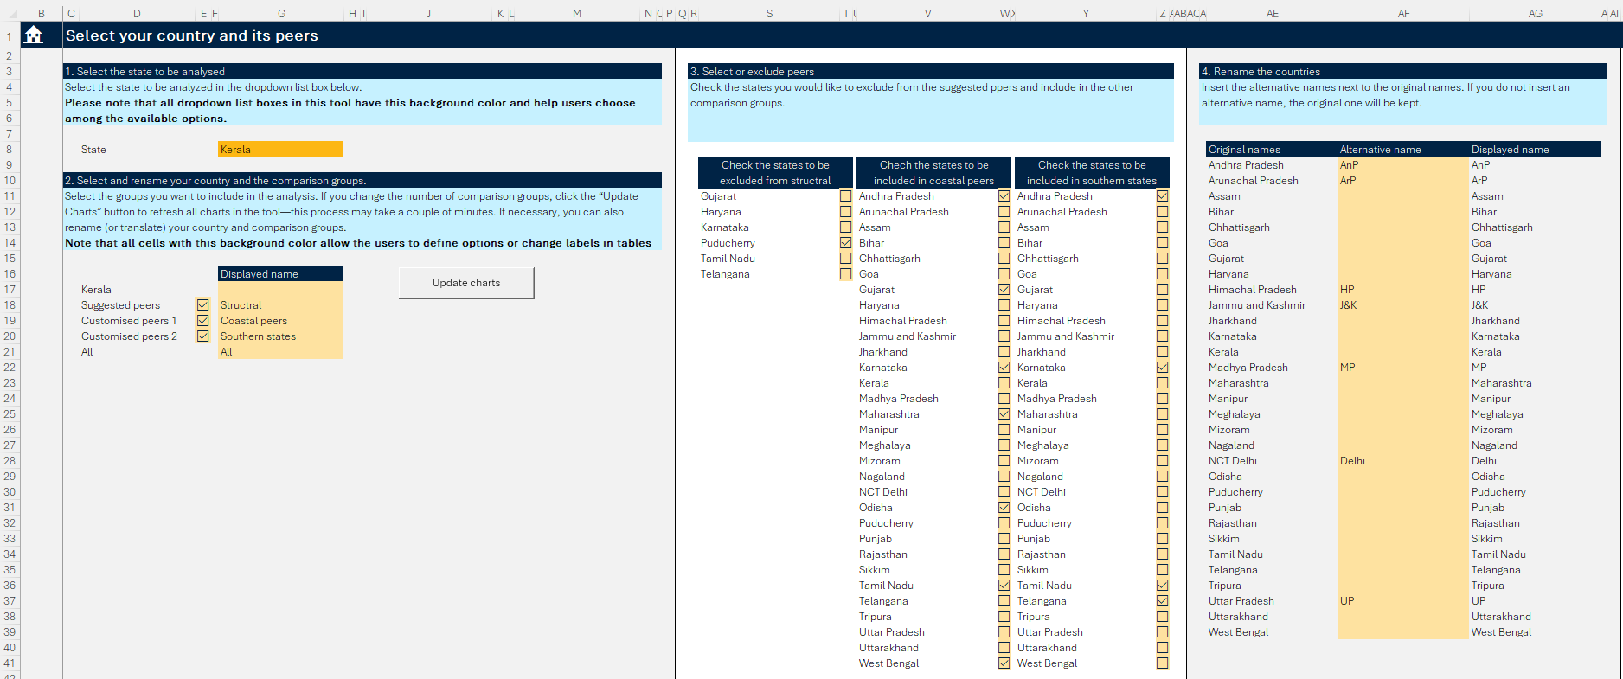
8
7
6
5
4
3
2
1

Macro-fiscal section
This section presents a series of charts and tables designed to evaluate key macro-fiscal trends and illustrate the role of fiscal policy in a state's development challenges. The Macro section includes various sheets summarizing key macro-fiscal indicators, drivers of fiscal balance, debt dynamics, and cyclically adjusted primary balances. As most of these visualizations are in very standard visualization modules, which do not merit additional description, the following paragraphs will focus on describing some modules that could be more difficult to understand.
The table on key indicators in “1_1” sheet provides a comprehensive overview of essential macroeconomic trends for the states to put their fiscal situation into context (Figure 8). This sheet has a table that shows the evolution of selected macroeconomic variables [1] and compares the state of interest with the average of all the comparison groups [2]. As in any other standard visualization, users can use the drop-down list boxes (dark orange cells) to define the initial and final year of the period and the time aggregation protocol (period average and last available period) [3]. Note that the end year not only defines the last year included in the averages of comparison figures but also determines the end year of the time series.
The table and chart sheet “1_3” allow users to evaluate the impact of primary deficits, economic growth, and interest rates on the liabilities to GDP ratio dynamics., Despite its apparent complexity, the visualization module only requires users to define the final field in the unique drop-down list box in the parameter box. The calculations carried out in this sheet are based on the debt dynamics decomposition conducted in the World Bank and the International Monetary Fund.
Figure 8. Selection of the state of interest and the comparison groups
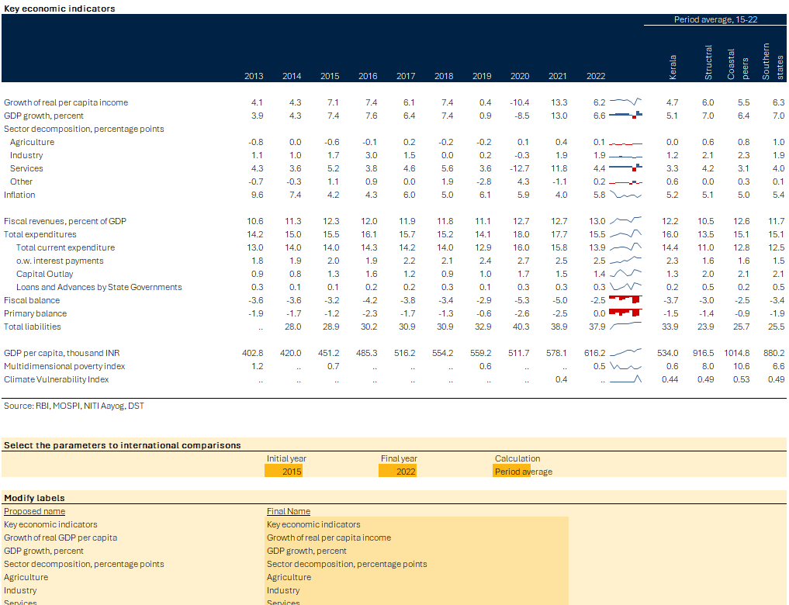
3
2
1
The visualizations in sheet “1_5” present the cyclically adjusted primary balance (Figure 9)., The cyclically adjusted primary balance shows a measure of the primary balance if the ups and downs of the business cycle, which affect revenues and expenditures, were netted out, thus giving a better measure of the budget balance of discretionary policies. In this case, users only need to set the initial years in the drop-down list box in dark orange cells [1] and the revenue and income elasticities in the medium orange cells [2]. If users do not have any estimation of the revenues and expenditures elasticities, they can use the recommended default values: the revenue elasticity at one and the expenditure elasticity at zero. Alternatively, users can use the visualization modules in sheet “1_6” to calculate the elasticities based on basic regressions. With these paraments, the tool calculates the cyclically adjusted primary balance and displays four charts [3]: (i) the GDP output gap calculated using the Hodrick-Prescott filter over time, (ii) the actual and cyclically adjusted primary balance over time, (iii) the output gap and fiscal impulse over time, and (iv) a scatter plot that categorizes the policy stance of each year as pro or countercyclical and expansionary or contractionary.

Figure 9. Cyclically adjusted primary balance
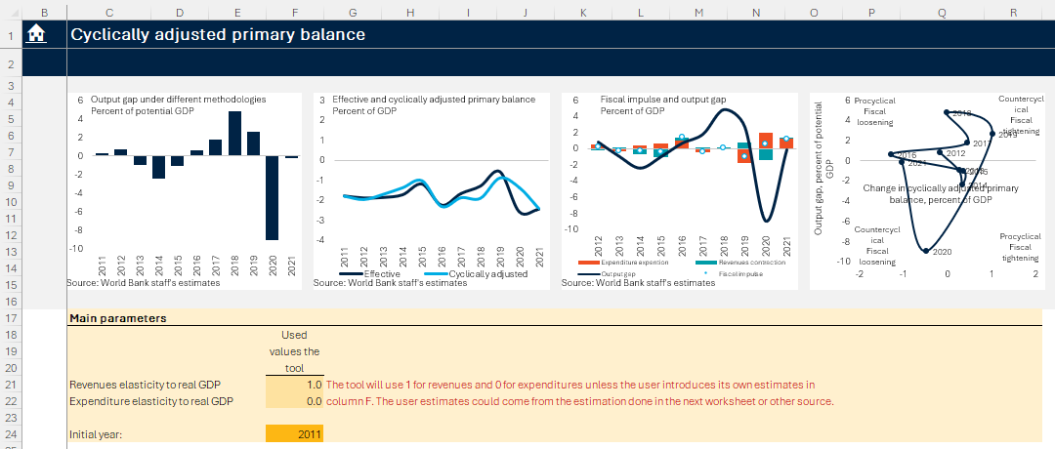
3
2
1
Figure 10. Revenue elasticity
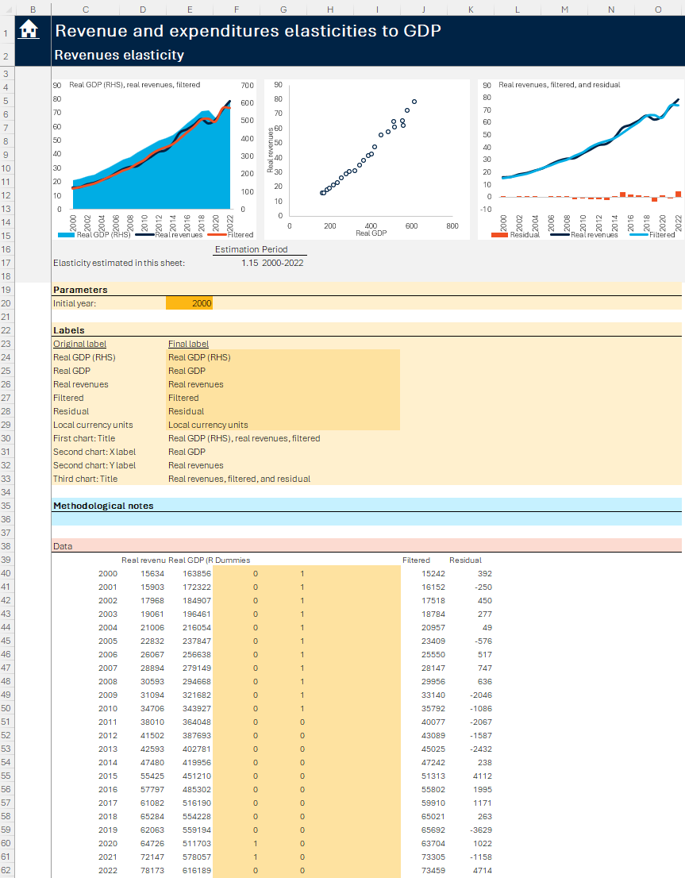
5
4
3
2
1
Sheet “1_6” has two identical modules to estimate the revenue and expenditure elasticities based on log-log regressions. Each module displays the estimated elasticity [1] and has three visualizations to evaluate the results: (i) a line-area chart with real GDP, the real revenues (expenditures), and the fitted value, (ii) a scatter plot of real GDP and real revenues (expenditures), and (iii) a line-area chart with the actual and filtered revenues (expenditures) and the residual (Figure 10) [2]. These modules only require setting the initial year [3] as the model automatically selects all years from this year to the last available year in the backend datasets. The option to set the initial year allows users to exclude data before an old structural change that can bias the estimation. With this information, the elasticity is calculated using a log-log regression in the data section [4], where users can use the orange cells to set up to four dummy variables to define structural breaks or one-off events [5]. The regressions will not work if users do not insert values different from one or zero in the entire column.

Revenues section
This section includes revenue profiles. It provides comprehensive insights into state revenues, including a detailed breakdown of fiscal revenues and indicators on the dependency on central government transfers. In this case, no visualization merits additional description as the tables and charts in 2_1 operate like the key indicators sheet discussed previously, and the other visualizations are in very conventional visualization modules. In each of these modules, users can use the drop-down list boxes in the dark orange cells to define the initial and final years of the period of comparison and the time aggregation protocol, but, in sheet “2_1”, the final year also defines the last year in the time series.

Expenditure section
This section includes details on expenditure categories of states based on functional classification and displays various visualizations to evaluate the efficiency of health and expenditure. While the tables and charts in the first sheet provide alternative visualizations to assess the composition of expenditures, the following two sheets offer a series of stacked bar charts to evaluate the composition of current expenditure and capital outlay, all of them in very conventional visualization modules that do not require further explanation. Conversely, the last two sheets include a series of unconventional visualization modules to analyze the efficiency of health and education expenditures that need additional explanation.
The last two sheets of this section include the health and education expenditure analysis with similar visualizations. Each of these sheets has four visualizations modules (Figure 11):
- Simple deterministic frontiers [1]: The first visualization plots the efficiency frontier based on Data Envelopment Analysis (DEA) and Free Disposal Hull (FDH). In this case, users only need to define the outcome variable in the drop-down list box in the parameter box [2]. In the case of education, the outcome variables are the Annual Status of Education Report (ASER) reading outcome, the ASER math outcome, and the language learning outcomes. In the case of health, the outcome variables are the National Institute for Transforming (NIT) health index, full immunization coverage, and tuberculosis treatment success rate.
- Efficiency score by outcome variable [3]: The second visualization plots the output-oriented efficiency score of each outcome variable using the methodology selected by users [4]. Users can select between six methodologies: the simple deterministic DEA, the simple deterministic FDH, the bootstrapped DEA, the bootstrapped FDH, the stochastic frontier, and the average of the previous five methodologies (the preferred one). Note that the first visualization can only display the DEA and FDH, because the results of the other methodologies cannot be plotted in a simple scatter plot.
- Efficiency score by methodology [5]: The third visualization plots the output-oriented efficiency score associated with the outcome variable selected by users [6] under the six methodologies pointed out in the previous bullet.
- Potential Gains Visualization [7]: The final visualization compares the potential gain in the state of interest with the average of the comparison groups. In this case, users need to select the outcome variables and the methodology to estimate the potential gain [8]. This visualization depicts the potential improvement in the outcome variable achieved by closing the efficiency gap measured by the user-selected methodology.
Figure 11. Efficiency analysis
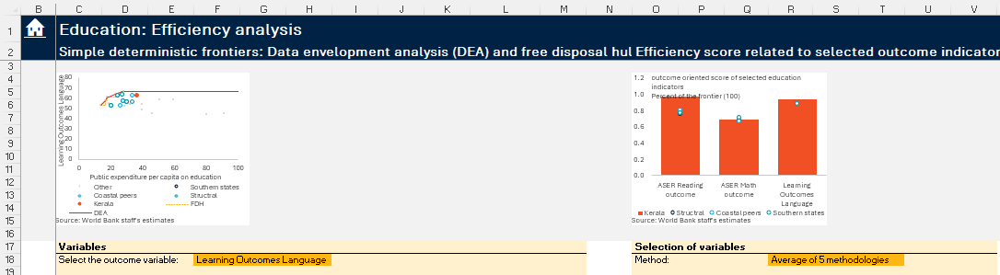
4
3
2
1
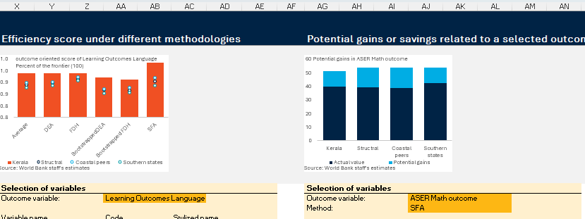
Continue…
8
7
6
5

Fiscal Dashboards
This section will describe the group of sheets that evaluate the fiscal health and sustainability indexes across all states. Unlike the previous groups of sheets meant to provide insight to assess the situation of the state of interest vis-a-vis its comparison groups, these sheets display the fiscal health and fiscal sustainability indexes for all states.

Fiscal Health Index
The FHI is used to evaluate the fiscal health of states. Based on a recent report by NITI Aayog (2024), this index provides data-driven insights to guide policy interventions at the state level. The FHI is the simplest average of five cluster indexes:
- Fiscal prudence: Reflects the states’ capacity to maintain a sustainable fiscal balance and tracks the gross fiscal deficit and the revenue deficit as a percentage of GDP.
- Revenue mobilization: Assesses the states’ ability to generate their own revenue and cover their expenditure independently and tracks the state’s own revenues as a percentage of GDP and total revenues.
- Quality of expenditure: Reflects the states’ capacity to prioritize spending more likely to foster long-term development and tracks the proportion of developmental expenditure as percent of total expenditure and total capital outlays as a share of economic GDP.
- Debt index: Assesses the state’s debt burden, focusing on interest payments to revenues and liabilities related to GDP.
- Debt sustainability: Compares GDP growth to interest payments over a period defined by users, with a positive difference indicating fiscal sustainability.
Each variable mentioned above is standardized, so the best value equals one hundred and the worst value equals zero. After calculating the individual indexes, each cluster index is calculated as a simple average of its subindexes so that the FHI can be calculated as a simple average of the cluster indexes.
Figure 12. Fiscal Health Index
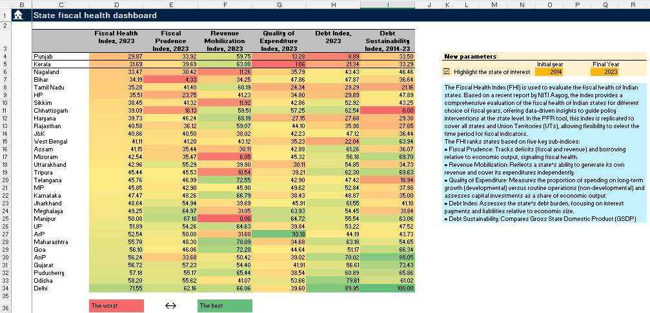
3
2
1
The “FHI” sheet shows a heatmap that summarizes the FHI and the cluster indexes. In this heatmap, the redder the cells’ background is the worse (the lower the index value), and the greener the cells’ background the better (the higher the index value) (Figure 12) [1]. Users only need to select the initial and final year [2]. Most of these indexes are calculated for the final year, except the debt sustainability index, which is calculated as the average of the difference between GDP growth and interest rates over the period defined by the initial and final years to address the high volatility of this indicator. Additionally, in the parameter box, users can check a checkbox [3] to change the border of the state of interest to facilitate its identification.
Sheet “4_1” is an extended heatmap with subindexes of each variable included in each cluster index. This heatmap is like the heatmap displayed in the previous sheet, but, in this case, the indexes of each variable within each cluster are shown with grayscale heatmaps where the darker the cells’ background the worse (the lower the index value) (Figure 13).
The subsequent sheets in this section provide more detailed visualizations of each cluster and variable subindexes. These visualizations are arranged in standard modules that do not have any parameters because all sheets in this group use the parameters set in the “FHI” sheet.
Figure 13. Desegregated Fiscal Heath Index
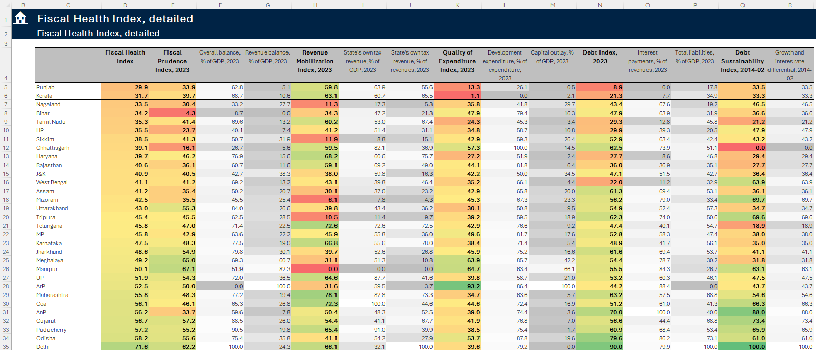

Fiscal Sustainability Index
This group of sheets presents the FSI developed to measure the states' capacity to repay their debt over the medium and long term. Unlike the FHI, it does not include revenues or expenditure. This index is the average of three indexes of liabilities, interest payments, and operations (revenues) balance. Each sub-index standardizes the original values, so it equals one hundred for the best-performing state and zero for the worst state. In the case of interest payments and total liabilities, the higher the value the worse, but in the case of the operations balance, the higher the value the better; after being translated into indexes, a higher value is always better.
The “FSI” sheet displays the FSI heatmap, its components, and a supplementary heatmap with the variables before standardization (Figure 14). In the FSI heatmap [1], the redder the cells’ background is the worse (the lower the index value) and the greener the cells’ background the better (the higher the index value). Additionally, this sheet has a supplementary heatmap with the original value of the variables to facilitate the analysis, where the conditional format is set so that the redder the cells’ background is the worse and the greener the cells’ background is the better [2]. To allow the tool to calculate the FSI, users only need to select the year [3] and the denominator code to be used by each variable in the drop-down list boxes [4]. The tool offers flexibility in expressing these indicators as a GDP or net revenue ratio. Additionally, as in the case of FHI, users can check a checkbox in the parameter box of this visualization to change the border of the state of interest [5], thus highlighting it.
Figure 14. Fiscal Sustainability Index
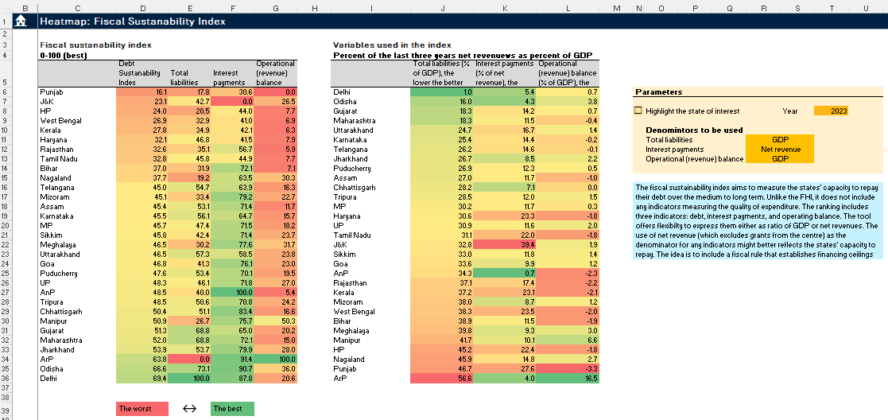
3
5
4
2
1
The ”5_1” sheet includes some visualization modules to evaluate the subindexes and original variables. As in the case of the FHS group, these complementary visualizations do not have a parameter box because they use the parameters set in the “FSI” sheet.

Analyzing variables
This section explains how to use the last group of sheets to evaluate any variable in the dataset. This group of sheets contains four worksheets that allow users to assess any variables in depth through different visualizations to, for example, evaluate if the result in the standard charts could be biased by outliers or to assess a state-specific issue.

Manually setting the variable to be analyzed
The “Analysis” sheet has a three-section interface that allows users to define the parameters to be used by the visualizations in the subsequent sheets (Figure 15). These parameters should be set in the medium orange cell, arranged in three sections. In the first section, users can define the main variable to be evaluated [1]. In the second section, users can define a complementary variable that is used to evaluate if there is a relationship between this variable and the main variables [2]. In the third section, users can define time parameters, including the time aggregation protocol [3].
The first and second sections allow users to define the variables to be employed and apply some basic transformations. In the first dark orange cell [4], users can select the variable to be evaluated using the drop-down list box, which narrows the list of variables as users type any string contained in the variable names, including the variable code. In this second drop-down list box [5], users can select which transformations to apply to the variables: none, difference, growth, percent, difference of percentages, and incidence. If users express the variable as a percentage, difference in percents, or incidence, a denominator variable should be selected in the third drop-down list box [6]; if no variable is chosen, the tool will use nominal GDP by default. Finally, in the medium orange cell [7], users can introduce a stylized name of the resulting variable to replace the formal name in the visualizations; if no name is introduced, the tool will use the primary variable name as a default.
Figure 15. Setting the parameters in the “Analysis” sheet
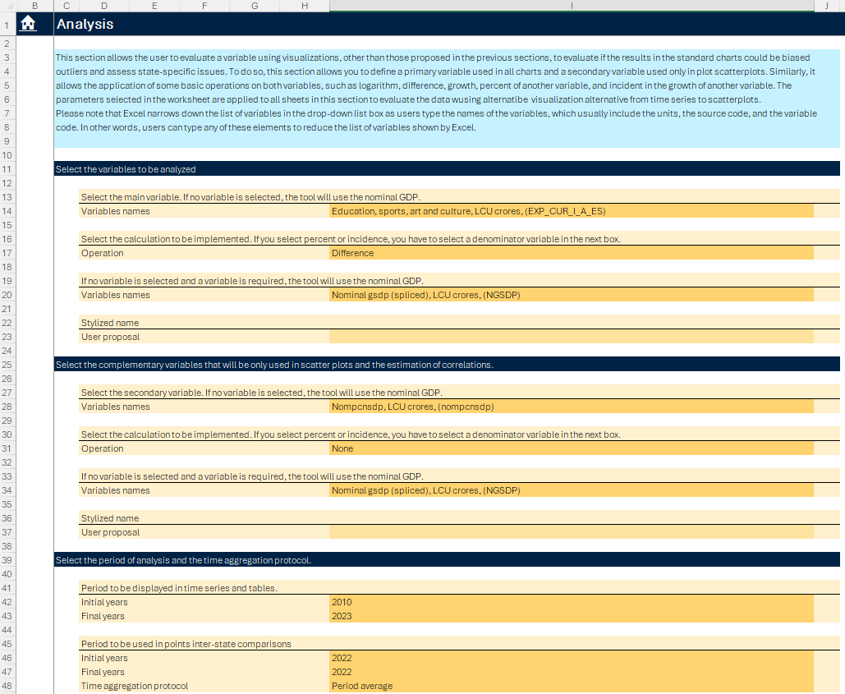
9
8
3
4
5
6
7
7
6
5
4
1
2

The third section allows users to define the time parameters. The initial and final years used in the time series are set in the first group of drop-down list boxes [8]. The initial and final years and the time aggregation protocol for cross-state comparisons are set in the second group [9].

Using context menus to set the variables to be analyzed
Users can use Excel context menus to set the parameters in the “Analysis” sheet (Figure 16). When users right-click on a cell with a variable code [1], the context menu includes the "Analyze this variable" button [2] at the top of the menu that uses the selected variables as the first parameters of the “Analysis” sheet so users can evaluate the variables throughout the alternative visualizations in this group of sheets. This button also sets the second and third parameters in the “Analysis” sheet to facilitate the analysis. When the variable is denominated in millions of local currency units (crores), the tool sets that the selected variables should be calculated as a percentage of GDP.

Figure 16. Use the “Analyze this variable” option in Excel context menu
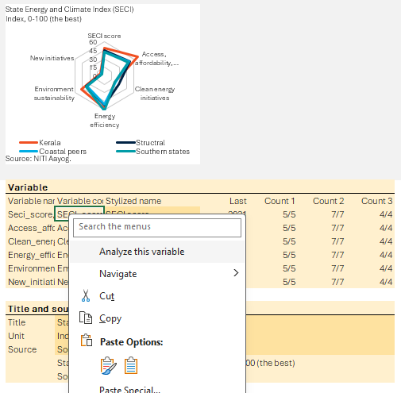
2
1

Alternative visualizations to analyze variables
After setting the parameter, the users can evaluate the selected variables in the other sheets of this section:
- The “A1” sheet has a chart that compares the dynamics of the primary variable selected in the “Analysis” sheet in the state of interest with peer averages over time. This sheet also includes tables with group and state data to evaluate the dynamics of the variable in question and the density of available information.
- The “A2” sheet compares the state of interest with the groups' averages and individual countries using different visualizations, including a scatter plot that confronts the variable of interest with the logarithm of GDP per capita.
- The “A3” sheet has visualizations to evaluate the relationship between the variable of interest and a secondary variable, which is also set in the “Analysis” sheet, through differences visualization, including a scatter plot.
Note that these visualizations lack orange boxes because all parameters of this group of sheets are set in the “Analysis” sheet. In other words, each visualization module in the group of sheets only has a chart with the data used to create the chart.

The tool was create in Excel because most people continue using this software to carry of fiscal analysis, Excel tables and figures can be easily exported to PowerPoint and Word, Excel allows users to edit the charts and tables and to set any parameters required by the visualization tool, and new Excel features allow the tool to be connected to a server to update the information and process large amounts of data.
As the tool relies on some new Excel features, Microsoft Excel 2016 or newer is needed.
The “Macro-fiscal” group contains visualizations to evaluate the key macro-fiscal trends, identify drivers of fiscal balance changes, and assess debt dynamics, fiscal risks, and cyclically adjusted fiscal balances. The second group, “Revenues”, provides detailed revenue profiles of states, including dependency on central government transfers and analysis of fiscal revenues. The third group, “Expenditures”, breaks down expenditure categories based on functional classification, compares spending efficiency, and includes analyses of public expenditure, current expenditure, and capital outlay.
This information is retrieved in the hidden backend so users can access the data in Excel. Alternatively, users can download the backend databases in CSV format from SharePoint.
This password can also be used to explore and edit the Visual Basic for Applications (VBA) code.
We use K-means clustering to identify the suggested peer group based on income per capita and population. For details on K-means clustering algorithm, refer to James, G., Witten, D., Hastie, T., & Tibshirani, R. (2013). An introduction to statistical learning: with applications in R. Corrected edition. Springer.
Total outstanding liabilities include a comprehensive range of financial obligations such as market loans, power bonds, UDAY, compensation and other bonds, loans from various financial institutions (including NSSF, LIC, GIC, NABARD, SBI, and other banks), loans and advances from the Centre, provident funds, reserve funds, deposits and advances, and the contingency fund, with the total being the sum of these components.
For additional information on this decomposition refer to “A Guide and Tool for Projecting Public Debt and Fiscal Adjustment Paths with Local- and Foreign-Currency Debt” (IMF, 2021).
Although the use of cyclically adjusted primary balances at the subnational level is not entirely appropriate because the income of a state does not depend more on country income than on states’ income, this analysis was kept as per the country team’s requirement.
For additional information on how to calculate the cyclically adjusted primary balance, refer to “PFR Fundamentals: Fiscal Policy Cyclicality” (World Bank, 2024) or “Computing Cyclically Adjusted Balances and Automatic Stabilizers” (Fedelino, Ivanova, and Hoston, 2009).
Total current expenditure is further divided into current developmental spending, which includes social services and economic services, and current non-developmental expenditure, which encompasses organs of state, fiscal services, interest payments and servicing of debt, administrative services, pensions, miscellaneous general services, grants, and reserves with the financial department. Total capital outlay is categorized into development capital outlay, social and economic services, and non-development capital outlay. Loans and advances are classified into development purposes, including social and economic services, and non-development purposes.
For details on methodology, refer to “Public Finance Review Data Visualization Tool: An Application to Indian States” in NIPFP States Forum 2024 Compendium or “PFR Fundamentals: Spending Efficiency” (World Bank, 2025)
The NITI Health Index is a composite index to monitor progress, identify areas for improvement, and potentially provide performance-based incentives. The NAHI evaluates states based on 23 essential factors: health outcomes, governance, key inputs, and processes. For details refer to “Fiscal Health Index, 2025” (NITI Aayog, 2025)
Revenue deficit is the difference between current expenditure and current receipts, while fiscal deficit compares the total expenditure and total receipts (including capital expenditures and non-debt-creating capital receipts).
Development expenditure includes all current and capital outlays for development purposes, including social (like education, health, etc.) and economic services (like rural development, power projects, etc.). Capital outlays include capital outlays related to both developmental and non-developmental purposes. Refer to RBI State Finance Study for detailed classification.
This index can be modified to set a traffic light system like the one used in some Latin American countries to set sub-national fiscal rules. For example, Mexico used a similar index to set a traffic light system to establish financing ceilings (overall balance targets).
The state total outstanding liabilities include a comprehensive range of financial obligations such as market loans, power bonds, UDAY, compensation and other bonds, loans from various financial institutions (including NSSF, LIC, GIC, NABARD, SBI, and other banks), loans and advances from the Centre, provident funds, reserve funds, deposits and advances, and the contingency fund, with the total being the sum of these components.
Operational balance or the revenue balance is defined as revenue (or current) receipts less revenue (or current) expenditure.
Net revenues are defined as total receipts including current receipts, non-debt creating capital receipts but exclude grants from the Centre/Union government. Using net revenue as the denominator for any indicators might better reflect the states' capacity to repay.

